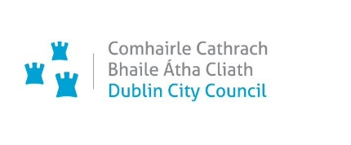



Dublin City Active Travel Network

Report on Non – Statutory Consultation

South Circular Road / Brookfield Road Junction Upgrade Scheme

July 2025

TABLE OF CONTENTS
1. INTRODUCTION 3
2. CONSULTATION PROCESS 4
3. CONSULTATION RESULTS 5
4. SUBMISSION THEMES AND RESPONSES 9
Theme 1: Traffic Flow/Congestion 9
Theme 2: Access 10
Loading/Unloading at MACE South Circular Road 10
Access to Hospital Including Emergency Access 10
Theme 3: Safety 10
Driver Behaviour 10
Pedestrian and Cyclist Safety 10
Theme 4: Design Suggestions 11
4.1 Road Design Suggestions 11
4.2. Cycle Lane Design Suggestions 12
4.4 Footpath design suggestions 14
Theme 5: Parking 15
Theme 6: Greenery 15
5. CONCLUSION AND NEXT STEPS 16
6. APPENDIX A: CONSULTATION QUESTIONS AND RESULTS 17
7. APPENDIX B: PROMOTION OF PUBLIC CONSULTATION 18

INTRODUCTION

Dublin City Council’s (DCC’s) Active Travel Network will enhance quality of life by connecting people through the delivery of a walk-wheel-cycle network. This will be achieved by improving access, connectivity and sustainable mobility. The Network will also contribute to the reduction of transport-related carbon emissions. Over the lifetime of the programme, the Active Travel Network will grow from 10 kilometres to a connected network of 314 kilometres across the city.

The South Circular Road/ Brookfield Road Junction Upgrade Scheme is part of the DCC core Active Travel Network. It is co-funded by the National Transport Authority (NTA) and DCC.

This junction is at the entrance to the new National Children’s Hospital and St James’ Hospital. The objective of the scheme is to improve the safety of pedestrians and cyclists through the junction. This junction is part of the South City Loop scheme. When fully complete, it will provide 9 kilometres of high-quality walking and cycling facilities linking Kilmainham to Ballsbridge. The proposed route will also link Rialto, Crumlin, Kimmage, Harolds Cross, Rathmines, Ranelagh and Donnybrook.

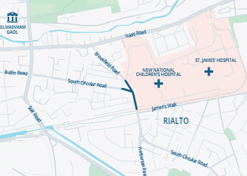

Figure 1- South Circular Road/ Brookfield Road Junction Upgrade Scheme

CONSULTATION PROCESS

A non-statutory public consultation was held to inform the public of the key features of the scheme and gather comments to better inform the decision-making process for the implementation of the scheme. This consultation consisted of:

- An online public consultation via DCC’s Consultation Hub (from the 5th of June to the 2nd of July 2025)
- Information leaflets were distributed to 2,255 residential houses and businesses close to the route
- Drawings were available to view in hard copy in St. Andrew’s Community Centre, 468 South Circular Road, Rialto, Dublin 8, D08 H51F and in F2 Centre, 3 Reuben Plaza, Rialto, Dublin 8, D08 PV0H for the duration of the consultation period
- Awareness was raised via social media across DCC’s social media channels (Twitter, Facebook, LinkedIn and Instagram)

The public could comment via the online questionnaire, by email or post.

After the public consultation, detailed design drawings will be prepared. The design will be modified where appropriate taking into account the feedback from the public. Once approval and funding are obtained from the NTA, a contractor will be procured and the scheme installed.
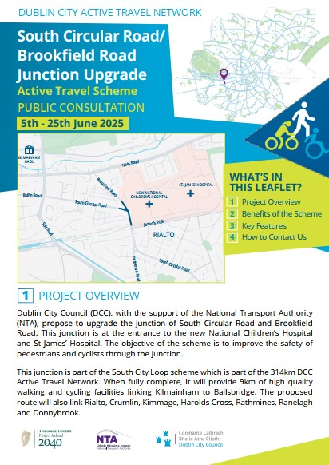
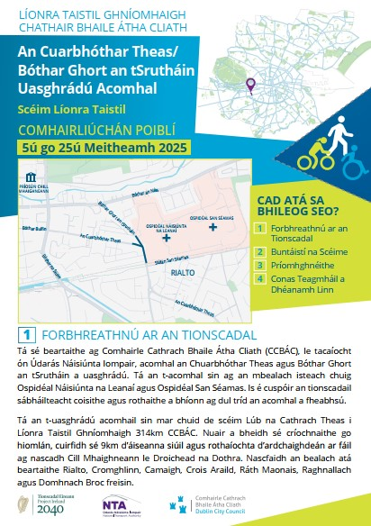

Figure 2- Extract from the Information Leaflet for the South Circular Road/ Brookfield Road Junction Upgrade Scheme

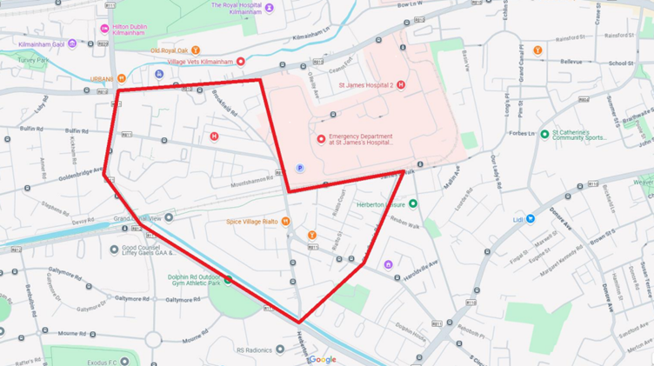

Figure 3 - Extent of Leaflet Distribution Area

CONSULTATION RESULTS

There were 72 responses to the public consultation made through the online questionnaire and email. Respondents to the online questionnaire were asked a series of questions about their age; whether they live/work/ travel along the scheme; their frequency of travel; their primary mode of transport; and the comments they wished to make about the proposed scheme (see tables below and Section 4). This report contains a review of the submissions.

Age

Figure 4 - Age profile

Most respondents who answered this question were in the 35 to 44 age group (22% of respondents), followed by 25 to 34 (18% of respondents), 45 to 54 (14% of respondents), 55 to 64 (7% of respondents), 65 or older (5% of respondents), and 18 to 24 (3% of respondents). 31% of respondents did not provide age information.

Categories

Figure 5 – Categories

Most respondents who answered this question live or work close to the route (33% of respondents); followed by those that travel along it (20% of respondents); and those who both live or work close by and also travel along the route (18% of respondents). 25% of respondents did not reply.

Primary mode of transport

Figure 6 - Primary mode of transport

Respondents were able choose multiple options to answer this question. The first choice on each answer shows that most respondents primarily walk (32%) or cycle (28%).

Sentiment

Figure 7 - Submission Sentiment Analysis

The results indicate that 61% of the respondents are in support of the scheme, of which half suggest alterations to the proposals to make it more acceptable. 28% of respondents do not support the scheme. Finally, 11% were neutral; they didn’t indicate their sentiments either for or against the scheme and only submitted some general comments.

Many respondents submitted several different suggestions and concerns. The main ones were grouped into 7 themes, which are discussed in section 4. Many respondents dealt with multiple themes in one response.

It is worth noting that several respondents mentioned there was a fatality in the area in the recent past. Also, some respondents noted that there have been traffic works regularly for several years in the area, and they pointed to the fatigue and discomfort that this has caused.

Opinion Categories: | Number of submissions | % of submissions
Fully supports the scheme | 22 | 30.5%
Supports the scheme with alterations | 22 | 30.5%
Does not support the scheme | 20 | 28%
Neutral | 8 | 11%
Total | 72 | 100%

Table 1: Submission Sentiment

SUBMISSION THEMES AND RESPONSES

The review of the submissions identified several key recurring themes. Those themes and DCC’s responses are summarised in the subsections below.

Many respondents indicated that they use active travel modes regularly. There was support for the scheme and to extend the project with additional walking and cycling infrastructure. A number of suggestions were put forward for the wider Dublin 8 area.

The proximity of the junction to the hospital campus containing St James Hospital and the new National Children’s hospital was raised in several submissions. They highlighted the existing traffic congestion and the need to ensure access for emergency vehicles and hospital users.

The responses also identified the need for traffic calming. There were several references to excess speed and vehicles passing red traffic lights.

The northwest corner of the junction is the location of a local convenience shop and a Dublin Bike sharing station. The importance of these amenities was mentioned, and responses identified the need for them to continue to operate efficiently.

Respondents asked for clarification on the impact of the project on parking.

Theme 1: Traffic Flow/Congestion

Increase in traffic congestion was one of the main concerns in the submissions. The responses expressed concern that this project will further restrict vehicles and lead to additional congestion. Some comments also mentioned that congestion will likely increase when the new hospital opens.

Response:

A detailed traffic modelling of the junction was carried out by the project team to evaluate the traffic impacts of the proposed changes. The assessment also considered the future traffic generated by the National Children’s Hospital. The results indicate that the proposal will have minimal impacts on traffic flow at the junction. This is mainly because the proposal preserves the existing number of traffic lanes. Maintaining access for emergency vehicles to the hospital is a primary objective of the project.
Additionally, computer simulations were carried out to assess vehicle movements, including those of buses and heavy goods vehicles, to ensure that all such vehicles can safely move through the junction. The proposed protected junction will make the junction more compact and help prevent conflicts between cyclists and vehicles, thereby enhancing overall safety of the junction for all road users.

Theme 2: Access

Loading/Unloading at MACE South Circular Road

There are concerns that the proposed cycle route will create operational difficulties for delivery, increase congestion and potentially worsen traffic conditions.

Response:

The loading and unloading options for MACE and the bike station will be clarified as part of the detailed design phase.

Access to Hospital Including Emergency Access

Submissions raised concerns about how the proposed changes would affect access to the hospital for workers, patients and emergency vehicles. There were concerns that introducing cycle paths and narrowing the road in an already busy junction will increase congestion and hinder access to the hospital, including access for ambulances. There were concerns that bollards and kerbs for cyclists will prevent traffic from moving out of the way of emergency vehicles.

Response:

Maintaining access for emergency vehicles has been a key consideration in the design of this scheme. The proposal preserves the existing number of traffic lanes, with only a minimal reduction in lane widths. No bollards are proposed in the scheme. The height of the segregation kerb has not yet been determined and will be addressed during the detailed design stage. This will be done in consultation with Dublin Fire Brigade and other emergency services to incorporate their requirements into the detailed design.

Theme 3: Safety

Several submissions highlight safety concerns at different locations:

Driver Behaviour

Several submissions highlighted instances of drivers breaking red lights at the junction. There were also submissions highlighting drivers not observing the stop sign when exiting the hospital.

Pedestrian and Cyclist Safety

Comments highlight the problem of speeding traffic, which makes it unsafe for pedestrians. Bicycle users highlight vehicles passing very close and excessive speed in the junction and approach roads.

Response:
The main objective of the scheme is to make the junction safer for all road users, particularly for cyclists and pedestrians. This will be achieved by converting the junction to a protected junction which will separate pedestrians, cyclists and vehicles as they move through the junction. Pedestrian, cyclist and vehicle movements will all be controlled by traffic signals.

Raised concrete islands will be installed at the corners of the junction to protect cyclists from turning vehicles and to provide a safe waiting area for them while crossing. Along with these features, the proposed reduction in traffic lane widths will help create a more compact junction, which is expected to have a calming effect on vehicles navigating through the junction.

Theme 4: Design Suggestions

There were many suggestions to modify the proposed design:

4.1 Road Design Suggestions

Cycle Lane Protection
Concerns that the kerb-protected lane may still be misused for parking. Suggestions to add extra barriers or wands to ensure it is kept clear.
Traffic Lane Layout
Some submissions questioned the need to keep two traffic lanes on certain approaches. Suggestions included removing the left-turn lane and replacing it with continuous cycle facilities or reducing to one wide lane to free space for walking and cycling.
Junction Management and Signals
Concerns that adding more traffic lights could increase delays, as the area already has many signalised junctions. Some suggested reviewing signal timings to prioritise pedestrians and cyclists.
Parking and Access Issues
Specific concerns about vehicles blocking laneways and gates near Brookfield Road. Suggestions included extending yellow boxes to keep access points clear.
Pedestrian Crossings
Request for more direct and safer pedestrian crossing near the hospital entrance, where current zebra crossings are seen as poorly located.
Active Travel Space
Suggestions to redesign the junction to give more space to pedestrians and cyclists, using layouts recommended in the Cycle Design Manual, even if this required removing turning lanes.

Response:

An option involving the removal of the left-turn traffic lane to facilitate segregated cycle tracks on both sides of South Circular Road was considered at the options development stage of the project. However, the traffic modelling results of this option indicated that it would result in increased congestion and potential traffic queue length extending south up to the Rialto roundabout on South Circular Road. This would also have significant impacts on the emergency vehicle movements through the junction, making this option unfeasible. Due to constrained widths, provision of cycle tracks on both sides of South Circular Road is not possible without the removal of the left-turn lane.

Consequently, the proposed design was developed with the intention of improving the safety of cyclists and pedestrians at the junction whilst ensuring that emergency vehicles can still access the hospital effectively.

The proposed design provides full signal-controlled crossings on all three arms of the junction. The proposal also provides protection to cyclists by removing the conflict with left turning vehicles. The layout proposed has been identified as the preferred option as it maximises the safety of pedestrians particularly for vulnerable road users and cycle safety while also maintaining access for emergency vehicles to the hospitals.

4.2. Cycle Lane Design Suggestions

Discontinuation of the (segregated) Cycle Way
Responses showed discontent with discontinuation of the segregated cycleway. They mention that it increases risk for cyclists forcing them into the traffic. Suggestions include:

Some submissions suggested providing continuous segregation for cyclists in both directions. Options mentioned included creating a two-way cycle track on the hospital side of the road to connect with the existing two-way facility at Rialto Bridge.
Concerns were raised about points where cycle lanes appear to end, such as near the hospital entrance, Mount Shannon Road, and Brookfield Road. Respondents noted that more continuous facilities could make cycling safer and easier to navigate.
Several submissions highlighted the interaction between cycle lanes and the left-turn lane on South Circular Road. Some suggested reducing or removing the left-turn lane to provide more space for segregated cycling facilities.
Respondents highlighted potential risks at junction corners and filter lanes, where vehicles turn left. Suggestions included re-designing these areas to give more protection to cyclists, especially younger or less experienced riders.

Response:

An option involving the removal of the left-turn traffic lane to facilitate segregated cycle tracks on both sides of South Circular Road was considered at the options development stage of the project. However, the traffic modelling results of this option indicated that it would result in increased congestion and potential traffic queue length extending south up to the Rialto roundabout on South Circular Road. This would also have significant impacts on the emergency vehicle movements through the junction, making this option unfeasible. Due to constrained widths, provision of cycle tracks on both sides of South Circular Road is not possible without the removal of the left-turn lane.

Consequently, the proposed design was developed with the intention of improving the safety of cyclists and pedestrians at the junction whilst ensuring that emergency vehicles can still access the hospital effectively. This is the first phase of the South City Loop scheme which focuses on upgrading the South Circular Road-Brookfield Road junction ahead of the new Children’s Hospital opening. Future works will enhance walking and cycling infrastructure, linking the junction to Rialto and extending to Ballsbridge via Crumlin, Kimmage, Harold’s Cross, Rathmines, Ranelagh, and Donnybrook. This junction will be monitored following the opening of the National Children’s Hospital.

4.3 Extension of Cycle Lanes

Several responses received suggested extending the cycleway along the east west section of South Circular Road northbound to the Rialto Roundabout linking the section to Rialto and Kimmage, at the James Street entrance to the hospital.

There was also a suggestion to have the cycleway on both sides of the street or two-way on one side mentioning that the approach from Rialto Bridge by bike is difficult.

Response:

The scope of the current proposal is to upgrade the South Circular Road/Brookfield Junction to enhance its safety in advance of the opening of the New Children’s Hospital
The proposed junction upgrade is Phase 1 of the wider Kilmainham to Ballsbridge South City Loop project (approximately 9km) which is planned for delivery post 2028. Therefore, any requests outside the immediate vicinity of the junction will be addressed when the wider project is developed.

Other Suggestions

Some submissions suggested extra safety measures, such as adding bollards to protect the cycle lane turning onto Brookfield Road.
One submission proposed a different layout, with two one-way cycle lanes side by side on the hospital side of the road, each 1.5m wide. This would, in their view, reduce interaction with cars, as most cyclists in this area are travelling between James Walk and the hospital. The same submission suggested removing the separate northbound left-turn lane, with traffic signals combining straight-through and left-turn movements. It also raised concerns about the lack of safe space for cyclists waiting to turn right from the hospital side towards Inchicore, noting possible conflicts with cyclists heading towards Rialto or vehicles turning left.
The submission also questioned whether the proposed cycle lanes would be wide enough for safe passing. It suggested that either wider lanes, or some wider sections, would improve safety. Concerns were also raised about points where protected cycle infrastructure appears to be removed to maintain car access. Finally, the submission noted that well-designed wider cycle lanes could also support emergency access, as cyclists are generally able to move aside quickly for ambulances.

Response:

As noted in previous responses, removal of the left-turn lane on South Circular Road was considered at the options stage with the intention of providing wider cycle tracks and footpaths. However, the traffic modelling results indicated that it would result in increased traffic congestion, which could significantly impede emergency vehicle access to the hospital. The junction is also frequently used by fire engines to access the Inchicore area from the Dolphin’s Barn Fire Station. Due to constrained widths, provision of wider cycle tracks on South Circular Road is not possible without the removal of the left-turn lane. Taking these constraints into account, the proposed design incorporates a maximum cycle track width of 2.0 metres, while allowing for pinch points of up to 1.55 meters in sections where space is limited.

4.4 Footpath design suggestions

Footpath Width
Concerns were raised about narrow footpaths. It was suggested that widths be reviewed in line with design guidance to ensure safe and comfortable use.
Hospital-Related Footfall
Several respondents noted that the proposed footpath widths may not be enough to handle the higher numbers of people expected once the hospital opens. They also raised concerns that the current junction layout could result in longer and less direct crossings for pedestrians, especially for older people and those with mobility difficulties.
Crossing at Mount Shannon Road
Some respondents suggested adding a raised pedestrian crossing at Mount Shannon Road, as this is a busy location for people walking.
Request for Mid-Block Pedestrian Crossing
There were requests for an additional mid-block crossing on South Circular Road between Brookfield Road and Bulfin Road.

Response:

As noted in previous responses, removal of the left-turn lane on South Circular Road was considered at the options stage with the intention of providing wider footpaths and cycle tracks. However, the traffic modelling results indicated that it would result in increased traffic congestion, which could significantly impede emergency vehicle access to the hospital. The junction is also frequently used by fire engines to access the Inchicore area from the Dolphin’s Barn Fire Station.

The current design seeks to find a balanced approach, enhancing safety for pedestrians and cyclists while ensuring that emergency vehicles can navigate the junction effectively. The layout proposed has been identified as the preferred option as it best meets the needs of vulnerable road users, particularly the visually impaired.

The scope of the current proposal is to upgrade the South Circular Road/Brookfield Junction to enhance its safety in advance of the opening of the New Children’s Hospital
The proposal is Phase 1 of the wider Kilmainham to Ballsbridge South City Loop project (approximately 9km) which is planned for delivery post 2028. Requests for additional crossings outside the immediate vicinity of the junction will be addressed when the wider project is developed.

Theme 5: Parking

Concerns about the elimination of parking, especially for elderly residents. Mention that residents lost 5/6 parking spaces at the top of Brookfield Rd - opposite the Family Accommodation Unit - at the start of construction, which have not been reinstated.

Response:

The proposed design does not include any changes to the on-street parking within the project area.
The scope of the current proposal is to upgrade the South Circular Road/Brookfield Junction to enhance its safety in advance of the opening of the New Children’s Hospital
The proposed junction upgrade is Phase 1 of the wider Kilmainham to Ballsbridge South City Loop project (approximately 9km) which is planned for delivery post 2028. Therefore, any requests outside the immediate vicinity of the junction will be addressed when the wider project is developed.

Theme 6: Greenery

Three responses pointed to the lack of greenery in two areas. One suggested tree planting in front of MACE and the other two responses suggested adding greenery close to the hospital area.

Response:
The project team will strive to include greening where feasible, depending on available space. This will be assessed during the detailed design stage.

CONCLUSION AND NEXT STEPS

The findings of the non-statutory public consultation indicate that there is a high level of support for the scheme (30.5% fully support and 30.5% support with some alterations). The concerns and comments received were summarised in the themes outlined in Section 4. Those themes will inform the detailed design phase of the project.

61% of respondents broadly support improving pedestrian cycling provisions and safety. However, respondents also identified important considerations mainly regarding traffic flow/ congestion; access, especially emergency access to the hospital; and safety; as well as providing road/ cycling lane/ footpath suggestions to improve the proposed design.

The next steps required are to modify the design elements to address key concerns where feasible and prepare the detailed design drawings. The detailed design can better reflect community priorities while fulfilling the project’s core objectives of promoting active travel, improving safety and enhancing the area’s environment.

The Active Travel Programme Office (AcTPrO) has received a determination from the Planning Department confirming the recommendations from the Environmental Impact Assessment (EIA) Screening and the Appropriate Assessment (AA) Screening. The reports recommend that neither an EIA Report nor an AA Natura Impact Statement is required. In addition, and in accordance with the provisions of Section 4(1) (e) and Section 179(6) (bb) of the Planning and Development Act 2000, as amended, the proposed project is exempt from the statutory planning processes as set out under Part 8 of the Planning and Development Regulations 2001, and Part 10 of the Planning and Development Regulations 2001 (submission to An Bord Pleanála). Therefore, the proposed scheme will now proceed to implementation under the provisions of Section 95 of the Road Traffic Act, 1961 as amended by Section 37 of the Road Traffic Act 1994, and under Section 38 of the Road Traffic Act 1994 as required.

The scheme is expected to go to construction in Q1 2026, subject to funding availability and approval by the NTA.

APPENDIX A: CONSULTATION QUESTIONS AND RESULTS

The following tables contain further information on the survey responses.

- What age group are you in?

Age Category | Total | Percentage
18-24 | 2 | 3%
25-34 | 13 | 18%
35-44 | 17 | 22%
45-54 | 10 | 14%
55-64 | 5 | 7%
65 or older | 4 | 5%
Prefer not to say | 23 | 31%
Total | 72 | 100%

- Which category below best describes you?

Option | Total | Percentage
Live/ work on or close to the proposed route | 24 | 33%
Live/ work on or close to the proposed route & travel along this route | 13 | 18%
Travel along this route | 14 | 20%
Other | 4 | 4%
No response | 18 | 25%
Total | 72 | 100%

- What is / are your primary mode(s) of transport?

Option | Total | Percent
Walk | 23 | 32%
Use public transport | 6 | 8%
Cycle | 20 | 28%
Car | 2 | 3%
No response | 21 | 29%
 | 72 | 100%

APPENDIX B: PROMOTION OF PUBLIC CONSULTATION

