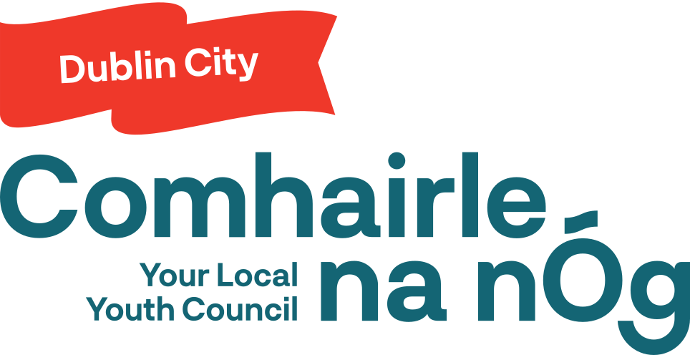

Dublin City Comhairle na nÓg
Annual Report 2025

Dublin City Comhairle Youth Conference 2024

The 2024 Dublin City Comhairle na nÓg Annual Youth Conference was held in the Round Room of the Mansion House on 5th November 2024. The Annual Youth Conference is both youth friendly and youth led. The Youth Conference was chaired by Dublin City Comhairle Chairperson Calvin and Master of Ceremonies for the day Max. The Youth Conference was formally launched by Lord Mayor James Geoghegan.

The youth conference acts as both the final event for the previous term of Comhairle and the beginning of the new term for Comhairle with many delegates at the conference going on to become full members of Dublin City Comhairle na nÓg.

Results of the Youth Conference:
1. New members nominated to Comhairle
2. ‘Inclusive & Diverse City – Making Way for Kindness’ selected as the working topic for 2025
3. Feedback received from delegates on how to improve Comhairle & the Youth Conference going forward

December Meeting 2024

The December meeting served as the first meeting of the new term. It took place in the Wood Quay Venue from 10am to 2pm. The first half of the meeting was used to have new members get better acquainted with the rules of Dublin City Comhairle. The second half of the meeting was used to discuss the working topic for 2025 and what early thoughts everyone had.

January Meeting

The meeting took place on 25th January 2025 from 10am to 1pm. The meeting was held online as a safety precaution due to the storm the previous day. The Rules of the group were reviewed by members and members pledged to follow them. Members were presented with examples of possible focuses for the working topic.
The timeline for the working topic was discussed at the meeting and the members decided to hold a panel discussion for the March meeting so they could receive expert advice for the working Topic.

Planning Committee

The planning committee consists of the Chairperson, Vice-Chairperson, x 3 Social Media Managers, 3 Liaison Officers and the National Executive Rep.
The planning committee was appointed at the February meeting. They meet in the beginning of each month to approve the agendas for all events taking place that month and review the progress of the working topic.

Planning Committee Dates 2025:
03/03/2025

03/04/2025

22/05/2025

February Meeting

The meeting took place on 22nd February 2025 from 10am to 3pm. The meeting began with Comhairle members listening to a talk from Head Chef Dave about how food in Dublin City Council’s staff restaurant is produced to ensure as little food waste as possible.
Afterwards the planning committee members were elected. The new chair is Aaron Kiernan, the vice chair is Sofia Corpuz, Secretary is Eabha, social media officers are Rachel and McElvany and the ordinary members of the planning committee are Tori, Alex M, Alex P, Fiona, Edward, Lily, Katie & Eblina.
After the election Comhairle members participated in a workshop discussion with Christopher Nugent of Dublin City Libraries. After Lunch Members held an open discussion on possible focuses for the working topic and held a walking debate on the pros and cons of each topic. Migration and multiculturalism were chosen as the main focus for this year.

March Meeting
The meeting took place on 8th March 2025 from 10am to 2pm. At this meeting members were briefed on the Tokyo Trip application process. Members were also informed of the Park consultation taking place on 12th March and the Young Social Innovators workshops taking place in April and were asked to register their interest if they wanted to attend.

Members also discussed the selection of experts for the panel discussion in April. Members split into groups and came up with questions to ask potential members of the panel. Members also took part in a speed friending event in an effort to get know more about each other.

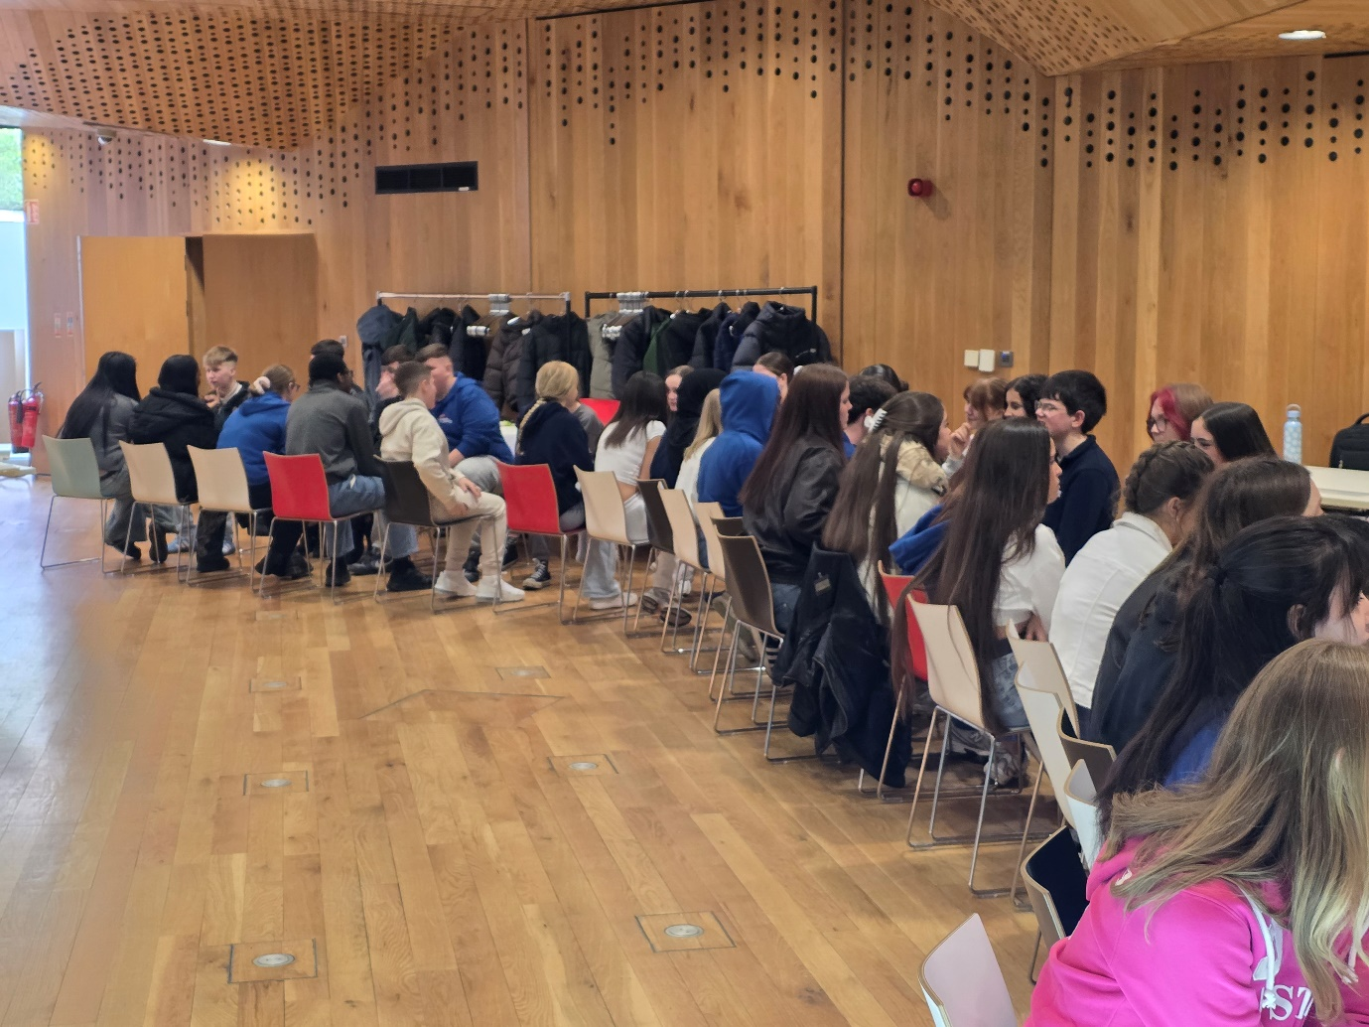

April Meeting – Expert Panel

The meeting took place on 12th April 2025 from 10am to 3pm. The meeting began with Dublin City Comhairle na nÓg Chairperson Aaron giving an opening speech and welcoming the experts to the meeting. The Experts attending were:

• Cllr Daniel Ennis
• Detective Chief Superintendent Brian Woods
• Jaime Hutton (Refugee Council)
• Taha Hassen (SARI)
• Mary Henderson (Immigrant Council)

Each expert gave a speech on the work they do. Afterwards members were given the chance to ask the experts questions.

After Lunch, members discussed what possible actions they could take in relation to the working topic. Members agreed to have a final vote at the next meeting to decide their final plan of action.
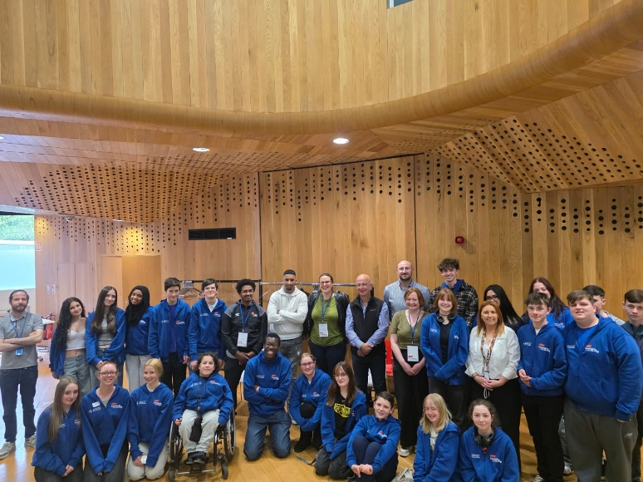

National Showcase

The Comhailre na nÓg National Showcase took place on 15th April 2025 at Dublin Castle. 10 Members of Dublin City Comhairle na nÓg were in nattendace accompanyied by Christine & John as chaperones. Members took part in panel discussions and Dublin City Comhairle na nÓg was presented with a certificate of achievement by Minister for Children Norma Foley & Taoiseach Micheál Martin.
Dublin City Comhairle na nÓg Social Media Officer McElvaney Sangi was in attendace and interviewed several members from other Comhairle na nÓg branches across the country.

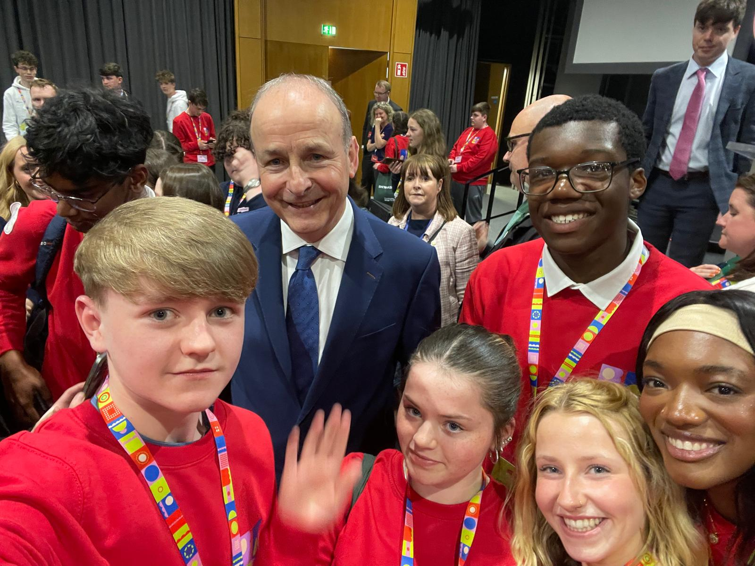

The senior members of Comhairle also took part in the Gluais Leadership Training Programme to further their skills and knowledge within leadership and how to actively guide their peers.
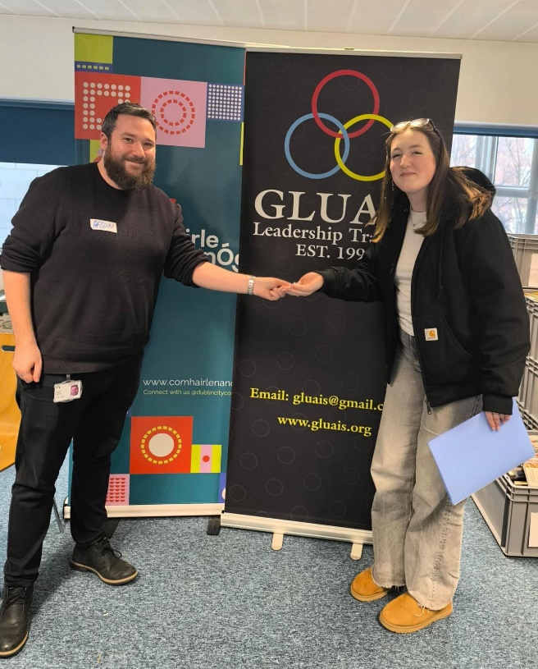
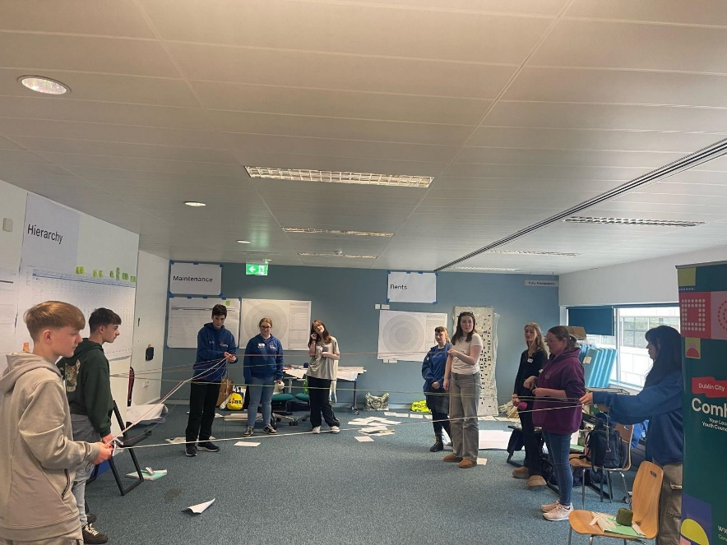
May Meeting – SoCircular Presentation
The meeting took place on the 10th of May from 10:00 to 3:00.
Started the day off with an ice breaker from Marianna to wake everyone up and get them active for the day. Christine went over the agenda and updated us on upcoming Comhairle events.
Abby from Economic Development came in and presented the group with a Presentation – Socircular, and would like to invite CNN to do a mini AYC, Aaron is going to look into inviting the other 3 CNN groups in Dublin.
After lunch the council regrouped to work on our Working Topic and the group went through what we could do with the topic, culture day, leaflets, schools education pack. Each group developed from key points and presented their ideas to eachother.
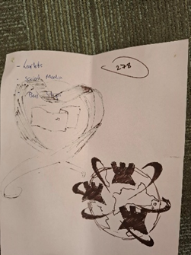
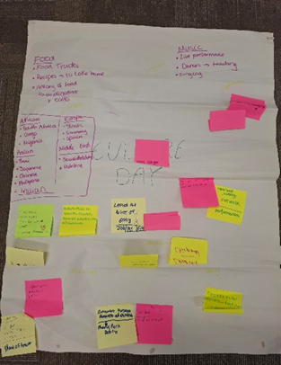

June Meeting – College Green/Dame Street Public Realm Project
The meeting was held on the 21st of June from 10:00 to 4:30 in Ormond House.
After all the members were settled in , we decided on doing a video in the Matter Hospital , DCC and other organisations. We split the members up into groups and decided on the who , what , where , when and why details of the video. Each group then presented their ideas and took key points from each group.
We then spoke about upcoming events like the SoCircular Mini AYC , Pride March and attending a talk on the dangers of sunbeds with the NCC and decided on who was attending each event.
We broke off for icebreakers after to decompress before lunch and worked on some games that improved teamwork.
Following lunch we had Maria from the Public Realm Project in and she picked the brains from our council on ideas for what they would like to see in a new public space ( types of benches , picnic tables , decor etc. )
Each member completed a sheet with their ideas and drew up some diagrams of what they would like to see.
We ended after speaking about possibly joining in with Culture Night on September 19th ( yet to get in touch with Ray Yeates and Tony Smithers )
*spoke about getting in touch with Matter Hospital for video.

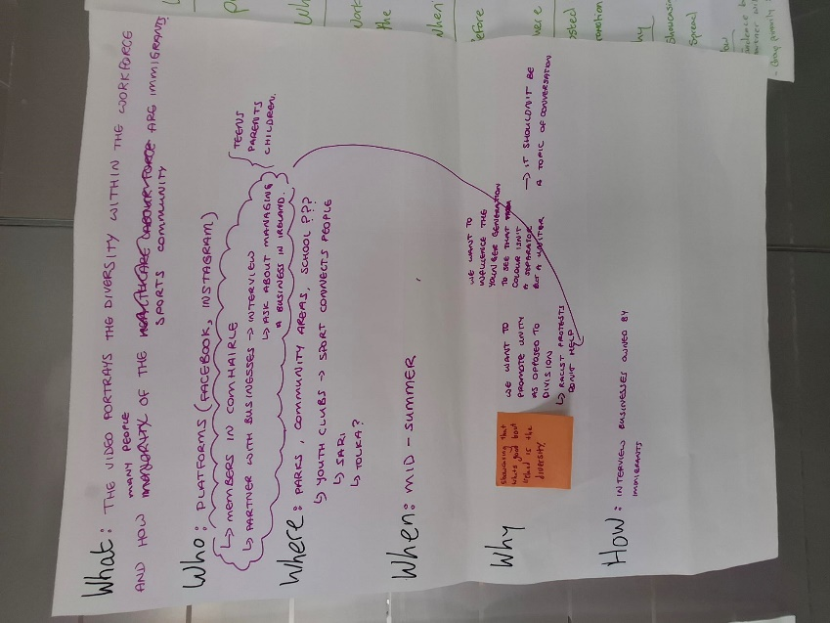

Pride 2025 – June 28th
Members of Dublin City Comhairle na nOg took part marching in the pride parade and enjoyed pride breakfast in the Civic Offices canteen.
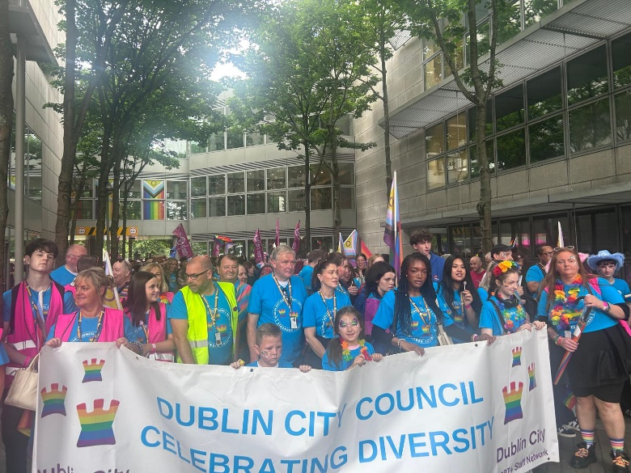
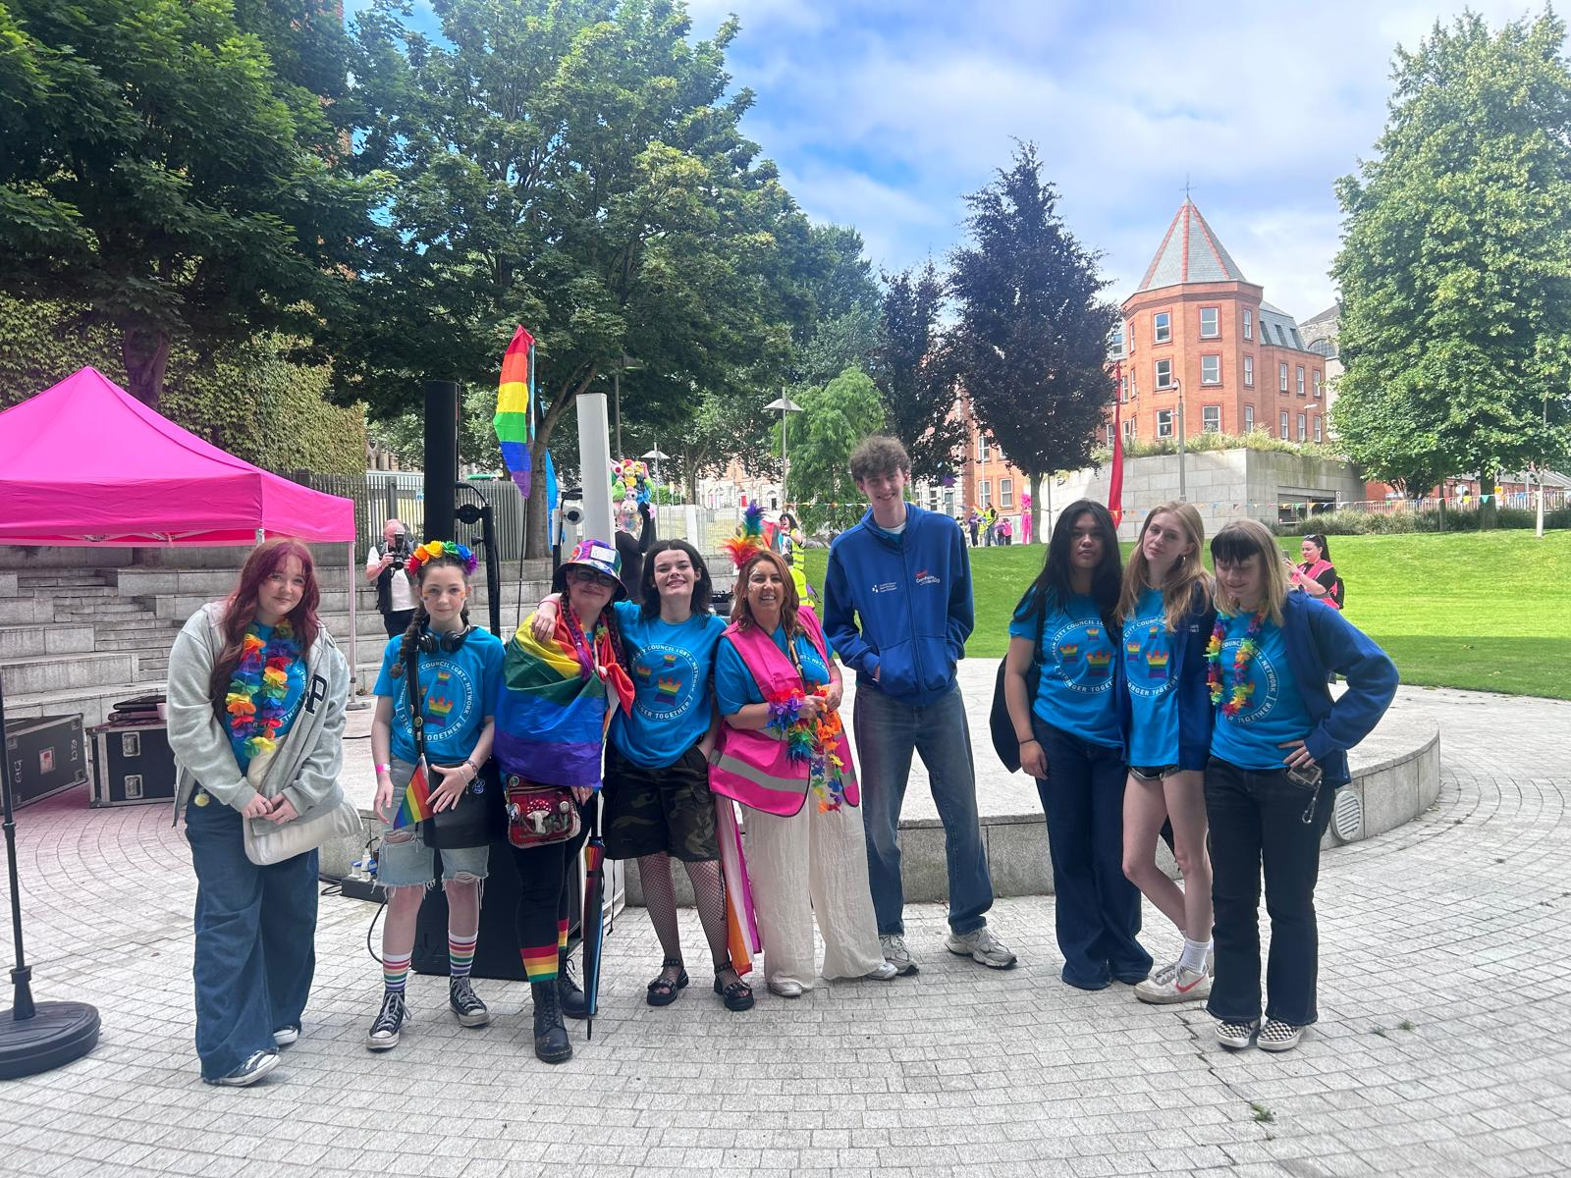

SUNBED USE IN IRELAND EVENT-30TH JUNE KINGS IN HOUSE

Some of our COMHAIRLENA NOG members attended the sunbed use in Ireland and policy to reduce skin cancer risk event. We learned the dangers sunbeds cause in cancers such as melanoma we got to here from minister for health Jennifer O’Connor on being smart out in the sun. It was a great opportunity for our members to understand the dangers of skin cancer.

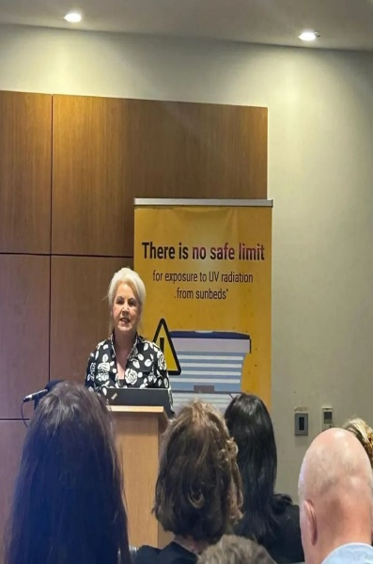

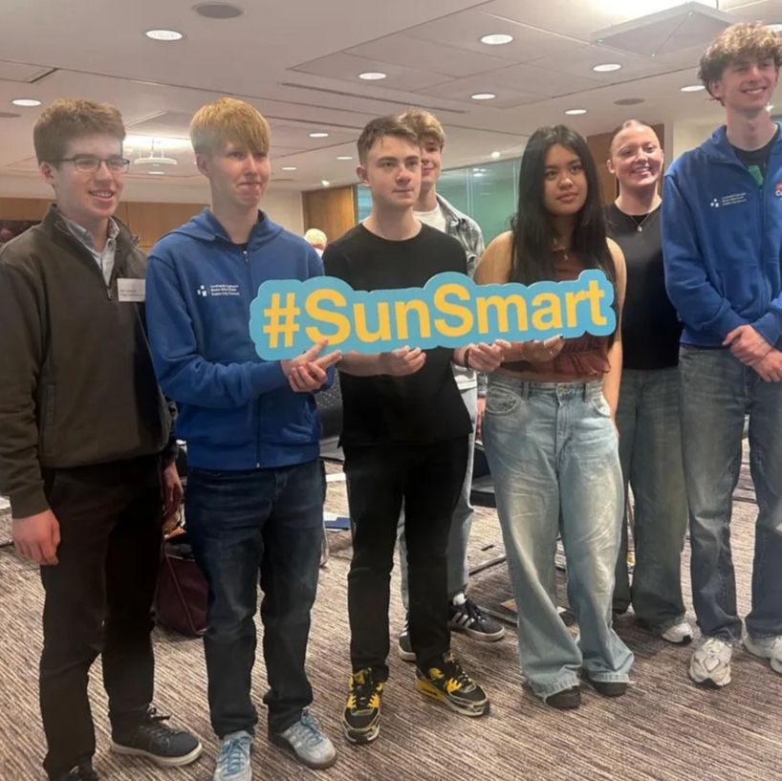

EMERALD PARK-4TH OF JULY
Our COMHAIRLE na nog members had our yearly group trip to emerald park we invited 25 children from Ipas centre in Dublin city.

Throughout the day we had lunch curtsey of food trucks in Emerald Park we also enjoyed a day filled with fun and a great opportunity for our members to hear the voice of the Ipas children. 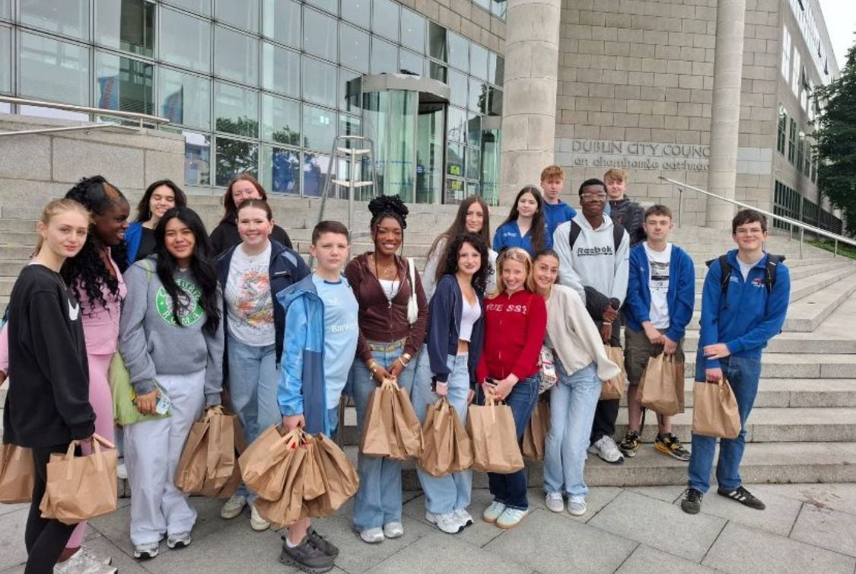

REGIONAL NETWORKING-07TH OF JULY DEPARTMENT OF CHILDREN
Four of our members Aaron, Mason, Sofia and Alannah attended the annual lenister regional networking event where they got the opportunity to meet other COMHAIRLE members from across lenister it was an amazing opportunity and our chairman Aaron delivered a speech at the event.
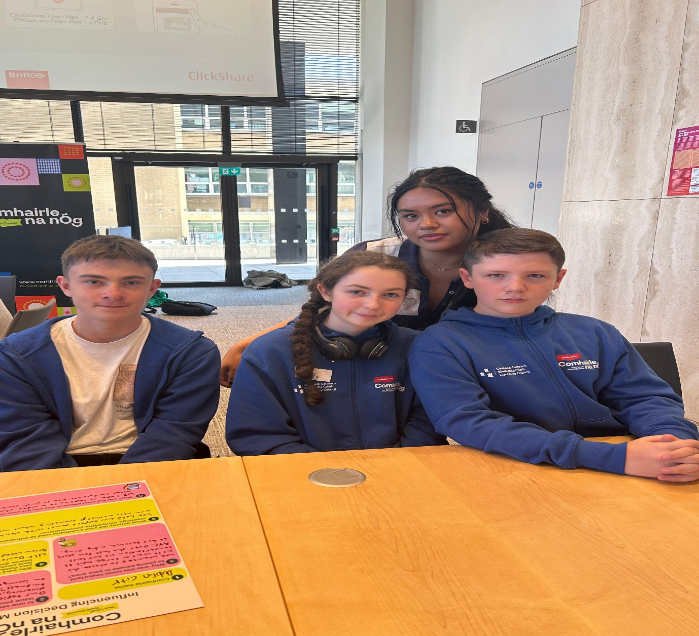

July Meeting
The meeting was held on the 09th of July 2025 from 10:00 to 4:30 in Ormond House.
After all the members were settled in, we did an ice breaker, after the ice breaker we put the group into teams and spoke out Culture night date 19th of September 2025. We came up with Plan B incase the video doesn’t work out.

We contacted the Lord Mayor’s office to ask for support with our Video.
We broke off for icebreakers after to decompress before lunch and worked on some games that improved teamwork.
Following lunch we designed the poster for our Culture night which will take place at Hill Street Family Resource Centre.
Each member completed a sheet with their ideas and drew up some diagrams of what they would like to see.

Some members of the group broke away to ring organisations to support our video.

16th of July 2025 Bodyways
Comhairle na n'Og members had an opportunity to collaborate with development of video content to promote positive body image. working with award winning documentary maker Alan Bradley (https://alan-bradley.com/about ) in filming content for the new Bodywhys school programme which will be launched in October.

The filming was scheduled for Wednesday 16th July in Dublin – Children of Ombudsman’s Jervis Street office. Two members from the group went, Soifa and Chelsea. The invite was from Dr Fiona Flynn, Youth Development Manger Think Bodywhys CLG, t/a Bodywhys - The Eating Disorders Association of Ireland,

18th of August – 22nd of August 2025 – Tokyo - Japan
5 members of the group went to Teen Square Tokyo Project 2025. This project is an initiative by the Tokyo Metropolitan Government to promote the Tokyo 2050 Strategy . The objective to promote policies from perspective of Children and Internation Cooperation & Co- creation with overseas cities. Young people from Dublin, Brussels, Surabaya, Taipei & Tokyo came together on 20th to 22nd of August for workshops and symposium on the 21sst of August which was streamed on YouTube to present on what is happening in their cities and exchange opinions Theme – My idea of a Child Friendly City.
On their travels the group also got official invite to the Irish embassy Irish House.
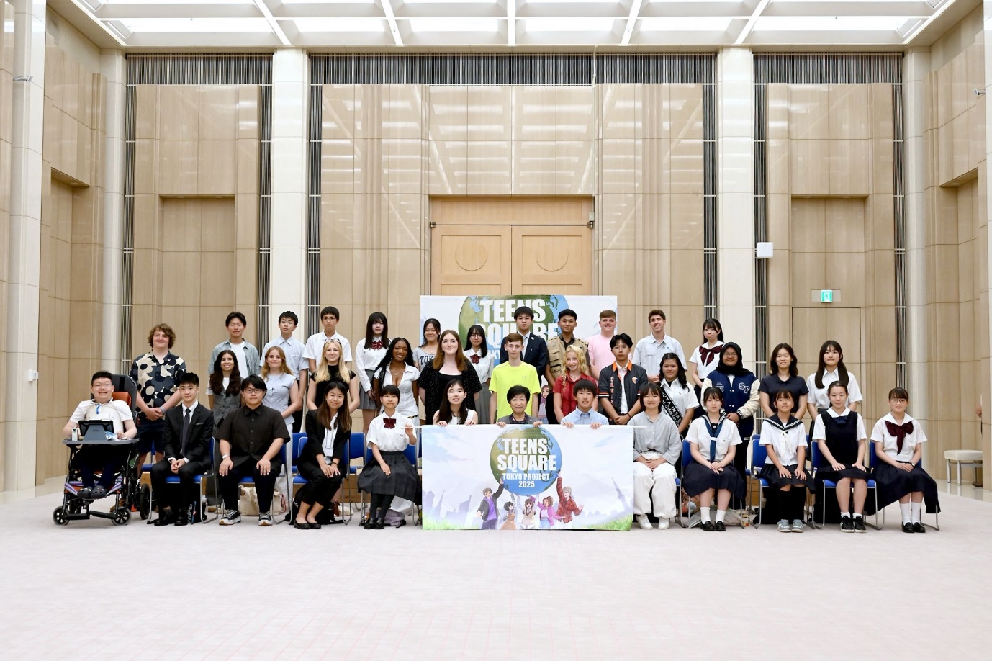

September Meeting
The meeting was held on the 06th of September 2025 from 10:00 to 4:30 in Ormond House.
After all the members were settled in, we did an ice breaker, after the ice breaker we put the group into teams and spoke out Culture night date 19th of September 2035 of what duties the group members will be doing, we spoke about the agenda for the event and went through the food menu.
We also had a workshop on the debate they Comhairle will be having in City Hall with the Lrrd Mayor.
Abby called in regarding the new date for the Next Gen meeting 29th of October 2025, will take place in Woodquay.

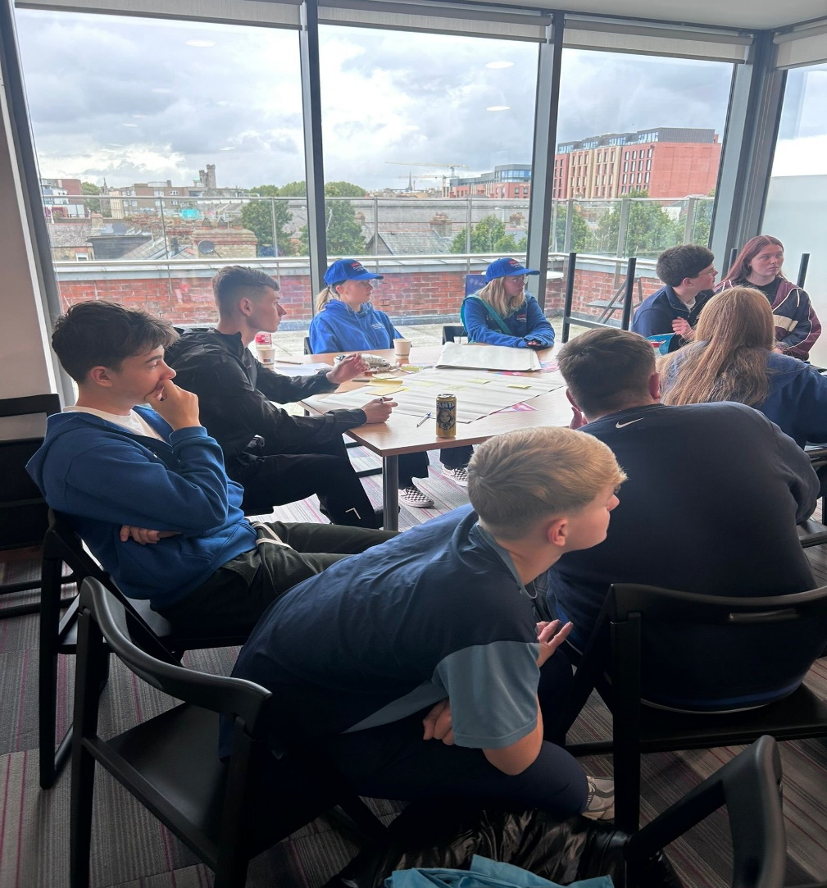

September 9th – Urbact – Wish Cities.
Since 2002, URBACT has been driving change all over Europe by enabling the cooperation and idea exchange amongst cities within thematic networks, by building the skills of local stakeholders in the design and implementation of integrated and participatory policies, and by sharing knowledge and good city practices.
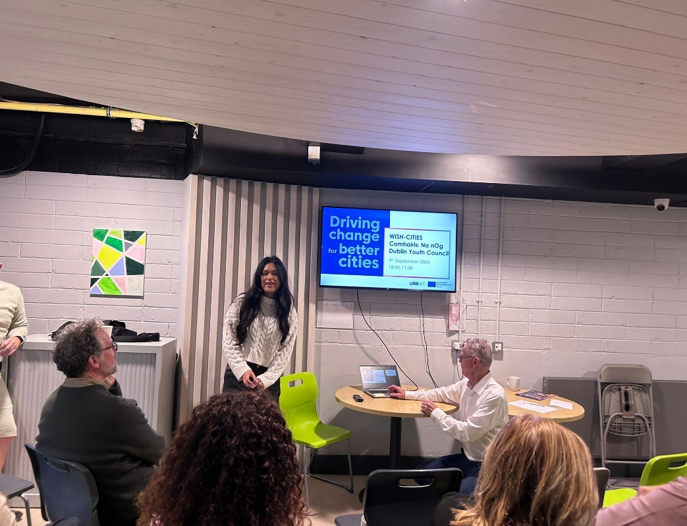

16th September City Hall, Debate with Lord Mayor
On the 16th of September Dublin City Comhairle na nÓg took part in a Debate at City Hall. The debate was chaired by Lord Mayor of Dublin, Councillor Ray McAdam. The discussion was part of the Comhairle's 2025 Topic "Inclusive & Diversity making away for kindness" and their vision for the city.
Young people’s vision for the city – focusing on inclusion diversity and building a kinder Dublin for all.
We discussed how we can build an inclusive Dublin by 2050 where all Dubliners are valued in the Mansion House with the Lord Mayor.
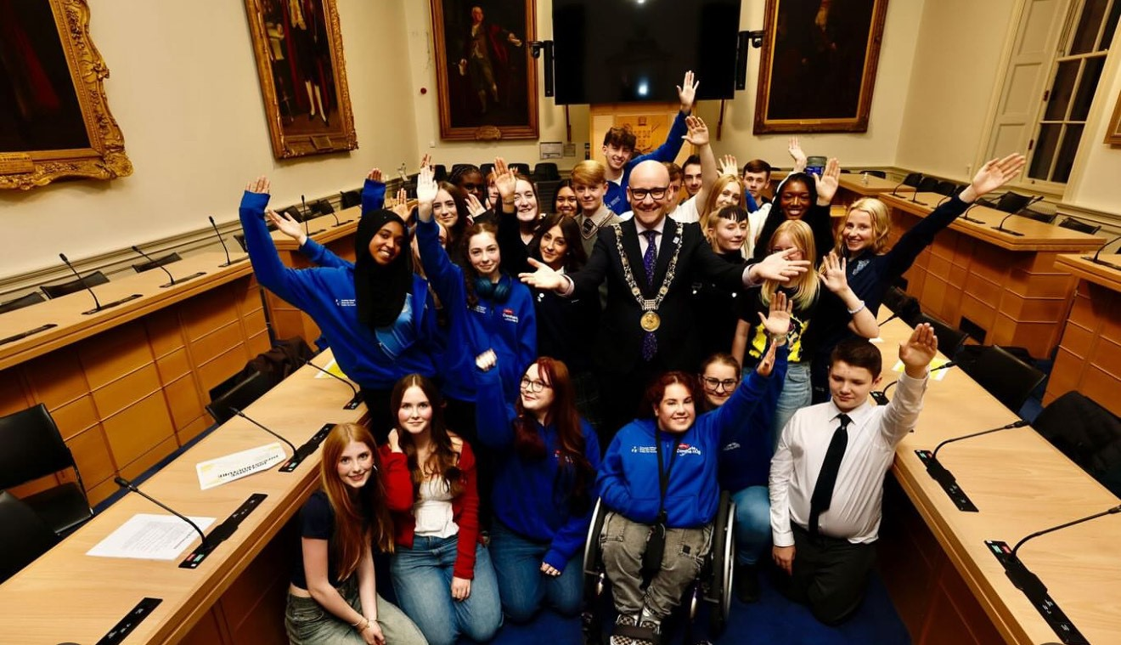
September 19th Culture Night Hill Street Family Resource Centre
As part of Culture Night Dublin, Dublin City Comhairle na nÓg (partnered with the Local Authority Integration Team) hosted an evening at Hill Street Family Resource Centre, all about Diversity, Inclusion, and spreading Kindness.
Aligned with this year’s theme, "Inclusive & Diversity: Making a Way for Kindness," the event highlighted the importance of creating spaces where all individuals feel valued and connected. Culture Night is a moment to bring together communities, celebrate creativity, and promote cultural understanding – and we are grateful to all who contributed to making this event a success.

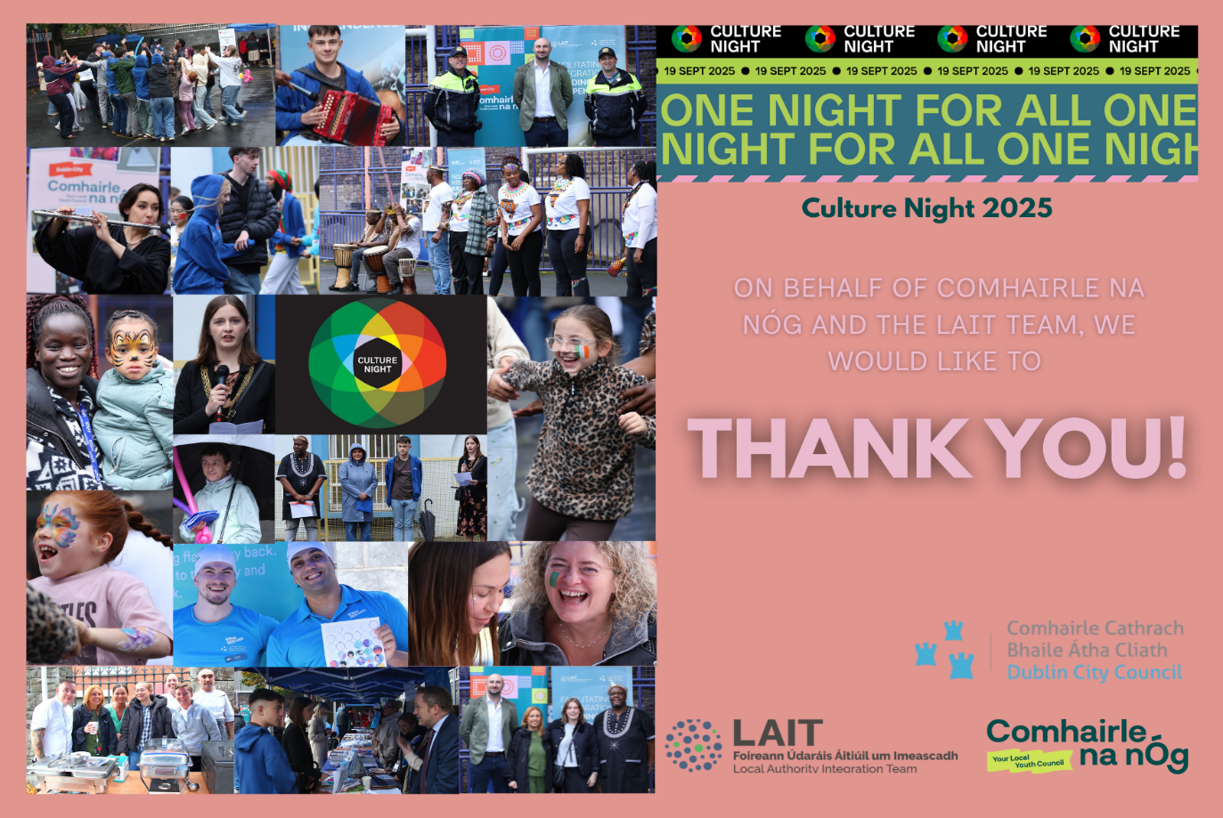

Mansion House, Tokyo Reception
Reception at the Mansion House, where the children were presented with certificates by the Lord Mayor in recognition of their trip to Tokyo.
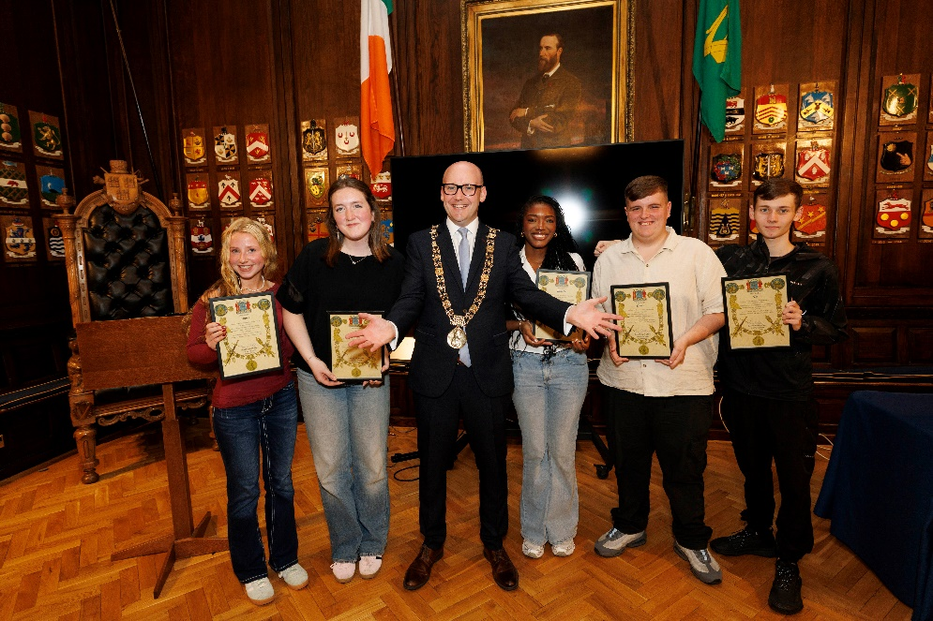

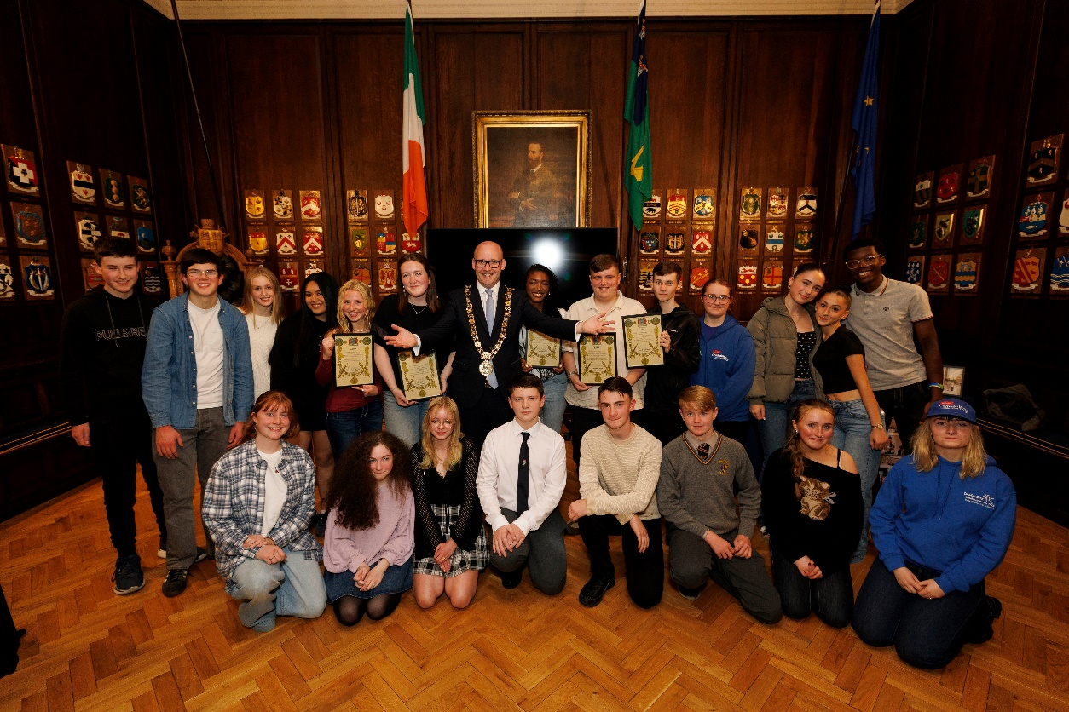

October Meeting
On Saturday the 4th of October we met in Wood Quay Venue to discuss the upcoming Annual Youth Conference and start planning.

October 6th at European Union House
🇪🇺 President Kata Tüttő visits Dublin!

Monday the 6th of October @ European Union House, Chatham Street, Dublin 2. Where the chairperson of Comhairle na nOg Aaron Keirnan addressed President Kata Tüttő of the European Committee of the Regions —highlighting Dublin’s strong ties to EU-led urban and social development.

🇪🇺 Europa Experience & EPLO
President Tüttő explored the interactive exhibition and joined a vibrant discussion with Comhairle na nÓg, PPN, and EPSO on youth participation and local democracy.

🤝 Who was involved:
European Committee of the Regions, EPSO, EPLO Ireland, DCC Active Travel, URBACT, Scoil Íosagáin,

Comhairle na nÓg, PPN, and the Bluebell Regeneration Programme.
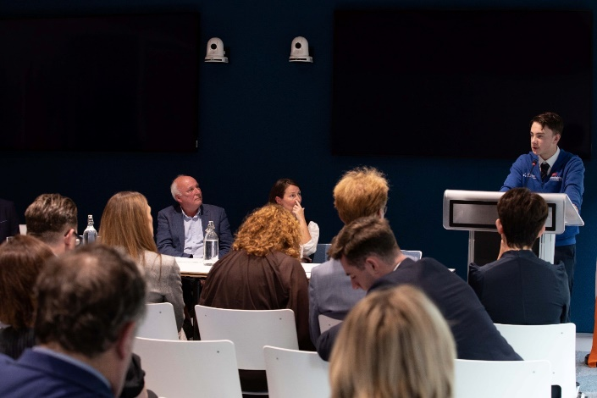
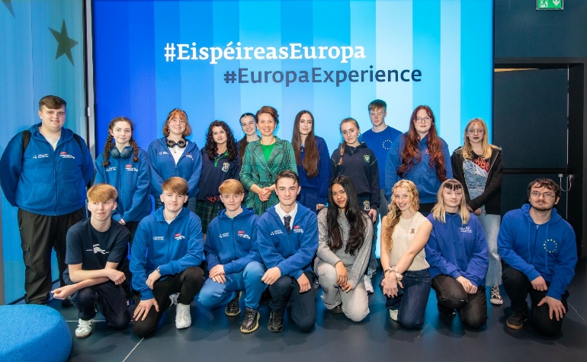
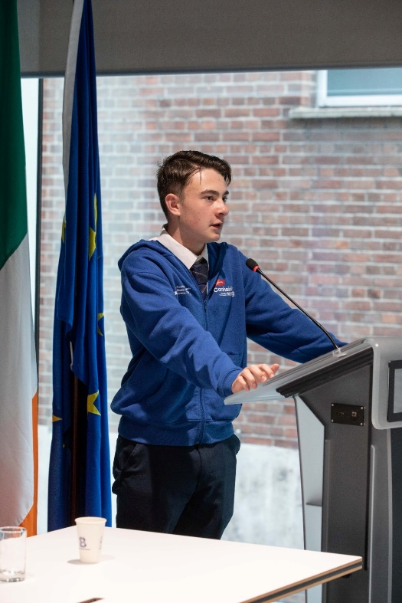
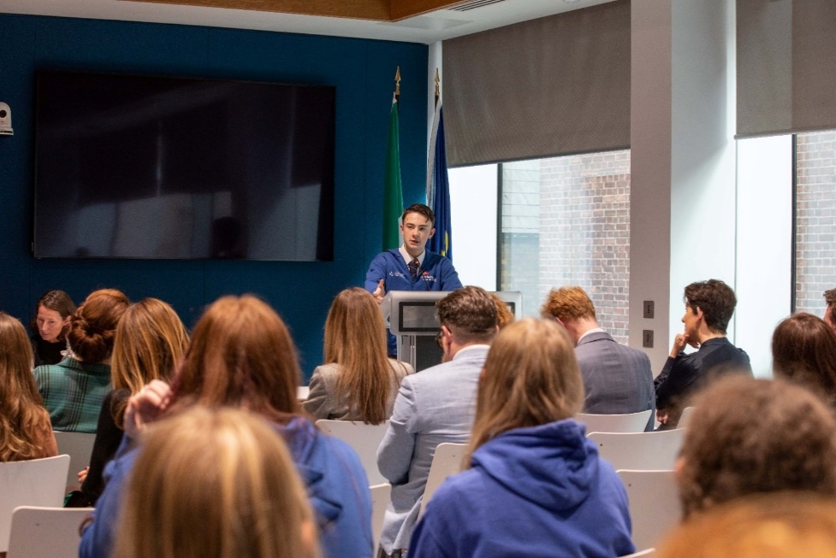

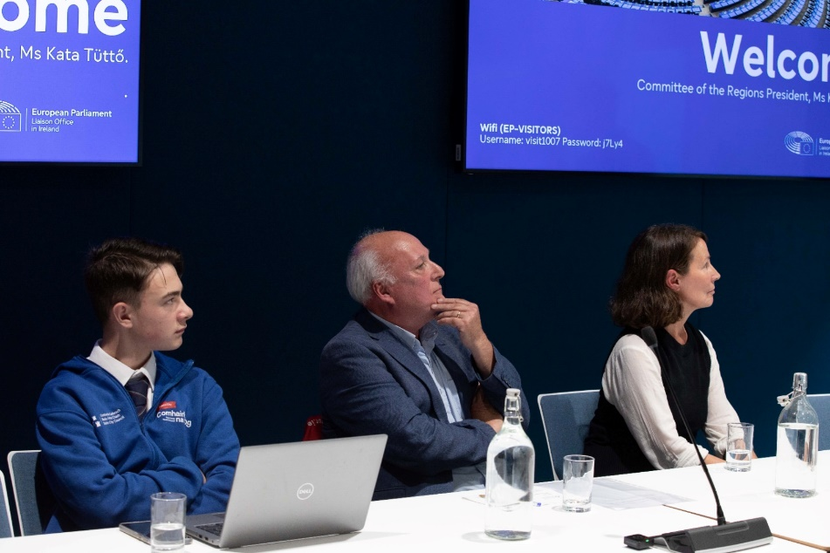
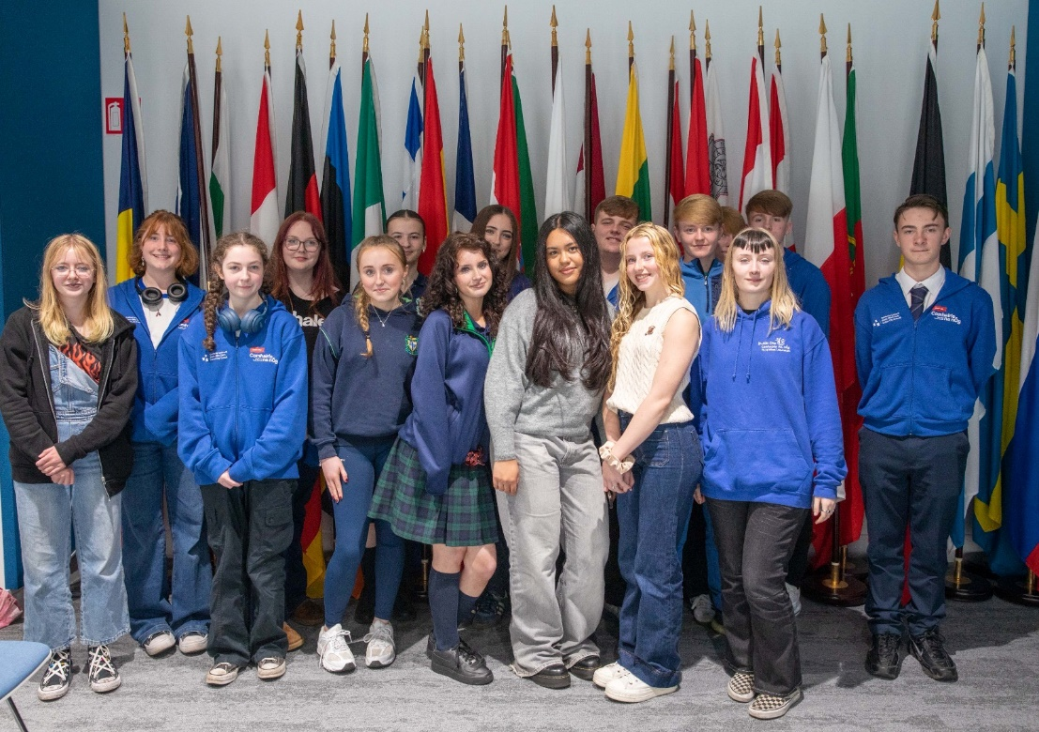
October 15th Bodywhys
Official launch of the new secondary school programme ‘Inside Out’.
Developed in collaboration with teachers, young people and mental health professionals this two- part educational resource is designed to improve body image and social media literacy.
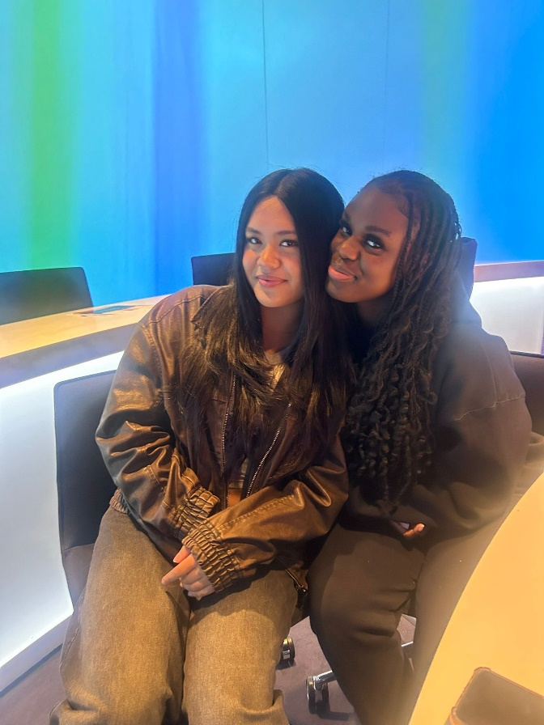
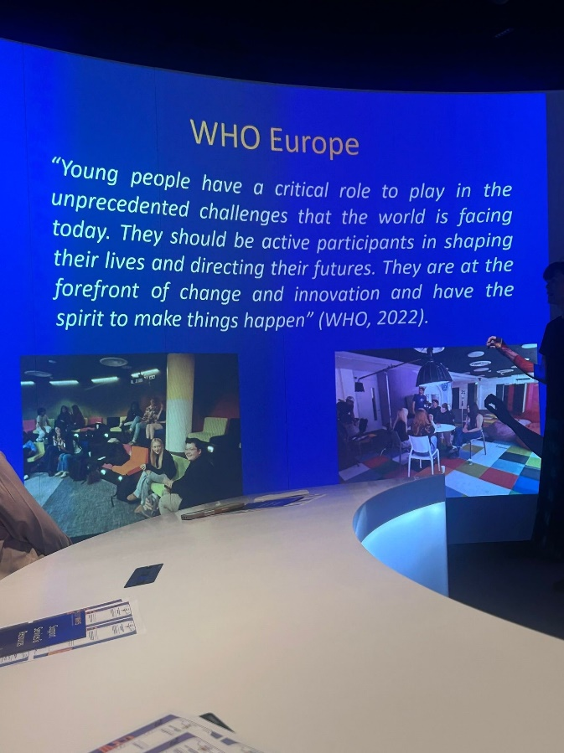
2 members took part in this educational piece, with members from Belong too, Spun Out.

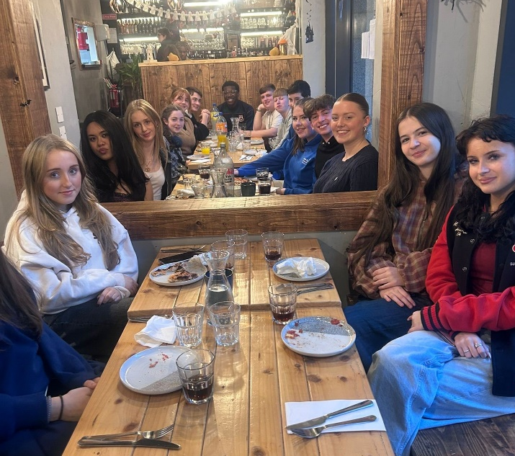
October 21st – Pizza Party
A pizza party at Hidden by One Society to celebrate all the member’s hard work!

October 29th – So Circular
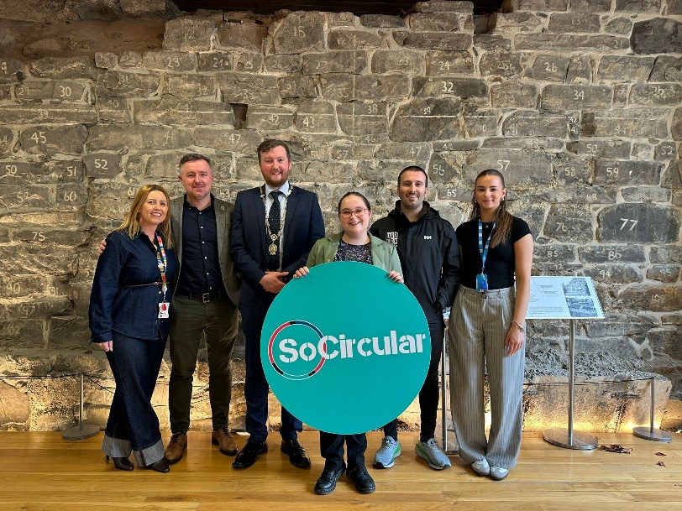
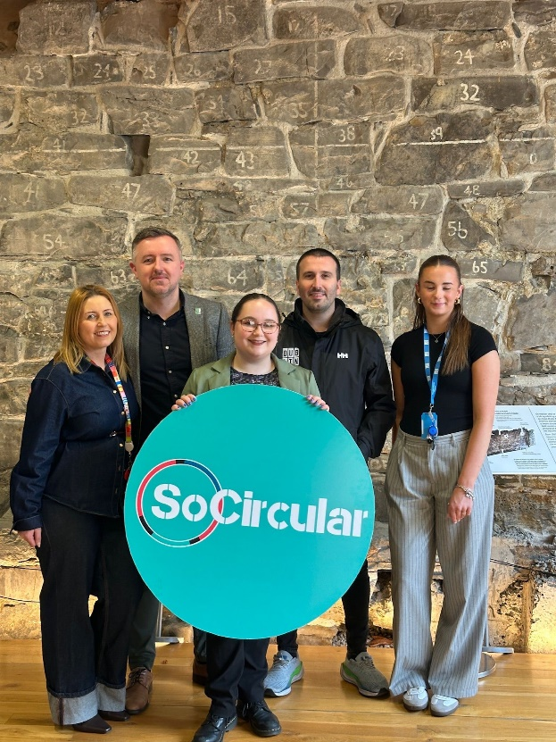
On the 29th of October at the Woodquay venue, Comhairle na nÓg, partner with So Circular. Next Gen- Now is tackling climate change by focusing on fast fashion and textile waste! The event featured Sean McCabe of Bohemians FC and Clontarf GAA. Who will share how clubs are leading the way in reducing waste.
