6)/

BARDAS ATHA CLIATH

CORPORATION OF DUBLIN

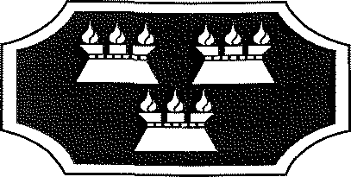

BYE-LAWS

made under

LOCAL GOVERNMENT ACT, 1994

The Right Honorable The Lord Mayor, Aldermen and Burgesses of Dublin in exercise of the powers conferred on them by Section 37 (6) of the Local Government Act, 1994 hereby revoke the Bye-Laws, made on the 21st day of September, 1994, under the Public Health (Ireland) Act, 1878 and the Control of Dogs Act, 1986.

In exercise of the powers conferred on them by Part VII of the Local Government Act, 1994 (No. 8 of 1994) hereby make provision for:

- The control of dogs in certain places.

C O R P O R A T ION O F D U B L I N

BYE-LAWS FOR THE CONTROL OF DOGS UNDER THE LOCAL GOVERNMENT ACT 1994.
The Right Honorable Lord Mayor, Aldermen and Burgesses of Dublin in exercise of the powers conferred on them by Part VII of the Local Government Act, 1994 (No. 8 of 1994) hereby make the following Byelaws relating to the control of dogs:-
PART I

DEFINITIONS

- In these Bye-Laws -

“dog” includes a bitch of any age or a dog of any age;
“the Corporation” means The Right Honorable The Lord Mayor, Aldermen and Burgesses of Dublin.

PART II

- These Bye-Laws shall apply to the County Borough of Dublin and the area of their operation is hereby extended pursuant to Section 37(7) of the Local Government Act, 1994 to the foreshore adjoining the County Borough of Dublin.

- A person in charge of a dog in an area specified in the First Schedule to these Bye-Laws (except any “Dangerous Dog”, as defined in the Control of
Dogs (Restriction of Certain Dogs) Regulations, 1991) shall keep the dog on a sufficiently strong chain or leash, not exceeding two meters in length if a fixed leash, or ten meters if retractable, while in that area, except during the following times when the dog may be unleashed in such areas (but excluding the North Bull Island and any other such area for which a Special Amenity Area Order is made) provided that such dog must still be under the effectual control of the person-in-charge of the dog in accordance with the Control of Dogs Act, 1986:

January & December: 8.00 a.m. - 11.00 a.m.
4.00 p.m. - 5.00 p.m.

February & November: 8.00 a.m. - 11.00 a.m.
4.30 p.m. - 5.30 p.m.

March & October: 8.00 a.m. - 11.00 a.m.
5.30 p.m. - ó.30 p.m. (Wintertime)
6.30 p.m. - 7.30 p.m. (Summertime)

April & September:

May & June: July & August:
8.00 a.m. - 11.00 a.m.
7.30 p.m. - 8.30 p.m.

8.00 a.m. - 11.00 a.m.
8.30 p.m. - 9.30 p.m.

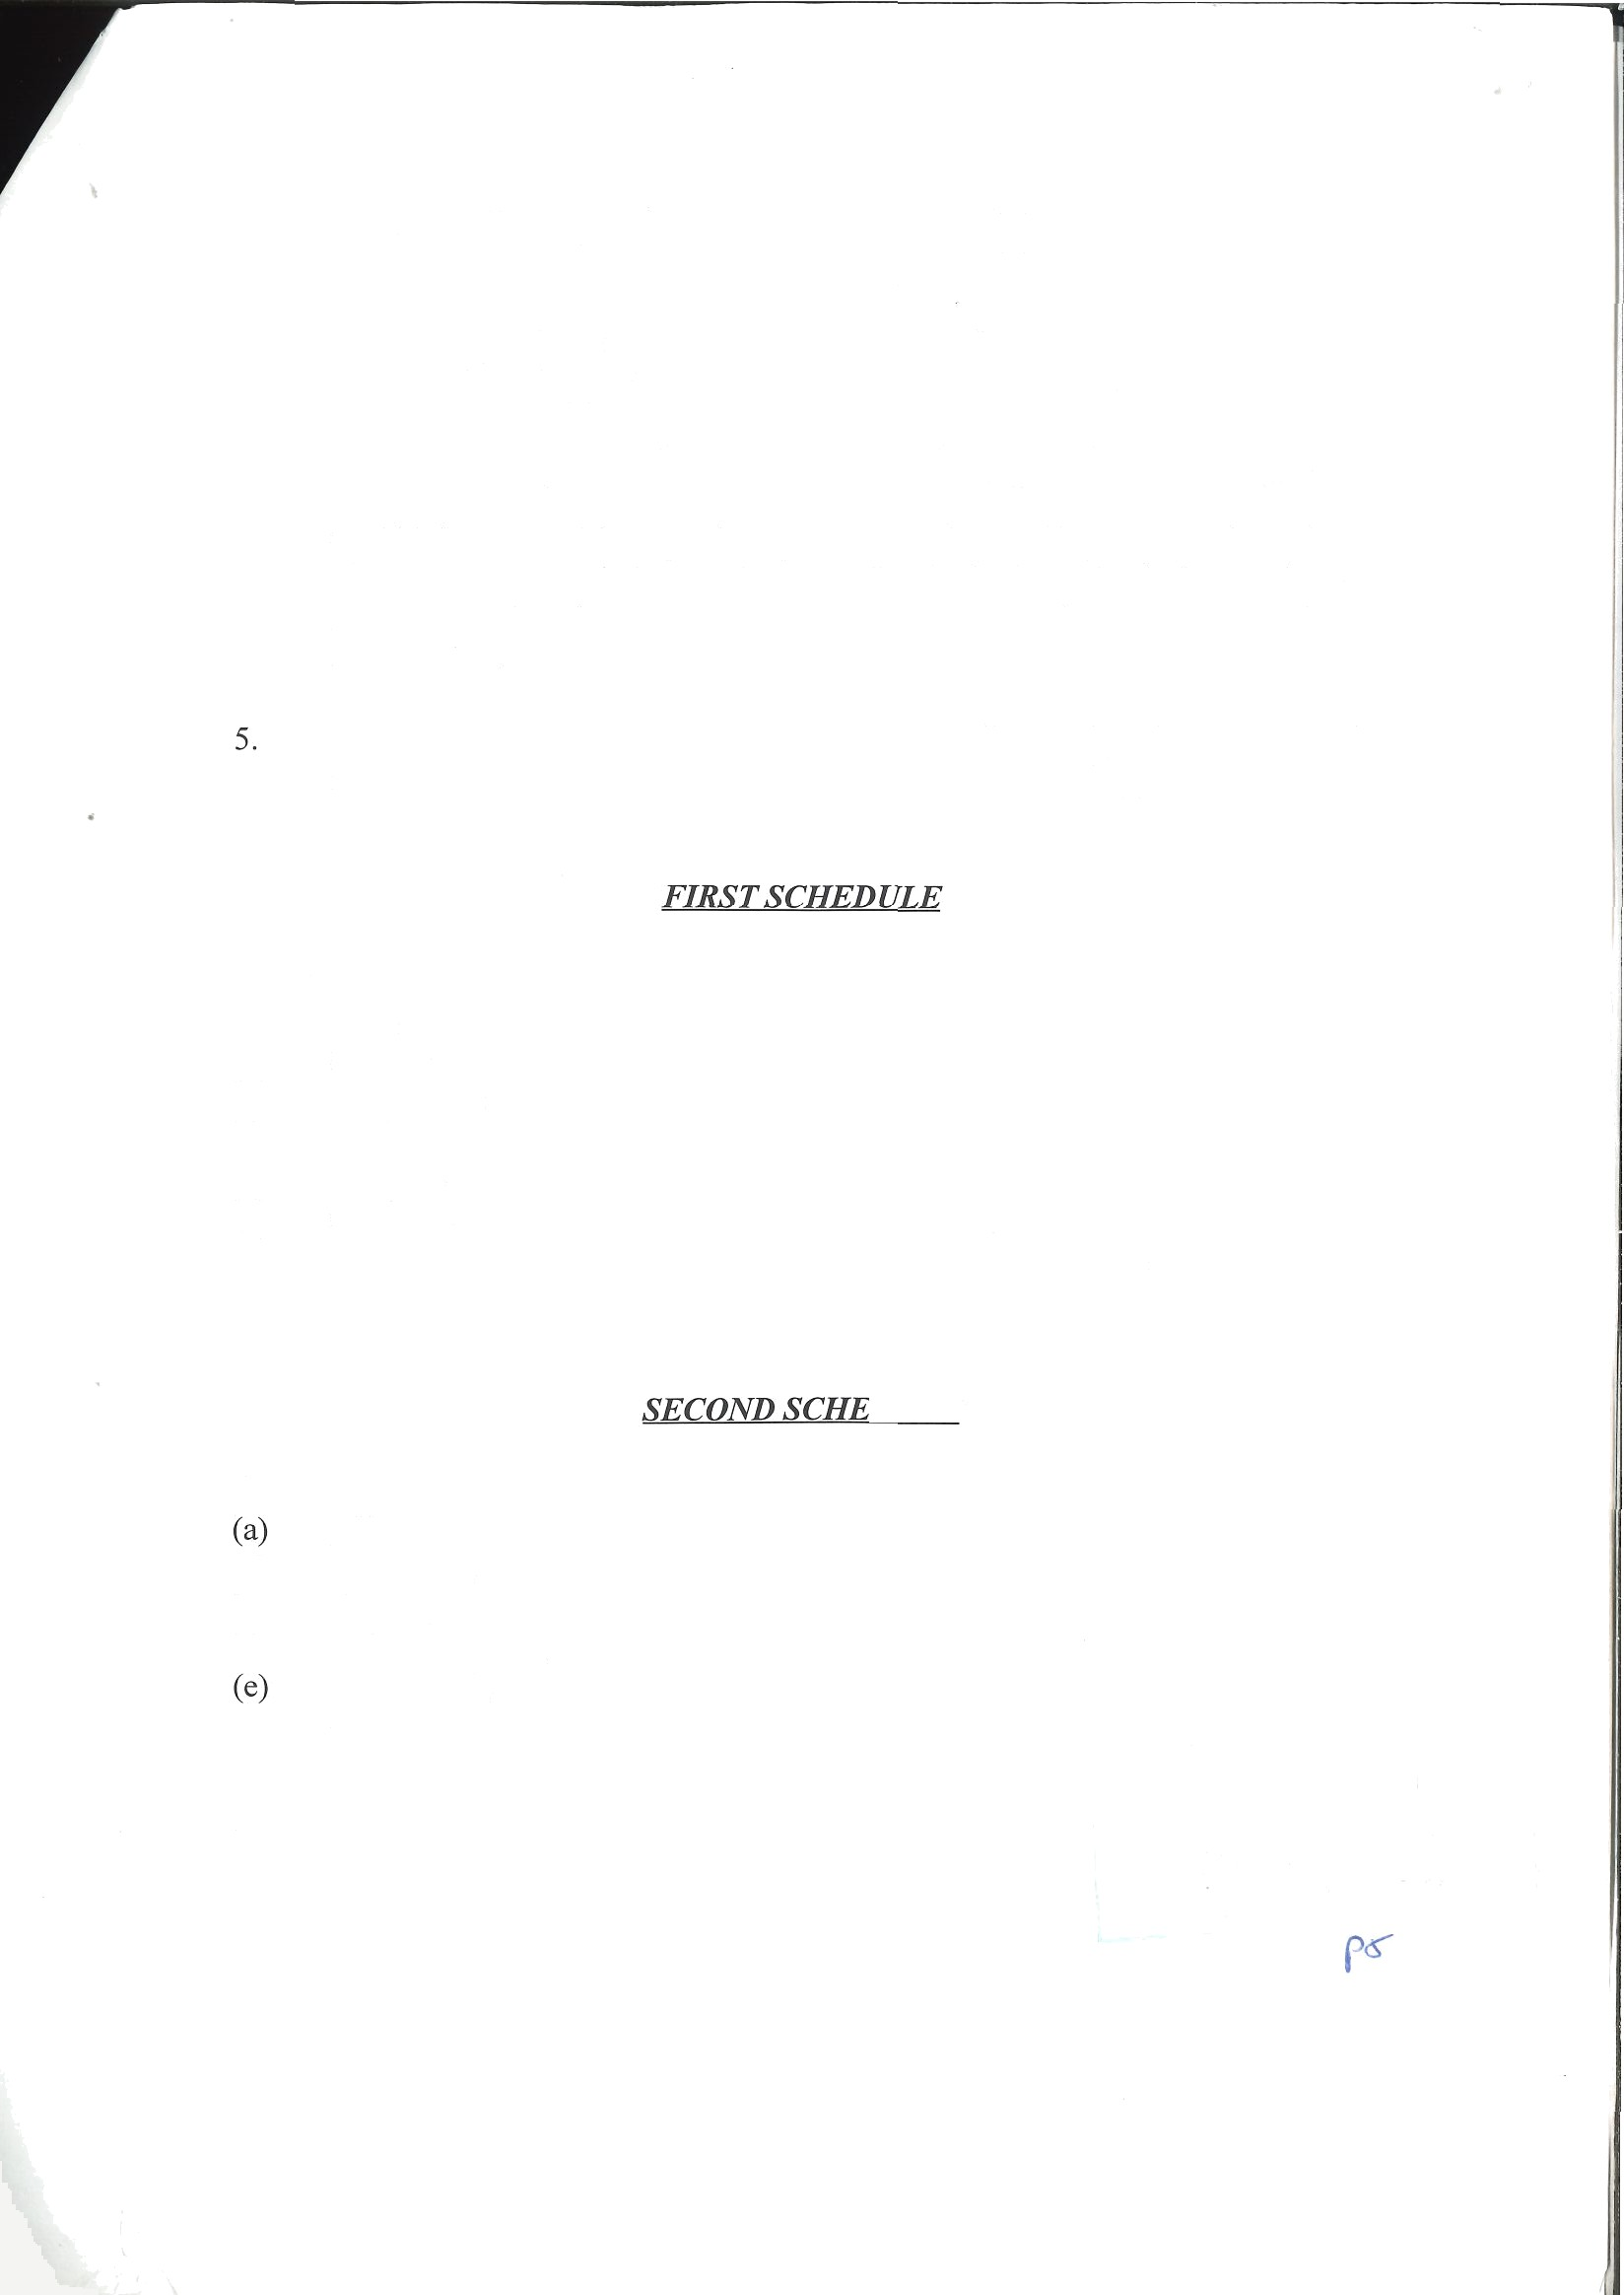
- A person in charge of a dog, other than a dog being used for guidance by a blind person or by a person whose eyesight is so defective as to be unable to find his/her way without guidance, shall not bring the dogs into, or allow the dog to enter or remain in any place specified in the Second Schedule to these Bye-Laws unless that person has the permission of an officer or servant of the Corporation.

A person who is in breach of these Bye-Laws shall be guilty of an offence and shall be liable on summary conviction to a fine not exceeding £1,500.

Any -
  - park,
  - garden,
  - open space,
  - field,
  - stadium,
(f1 seashore,
(g) other place used for outdoor recreational or sporting activities, which is under the control of the Corporation.

Any -
office,
- art gallery,
- library,
- swimming pool,
playground,
(II sports hall or other similar building, which is under the control of the Corporation.

These Bye-Laws will come into effect on 12th May 1998.

