Dublin Citys Local Community Safety Partnership
Expression of Interest
Name
Address

Contact Number
Email

Male Female Prefer to self-describe __________ Prefer not to say

Which one of the 5 Dublin City Local Community Safety Partnerships (LCSP) are you expressing an interest in joining?
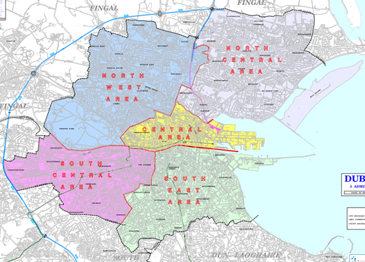
Dublin North Central  Dublin North West 
Dublin Central Dublin South Central
Dublin South East

What area of interest do you wish to represent on the LCSP?
Choose a maximum of 3.

Local Resident (must reside in the DCC administrative are being applied for)
Older people
Social Inclusion
Sports
Youth
Drugs and Alcohol rep/substance misuse
Domestic, sexual and gender-based violence
New communities
Minority
Disability
Business

*Other________________________________________________________
*Is there another issue relevant to your area not included here that you would like to see represented. Please use this space to tell us about it.
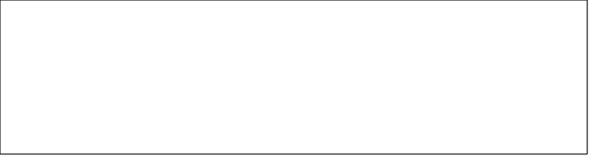

- Tell us why you are interested in joining a Local Community Safety Partnership

- Do you represent a specific group or organisation? If so, do you have permission to speak or act on behalf of them? What is your role in the group/organisation?

- Is the group/organisation registered with the PPN
Yes No

- Can you share an experience whether through a project, initiative, or other involvement where community safety was the focus. What was your role or contribution?


- How will you represent this group’s safety concerns and keep them informed of progress and outcomes?


Subgroups with a specific focus will be established to support a community safety plan for your area. Would you like to receive further information about this?
Yes No

Do you give consent for your information to be share with the National Office for Community Safety?
Yes No

Thank you for taking the time to complete this nomination form. We will notify of the outcome of your application in due course.

The closing date for receipt of expressions of interest for membership on the Local Community Safety Partnerships for Dublin City is 5pm on Friday 21st November 2025.

Completed forms should be submitted to:

By email to LCSP@dublincity.ie

Or posted to C/o Local Community Safety Partnership, Dublin City Council, North Central Area Office, Bunratty Road, Bonnybrook, Coolock, D17 K462

