Dublin City Council Draft Litter Management Plan 2026-2028

Working Together to Keep Dublin Clean
Formulation of the New Plan will involve:
- Internal Consultation: Key Stakeholders
  - Key Stakeholders: WMS Operations. Area Offices, Parks, Werla, Litter Office, RMWPO, Waste Enforcement
  - Review previous plan,
  - Draw out ideas
- Drafting the Plan:
  - Background research, data, results, fines, internal consultation
  - Review of current Plan
  - Draft plan and local review
- Statutory Consultation
  - Draft Plan approved by Climate SPC and full council for the statutory phase of Public Consultation to commence
  - Consultation media advertisement and display inviting submissions
  - Results of consultation reviewed through Special meeting of SPC
- Review and Publish the Plan
  - Review and amend based on submissions
  - Adoption at full council

Acknowledgement
Dublin City Council wishes to acknowledge and thank the individuals, organisations, elected members and staff who contributed in the preparation of this Litter Management Plan during the consultation and review process. A broad range of views were received by Dublin City Council through the statutory consultation period held in 2020.

Contents

1. Introduction 1
1.1 Our City 1
1.2 Preparing the Plan 3
2. Review of previous Litter Management Plan 4
2.1 Resources 4
2.2 Partnership 10
2.3 Enforcement 14
3. Objectives for the 2026-2028 Litter Management Plan 17
3.1 Operational Enhancements and Resources 19
3.2 Litter Awareness and Prevention 20
3.3 Enforcement and Regulation Change 20
4. Monitoring and Implementation of the 2026-2028 Litter Management Plan 25
4.1 Implementation Plan 25
4.2 Key Performance Indicators 27
4.3 Review and Reporting 27

Introduction

The Litter Management Plan (LMP) for the period of 2026-2028 is a statutory plan prepared as prescribed in Section 10 of the Litter Pollution Act 1997. A key aspect of drafting a Litter Management Plan is statutory consultation, including discussions at Area Committee Meetings, Strategic Policy Committee meetings and public submissions. The statutory consultation process informs the Local Authority of the concerns and ideas of businesses, residents and community groups and individuals.
The principal objective of this LMP is to provide information on litter prevention and control activities and the setting of appropriate objectives and targets for the three-year period covered by the LMP
DEFINITION OF LITTER: Litter is defined in the Litter Pollution Act, 1997 as ‘a substance or object, whether or not intended as waste that, when deposited in a place other than a litter receptacle or other place lawfully designated for the deposit, is or is likely to become unsightly, deleterious, nauseous or unsanitary, whether by itself or with any other such substance or object, and regardless of its size or volume or the extent of the deposit’
RESPONSIBILITIES OF Dublin City Council. The Litter Pollution Act, 1997 requires all local authorities to take practicable measures for the prevention of the creation of litter in its functional area. Local authorities have a responsibility for the collection and disposal of litter, promotion of awareness of the polluting effects of litter and encouraging participation by persons in preventing and overcoming the effects of litter. DCC are responsible for keeping the following areas litter free in so far as it is practically possible: Public Roads, DCC owned Green/Open spaces, council managed Playgrounds, Streams flowing through Council property.
The Household Food and Bio Waste Regulations 2015 were amended in 2023 and there main change is that there is now a requirement for all households to segregate and manage their food/organic waste. The WERLAs are enforcing the requirements of the waste collectors to ensure that they have provided the food waste bin to all their customers and the Local Authorities are required to ensure that households are meeting their obligations to source segregate their food waste through the bye laws. This also applies to apartments/multi unit developments and local authorities are required to enforce this on the ground with the management companies in line with Bye law 2.9.
- Inspections under the Bye Laws for the Storage, Presentation and Segregation of Household and Commercial Waste to ensure compliance with waste segregation requirements for residual, recyclable and organic waste at household level, including in multi unit developments and at commercial premises in line with regulatory requirements
- Increased awareness to encourage citizens and businesses to source segregate their recycling and organic waste
- All development plan requirements for all new residential and commercial developments to include appropriate space for provision of infrastructure for residual, recycling and organic waste.

RESPONSIBILITIES OF BUSINESSES AND THE PUBLIC The Litter Pollution Act, 1997 places legal responsibilities on businesses and members of the public to control litter. It is an offence under the Litter Pollution Act to carry out the following: • Deposit any substance or object so as to create litter in a public place or in any place that is visible from a public place; • Deposit anything that is commercial, household, industrial or municipal waste in any place for collection by or on behalf of a local authority or by another person, or load, transport, unload or otherwise handle or • process anything or carry on a business, trade or activity in such circumstances as to create litter or lead to litter in any public place or any place that is visible to any extent from a public place; • Place household and other municipal waste into or near a litter receptacle; • Move or interfere with a litter receptacle that has been provided by a local authority unless the movement or interference is authorised by the local authority
Litter Generators
- Pedestrians
- Motorists
- Retail
- Pubs /Bookmakers
- Presented bagged waste by business or residential properties
- Major Events: requires litter control measures in and around area
- Bus Stops/ Train stations
- Take Aways/Fast Food
- Schools
- Bottle and clothes banks
- Private Property/Derelict Sites
- Official Halting Sites/ encampments
- Car Parks
- Laneways

Our City
Dublin is a vibrant, modern city, of huge cultural and historical significance. It is the economic centre of the Country, with a diverse geographical landscape, including a coastline stretching from Clontarf to Sandymount within Dublin Bay. Dublin City Council is the largest Local Authority in Ireland. The council provides a wide and varied range of services to the citizens of Dublin City, population in excess of 590,000 (2022 census), to businesses and to the estimated 6.5m tourists who visit Dublin every year. Dublin City Council is responsible for the social, economic, infrastructural and cultural development of the city.
Litter management in Dublin City is primarily the responsibility of the Waste Management Department. Services include street sweeping and cleaning, litter management, provision and emptying of litter bins, street washing, graffiti and chewing gum removal, provision of recycling facilities, community engagement, education and enforcement. Responsibilities also lie with businesses, residents and the general public who are the primary source of all litter. The Litter Pollution Act, 1997 therefore places legal responsibilities on all businesses and members of the public to control and manage their litter.
Waste Management Services has operational depots on the north and south of the city and 8 bring centres facilitating community recycling. There are 80 bottle and textile bank locations throughout the city and the network of recycling infrastructure is completed with 3 civic amenity recycling facilities. Street Cleaning activities are carried out 365 days of the year and are provided on an almost 24 hour basis in the city centre.
The Waste Management Department removes approximately 18,000 tonnes of litter and street cleaning waste annually and currently has a network of 3,223 litter bins. In excess of 2,200 tonnes of mixed dry recyclables are collected at bring centres annually and over 9,000 tonnes of glass is recovered through the network of bottle banks, green waste is also segregated where possible for composting each year. A further 4,500 tonnes of recycling of various waste streams are recovered through the 3 Civic Amenity recycling facilities. A full review of recycling infrastructure, and development of forward strategy will take place over the duration of the Litter Management plan 2026-2028.
The introduction of the government nationwide Deposit Return Scheme (DRS) has also created multiple additional recycling facilities within private businesses for the recycling of plastic bottles and cans. In the first year of operation a reported 960 million bottles and cans were directly recycled nationwide in this manner leading to a corresponding drop in these same materials been deposited into litter or recycling bins or simply discarded in public in such a manner as to cause litter. The scheme while undoubtedly a success has however created some unintended consequences in that it has resulted in an increase in a relatively new phenomenon of scavenging among bagged and bin waste by persons looking to obtain bottles/cans that can later be redeemed for money, which in turn increases litter due to torn open bagged waste.
The objectives of the Waste Management Department are set out in the table below.
- Ongoing review of street cleaning operations to ensure optimum use of resources.
- National Litter Pollution Monitoring System (NLPMS) survey results, specifically in relation to the issue of illegal dumping.
- To ensure that a value for money service is delivered in all aspects of recycling.
- Commence implementation of the Litter Management Plan for 2026- 2028.
- Implementation of Bye Laws for the Storage, Presentation and Segregation of Household and Commercial Waste.
- Continue to implement trials of smart systems and enhance the use of technology in the area of street cleaning
- Ongoing review of fleet operations.
- Utilisation of GPS on fleet to analyse route information.
- Continue initiatives to combat the issue of dog fouling.
- Continue to support Community engagement.
- Continued enforcement of Litter Pollution Acts.
- Continued enforcement of the Bye-laws for the Prevention and Control of Litter.
- Continue to promote and develop projects within DEEC Anti-Dumping Initiative.
- Develop awareness campaigns to combat specific litter and recycling/refuse issues.
- Improved power washing of urban villages and key locations.

Litter Management in Parks and Public Open Spaces.
Litter Management in Parks and Public Open Space.
Parks, Biodiversity and Landscape Services also provide significant litter management services to the City’s Parks, green spaces, beaches and environs. In 2024 Parks Services collected and disposed of in the order of 1,555.13 tons of waste materials. This derived from the following operations and activities:
- Servicing 292 litter bins located in Parks and fortnightly maintenance schedules for parks, open spaces, road environs and margins, carried out by a combination of direct labour and contracted services, where litter and dumped material is collected.
- Halloween. Disposal of material pre and post event
- St Anne’s Park (32 bins, including 10 large compactor bins), the Bull Island and Dollymount Strand provided 396.38 tons of waste material in 2024. This includes waste that derives from fly-tipping on the island and The Bull Island Action (volunteer) Group who carry out monthly clean-ups on the island.

Dollymount Strand is maintained to a ‘Blue Flag’ standard so three weeks prior to the bathing season (which commences 1st June) the beach is mechanically raked from 6.00am each morning, along with a litter pick. This operation is carried out seven days a week throughout the bathing season until 15th September each year. We no longer use barrel bins on Dollymount Strand. Given that it is a nature reserve, these bins are considered unsightly and due to a lack of covers on these bins, they are prone to waste being scattered due to wind, bird activity and tides. Large covered units, which contain a total 14 x 200litre bins, have now been installed at the Causeway Road and Wooden Bridge ends of the beach for the collection and deposit of litter.
Waste Management Services maintain bins along the seafront promenades at Sandymount and Clontarf and co-operate with the Parks Service in terms of monitoring the best placement of public litter bins to coincide with entrances to parks and open spaces where feasible.
Parks Service utilises solar compactor bins in their Parks which have a capacity equal to 4 normal sized litter bins and these are located throughout City parks where there is a significant weekend usage.
Complaints in relation to litter are continuously monitored and if there are requests for additional bins in parks, each request is considered based on a local needs assessment.

Preparing the Plan

For the 2026-2028 Litter Management Plan, Dublin City Council decided to take a streamlined and focused approach to its preparation. This involved a four stage process:

- Internal Consultation
Consultation was held with key stakeholders, waste management and enforcement staff to review the success of the previous plan and to discuss and draw out ideas about the new plan, based on their experiences on the front line of litter management in the city.

- Drafting the Plan
Background research was conducted and a review of the internal consultation was undertaken for the preparation of the new Litter Management Plan.

A review of previous Litter Management Plan and evaluation of performance against previous targets was completed.

The draft plan was then reviewed by the Dublin City Council Litter Management Team and other key stakeholders.

- Statutory Consultation
The Draft Plan must be approved by Mobility and Public Realm Strategic Policy Committee and Dublin City Council for the statutory phase of Public Consultation to commence.

During the Public Consultation, the Draft plan will be published on the Dublin City Council website and advertised through a media campaign inviting submissions including press and radio advertising.

The results of the Statutory Consultation will be reviewed through a Special Meeting of Strategic Policy Committee.

- Review and Publishing the Plan
The Draft Plan will be reviewed and amended on the basis of the submissions received, followed by adoption of the Plan by Dublin City Council. The final stage will be the publication of the full and final Litter Management Plan 2026-2028.

Review of the Previous Litter Management Plan

The previous plan described the activities and resources to be put in place by Dublin City Council for the management of litter over this period. The Litter Management Plan adopted in 2021 contained three key pillars and 35 objectives:

The plan was structured around three key areas; Resources, Partnership and Enforcement with various objectives under each to be delivered over the lifetime of the plan. A summary report on actions in each area over the period of delivery is presented below.

Resources
Resources Overview:
- Dublin City Council new citizen hub platform is now fully in place and operates 24/7 and 365 days of the year making the Council and the services it provides more accessible to the public. In 2024 the waste management department received and responded to in excess of 33,000 service requests.
- Circa 380 solar compactor bins are in service across the city streets. Bin QR code reporting has been fully rolled out and now represents the primary source of all reported litter bin issues. Complete quantity of bins circa 3223 increasing year on year. 60 Recycling on the go bins (Circle city) are in operation have changed to standard recycling.
- Segregated collections for leaf and Christmas trees continues
- Online Cleaning Schedule live since 2022 and ongoing operational review in progress.
- New North City Operations Depot building completed and now fully operational.
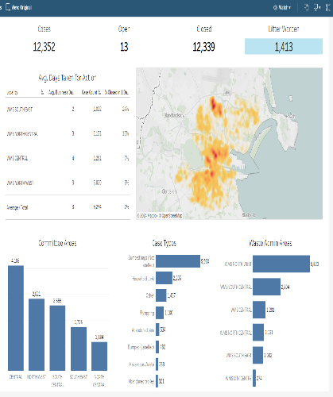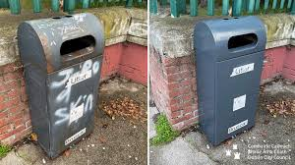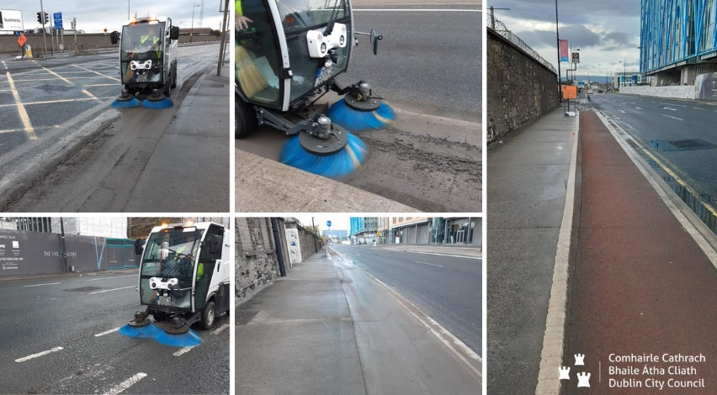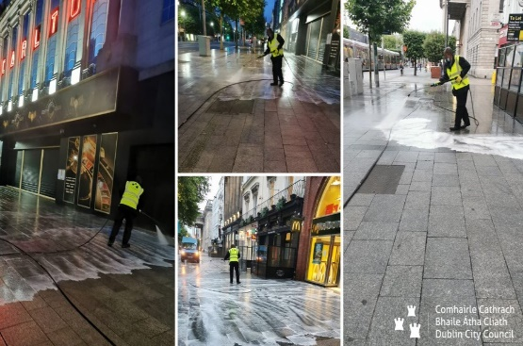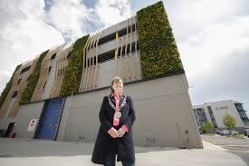

Actions and Targets
A set of tangible actions and realistic targets for Resources were set for the previous Litter Management Plan. The implementation of the objectives set out in the plan were monitored and a selection of the targets and their implementation are outlined below:
 | Resources Objectives From Previous Litter Management Plan | Status
1 | Advertise and extend on demand street cleaning service to facilitate cleaning in cooperation with residents' groups arranging for removal of parked cars | Sweep my Street and Online cleaning schedule launched with ongoing review
2 | Extend QR Code customer service system to all Dublin City Council Bottle and Textile Bank sites | Not achieved 2023/4, further engagement with operators and capability and servicing improvements  Painting Programme in place to upgrade banks
3 | Trial use of sensor technology in Bottle / Textile banks | Talks with potential supplier took place. No further progress due to lack of available resources.  Requirement for electronic monitoring included in tender required
4 | Ongoing bin replacement and upgrade programme | Year on Year increase total count 3223 bins with significant refurbishments and replacements in 2023. 380 of which are solar compactors. Capacity improvements with DRS now fully operational
5 | Trial the use of compartmentalised waste and recycling bins at selected public spaces. | Circlecity Scheme of 60 can and bottle bins will change to standard recycling bins early 2024. A review of contamination and future scope progressed.
6 | Introduce a composting programme to investigate potential to ensure all leaves collected are used to produce compost.  Compost to be made available to the public at bring centres where feasible. | Segregated collections for leaf fall and Christmas tree collections are in place. Compost available at Rathmines Bring Centre
7 | Introduce and manage an online resource to provide information on street cleaning schedules | Service has gone live 2022
8 | Continue to provide graffiti and chewing gum removal services | In house graffiti team working well and supplemented by contractors for specialised services
9 | Seek to include in the Dublin City Development Plan a requirement for all new residential and commercial developments to include appropriate space for provision of recycling infrastructure | Provision included in the drafting Dublin City Development Plan
10 | Carry out public consultation to seek additional locations for recycling infrastructure in the city | Completed Oct 2023 through Your Dublin Your Voice, over 1000 submissions. Recycling infrastructure supported the recycling of 20000 tonnes of material in 2023
11 | Continue to provide and enhance Open Data on waste management services | Ongoing work in conjunction with Smart Cities, Solar compactors and data analytics

Partnership
Partnership Overview
- Waste Management continues to work in close partnership with local communities, residents groups and Dublin City Council Area Offices to deliver services and support local environmental initiatives. Community clean ups are supported throughout the city on an ongoing basis. In 2024 we provided support to 4316 community cleanups.
- The City Neighbourhoods competition is supported and promoted to reward active communities for the invaluable contribution they make to their environment and locality, 300 entries in 2023 with Dublin City Council celebrating the 20th Anniversary in hosting the awards in 2024.
- The All Ireland Pride of Place Awards were hosted and coordinated by Dublin City Council in 2023 and in 2024 four groups were entered with two receiving winners prizes.
- The green schools programme and Picker Pals continues to be supported.
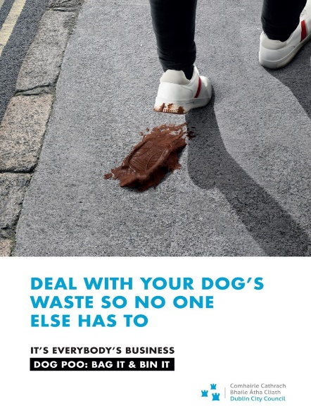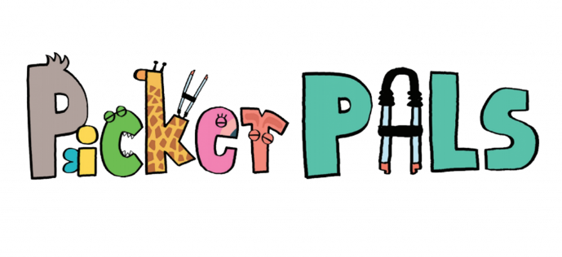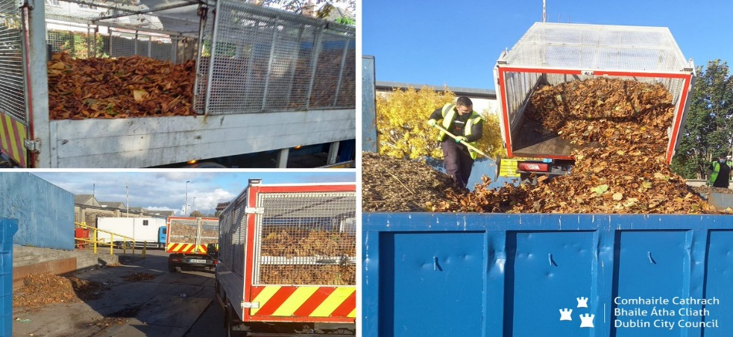
Actions and Targets
Below is a summary outlining our performance against the objectives set out for Partnership in the previous Litter Management Plan.
 | Objective From Previous Litter Management Plan | Status
12 | Develop and implement a ‛communications plan’ | Monthly comms meeting set up, press support and collaboration internally: Halloween, Leaf Fall, Community Clean ups, Corporate clean ups, ALAGS grant usage, Leave no Trace
13 | Seek to foster greater engagement with the community on topics of environmental concern | Recycling Infrastructure Consultation 2023. Social media engagement
14 | Investigate trial of incentivised reward schemes for recycling / anti-litter initiatives | Anti Litter anti graffiti departmental grant is used to fund awareness and education schemes. Anti Dumping Initiatives grants completed 9 projects across all areas in 2024. National Deposit return scheme will support a potential change in litter habits across the country. Early awareness of DRS was part of circlecity scheme and in conjunction with Voice Ireland
15 | Strengthen Internal communication between departments | Collaboration across departments and stakeholders, Enforcement, City Recovery, Area Offices, Roads, Halloween key bridge with all stakeholders
16 | Introduce a portal or set of webpages on the Council website, with centralised litter management data included up-to-date statistics, mapping, and information on littering | New Online cleaning schedule live  CitizenHub reporting will encompass all service requests and give scope for future data sharing, complaints and service requests
17 | Continue to develop and roll out the Green Schools programme to Primary and Post Primary Schools | The programme focused on long term education with each of the nine flags taking two years to achieve. In the 2022-23 school year, 56 schools received new flags in total.  Litter and waste is the first flag a school can achieve. In the 2022-23 school year, 7 obtained a flag for Litter and Waste.
18 | Continue to expand success of Dublin Community Clean Up Day | Strong participation and solid plans, media engagement and launch. 2023 saw circa 1000 bags of litter collected and 80 groups involved. In 2024 110 groups participated in the event.
19 | Develop liaison with primary and secondary schools on litter education including providing an updated Litter Education Packs to schools | Since 2019, 273 classrooms from 143 different schools within Dublin City have taken part. In 2022-23, 131 classrooms took part.  Waste Management procured the Rubbish Film Festival educational programme for the 2022/23 academic year. Each school produced a video about a chosen environmental topic. The programme was funded through the Anti-Litter Anti-Graffiti Grant. The programme was trialled in fifteen secondary schools within Dublin City.
20 | Facilitate Community Clean Ups with Residents Associations and community groups. | Over 4500 Community Clean ups are supported yearly and the introduction of clear community bags.
21 | Create awareness campaign to encourage citizens to reduce use of single use plastics. | In 2022 awareness campaigns were created for social media to highlight EU Waste Prevention Week. This campaign focused on options to reduce and reuse in Dublin city. Free conscious Christmas webinars were held in collaboration with the Sustainable Life School. A Christmas Stop Food Waste social media campaign ran in December.  2023 – Waste Mgt procured a facilitator to deliver circular economy workshops to secondary schools within DCC in 23/24. DCC supported the international Circular Economy Hotspot 2023. National Campaign on Ireland's Deposit Return Scheme. Re-turn goes live from 1 February 2024. From that date, everyone who returns undamaged bottles and cans with the Re-turn logo is helping to reduce single-use, litter and increase recycling rates.
22 | Develop and implement initiative targeting to local businesses to replace single use plastics with sustainable alternatives. | The LEO and ERMWO ran a MODOs circular economy training programme for micro, small and medium size enterprises within the life of the plan. Modos continues to be rolled out In 2023/24. This circular economy training course from the Regional Waste Planning Office with Economic Development that provides business with the knowledge to implement effective sustainability strategies.
23 | Phase out single use Plastics at all Dublin City Council offices and facilities. | A deposit return scheme for cups was trialled in the civic offices in 2018 in to provide an effective solution for single use cups. Deposit Return Scheme now live
24 | Develop clear, unambiguous strategy informing the public that bagged dog litter can be disposed in any litter bin | Posters were placed in litter bins in areas in the city that were regarded as litter hot spots in relation to dog fouling in 2021. 2022 Poster competition. Combined approaches with An Gardai and Wardens pilot enforcement. Behavioural Study also completed in conjunction with Leave no Trace. Additional signage supported in areas reported.
25 | Continue to run advertising campaigns on litter, dog fouling and illegal dumping. | Dog fouling campaigns ran across the period of the plan. DCC joined the Love this Place, Leave No Trace campaign 2021. DCC continue to place signage throughout the city to make dog owners and dog walkers aware that they must 'Bag it and Bin it'  Bottle/Clothes bank campaign Q1 2022  Love this place 2022/3/4
26 | Collaboration with all relevant stakeholders to carry out clean-ups of waterbodies in the city’s jurisdiction. | DCC collaborate with stakeholders to carry out clean-ups of waterbodies in the city's jurisdiction by providing equipment and collection bags after clean-ups.
27 | Collaboration with businesses surrounding the docklands to collect litter removed from the River Liffey. | Marine litter project part funded by Docklands. Dublin Community clean up continues to support organisations and water groups along with area office and dockland support.

Enforcement
Enforcement Overview
- The use of CCTV in community bring centres and areas where illegal dumping is prevalent has been suspended until such time as the legislation has been commissioned and a new contract for a service provider is in place.
- Door to door compliance campaigns have been in place with Litter enforcement and Area Offices in areas of concern with 1659 correspondences.
- Dog fouling patrols and illegal dumping investigations have also been ongoing over the lifetime of the plan.
- New nightshift Litter Warden Appointments due 2025.
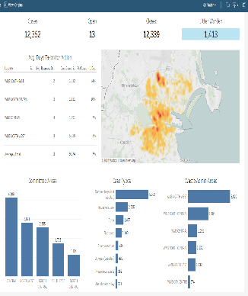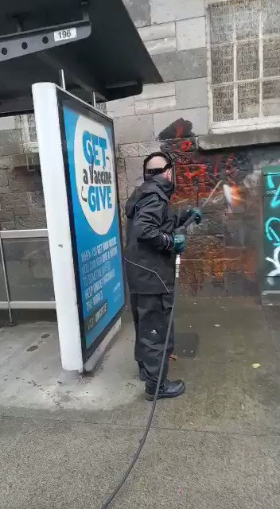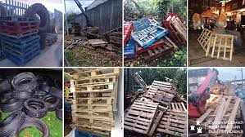

Actions and Targets
Implementation of the various objectives set out for Enforcement in the previous Litter Management Plan were monitored through a set of tangible actions and the achievements are set out below:

 | Objective | Status
28 | Concentration of resources on areas where litter incidences are particularly prevalent. | 1197 Litter pollution fines issued in 2023, 397 Bye Law fines issued (2024 394 and 105 bye laws)
29 | Coordination with other enforcement bodies, particularly An Garda Síochána. | Halloween saw a successful collaboration with An Garda Síochána, waste enforcement and internal departments in the reduction of bonfire materials available.
30 | Continue successful Halloween Response Actions. | In place and improving yearly complete and positive result bonfires reduced
31 | Continue the use of CCTV surveillance and associated signage. | The use of CCTV in community bring centres and areas where illegal dumping is prevalent has been suspended until such time as the legislation has been commissioned and a new contract for a service provider is in place.
32 | Investigate households who are not serviced by a registered waste provider | Post Covid, surveys and compliance obligation to have a waste provider has been in place and active through wardens and area offices and reported through national inspection database.
33 | Complete Reorganisation of Litter Warden Service | Litter Warden Manager in place and night shift warden presence due for the city centre 2024. All wardens now report to Waste Management Services.
34 | Devise and implement a strategy engaging with tenants of multi-occupancy buildings to ensure compliance with waste and littering laws. | Engage and plan with Litter enforcement and waste enforcement strategy.
35 | Carry out review and update of Litter Prevention and Control Bye Laws. | Reviewed 2022 by Litter office, no national change planned

Key Performance Indicators for previous Litter Management Plan implementation period:
The Litter Management Plan makes references to Key Performance Indicators to be used over the lifetime of the plan. These include enforcement data annually and performance in national surveys.
- +5000 litter patrols carried out in 2024
- National Litter Pollution Monitoring System
Grading | 2020 | 2021 | 2022 | 2023
Unpolluted by Litter | 22.4% | 17.7% | 10.8% | 13.3%
Slightly Polluted by Litter | 51.6% | 46.9% | 56.2% | 57.4%
Moderately polluted by Litter | 19.6% | 27.1% | 26.7% | 23.5%
Significantly polluted by litter | 5.5% | 7.5% | 5.7% | 5.8%
Grossly Polluted by Litter | 0.9% | 0.8% | 0.7% | 0.0%

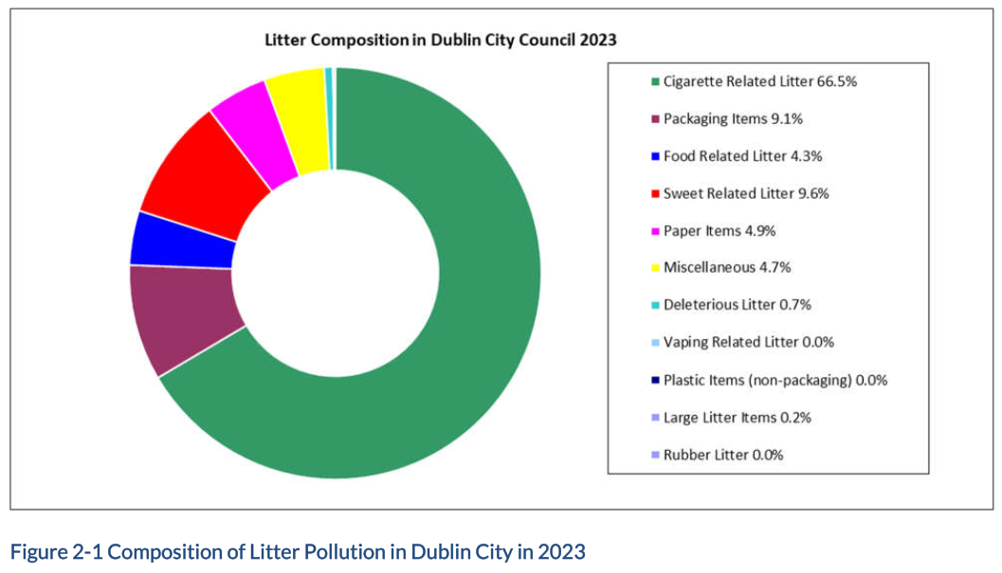
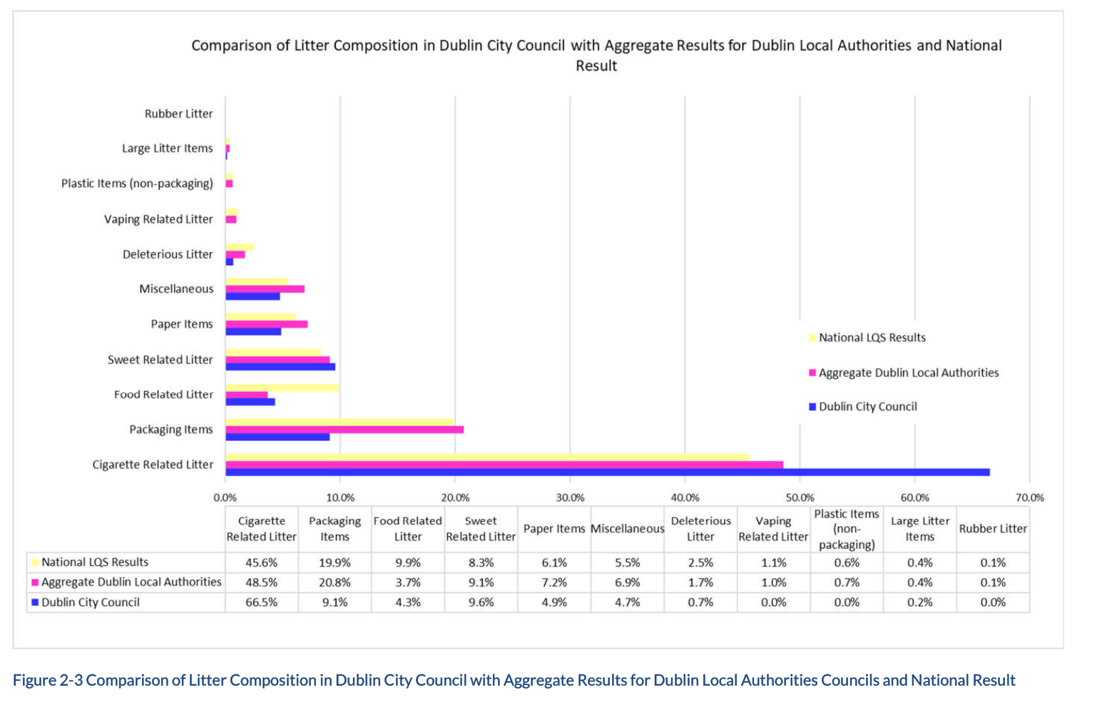
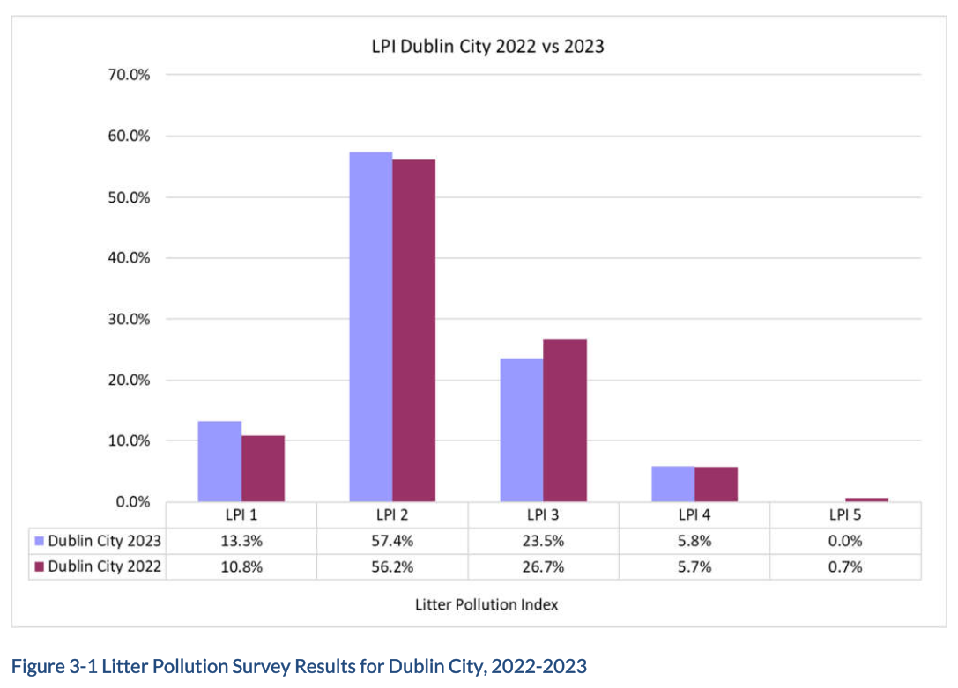

- Street Grading: 757 surveys conducted in 2023, review and revision of service commencing Q2 2024??
 | Grade A | Grade B | Grade C | Grade D
Rating 2023 | 70% | 20% | 10% | 0

Fines Issued | 2019 | 2020 | 2021 | 2022 | 2023 | 2024
Litter Fines | 820 | 763 | 914 | 806 | 1197 | 394
Bye-Law Fines | 111 | 253 | 143 | 132 | 397 | 105
Total | 931 | 1016 | 1057 | 938 | 1594 | 499

Objectives for the Proposed 2026-2028 Litter Management Plan

The 2026- 2028 Litter Management Plan has been prepared in accordance with the requirements of the Litter Pollution Act 1997 to 2009. The Plan has been developed in consultation with Dublin City Council staff, elected representatives and with the citizens of Dublin who live and work in the city through the statutory consultation process.
The plan is built on the three pillars of litter management in the City: Operational Enhancements, Enforcement and Regulation Change and Litter Awareness and Prevention. Effective management of litter can be achieved when we make the best use of the human resources, skills and knowledge from Dublin City Council, coupled with improvements in service delivery, by working together with the public, residents and businesses who call Dublin home and by taking enforcement action on those who do not respect our shared environment and illegally dump waste materials, fail to clean up after their pets and incidentally litter the city.
The aims, objectives and actions for the management and prevention of litter are outlined for each key area and are to be undertaken during the lifetime of this Litter Management Plan.
The overall aim is to improve the standard and consistency of cleanliness throughout the city for residents, businesses and visitors over the lifetime of this plan. Successful initiatives, projects and operational activities that have been implemented over the lifetime of previous litter management plans will continue and improvements will be sought in all aspects of service delivery.
The 2026-2028 Plan will be structured around the 3 Pillars with 2 primary goals per pillar and key objectives for each goal to be delivered.

Operational Enhancements and Resources
In previous years, Dublin City Council implemented a number of technological innovations to improve the efficiency of litter management and street cleansing. The Council intends to combine these innovations with the most efficient deployment of existing and additional resources in order to keep pace with the ever changing city.
Waste Management have now divided the administrative area of Dublin City Council into six smaller areas for improvements in service delivery. The city centre will have a new weekly wash programme that will focus on key areas to be serviced by a combination of Multihog Wash vehicles that have a deck scrub to buff wash stains on wide pedestrian locations in a highly efficient way, and a fleet of wash vans that will provide a regular and robust street washing service to other pavements in the commercial district. The number of streets washed in the city centre will increase during the summer months as additional shifts and resources are deployed during this critical period.
Areas outside the city centre will receive a street washing service Monday to Friday that focuses on areas of high footfall, commercial locations and other locations in need of a regular wash service. All locations are identified through consultation with Local Area Managers and Public Domain Officers.
A review of all cleaning schedules will be carried out over the lifetime of the Litter Management Plan. This will include reviewing the Online Cleaning Schedule for the number of streets to be cleaned daily and streets in residential locations on a schedule. A review of the midweek afternoon / evening and weekend schedules provided by the Suburban 7 over 7 shift will also take place.
The Online Cleaning Schedule, located on the Dublin City Council website will remain in place and provide information of Street Cleaning schedules for all locations within the administrative area of Dublin City Council.
Waste Management will continue to carry out internal audits on the standard of street cleaning, covering the full administrative area. These audits will be carried out by Waste Management Inspectors within their area of responsibility. The results of these inspections will provide important data for improvements in service delivery.

Core Goals:
  - Robust Resources of Staff and Equipment to improve cleanliness

    - Staff Numbers
    - Fleet Improvements
    - Recycling Infrastructure Review
    - Washing Teams
    - Depot Improvements

  - Efficient and Innovative Approaches

    - Solar Compactors
    - Digitising Work
    - Cleaning Schedules
    - Bin Quantity and Policy

Litter Awareness and Prevention
Engagement with citizens and businesses residing within the City has proven successful in the past and community buy-in is viewed as being paramount to maintaining a litter-free City. The City Council will continue to foster engagement in these areas and work in partnership with all stakeholders to promote, support and reward environmental best practice at local levels. Additional 5 wardens recruited and in place by end of 2025.
2.1 Engaging and Recognising Community groups support
2.1.1 Team Dublin Clean Up
2.1.2 City Neighbourhood awards
2.1.3 Pride of Place Awards
2.1.4 Community Clean-up Supports

2.2 Creating Awareness, Education and Anti Litter Schemes across the city
2.2.1 Awareness campaigns
2.2.2 Reverse Register Project
2.2.3 Schools Programmes
2.2.4 Anti Litter Anti Graffiti Awareness grants

  - Enforcement and Regulation Change
Dublin City Council has a statutory responsibility to enforce the Litter Pollution Act, bye-laws and other relevant regulations. While tactical deployment of resources and education of citizens of the city are pertinent in preventing incidences of littering, there will always be individuals and groups who openly ignore the law. Enforcement measures such as fines, prosecutions and convictions are necessary to curtail the behaviour of citizens who choose not to abide by the law.
New CCTV legislation in Ireland, specifically amendments to the Litter Pollution Act 1997, allows local authorities to use CCTV to tackle littering and illegal dumping. This legislation, introduced through the Circular Economy and Miscellaneous Provisions Act 2022, aims to deter, prevent, detect, and prosecute offences related to waste management and littering. Local Authorities can now deploy CCTV schemes, subject to specific codes of practice, to monitor areas prone to illegal dumping and gather evidence for enforcement.
The legislation necessitates that local authorities operate CCTV schemes in accordance with approved Codes of Practice, ensuring compliance with data protection regulations, including GDPR.

3.1 Prevention
3.1.1 Halloween Response Group
3.1.2 Anti Dumping initiatives
3.1.3 Derogation Reviews and changes

3.2 Visibility and Action

3.2.1 CCTV Usage
3.2.2 Bye Law Compliance, Presentation and Control
3.2.3 Signage and awareness Audio, Stencils and signage
3.2.4 Staffing and Patrols

Monitoring and Implementation of the 2026-2028 Litter Management Plan

Implementation Plan
Implementation of the various objectives of the plan will be monitored through a set of tangible actions and realistic targets as follows.

Operational Enhancements and Resources
 |  | Robust Resources of Staff and Equipment Primary Goal No1
No. | Key Objective |  | Target | Measurement
1.1.1 | Staff Numbers |  | Operational Staff Employed currently at 525 to be increased to 565 to allow provision of additional service delivery | Overall numbers increased to target level No of 565 and maintained
1.1.2 | Fleet Improvements |  | EV Fleet to be at 35% of total Fleet to comply with Clean Vehicle Directive | 35% level to be achieved at a minimum
1.1.3 | Recycling Infrastructure Review |  | 100% of existing structures maintained and were possible increased. | No of Bring Centres and bottle banks to be maintained at current levels.
1.1.4 | Additional Wash Teams established to provide additional street washing services on a scheduled basis |  | Wash Crews and schedule in place in first year of plan and operating to maximum efficiency | Schedule established and maintained throughout the lifetime of the plan
1.1.5 | Depot Improvements |  | Works completed on City Centre Depots. Slaney Road depot refurbished and reopened and fully operational. Planning progressed on S.C.O.D.  Source new City Centre Depot Site to Replace O Rahilly Parade should it close | Refurbishment of Cleansing Depots at Bow Lane and O’Rahilly Parade completed. Slaney Road Cleansing Depot in North West Area operational. Planning of new S.C.O.D. to be progressed. New City Centre site location identified and agreed

Efficient and Innovative Approaches |  | Primary Goal No 2
No. | Key Objectives | Target | Measurement
1.2.1 | Solar Compactors Bins | Increase the number of solar bins installed at suitable locations. 380 Currently in place | No of Solar Compactor Bins in use
1.2.2 | Digitising work and Visualisation | New Technologies in use to facilitate more efficient and cost effective service delivery. Increase app development and usage by all operational staff | No of New Apps in place and fully utilised.1 Work validation App 2. Street Washing App.3 Street Grading App. 4.Citizen Hub Upgrades to provide automatic feedback on reported cases when closed.
1.2.3 | Cleaning schedules | Increased frequency of cleaning schedules particularly in suburban areas. | Street sweeping schedule reduced to every 8 weeks in suburban Category c areas
1.2.4 | Litter bin policy delivered | Policy in Place | During the lifetime of the LMP

Litter Awareness and Prevention
Engaging and Recognising Community Groups Support Primary Goal 1
No. | Key Objective | Target | Measurement
2.1.1 | Team Dublin Clean up completed each year | Planned and completed each year on schedule | No of Participant Groups and persons takin part in event each year
2.1.2 | City Neighbourhood Awards | Planned and completed each year | No of groups participating in competition
2.1.3 | Pride of Place Awards | Planned and completed each year | No of groups participating in competition
2.1.4 | Community Clean Up supports | Increase the number of Community Collections supported by Department. 4316 supported in 2024 | No of supports provided each year throughout the lifetime of the plan

Creating Awareness, Education and Anti Litter Schemes Primary Goal 2
No. | Key Objective | Target | Measurement
2.2.1 | Awareness Campaign | 1 National Campaign within lifetime of Plan and Yearly local plans over the lifetime of the plan | No of Campaigns Completed
2.2.2 | Reverse Register Project | Project in place and completed within the lifetime of the LMP | Project in place and in operational use by Litter Warden Service
2.2.3 | Schools Programmes | Provide ongoing supports to the Green Schools Programme | No of Schools supported and visited as part of the educational awareness programme each year
2.2.4 | Anti Litter Anti Graffiti Awareness grant usage | Working with Area Offices to encourage and increase supports for ALAG schemes | No of approved schemes each year over the lifetime of the plan.

Enforcement and Regulation Change
Prevention Primary Goal No 1
No. | Key Objective | Target | Measurement
3.1.1 | Halloween Response Group Lead | Multi DCC departmental and first responder groups in place each year to prepare for Halloween night. Citizen Hub reports actioned on bonfire materials within 24 hours. | Increased Tonnages of bonfire materials removed in run up to Halloween each year
3.1.2 | Anti Dumping Initiatives | Increase No of antidumping initiatives | No of new antidumping initiatives over the lifetime of the plan
3.1.3 | Derogations Reviews and Removals | 100% over lifetime of the plan. Almost 900 streets with derogations at present | No of Streets with Derogation Removed

Visibility and Action Primary Goal No 2
No. | Key Objective | Target | Measurement
3.2.1 | CCTV Usage | New suitable CCTV Locations Identified and approved over the lifetime of the plan | Increase in the no of suitable CCTV Locations Identified and approved over the lifetime of the plan
3.2.2 | Bye Law Compliance Presentation and Control | New Bye-Laws Leaflets to be created and distributed in targeted areas | No of Problem Areas where leaflets are distributed
3.2.3 | Signage and Awareness, Audio, Stencils schemes | Increase no and use of signage, stencils and audio messaging schemes | No of new schemes completed each year over the lifetime of the plan
3.2.4 | Staffing and Litter Warden Patrols increased | Increase No of Litter Wardens on Duty in 2025 by 5 New Wardens | No of Litter Wardens employed and no of targeted patrols undertaken each year.

4.2 Key Performance Indicators
In addition to the actions and metrics specific to the 2026 - 2028 Litter Management Plan, general statistics on litter management and Citizen Hub data will be collected and collated for measuring the success of the plan. This data will include, but is not limited to, the following Key Performance Indicators (KPIs):
- Number of litter patrols undertaken per year
- Number of litter pollution / bye law enforcement actions issued per year
- Performance in EPA Environmental Enforcement Assessment
- All relevant litter and waste Citizen Hub data for the period of the plan
- Performance in annual NLPMS litter survey
- Results of Street Grading Programme

4.3 Review and Reporting
The actions outlined in the implementation plan shall be reviewed against the metrics and timeframe targets. A progress report will be prepared on an annual basis with status and findings for presentation to the Strategic Policy Committee

Glossary of Terms Used throughout the plan:
            - ALEGS = Anti Litter Anti Graffiti Schemes/Grants
            - LEO = Local Enterprise Office (DCC)
            - ERMWO = Eastern Region Midlands Waste Office
            - NLPMS = National Litter Pollution Monitoring System, https://www.litter.ie/about/National_Litter_Pollution_Monitoring.shtml
            - ADI = Anti Dumping Initiative

