User Manual for Operators
and Competent Authorities

Registration of Operators

Version proposed by the Commission
Version 2.0

Table of Contents
Introduction 3
Chapter 1 How to log in to DIWASS using EU login 4
Chapter 2 How to register a new operator for users that are not yet active in DIWASS 5
General note 5
Specific instructions 5
Chapter 3: How to request to be authorised to represent operators in DIWASS as a user, in the case this user is not yet active in DIWASS 17
General note 17
Specific instructions 17
Chapter 4 How to register a new operator for users that already have access to other operators in DIWASS 21
General note 21
Specific instructions 21
Chapter 5: How to request to be authorised to represent operators in DIWASS as a user, in the case this user already has access to other operators in DIWASS 31
General note 31
Specific instructions 32
Chapter 6 How to approve authorisation requests of users that represent operators in DIWASS 36
General note 36
Specific instructions 36
Chapter 7 How to register a new site of the operator in DIWASS 39
General note 39
Specific instructions 40

Introduction
This document contains specific instructions on the use of Digital Waste Shipment System. In order to properly explain how certain operations work, this document often refers to the EU legislation concerning shipments of waste, to illustrate how certain requirements are reflected in DIWASS. This document does not contain any interpretation of these laws.
Abbreviations used in the document:
Abbreviation | Meaning
CA | Competent authority
DIWASS | Digital Waste Shipment System
Waste Shipment Regulation, WSR | Regulation (EU) 2024/1157 of the European Parliament and of the Council of 11 April 2024 on shipments of waste, amending Regulations (EU) No 1257/2013 and (EU) 2020/1056 and repealing Regulation (EC) No 1013/2006, OJ L, 2024/1157, 30.4.2024, ELI: http://data.europa.eu/eli/reg/2024/1157/oj
DIWASS Implementing Act | Commission Implementing Regulation (EU) 2025/1290 of 2 July 2025 laying down rules for the application of Regulation (EU) 2024/1157 of the European Parliament and of the Council as regards the requirements necessary for the interoperability between the central system for the electronic submission and exchange of information and documents related to shipments of waste and other systems or software, as well as other technical and organisational requirements necessary for the practical implementation of such electronic submission and exchange of information and documents, OJ L, 2025/1290, 14.7.2025, ELI: http://data.europa.eu/eli/reg_impl/2025/1290/oj

Please note that this document contains print-screens from DIWASS test environment. The screens in DIWASS may slightly differ from the ones included in this version of instruction manual.

Chapter 1 How to log in to DIWASS using EU login

To access DIWASS please follow the link: https://webgate.ec.europa.eu/env-traces
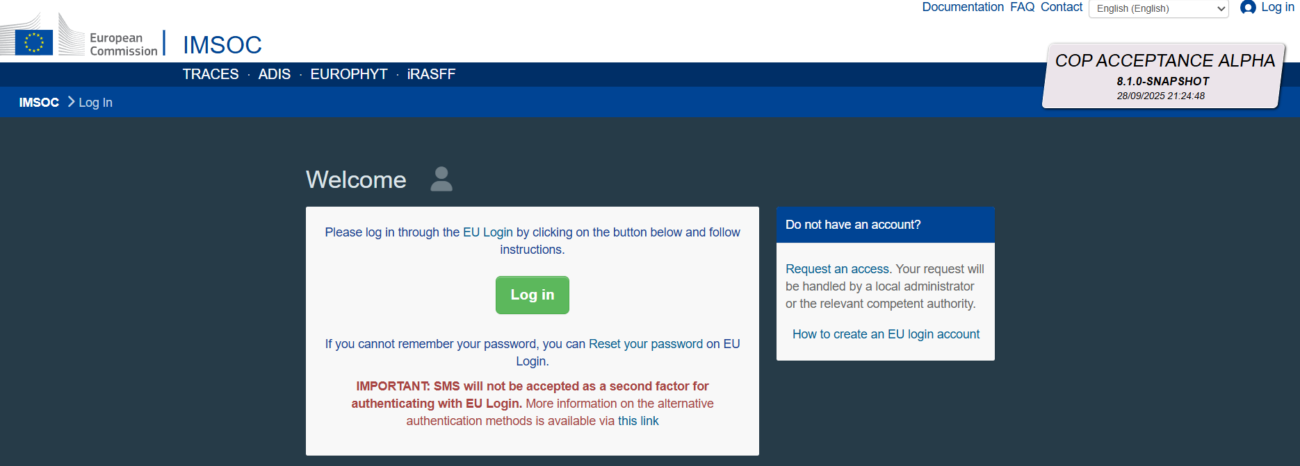
In order to use DIWASS, users are required to use the EU login account. If the user already has an EU Login from previous interaction with Commission’s systems, this login and credentials can be used to access DIWASS.
If the user does not yet have an EU Login account, one must be created following the steps below:
- Go to the EU login page: https://webgate.ec.europa.eu/cas/login
- Click on the “Create an Account” link
- Enter your personal details as requested and click on the “Create an Account” button. You will be informed that you will receive an email allowing you to complete the registration process.
- After going through the EU login registration process, you will have the credentials (username and password) that allow you to access TRACES NT.
For further instructions concerning the EU login, please refer to the following website: https://trusted-digital-identity.europa.eu/eu-login-help/external-self-registered-account-faq_en

Chapter 2 How to register a new operator for users that are not yet active in DIWASS

General note
This chapter provides instructions for creating an operator in the situation where a user is not yet associated in DIWASS to represent any operator and where this operator is not yet registered in TRACES NT. This part of instructions should be followed when users access DIWASS for the first time for the purpose of registering the operator they represent.
In case a user is already associated with an (other) operator in DIWASS, but would like to create a new operator, the user should follow the instructions in Chapter 4 of this manual.
Please note that the steps explained here apply to the creation of “operators” and not to the creation of “sites of operators”. Registration of site is possible only when the “main operator” is already registered in DIWASS. For registration of sites of operators please follow the steps described in Chapter 7 How to register a new site of the operator in DIWASS.
Like other Commission’s IT systems, DIWASS is based on the TRACES NT platform. When registering an operator in any system based on TRACES NT, the user must select options to indicate that the operator will act in the DIWASS system. Certain options displayed in this process (e.g. buttons regarding “Organic Control Body”) are not relevant for registration of operators in DIWASS and should be disregarded.
Please note that in order to submit notification documents or Annex VII documents in DIWASS, all operators involved in a given shipment of waste need to be first registered in DIWASS, as DIWASS will allow only to select registered operators (via drop-down lists). Operators that act as notifiers or persons who arrange the shipment must ensure that all relevant operators involved in their shipment are registered in DIWASS before they start drafting notification document or Annex VII documents in DIWASS.

Specific instructions
- Following the login, the user will see the screen and a communication that “You currently do not have any role allowing you to access the application”. Click on “Operator”.

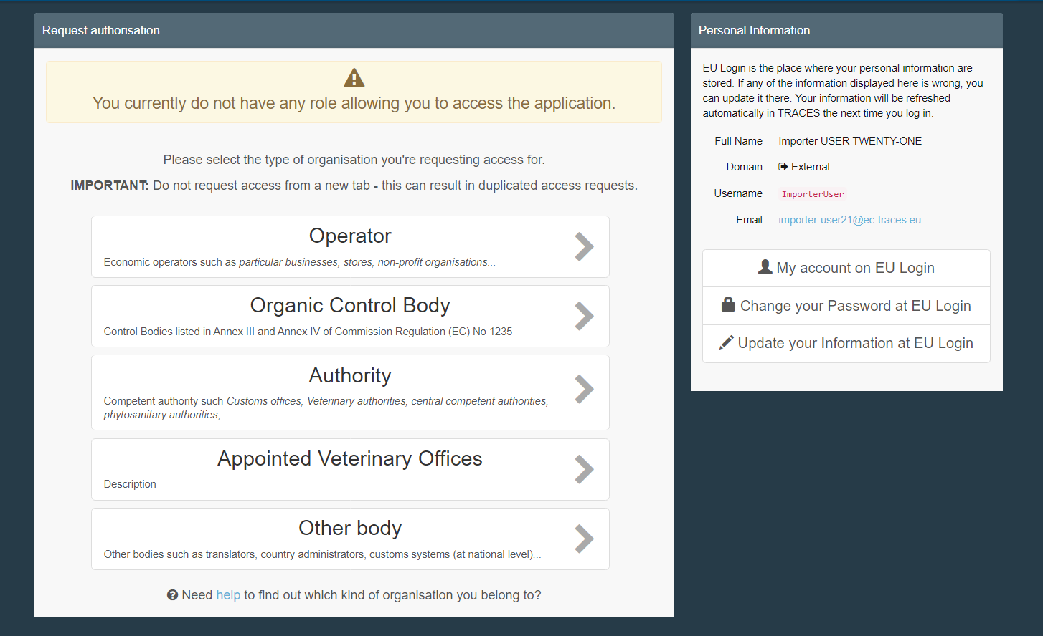

- Before allowing the creation of a new operator DIWASS will ask the user to verify whether the operator that the user intends to register in DIWASS has been already registered. This step allows to ensure that the same operator is not registered several times by different users. To do such a verification, user needs to provide the following data:
- Country: the country where the operator has a main registered office,
- Chapter: Waste Shipment Regulation
- Section: Waste Shipment Regulation (WSR)
- Activity type: WSR Operator
- Search: any element of the name of operator or its identification number
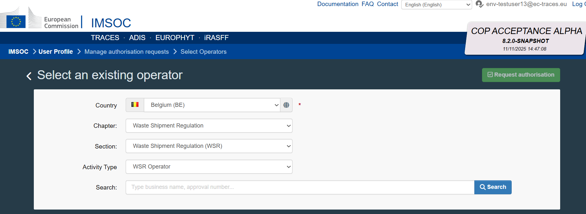

As a result of this search, DIWASS will return a list of operators that match the indicated criteria. Based on this list, a user can request access to any of the existing operators (in order to request such authorisation, please see instructions in Chapter 3: How to request to be authorised to represent operators in DIWASS as a user, in the case this user is not yet active in DIWASS).

If the operator that the user intends to register is not on that list, the user has to create it by clicking “Create a new operator”.

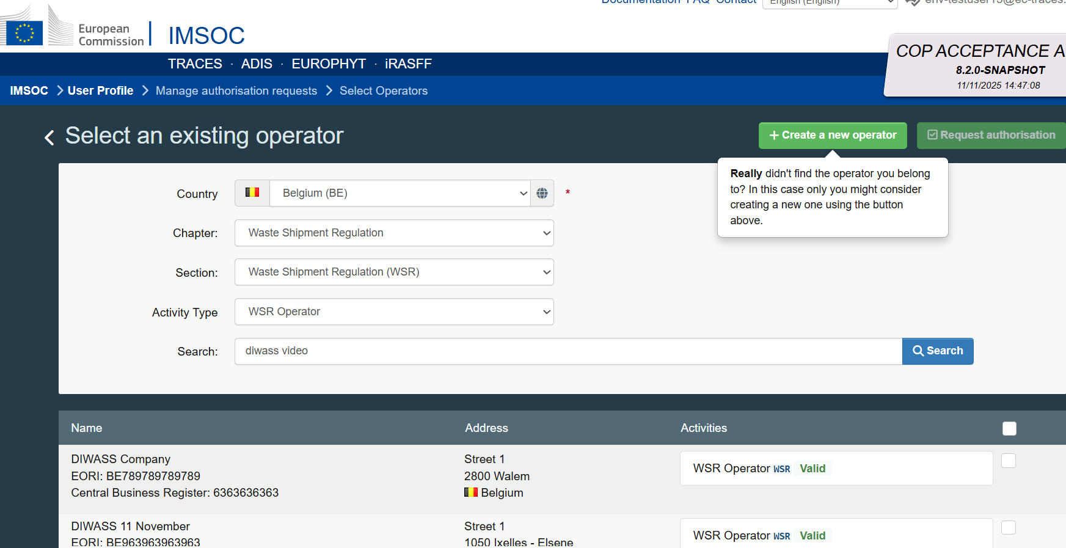
- To register a new operator, the user needs to provide at least the following information:
- Operator’s name;
To add operator’s name fill in the free text field “Name” in box “Operator details”.

- Address;
To add operator’s address fill in the information on “City” and “Adress” in box “Addresses”.
Please note that although TRACES NT permits the entry of multiple addresses, only the first address entered is reproduced on waste-shipment documents. To avoid inconsistencies between the system data and the official documents, the operator’s record should contain only one address.
In case a given operator has many addresses, that are relevant for its waste shipment activities, each address must be registered as an individual site of the same operator. Please see Chapter 7 How to register a new site of the operator in DIWASS for more information.

- Identifier: please note that each operator should have one main identification number.
For most operators, the main identification number will be the EORI number. In case the operator is not required to have an EORI number, please see this document explaining what identification number should be chosen as main identification number.
Please also note, that DIWASS does not contain the names of all national identification numbers. Therefore, the overview referred to above contains information on which label should be used to provide the required national numbers in DIWASS.

To add main identification number of the operator:
  - Click on “+ Add identifier” in box “Operator Identifiers”
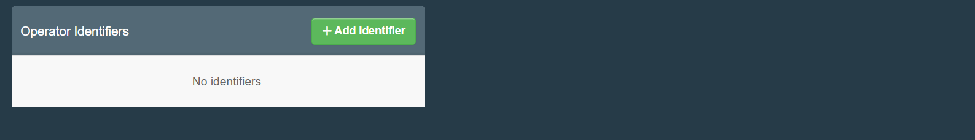
  - By clicking on the icon “v”, choose the name of the identification number to be provided;
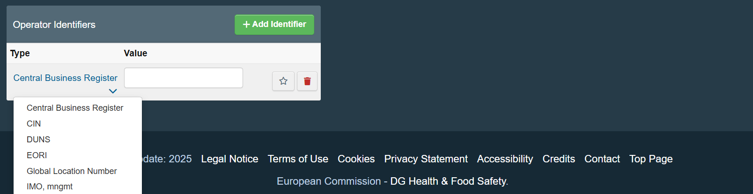
  - To mark the identification number provided as main identification number of the operator, click on the star icon.

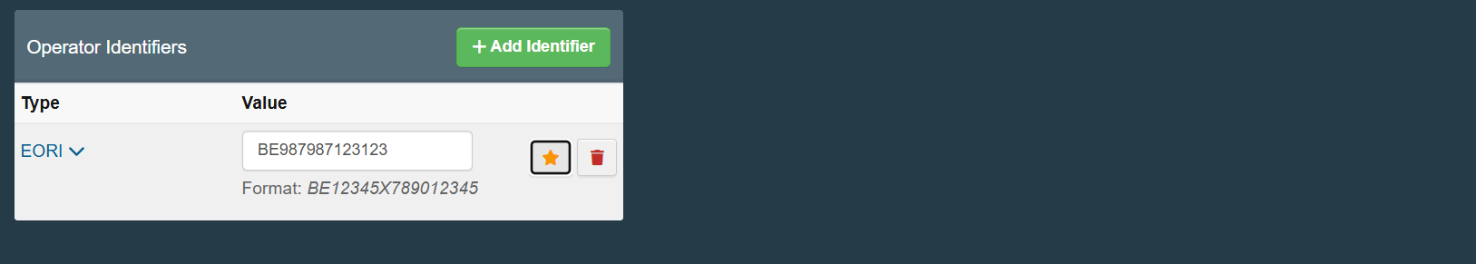

In some Member States, it is required also to provide additional identification numbers. Please see this document to verify, if the Member State where the operator has a registered office requires providing any of such numbers.
Please also note that an operator cannot have two identifiers of the same type (e.g. two VAT numbers, two registration numbers etc.).
Registration of third country operators
In general, the main identification number for third country operators should be the EORI number. In case the operator is not required to have such a number, the main identification number should be an identification number required by the country where the operator is based. Please consult this document [Commission will add the title of the document and a hyperlink leading to it at a later stage] listing identification number required by some third countries.

- Chapter: Waste Shipment Regulation
Please select this from the drop-down list of chapters available in Traces NT.
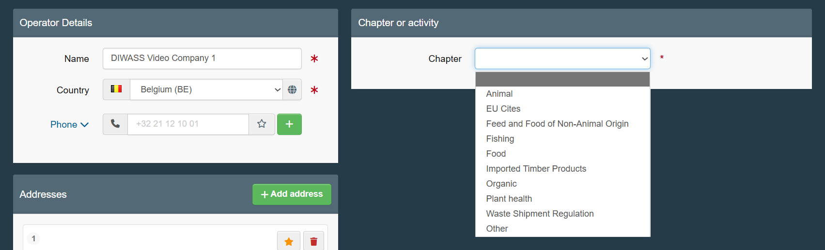
Following selection of this Chapter, additional boxes concerning Activity will appear.

Please also note, that at this stage DIWASS may display information warning about operators that are already registered in DIWASS with similar registration details. This is another mechanism preventing the users from registering the same operator twice.
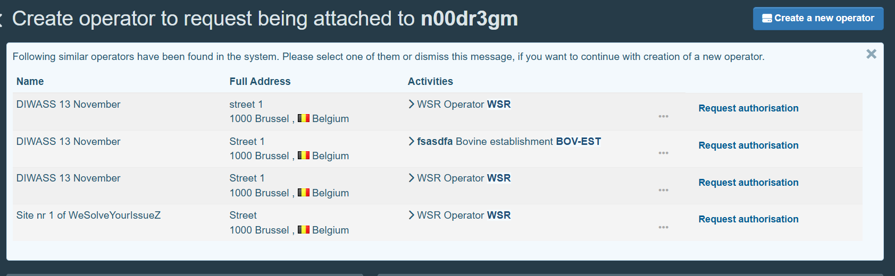
The users seeing such warning should verify whether any of the operators mentioned in the warning are not the same operator, that they intend to register. If this is the case, and the user intends to actively act for such operator in DIWASS, the user needs to ask for authorisation to do so (in order to request such authorisation, please see instructions in Chapter 3: How to request to be authorised to represent operators in DIWASS as a user, in the case this user is not yet active in DIWASS).

- Section: Waste Shipment Regulation (WSR)
Please select it from the drop-down list in field “Section”, in box “Activity”, “Activity details”.

- Activity: WSR Operator
Please select it from the drop-down list in field “Activity”, in box “Activity”, “Activity details”.

- Activity address: requires choosing the address introduced before as main.
To select the address, please click on the icon next to “Adress”, in box “Activity”, “Activity Address”.
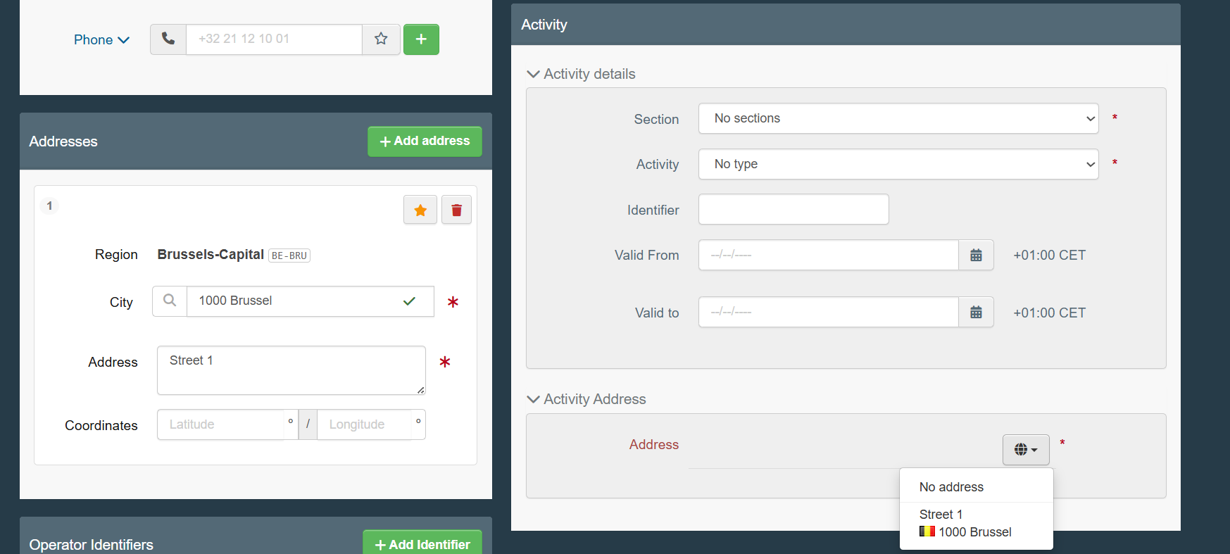
- Assigned responsible authorities: user should select the authority responsible for registration of operator in DIWASS.
To add such authority, the user needs to:
  - Click on “Search responsible authorities” in box “Activity”, “Assigned responsible authorities”
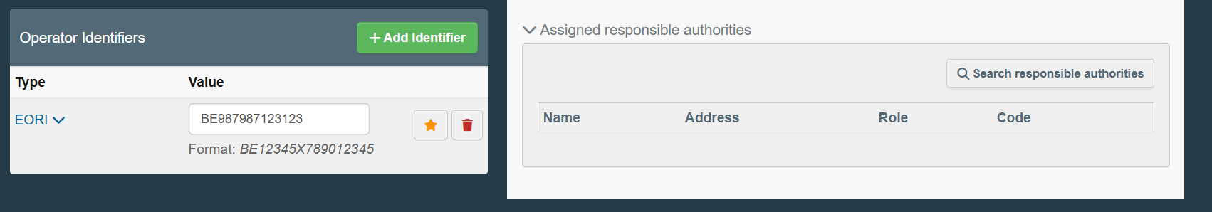
  - In the pop-up window, it will be possible to search for authorities based on name and address. The advanced search allows to search based on additional criteria: country, code of the authority and role of the authority.
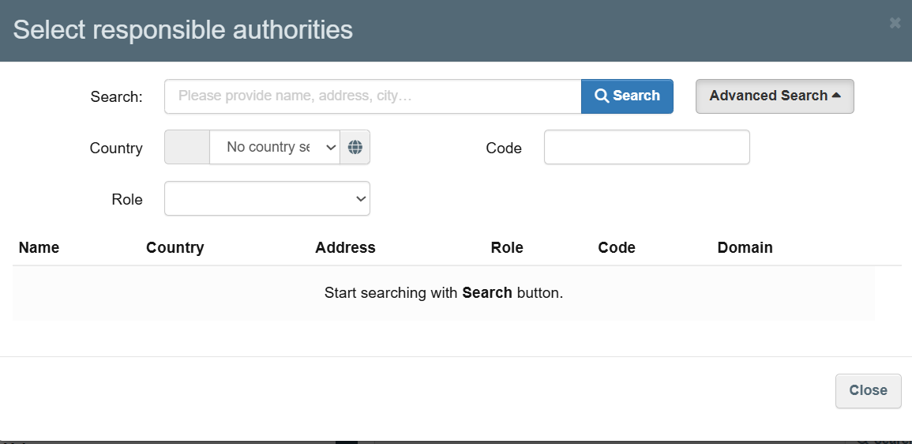
  - Following the search, the user needs to select the relevant competent authority and click on “Select”
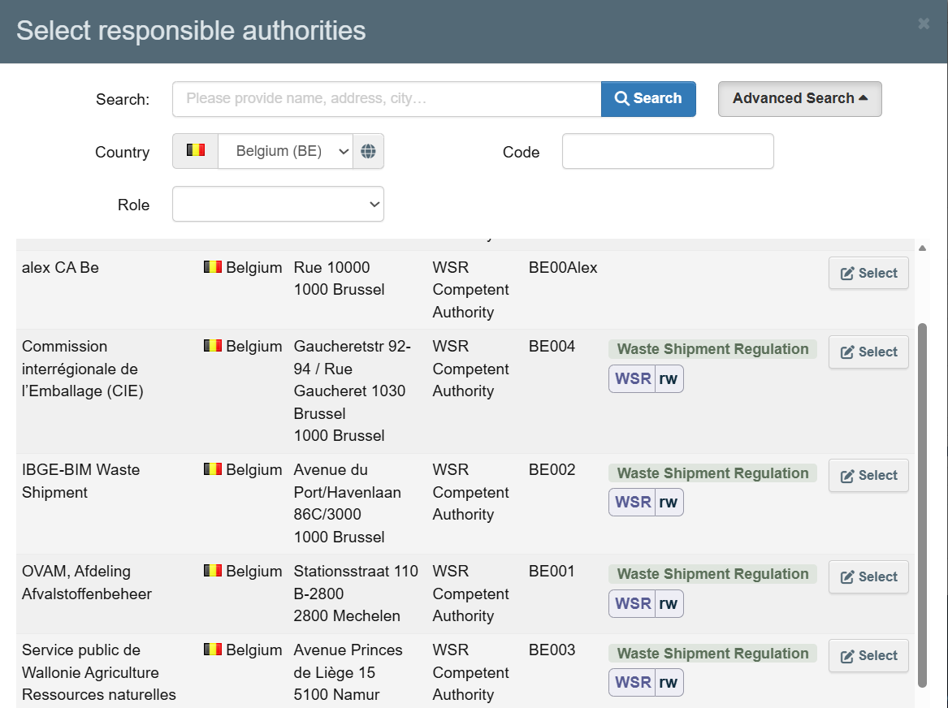

Registration of EU operators
If the Member State has just 1 competent authority for shipment of waste, the user should select this authority. If the Member State has more than 1 competent authority for shipments of waste, the Member State introduced rules on division of competences between authorities in the field of registration of operators. Please see this document explaining which authority should be chosen as assigned responsible authority.
Registration of third country operators
In case of registration of third country operators: if the operator comes from third countries whose authorities actively use DIWASS, the competent authority of this country should be selected as assigned responsible authority. Please consult this document [Commission will add the title of the document and a hyperlink leading to it] to verify this information. If the third country competent authority does not use DIWASS, the user registering the third country operator should select in this field an EU competent authority, who, in the context of planned shipment of notified waste, would act as competent authority of dispatch, destination or transit respectively.

Example: A Brazilian company would like to ship waste to French facility. Brazilian CA does not use DIWASS. This company (or the French facility) introduces basic data of the Brazilian company into DIWASS and as an “assigned responsible authority” selects the French competent authority. French competent authority needs to approve the registration of that operator, and subsequently, will be able to edit the data of that company, in line with general rules on editing operator’s data.

The user may provide also additional information such as:
  - Phone number, fax number, email address, url, contact person name – to do so, the user needs to go to box “Operator details” and click on the icon “v” to choose the type of information to be provided; to add another element, the use needs to click on the “+” icon;
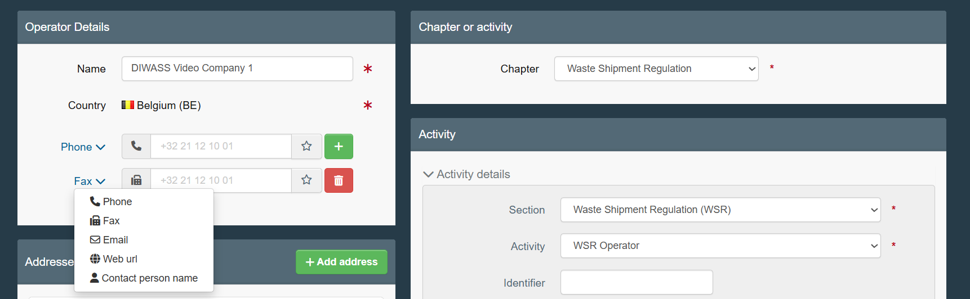
  - Coordinates, by filling in the respective fields in “Addresses” box:
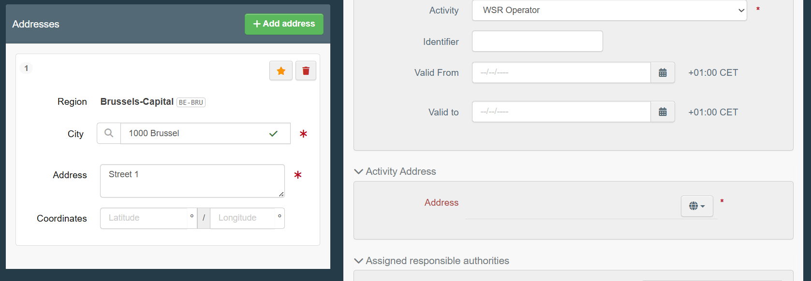
  - Additional identifiers by clicking on “+ Add identifier” in the “Operator Identifier” box and selecting a proper name of the identifier by clicking in “v” icon.
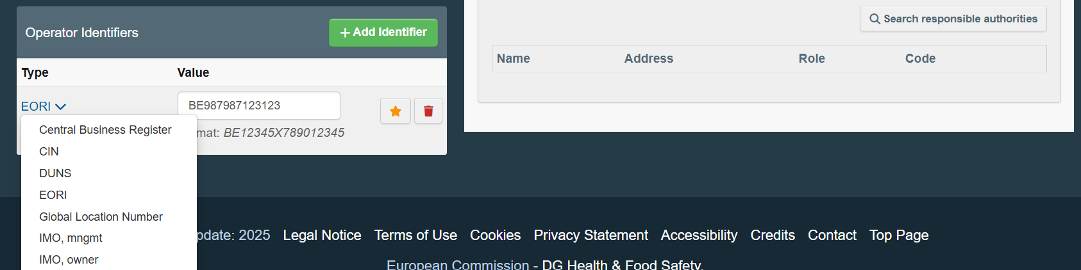

The Traces NT allows also, in box “Activity”, “Activity details” to:
  - provide identifier for activity type,
  - request the “activity” only for a certain period of time.
It is not advised to use these options in context of DIWASS.
After the form is filled click on the button “Create a new operator” on the top right corner of the page.
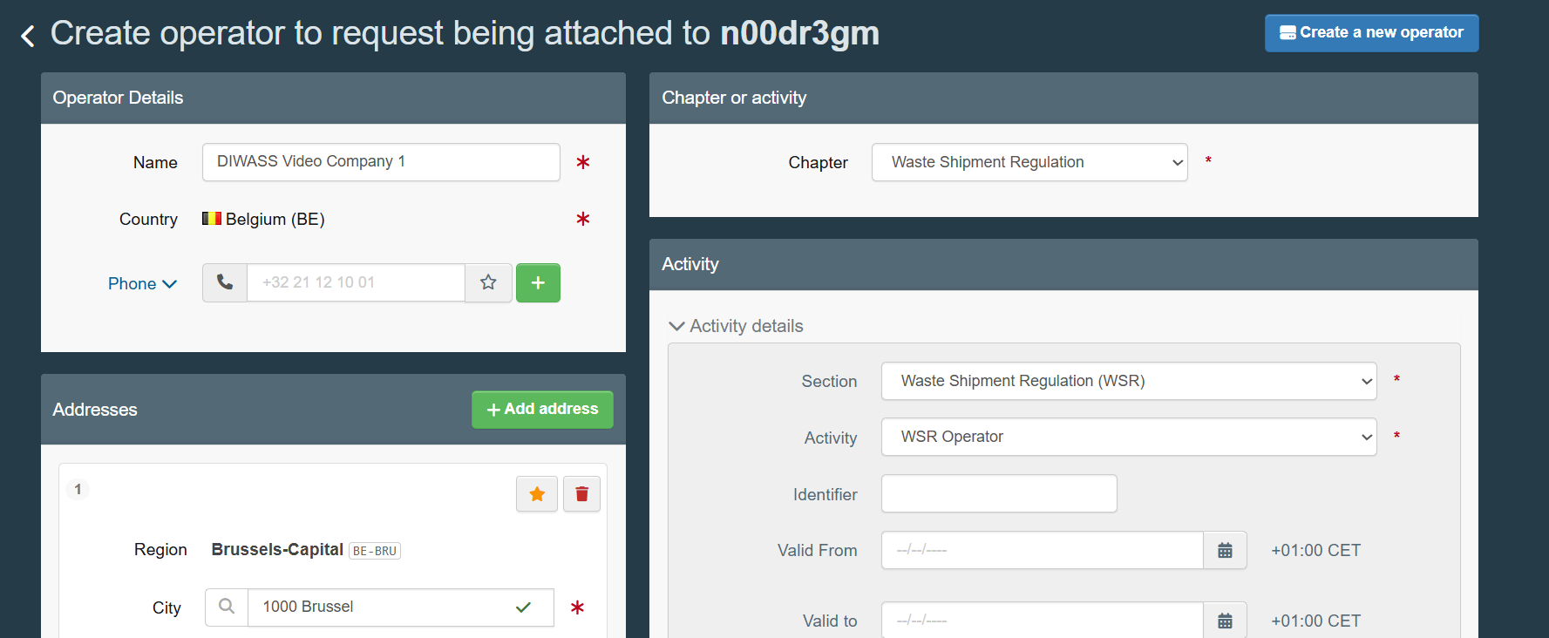
- Next, the user will see a pop-up window allowing to provide additional message regarding the authorisation of the user to represent the operator directly to the selected competent authority responsible for the registration of operator (i.e. authority selected in field “assigned responsible authority”). Please note that providing such message is not mandatory.

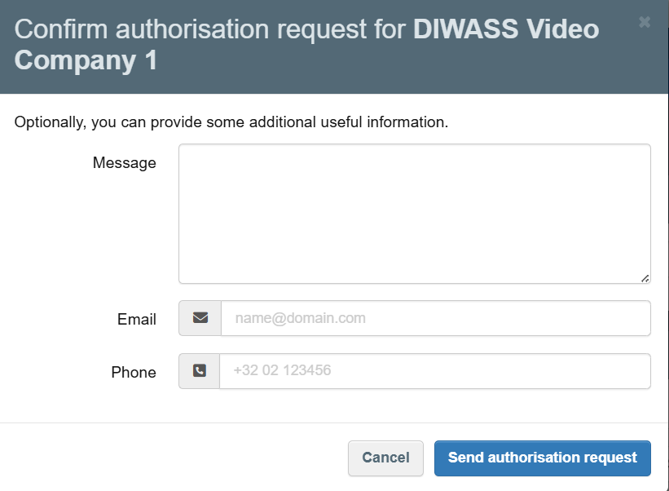

Important note: during the registration of operators, the competent authorities are required to verify the correctness of data provided for the operator and whether the user asking to create the operator is authorities to represent such operator. Such verification may require users to provide some additional documents to the competent authority concerned. Transmission of such documents should be done outside of DIWASS.
Please also note, that the third country operators need to be registered in DIWASS for the purpose of selecting them as operators involved in shipments of waste. However, such registration does not mean, that third country operators are actively using DIWASS. It means that the EU operator may ask for registration of the third country operator, but such registration will not be linked with approving users representing such third country operators in DIWASS. More more detailed information on third country operators in DIWASS please see this document [Commission will add the title of the document and a hyperlink leading to it].

- After the request is successfully sent, DIWASS will redirect the user in the “user profile” screen where the user will be able to see the status of registration requests. As soon as competent authority approves the registration request, the status of request will change from “New” to “Valid”.
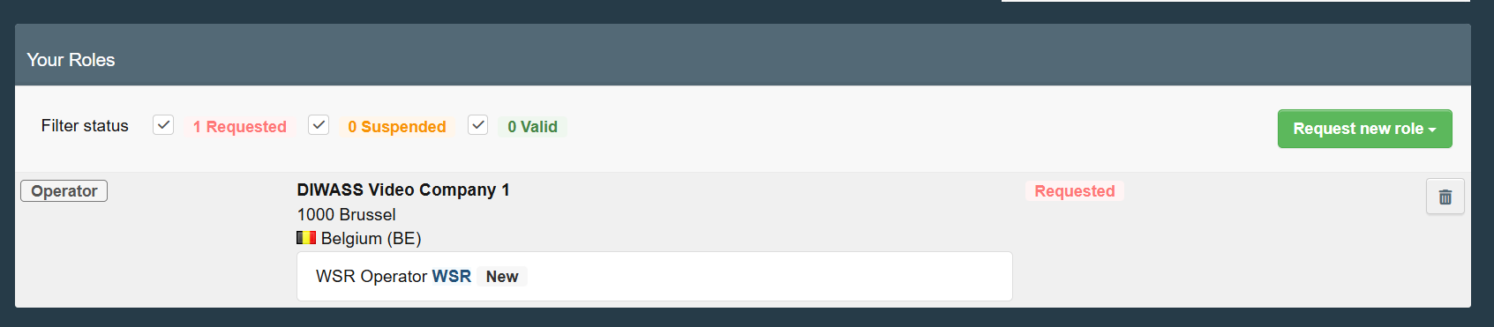
- The user may ask for registration of another operator immediately afterwards. Until the competent authority approves any of the operators, for registration of which user has requested, the user will see the screen below. To register another new operator, the user needs to click on “Operator” and follow steps described in points 2-5 of this Chapter.

Please note that registration of the site of the operator, described in Chapter 7 How to register a new site of the operator in DIWASS, will be possible only after the registration of the main operator is approved by the competent authority.

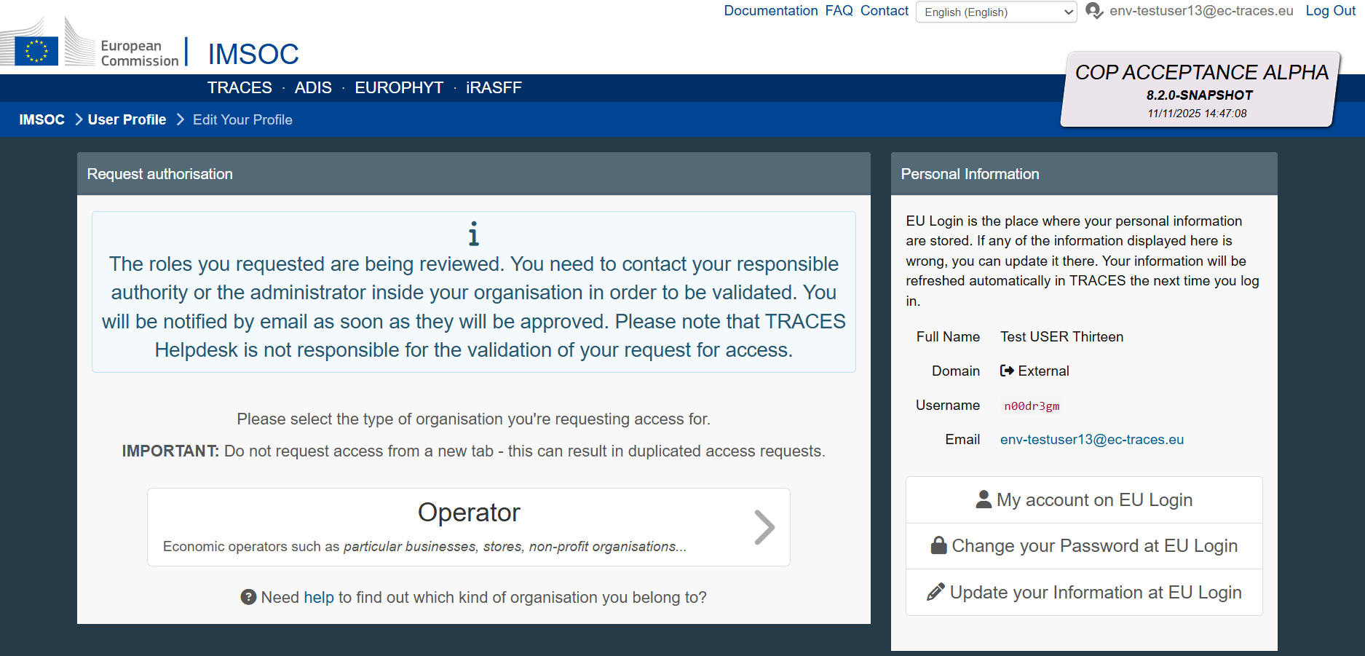
Please note: The user will be able to act in DIWASS representing operator as soon as the competent authority approves the registration of that operator. Then, the user will be able to add other users representing that operator, following the steps described in Chapter 6 How to approve authorisation requests of users that represent operators in DIWASS.

Chapter 3: How to request to be authorised to represent operators in DIWASS as a user, in the case this user is not yet active in DIWASS

General note
This chapter provides instructions for users that intend to request authorisation to represent operators already registered in DIWASS, in case they do not have access to other operators in TRACES NT. If users already have such access, submitting such requests needs to be done in line with Chapter 5: How to request to be authorised to represent operators in DIWASS as a user, in the case this user already has access to other operators in DIWASS.
Like other Commission’s IT systems, DIWASS is based on the TRACES NT platform. Certain options displayed in this process (e.g. buttons regarding “Organic Control Body”) are not relevant for DIWASS and should be disregarded.
Please also note, that each operator that intends to act in DIWASS should have at least one master user. Such master user is authorised to add further users or remove users within an operator’s account in DIWASS. Please note that CA are only obliged to approve the authorisation request from the first user from a given operator – any further authorisation requests should be approved by master users of such operator.
[EU operators must use DIWASS, whereas third country operators may use DIWASS on a voluntary basis. However, if they do not wish to do so, the operators should be still registered, and no users will be assigned to them. Commission works on more detailed instructions related to third country operators and how they work and appear in DIWASS]

Specific instructions
- Following the login, the user needs to click on “Operators”
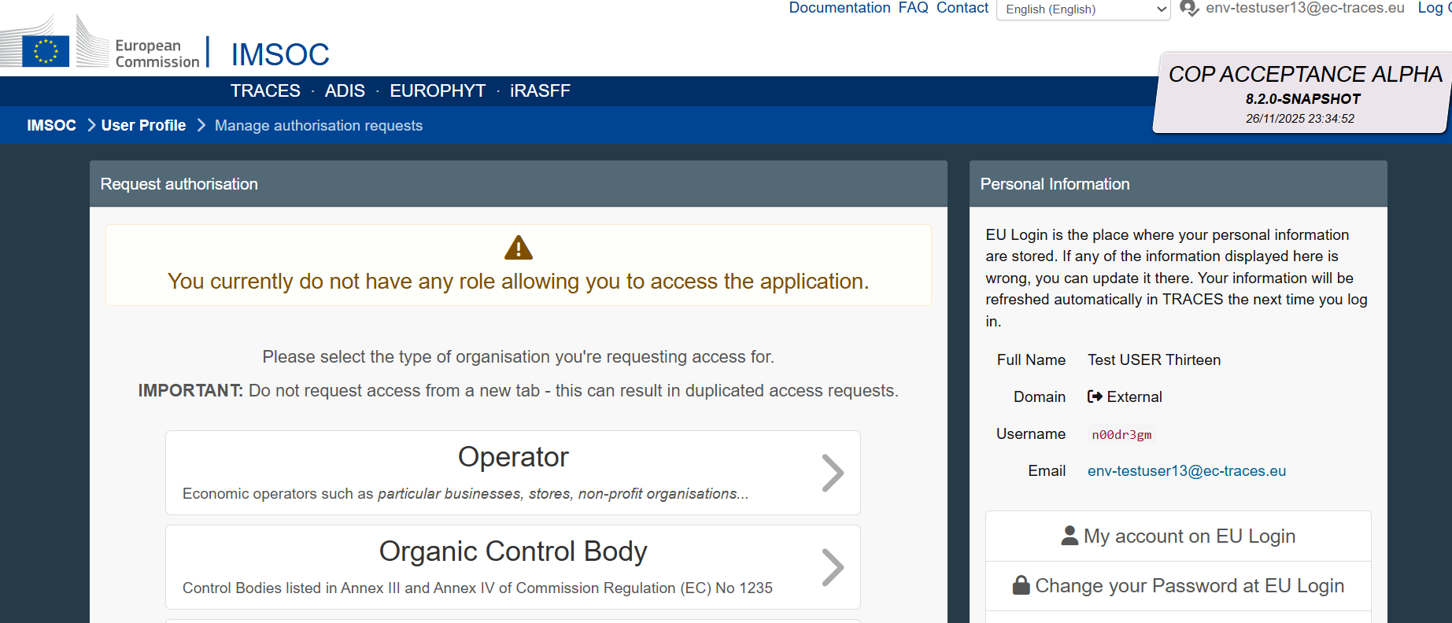
- “Search Operator” screen will open. The user needs to provide the following data:
- Country: the country where the operator has a main registered office,
- Chapter: Waste Shipment Regulation
- Section: Waste Shipment Regulation (WSR)
- Activity type: WSR Operator
- Search: any element of the name of operator or its identification number
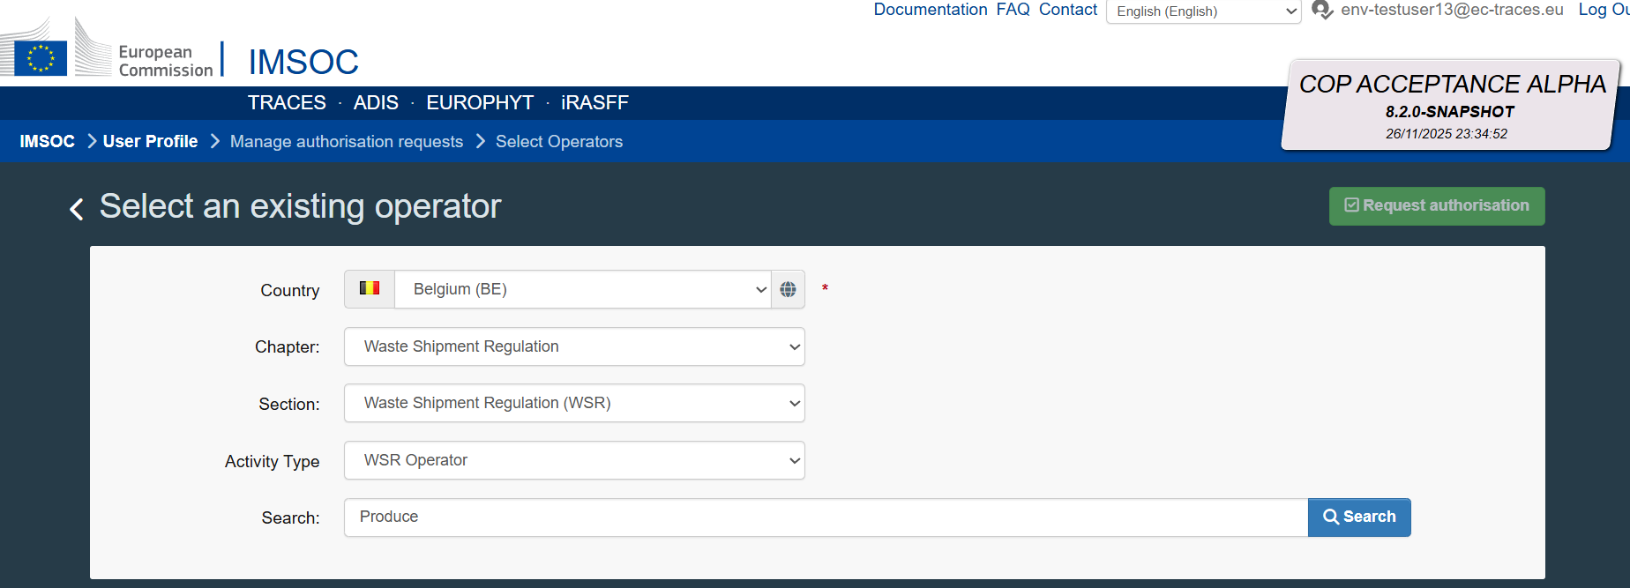
- As a result of this search, DIWASS will return a list of operators that matches the indicated criteria. Based on this list user can request authorisation to represent any of the existing operators. To do so, the user needs to tick the box, next to the details of selected operator, and click on “Request authorisation” in the top right corner of the page.
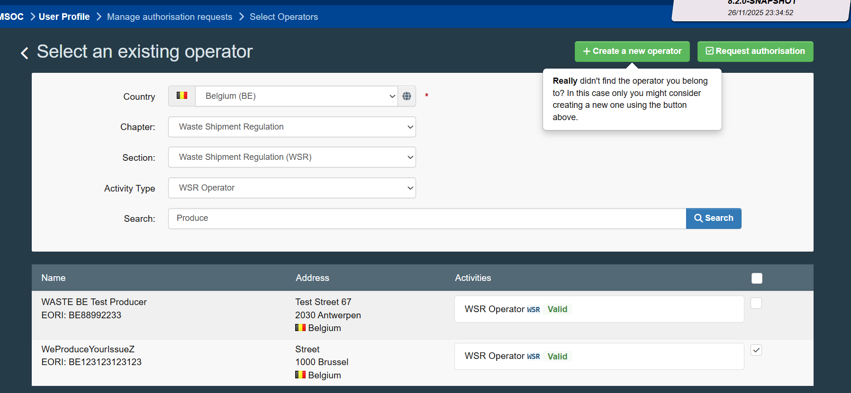
- Next, the user will see a pop-up window allowing to provide additional message regarding the authorisation of the user to represent the operator directly to the:
- competent authority responsible for the registration of operator,
- all master users authorised to represent this operator in DIWASS.
Please note that providing such message is not mandatory.
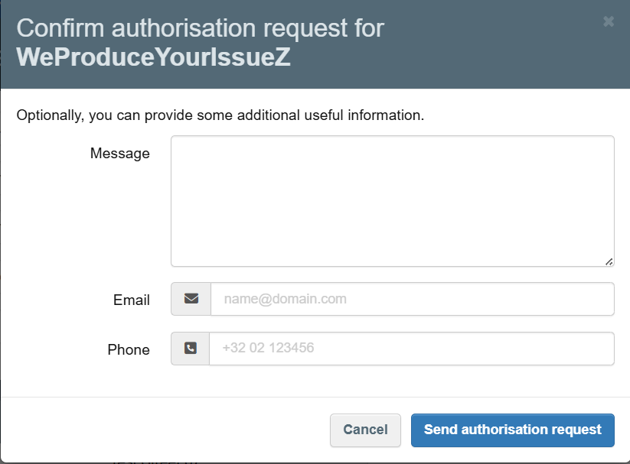
Please also note, that the competent authority is responsible only for authorizing the first user to represent an operator in DIWASS. All further users should be authorised by the master users already authorised to represent operator concerned in DIWASS.

- After sending the authorisation request, the user will see a confirmation message.
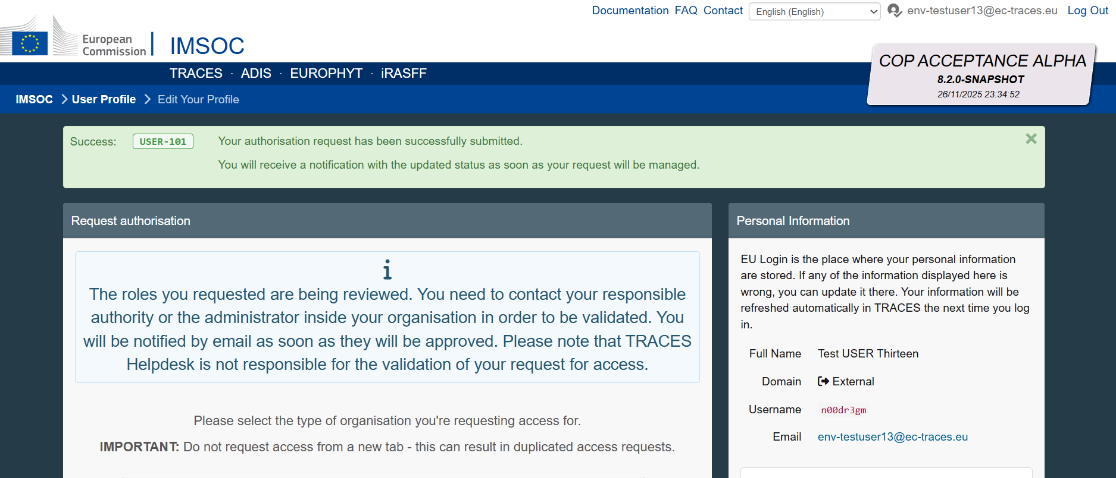

Chapter 4 How to register a new operator for users that already have access to other operators in DIWASS

General note
This chapter provides instructions for creating an operator in the situation where a user is already associated in DIWASS to represent at least one operator. Such association may have been done in two situations:
- the user was the one registering an operator (following the steps described in Chapter 1 How to log in to DIWASS using EU login and Chapter 2 How to register a new operator for users that are not yet active in DIWASS), or
- the user was associated with an operator by the master user (master user followed the steps described in Chapter 6 How to approve authorisation requests of users that represent operators in DIWASS).
This part of instructions should be followed when users access DIWASS for the purpose of registering another operator than the operator they are already associated with in DIWASS.
Please note that the steps explained here apply to creation of “operators” and not to the creation of “sites of operators”. For registration of sites of operators please follow the steps described in Chapter 7 How to register a new site of the operator in DIWASS.
Like other Commission’s IT systems, DIWASS is based on the TRACES NT platform. When registering an operator in any system based on TRACES NT, the user must select options to indicate that the operator will act in the DIWASS system. Certain options displayed in this process (e.g. buttons regarding “Organic Control Body”) are not relevant for registration of operators in DIWASS and should be disregarded.
Please note that in order to submit notification documents or Annex VII documents in DIWASS, all operators involved in a given shipment of waste need to be first registered in DIWASS, as DIWASS will allow only to select registered operators (via drop-down lists). Operators that act as notifiers or persons who arrange the shipment must ensure that all relevant operators involved in their shipment are registered in DIWASS before they start drafting notification document or Annex VII documents in DIWASS.

Specific instructions
- Following the login, the user needs to select the field “Actors” and then “Operators”.
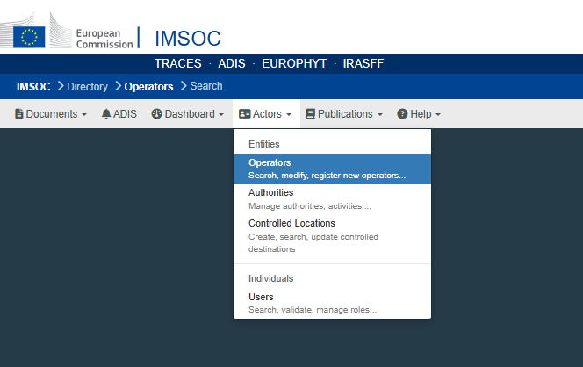
- “Search Operator” screen will open. The user should first check, if the operator user intends to register is already registered in DIWASS or not. To do such a verification, user needs to provide the following data:
- Country: the country where the operator has a main registered office,
- Chapter: Waste Shipment Regulation
- Section: Waste Shipment Regulation (WSR)
- Activity type: WSR Operator
- Search: any element of the name of operator or its identification number

As a result of this search, DIWASS will return a list of operators that matches the indicated criteria. Based on this list, the user can request access to any of the existing operators.
If the operator that the user intends to register is not on that list, the user has to create it by clicking “+ New Operator”.
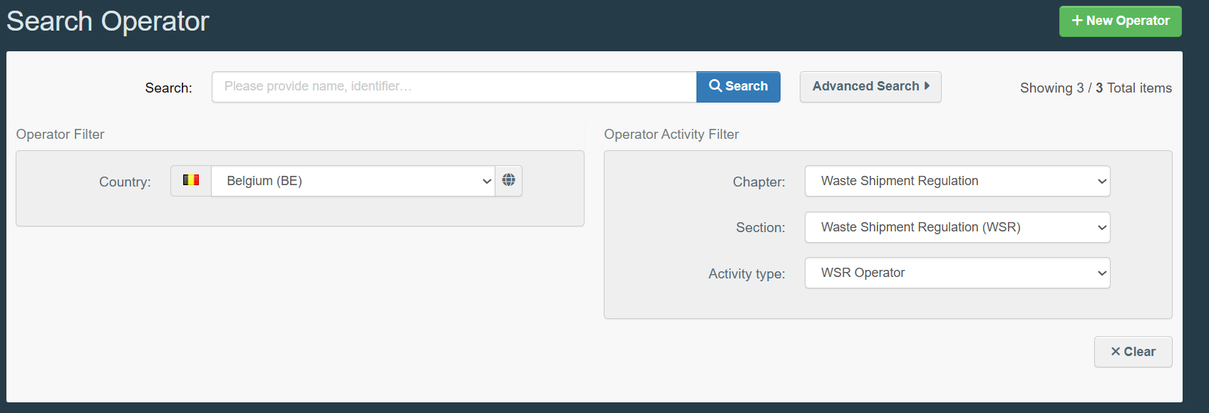
- To register a new operator, the user needs to provide at least the following information:
- Operator’s name;
To add operator’s name fill in the free text field “Name” in box “Operator details”.

- Country
To provide the operator’s country choose a country from the dropdown list in box “Operator details”.
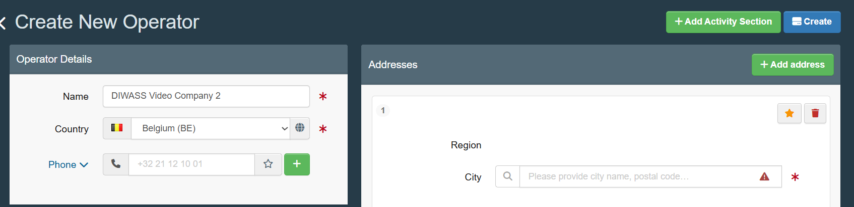
- Addresses;
To add operator’s address fill in the information on “City” and “Adress” in box “Addresses”.
Please note that although TRACES NT permits the entry of multiple addresses, only the first address entered is reproduced on waste-shipment documents. To avoid inconsistencies between the system data and the official documents, the operator’s record should contain only one address.
In case a given operator has many addresses, that are relevant for its waste shipment activities, each address must be registered as an individual site of the same operator. Please see Chapter 7 How to register a new site of the operator in DIWASS for more information.

- Identifier: please note that each operator should have one main identification number.
For most operators, the main identification number will be the EORI number. In case the operator is not required to have an EORI number, please see this document explaining what identification number should be chosen as main identification number.
Please also note, that DIWASS does not contain the names of all national identification numbers. Therefore, the overview referred to above contains information on which label should be used to provide the required national numbers in DIWASS.

To add main identification number of the operator:
  - Click on “+ Add identifier” in box “Operator Identifiers”
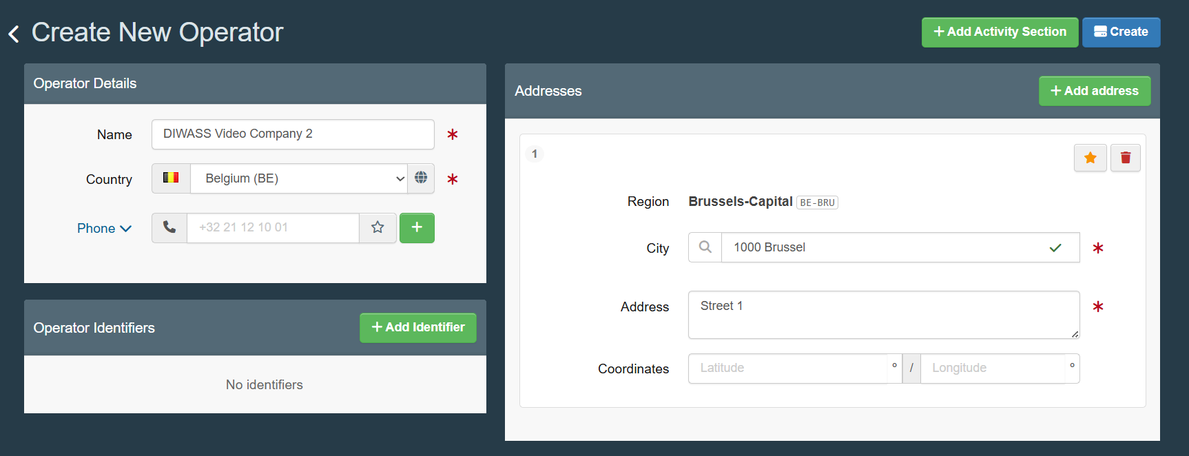
  - By clicking on the icon “v”, choose the name of the identification number to be provided;
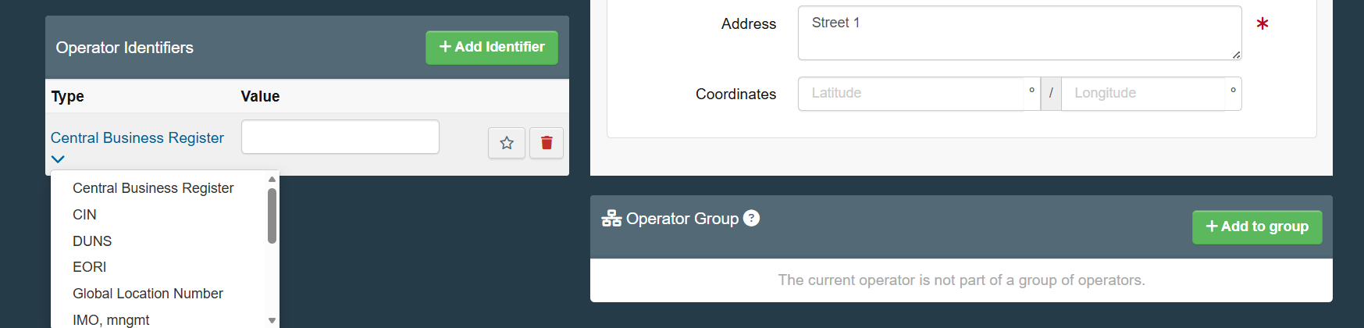
  - To mark the identification number provided as main identification number of the operator, click on the star icon.
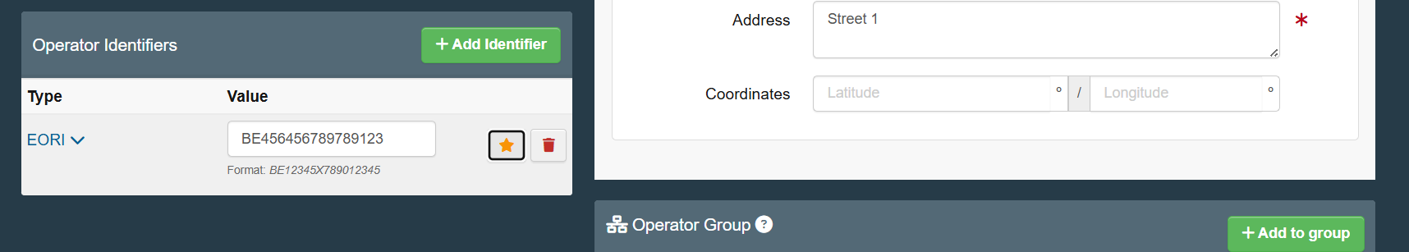

In some Member States, it is required also to provide additional identification numbers. Please see this document to verify, if the Member State where the operator has a registered office requires providing any of such numbers.
Please also note that an operator cannot have two identifiers of the same type (e.g. two VAT numbers, two registration numbers etc.).
Registration of third country operators
In general, the main identification number for third country operators should be the EORI number. In case the operator is not required to have such a number, the main identification number should be an identification number required by the country where the operator is based. Please consult this document [Commission will add the title of the document and a hyperlink leading to it] at a later stage listing identification number required by some third countries.

The user may provide also additional information such as: coordinates, contact details, additional identification numbers.

- After completing this information, the user should click the button “+ Add Activity Section” in top right corner of the screen.
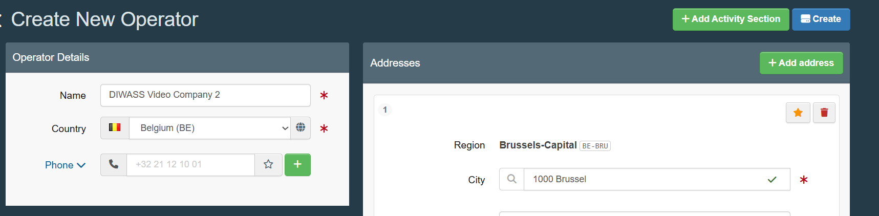
Following that step, the user is required to select section “Waste Shipment Regulation (WSR)” from the drop-down list.
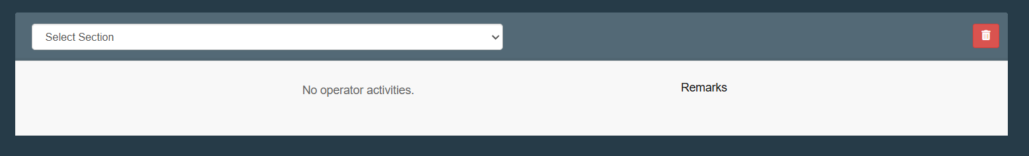
- Then, the user needs to click the button “+ Add activity”
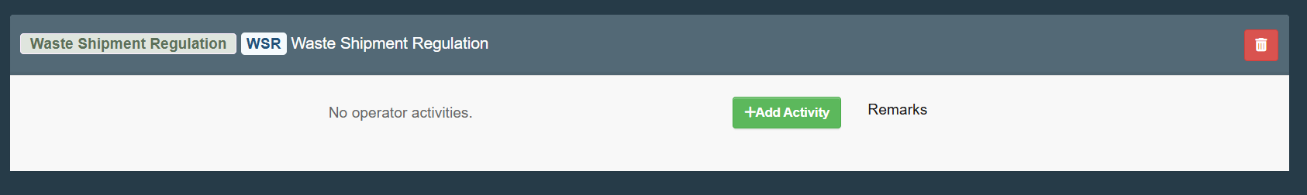
- Next, the user should click on “Select Activity” and choose “WSR Operator”.
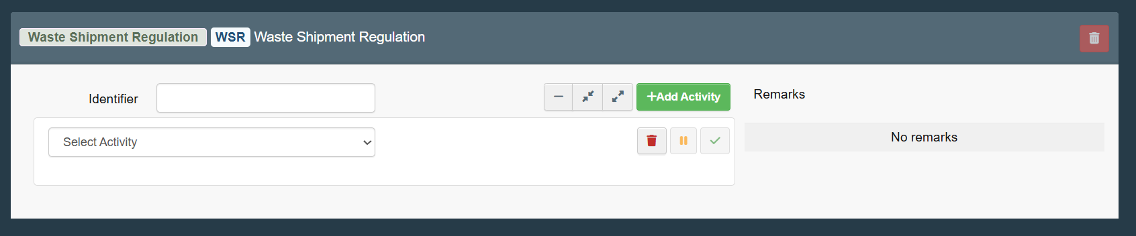
The user will see also a field “Identifier”, but it is advised not to use this option in context of DIWASS.
Please also note, that at this stage DIWASS may alert the user about operators that are already registered in DIWASS with similar registration details. This is another mechanism to prevent users from registering the same operator twice.
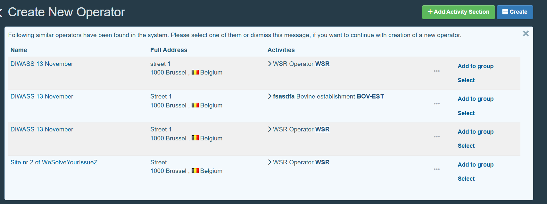
The users seeing such warning should verify whether any of the operators mentioned in the warning are not the same operator, that they intend to register. If this is the case, and the user intends to actively represent such operator in DIWASS, the user needs to ask for authorisation to do so (in order to request such authorisation, please see instructions in Chapter 6 How to approve authorisation requests of users that represent operators in DIWASS).
- Following that selection, additional three fields will become visible:

- Activity Details: The Traces NT allows also to request the “activity” only for a certain period of time. It is advised not to use this option in the context of DIWASS and leave these details blank.

- Address: this field requires the user to select the main address from the addresses introduced before. This address will be automatically pre-filled.

- Assigned responsible authorities: the user needs to select the authority responsible for registration of operator in DIWASS.

To select the authority, the user should click on the button “Search responsible authorities”.
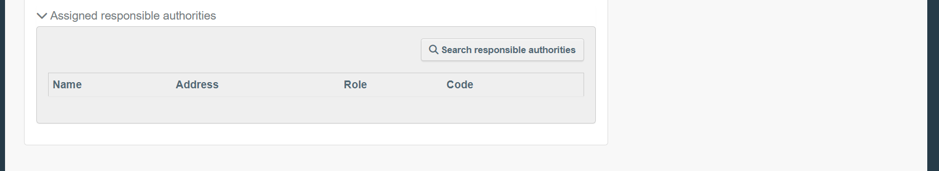
In the pop-up window, it will be possible to search for authorities based on name and address. The advanced search allows to search based on additional criteria: country, code of the authority and role of the authority (import, export, transit).

Following the search, the user needs to select the relevant competent authority and click on “Select”

Registration of EU operators
If the Member State has just 1 competent authority for shipment of waste, the user should select this authority. If the Member State has more than 1 competent authority for shipments of waste, the Member State introduced rules on division of competences between authorities in the field of registration of operators. Please see this document explaining which authority should be chosen as assigned responsible authority.
Registration of third country operators
In case of registration of third country operators: if the operator comes from third countries whose authorities actively use DIWASS, the competent authority of this country should be selected as assigned responsible authority. Please consult this document [Commission will add the title of the document and a hyperlink leading to it] to verify this information. If the third country competent authority does not use DIWASS, the user registering the third country operator should select in this field an EU competent authority, who, in the context of planned shipment of notified waste, would act as competent authority of dispatch, destination or transit respectively.

Example: A Brazilian company would like to ship waste to a French facility. The Brazilian CA does not use DIWASS. This company (or the French facility intended to receive the waste) introduces the basic data of the Brazilian company into DIWASS and as an ”assigned responsible authority” selects the French competent authority. The French competent authority needs to approve the registration of the Brazilian operator, and subsequently, will be able to edit the data of that company, in line with the general rules on editing operator’s data.

- The user may also provide additional information such as:
- Phone number, fax number, email address, URL, contact person name – to do so, the user needs to go to box “Operator details” and click on the icon “v” to choose the type of information to be provided; to add another element, the use needs to click on the “+” icon;
- Coordinates, by filling in the respective fields in “Addresses” box
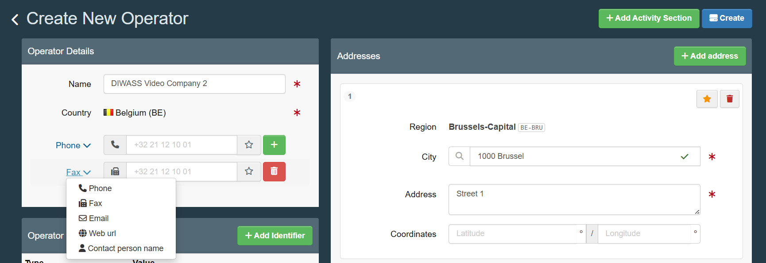

- Having completed all the elements described above, the user needs to click on the button “Create” in the upper right corner of the page.

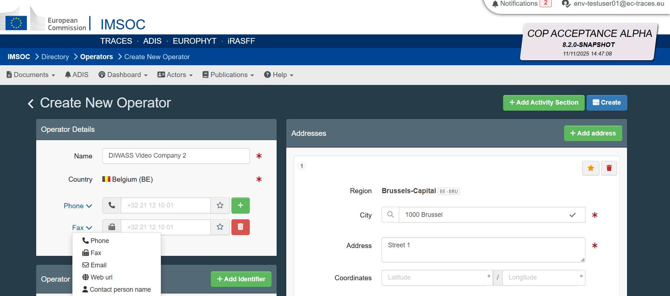

- The user will see the screen with all data of the operator, registration of which was requested.
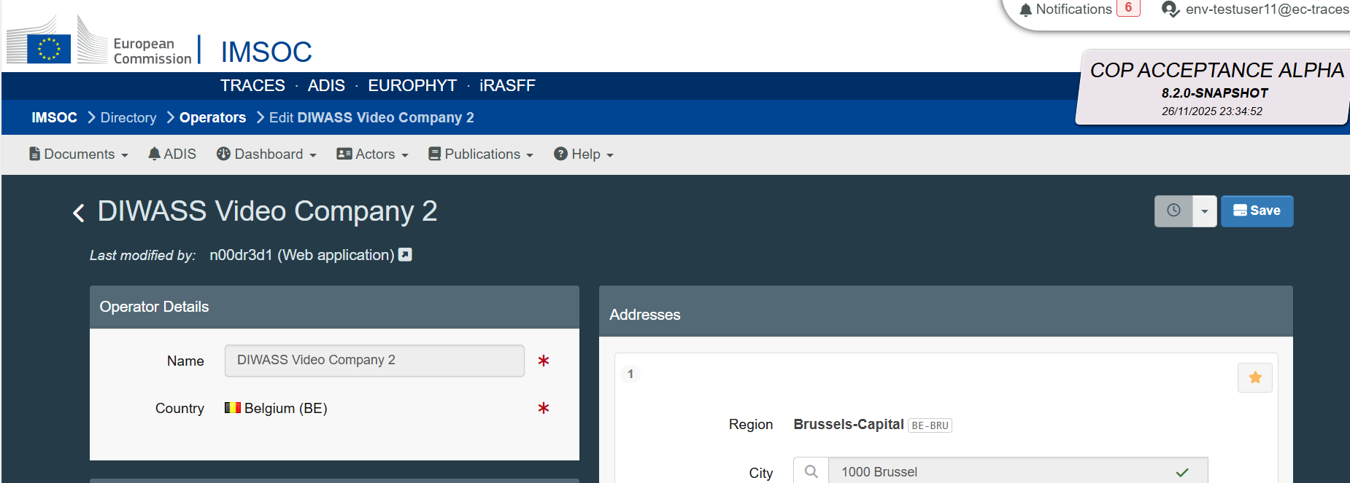
Please note: The user will be able to act in DIWASS representing operator as soon as the competent authority approved the registration of that operator. Then, the user will be able to add other users representing that operator, following the steps described in Chapter 6 How to approve authorisation requests of users that represent operators in DIWASS.

Chapter 5: How to request to be authorised to represent operators in DIWASS as a user, in the case this user already has access to other operators in DIWASS

General note
This chapter provides instructions for users that intend to request authorisation to represent operators already registered in DIWASS and is relevant for situations, in which the user has already access to other operators in TRACES NT.
In practice, this chapter applies to situations, when:
- the user was the one registering an operator following the steps described in Chapter 4 How to register a new operator for users that already have access to other operators in DIWASS,
- the user would like to request access to the operator that was already registered in DIWASS.
Please note that submitting a separate request to represent an operator in DIWASS is not required for users, who register that operator for DIWASS for the first time, following the steps described in Chapter 2 How to register a new operator for users that are not yet active in DIWASS. In such case, the request for registration covers also a request for authorizing the submitting user as master user in DIWASS.
If the user has already a right to represent operators in DIWASS, that user may register other operators (e.g. third country operators that do not wish to actively use DIWASS), in order to make them selectable in context of any waste shipment documents in DIWASS. The user may wish not to represent them in DIWASS though. Therefore, when a user registers the operator following the steps in Chapter 4 How to register a new operator for users that already have access to other operators in DIWASS, in case this user intends to actively use DIWASS representing those operators, it must submit an authorisation request according to this chapter of the manual.
Instructions in this Chapter apply also for requests to be authorised to represent a site of operator in DIWASS. For further information concerning sites of operator, please refer to Chapter 7 How to register a new site of the operator in DIWASS.
Like other Commission’s IT systems, DIWASS is based on the TRACES NT platform. Certain options displayed in this process (e.g. buttons regarding “Organic Control Body”) are not relevant for DIWASS and should be disregarded.
Please also note, that each operator that intends to act in DIWASS should have at least one master user. Such master user is authorised to add further users or remove users within an operator’s account in DIWASS. Please note that CA are only obliged to approve the authorisation request from the first user from a given operator – any further authorisation requests should be approved by master users of such operator.
[EU operators must use DIWASS, whereas third country operators may use DIWASS on a voluntary basis. However, if they do not wish to do so, the operators should be still registered, and no users will be assigned to them. Commission works on more detailed instructions related to third country operators and how they work and appear in DIWASS]

Specific instructions
- Following the login, the user needs click on its email address in the top right corner of the page, and then click on “Edit Your Profile”.
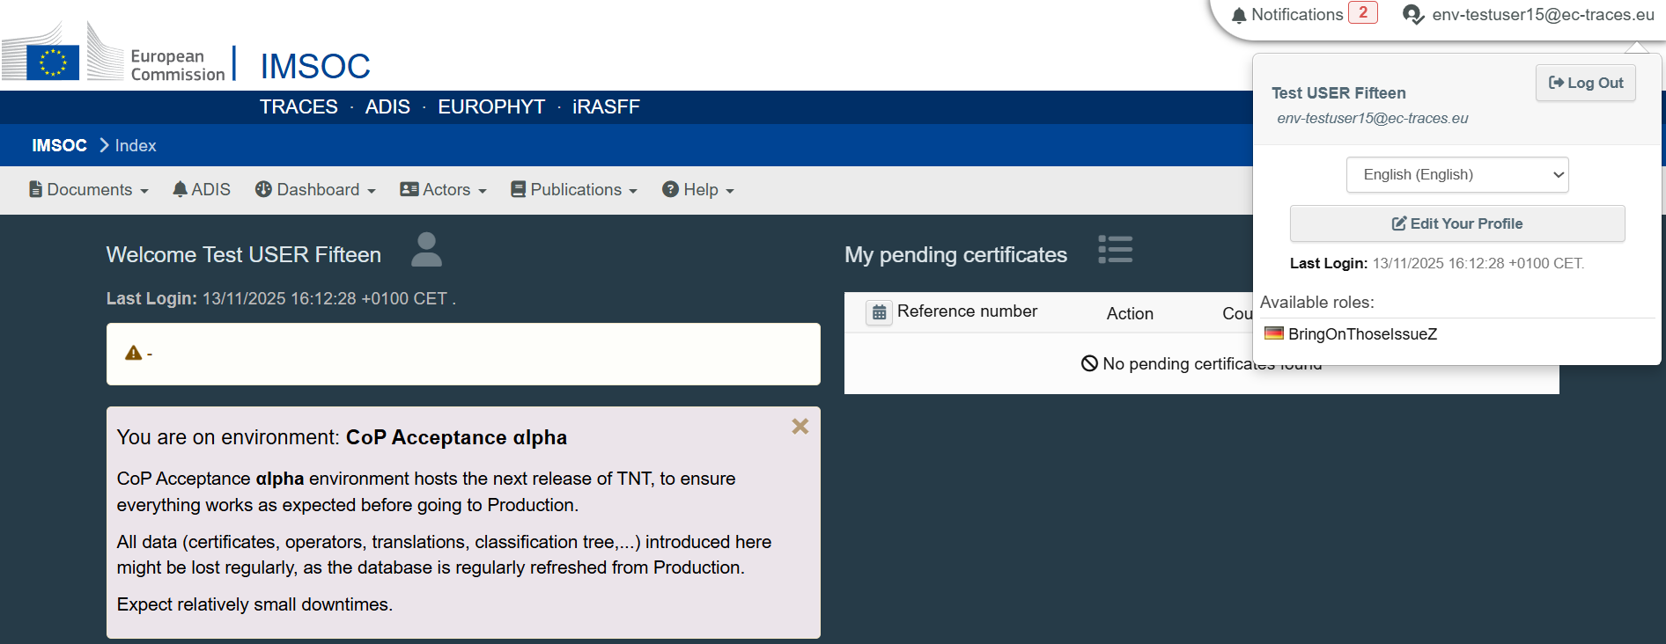

- On the next screen, the user needs to scroll down to the bottom of the page, to see the box “Your Roles”. The user will see information on all operators in TRACES NT, that it can represent in this platform. Operators active in DIWASS will appear with “WSR Operator WSR” label.
To submit a request to represent another operator, the use needs to click on “Request new role” and select “Operator”.
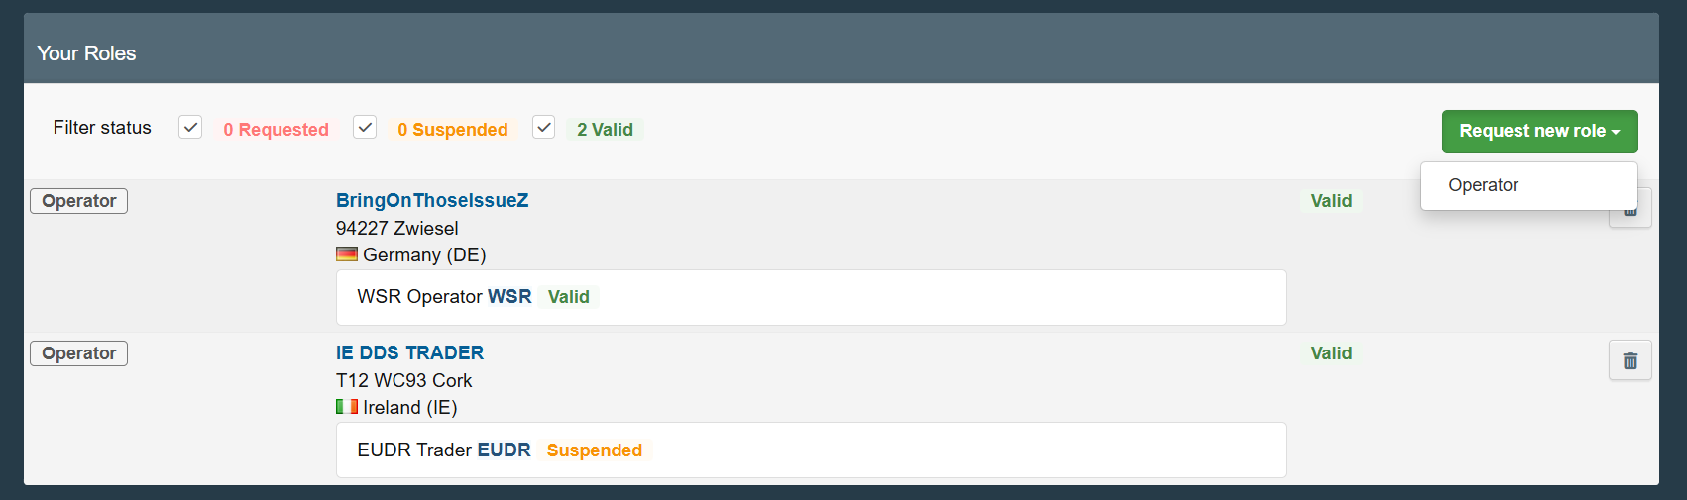
- The user will be moved to “Search operator” screen. The user needs to provide the following data:
- Country: the country where the operator has a main registered office,
- Chapter: Waste Shipment Regulation
- Section: Waste Shipment Regulation (WSR)
- Activity type: WSR Operator
- Search: any element of the name of operator or its identification number
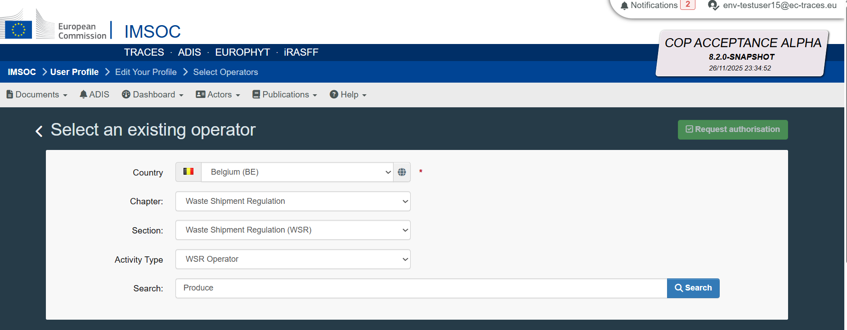
- As a result of this search, DIWASS will return a list of operators that matches the indicated criteria. Based on this list a user can request authorisation to represent any of the existing operators. To do so, the user needs to tick the box, next to the details of the selected operator, and click on “Request authorisation” in the top right corner of the page.

- Next, the user will see a pop-up window allowing to provide additional message regarding the authorisation of the user to represent the operator directly to the:
- competent authority responsible for the registration of operator,
- all master users authorised to represent this operator in DIWASS.
Please note that providing such message is not mandatory.
Please also note, that the competent authority is responsible only for authorizing the first user to represent an operator in DIWASS. All further users should be authorised by the master users already authorised to represent operator concerned in DIWASS.

- After sending the authorisation request, the user will see a confirmation message.
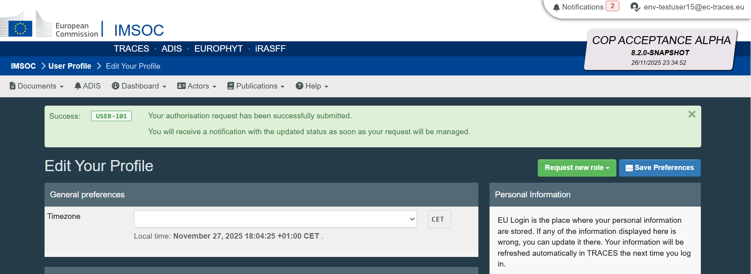

Chapter 6 How to approve authorisation requests of users that represent operators in DIWASS

General note
This chapter provides instructions on how to authorize additional users to represent a given operator in DIWASS.
This operation can be done by:
- Competent authorities that are selected as competent authorities responsible for registration of a given operator in DIWASS,
- Master users already authorised to represent a given operator in DIWASS.
Please also note, that the competent authority is notably responsible for authorizing the first user to represent an operator in DIWASS. All further users should be authorised by the master users already representing the operator concerned in DIWASS. It is therefore relevant, that the operators manage the user authorisation process effectively.

Specific instructions
- Following the login, the user needs to select the field “Actors” and then “Users”.
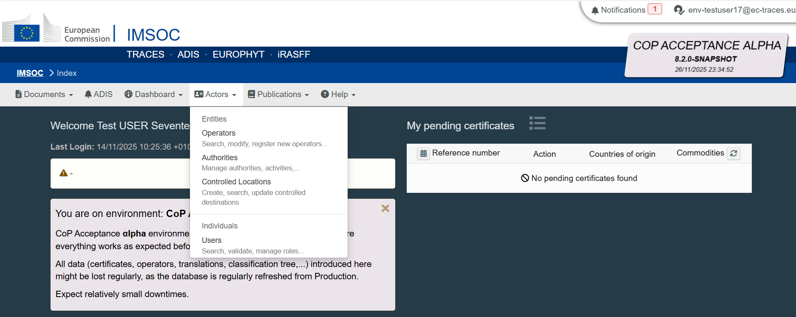
- “Search Users” screen will open. The user needs to click on the “Search pending requests” at the right top corner of the page.
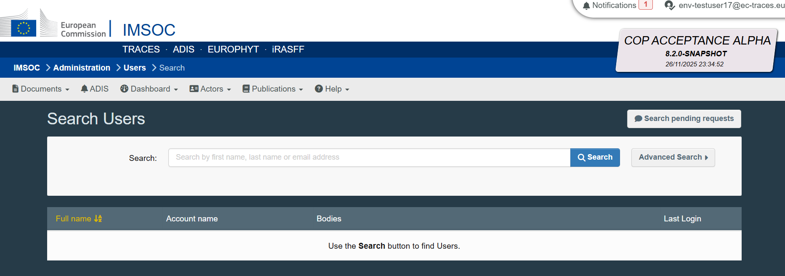
- DIWASS will display the list of all pending authorisation requests, that the master user may authorise. To do this, the name of the user requesting authorisation needs to be clicked.
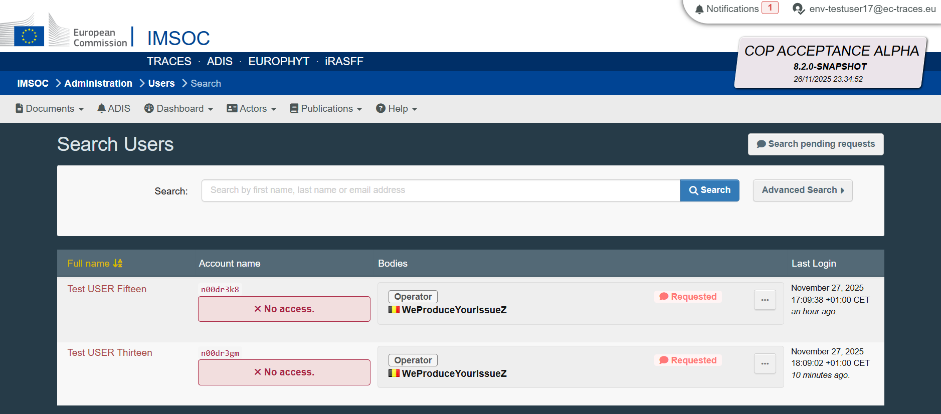
- Then, “Edit User” screen will open. To see the authorisation requests, the user needs to scroll down the page, to see the box “Roles”. To approve the request, it is necessary to:
- Click on the green tick sign, next to the details of the operator
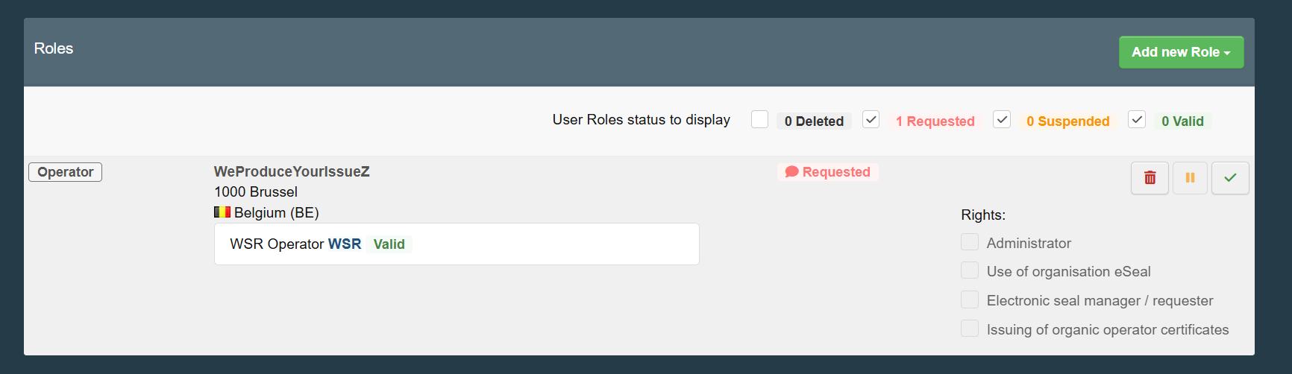
- Then, a possibility to indicate that the new user is an administrator, will appear. Granting such rights to the authorised user means, that such user will become a master user.
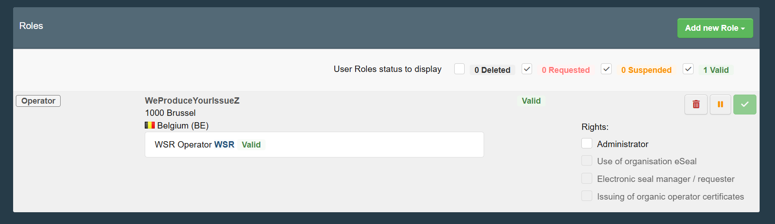
- Then the button “Save changes” in top right corner of the page needs to be clicked.
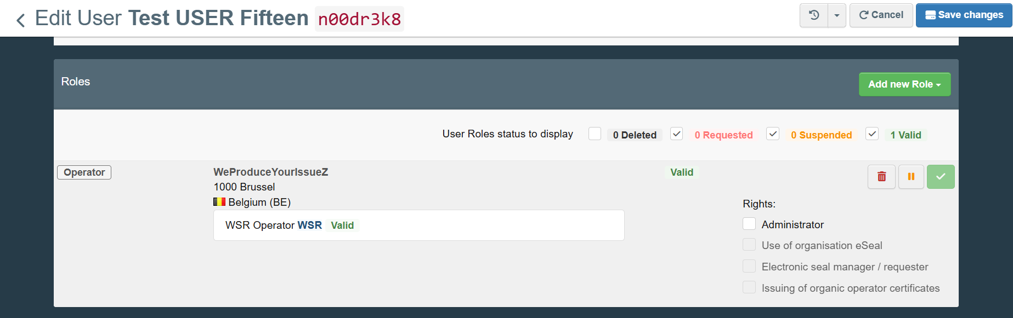

Chapter 7 How to register a site of an operator in DIWASS

General note
This chapter provides instructions for creating a site of an operator in DIWASS. It is structured around questions: - What is a site of an operator? - How to register a site of an operator in DIWASS? - What is the difference between “site” and “main operator” in DIWASS? - How will DIWASS display information on sites of operators?, followed by a set of step-by-step instructions of the site registration process in DIWASS.
What is a site of an operator?
As indicated in the DIWASS Implementing act, “site” means a location of an operator having a different address or name from the address or name indicated by such operator during their first registration in the systems or software, that is allowed under the respective national law to use the same main identification number as the operator concerned. Therefore, the sites in DIWASS:
- Cannot have the same name as the “main operator”,
- Cannot have the address as the “main operator”,
- Can provide identification numbers and registration numbers other than the identification numbers and registration number of its “main operator”.
- Cannot indicate any of the identification numbers provided as “main identification number”,
- Will always be linked to the “main operator” (please see Specific instructions point 4).

In practice, sites of operators could cover inter alia: branches of companies, facilities of a company having different addresses than the “main office” of the company, etc.
How to register a site of an operator in DIWASS?
The process of registering a “site of operator” is very similar to the process of registration of the “operator”. In the section below, you can find a step-by-step explanation of that process. Please note, that in DIWASS GUI the general term “operator” refers to both “sites of operators” and “operators”. In this instruction manual, operators having a main identification numbers are referred to as “main operators” or “headquarters”.
Registration of site is possible only when:
- the “main operator” is already registered in DIWASS. For registration of operators please follow the steps described in Chapter 2 How to register a new operator for users that are not yet active in DIWASS and Chapter 4 How to register a new operator for users that already have access to other operators in DIWASS, and
- user intending to register a site has already access to another operator or site in DIWASS
What is the difference between “site” and “main operator” in DIWASS?
The difference between “site” and “main operator” is that:
- “main operator” has one or more identification numbers but one of the identification number(s) provided must be indicated as the “main identification number”, whereas
- “site” can have no identifications numbers or one or more identification numbers. But, from the identification number(s) provided, it cannot indicate any as the “main identification number”.
- “site” is always linked to the “main operator”. (please see Specific instructions point 4).
Please note “site” and “main operator” can have a distinct set of users authorised to represent them in DIWASS. It means that:
- A user may be entitled to represent only the “main operator”,
- A user may be entitled to represent only the “site”,
- A user may be entitled to represent both “main operator” and its “site”.
This depends on whether the user is assigned main operator, site, or both.
For instructions on how to request authorisation to represent a “site” in DIWASS, please refer to Chapter 5: How to request to be authorised to represent operators in DIWASS as a user, in the case this user already has access to other operators in DIWASS.
How will DIWASS display information on sites of operators?
In all documents in DIWASS (notifications, movement and Annex VII documents) whenever a “site” is concerned as one of the actors involved in a given shipment, DIWASS will display not only the details of the “site” concerned by the document, but also the name and main identification number of the “main operator”.
Other relevant notes
Like other Commission’s IT systems, DIWASS is based on the TRACES NT platform. When registering a site in any system based on TRACES NT, the user must select options to indicate that the operator will act in the DIWASS system. Certain options displayed in this process (e.g. buttons regarding “Organic Control Body”) are not relevant for registration of “site” in DIWASS and should be disregarded.
Please note that in order to submit notification documents or Annex VII documents in DIWASS, all sites of operators involved in a given shipment of waste need to be first registered in DIWASS, as DIWASS will allow only to select registered operators (via drop-down lists). Sites that act as notifiers or persons who arrange the shipment must ensure that all relevant operators or their sites involved in their shipment are registered in DIWASS before they start drafting notification document or Annex VII documents in DIWASS.

Specific instructions
- Following the login, the user needs to select the field “Actors” and then “Operators”.
- “Search Operator” screen will open. The user should first check, if the site of an operator that the user intends to register is already registered in DIWASS or not. To do such a verification, user needs to provide the following data:
- Country: the country where the operator has a main registered office,
- Chapter: Waste Shipment Regulation
- Section: Waste Shipment Regulation (WSR)
- Activity type: WSR Operator
- Search: any element of the name of operator or its identification number

As a result of this search, DIWASS will return a list of operators and sites of operators that matches the indicated criteria. Based on this list, the user can request access to any of the existing operators or sites of operators.
If the site of an operator that the user intends to register is not on the list, the user has to create the site by clicking on the button “+ New Operator”.
- To register a new site of an operator, the user needs to provide at least the following information:
- Operator Details - name;
In this context, the Operator’s name refers to the name of the site. To add the name of operator’s site fill in the free text field “Name” in the box “Operator details”.

- Operator Details - country
In this context, the Operator’s country refers to the country where the site is located. To provide the country of operator’s site choose a country from the dropdown list in box “Operator details”.
- Addresses;
In this context, the Operator’s addresses refer to the addresses of the site. To add the address of operator’s site fill in the information on “City” and “Adress” in box “Addresses”.
Please note that although TRACES NT permits the entry of multiple addresses, only the first address entered is reproduced on waste-shipment documents. To avoid inconsistencies between the system data and the official documents, the operator’s record should contain only one address.
In case a given operator has many addresses that are relevant for its waste shipment activities, each address must be registered as an individual site of the same operator. An operator can have multiple sites. This approach ensures that every relevant address is correctly reflected in the waste-shipment documentation.

- Operators Identifiers: please note that each site of an operator can have no identifications numbers or one or more identification numbers. But, from the identification number(s) provided, the site of an operator cannot indicate any of the identification numbers as the main identification number.

To add identification number:
  - Click on “+ Add identifier” in box “Operator Identifiers”
  - By clicking on the icon “v”, choose the name of the identification number to be provided;

In some Member States, it is required to provide identification numbers for sites. Please see this document to verify, if the Member State where the operator has a registered office requires providing any of such numbers.
Please also note that site of an operator cannot have two identifiers of the same type (e.g. two VAT numbers, two registration numbers etc.).

The user may provide also additional information on the operators (meaning in this context a site) in the box “Addresses” such as: coordinates of the sites (latitude/longitude) and contact details.

- To link the site of the operator with the main operator, the user should go to section “Headquarters” and click “+ Add to headquerters”.
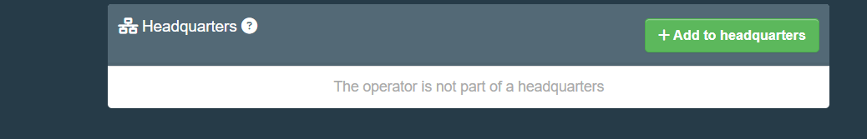
Following that, the user will see a pop-out window allowing to search for the main operator. The user can type the name of the main operator in the search box and click “Search”.

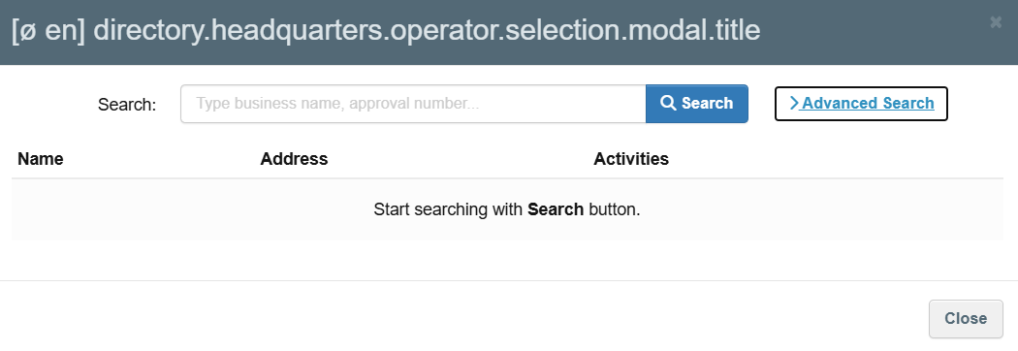
If the user clicks on “Advanced search”, it will be able to limit the search to operators from certain countries, sections (Waste Shipment Regulation WSR) or identifiers.

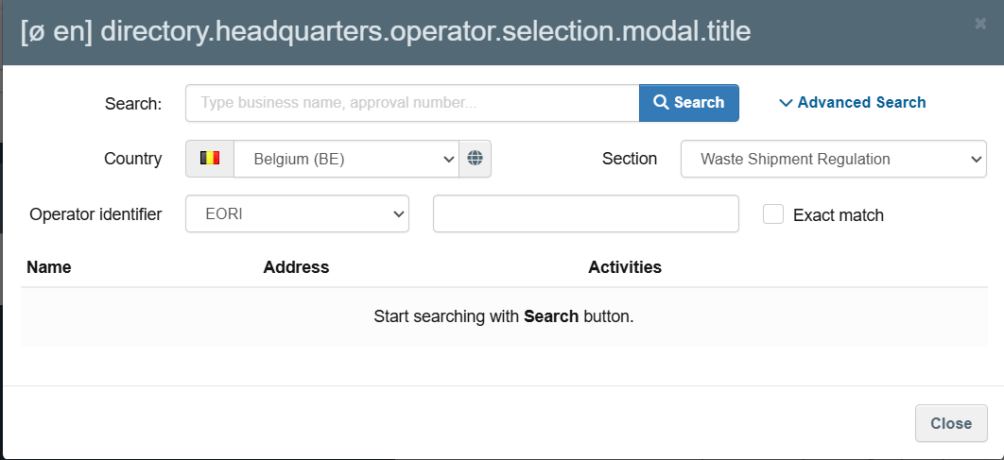

After clicking “Search”, DIWASS will display a list of operators meeting the search criteria. The user should select the relevant main operator and click on “Select”.

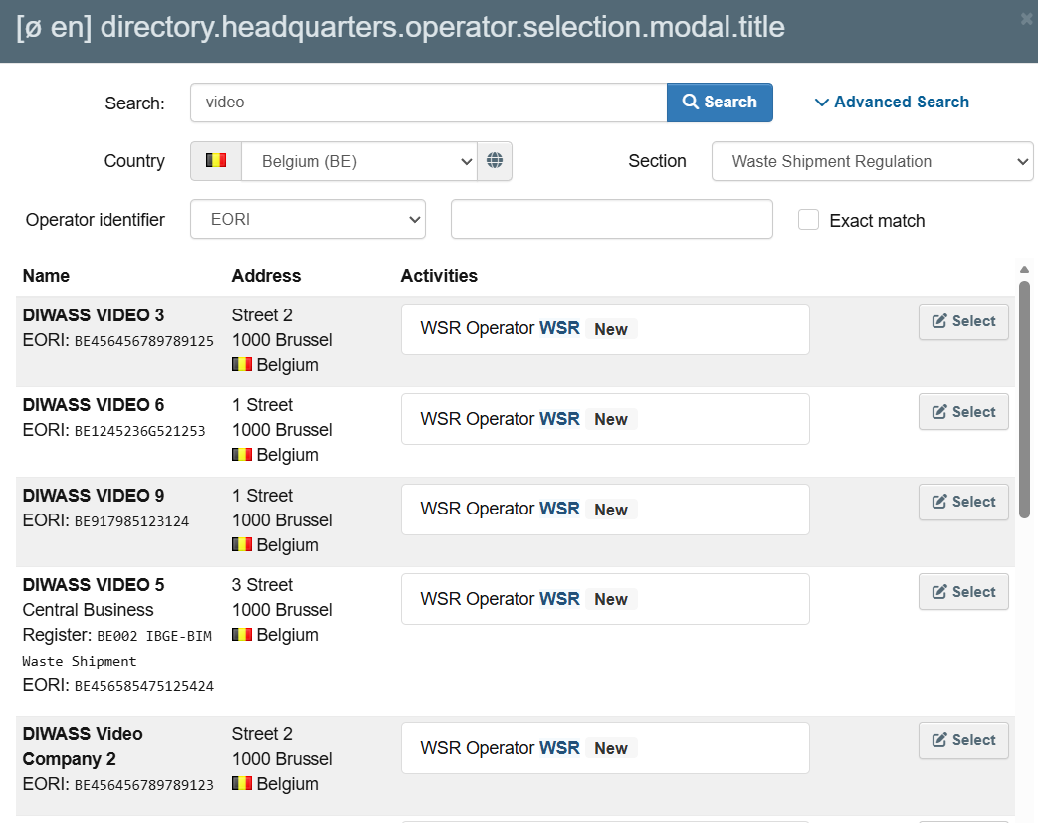

Following that, DIWASS will display the selected operator as “Headqarters”:
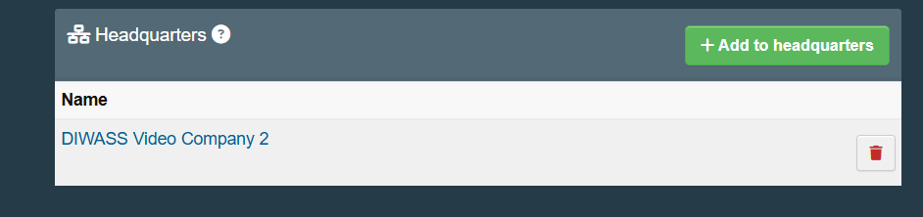

- After completing this information, the user should click the button “+ Add Activity Section” in top right corner of the screen.
Following that step, the user is required to select section “Waste Shipment Regulation (WSR)” from the drop-down list.
- Then, the user needs to click the button “+ Add activity”
- Next, the user should click on “Select Activity” and choose “WSR Operator”.
The user will see also a field “Identifier”, but it is advised not to use this option in the context of DIWASS.
Please also note, that at this stage DIWASS may alert the user about operators or sites of operators that are already registered in DIWASS with similar registration details. This is another mechanism to prevent users from registering the same operator or site of operator twice.
The users seeing such warning should verify whether any of the or sites of operators mentioned in the warning are not the same operator or site of operator, that they intend to register. If this is the case, and the user intends to actively represent such operator or site of operator in DIWASS, the user needs to ask for authorisation to do so (in order to request such authorisation, please see instructions in Chapter 6 How to approve authorisation requests of users that represent operators in DIWASS).
- Following that selection, three additional fields will become visible:

- Activity Details: The Traces NT allows also to request the “activity” only for a certain period of time. It is advised not to use this option in the context of DIWASS and leave these details blank.

- Address: this field requires the user to select the main address from the addresses introduced before. This address will be automatically pre-filled.

- Assigned responsible authorities: the user needs to select the authority responsible for registration of the operator in DIWASS.

To select the authority, the user should click on the button “Search responsible authorities”.
In the pop-up window, it will be possible to search for authorities based on their name and address. The advanced search button allows to search based on additional criteria: country, code of the authority and role of the authority (import, export, transit).

Following the search, the user needs to select the relevant competent authority and click on “Select”

Registration of EU operators and their sites
If the Member State has just 1 competent authority for shipment of waste, the user should select this authority. If the Member State has more than 1 competent authority for shipments of waste, the Member State introduced rules on division of competences between authorities in the field of registration of operators and their sites. Please see this document explaining which authority should be selected as the authority competent for registration of the operator (site) in DIWASS.
Registration of third country operators
In case of registration of third country operators and their sites: if the operator comes from a third country whose authorities actively use DIWASS, the competent authority of this country should be selected as the authority competent for registration of the operator (site) in DIWASS. Please consult this document [Commission will add the title of the document and a hyperlink leading to it] to verify which competent authorities and from which countries decided to actively use DIWASS. If the third country competent authority does not use DIWASS, the user registering the third country site or operator should select in this field an EU competent authority, who, in the context of planned shipment of notified waste, would act as competent authority of dispatch, destination or transit respectively.

Example: A branch of Brazilian company would like to ship waste to a French facility. The Brazilian CA does not use DIWASS. This branch of company (or the French facility intended to receive the waste) introduces the basic data of the Brazilian branch into DIWASS and as an ”assigned responsible authority” selects the French competent authority. The French competent authority needs to approve the registration of the Brazilian site of an operator, and subsequently, will be able to edit the data of that branch, in line with the general rules on editing operator’s data.

- In the box “Operators Details” the user may also provide additional information such as:
- Phone number, fax number, email address, URL, contact person name – to do so, the user needs to go to the box “Operator details” and click on the icon “v” to choose the type of information to be provided; to add another element, the use needs to click on the “+” icon;
- Coordinates, by filling in the respective fields in “Addresses” box

- Having completed all the elements described above, the user needs to click on the button “Create” in the upper right corner of the page.

- The user will see the screen with all data of the site of the operator, registration of which was requested.
Please note: The user will be able to act in DIWASS representing operator (site) only after the competent authority has approved the registration of that operator (site).

See more information about the EORI number: Economic Operators Registration and Identification number (EORI) - Taxation and Customs Union
Article 6(5) of DIWASS Implementing Act.
Article 6(3) point (a) of DIWASS Implementing Act.
Article 7(2) point (a), (3) point (a) and (5) of DIWASS Implementing Act.
Master users are authorised to add further users or remove users within an operator. Standard users are not authorised to do so. Please note, that all users authorised to represent the operator in DIWASS have the same view rights, access rights and are able to submit, update or otherwise change any waste shipment documents in DIWASS.
Master users are authorised to add further users or remove users within an operator. Standard users are not authorised to do so. Please note, that all users authorised to represent the operator in DIWASS have the same view rights, access rights and are able to submit, update or otherwise change any waste shipment documents in DIWASS.
See more information about the EORI number: Economic Operators Registration and Identification number (EORI) - Taxation and Customs Union
Article 6(5) of DIWASS Implementing Act.
Article 6(3) point (a) of DIWASS Implementing Act.
Article 7(2) point (a), (3) point (a) and (5) of DIWASS Implementing Act.
Master users are authorised to add further users or remove users within an operator. Standard users are not authorised to do so. Please note, that all users authorised to represent the operator in DIWASS have the same view rights, access rights and are able to submit, update or otherwise change any waste shipment documents in DIWASS.
Article 7(2) point (a), (3) point (a) and (5) of DIWASS Implementing Act.
In this context, the Operator’s Details are information relevant for the site.

