BROOMHILL HOUSE, SWORDS ROAD, DUBLIN 9
(To the rear of the Bonnington Hotel)
1 x 2 bedroom Apartment
Choice Based Lettings Scheme
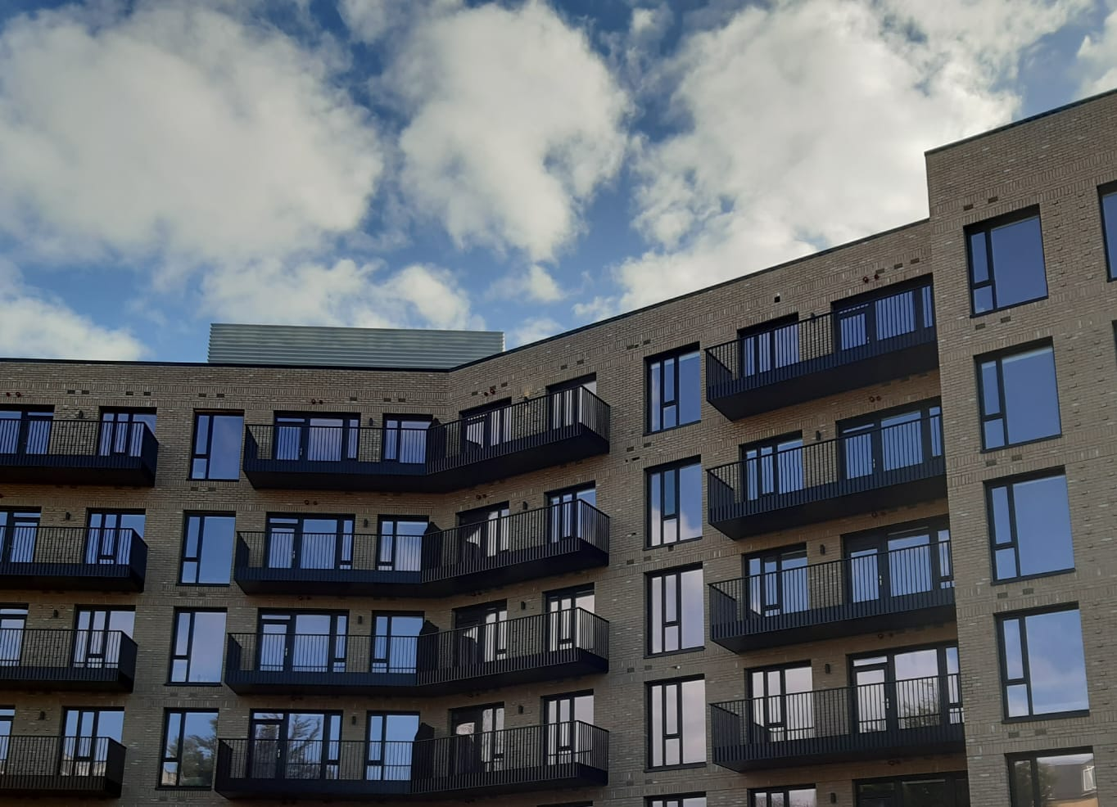

This development is being managed by Tuath Housing on behalf of Dublin City Council.

Dublin City Council is inviting applicants from all our waiting lists who have selected Area E as their area of preference to apply for this 2-bedroom apartment on the ground floor. There is NO parking included. There are NO pets permitted.

The location is second to none. Swords Road is one of North Dublin's most established and convenient residential addresses, with a wealth of local amenities on its doorstep. Excellent primary and secondary schools, shops, cafés, restaurants, sporting facilities and parks are all within easy reach. Dublin City University, Dublin Airport, Beaumont Hospital and the Mater Hospital are nearby, while Dublin City Centre is easily accessible via an excellent public transport network. The M1, M50 and Port Tunnel are also within close proximity, providing excellent connectivity to all parts of Dublin and beyond.

Furnishings and white goods are included

Procedure and Application Form
- All applicants must be listed for Area E.
- Please apply for this development by following this link for the portal:
https://citizenhub.dublincity.ie/service/Choice_Based_Lettings_Application or
This application form can be completed and returned to Dublin City Council, Housing Allocations, Civic Offices, Wood Quay, Dublin 8.
IF YOU APPLY ON THE PORTAL THERE IS NO REQUIREMENT TO POST OR EMAIL YOUR APPLICATION
- Start date of CBL advertisement is 19/6/2026 until 26/6/2026 at 5pm.
- If a number of applicants apply for the same property, the final offer will be made to the applicant with the highest position on list.
- All applications will be examined on estate management grounds including rent arrears.
- A successful candidate who refuses a Choice Based Letting will not be eligible for consideration for another Choice Based Letting unit for a period of 1 year.
- Under the Choice Based Letting Scheme only the successful candidates will be notified.
- If you need further information regarding the Choice Based Letting Scheme, please contact the Allocations Section on (01) 222 2207.
- PLEASE NOTE LATE APPLICATIONS WILL NOT BE CONSIDERED.
- As per your Social Housing application form, Dublin City Council will process your Choice Based Letting application in line with GDPR guidelines. Please see Dublin City Council Privacy Statement on Dublin City Council website

Application Form BROOMHILL HOUSE
Name _______________________________

Address _______________________________

_______________________________

PPSN _______________________________

Family Size ______________________________

Housing Reference Number ______________________________

Telephone/ Mobile Number ______________________________

Email address ______________________________

Did you read/understand the procedures above: Yes______ No _____

Signature ____________________________

Date ____________________________

