CHOICE BASED LETTINGS SCHEME
Canon Burke, Cabra, Dublin 7

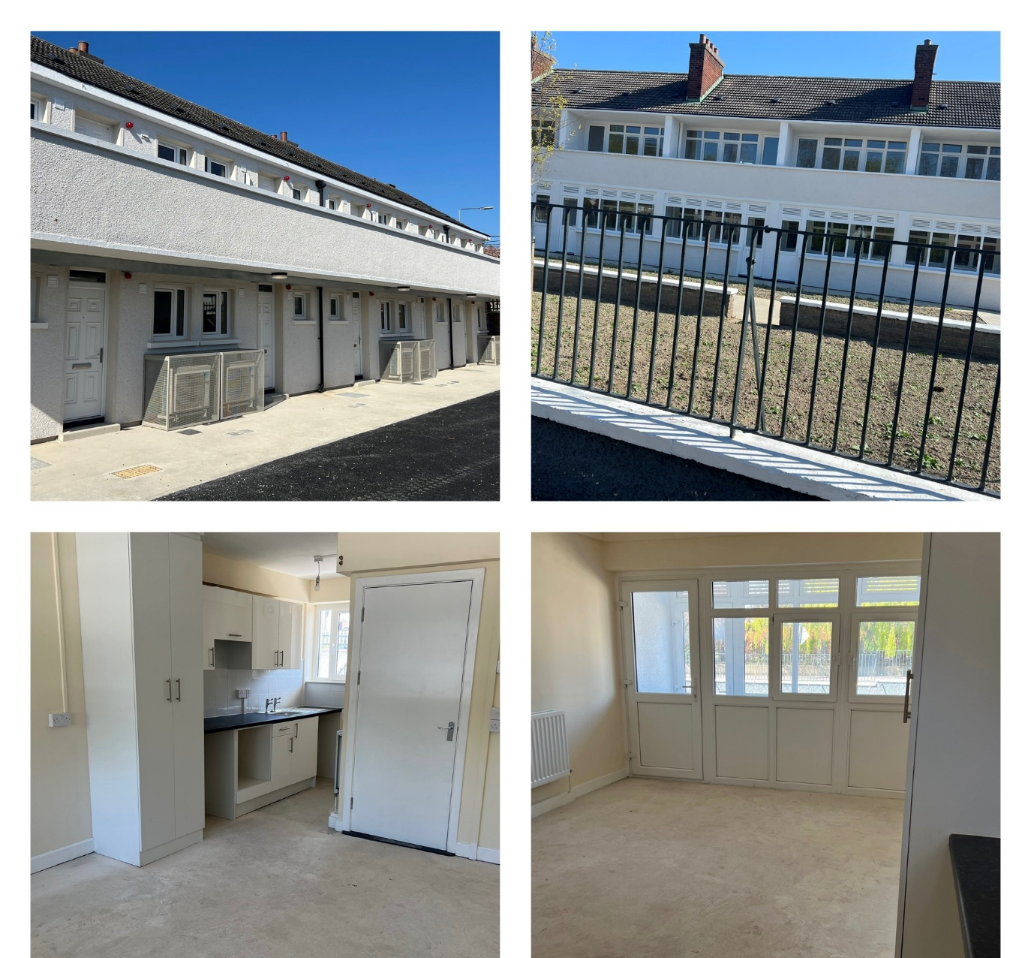

Eligible Senior Citizen applicants can apply for x1 Bedsit Unit
Start date for applications is Friday June 19th 2026
Closing date for applications is Friday July 3rd 2026
Dublin City Council is inviting applicants from all our SENIOR waiting lists who have AREA E as their area of preference to apply for the property above. This unit is located on the upper floor. Please note that this unit is not wheelchair accessible and there is no lift access. This unit comprises of one bedroom/living/ kitchen space and one bathroom.
Located in the Cabra area of the Dublin 7, the location is an established residential setting, with excellent accessibility to the city via bus routes and Luas. The complex is conveniently located off the Ratoath Road roundabout, close to local amenities and a short walking distance to Pope John Paul II Park “The Bogies”. The complex is also a short walking distance to the Cabra Road, leading to the centre of Phibsborough.

Furnishings and White Goods are NOT included. It is advised that you familiarise yourself with the location/surroundings of the property before applying.
Applications can be made online at:
https://citizenhub.dublincity.ie/service/Choice_Based_Lettings_Application

Procedure and Application Form
- If you need further information regarding the Choice Based Lettings Scheme, please contact the Cabra Housing Office on 01-222 7400. All applicants must be listed for Area E. Please do not apply if you are not listed for Area E.
- Start date for applications for this property is June 19th 2026 and will close on July 3rd 2026 at 5:00pm.
- Applications can be made at this link: https://citizenhub.dublincity.ie/service/Choice_Based_Lettings_Application or by the below application form and returned by post to Cabra Housing Office, 97 New Cabra Road, Cabra, Dublin 7.
- If a number of applications are received for these properties, the final offer will be made to the applicant with the highest position on the list.
- All applicants will be examined on Estate Management Grounds – including rent arrears.
- A successful candidate who refuses a Choice Based Letting will not be eligible for consideration for another Choice Based Letting unit for a period of 1 year.
If you need further information on the Choice Based Lettings Scheme, please contact the Allocations Section on 01-222 2207.
- PLEASE NOTE: LATE APPLICATIONS WILL NOT BE CONSIDERED.
- As per your Social Housing application form, Dublin City Council will process your Choice Based Letting application in-line with GDPR guidelines. Please see Dublin City Council Privacy Statement on the Dublin City Council website.

Application Form
Name: ______________________________
Address: ______________________________
______________________________
______________________________
______________________________
PPSN: ______________________________
Date of Birth: ______________________________
Family Size: ______________________________
Housing Reference: ______________________________
Contact Number: ______________________________
Email Address: ______________________________

Did you read/understand the Procedures above: Yes: __ No: __

Applicant Signature: ________________________________

