Choice Based Lettings Scheme
Cuffe Street, Dublin 2
Application Form for 1 x ground floor bedsit unit

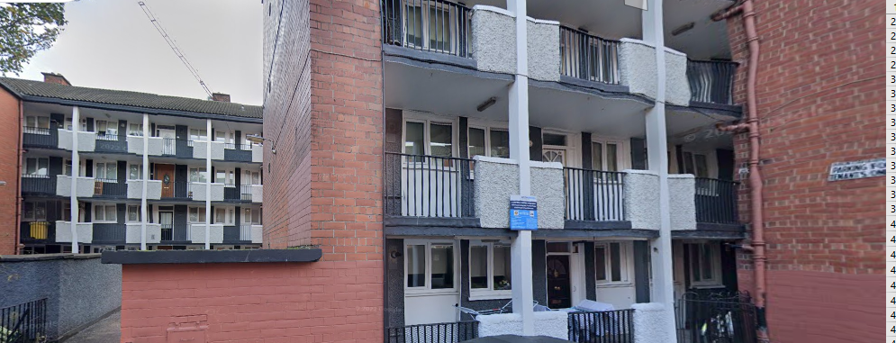

Dublin City Council is inviting eligible applicants from all our waiting lists who have selected Area L as their area of preference to apply for the above ground floor bedsit unit. It is strongly recommended that you check the website and familiarise yourself with this complex/location before applying.
Summer Street South is located in Dublin 8 and is close to all local amenities including schools, shops, and public transport services.

Furnishings and white goods are not provided

Start date of CBL advertisement is 19th June 2026. End date is Friday the 26th June 2026

- All Applicants must be listed for Area L. Do not apply if you do not have Area L as a preference.

- This application form can be completed online : www.dublincity.ie/Choice Based Lettings or can be returned to : Cuffe Street CBL, Dublin City Council, Housing Allocations, Civic Offices, Wood Quay, Dublin 8.

- As the final offer is made to the applicant in the highest position, there is no supporting documentation required as only position on your waiting list is considered.

- All applications will be examined on estate management grounds including rent arrears.

- A successful applicant who refuses a Choice Based Letting will not be eligible for consideration for another Choice Based Letting Unit for a period of one year.

- Under the choice based letting scheme, candidates will be notified of the outcome

- Start date of CBL advertisement is 19th June 2026. End date is Friday the 26th June 2026

- Please note late applications will not be considered.

- As per your Social Housing Application form, Dublin City Council will process your Choice Based Letting application in line with GDPR Guidelines. Please see Dublin City Council Privacy Statement on Dublin City Council website.

Application Form

Name _______________________________

Address _______________________________

_______________________________

PPSN _______________________________

Family Size ______________________________

Housing Reference Number ______________________________

Telephone/ Mobile Number ______________________________

Email address ______________________________

Did you read/understand the procedures above: Yes______ No _____

Signature ______________________________

