HAMPTON WOOD SQUARE, HAMPTON WOOD, FINGLAS D11
1 x 3 BEDROOM HOUSE
Choice Based Lettings Scheme

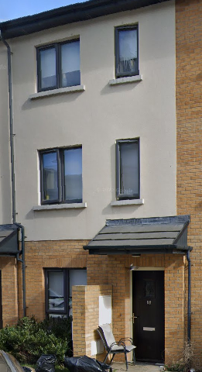

This development is managed by TUATH HOUSING

Dublin City Council is inviting applicants from all our waiting lists who have selected Area D on their area of preference to apply for this 3 BEDROOM HOUSE in HAMPTONWOOD, WITH ON STREET PARKING.

The location is exceptionally convenient and popular with families, offering an excellent selection of nearby schools including St. Aidan's CBS, St. Vincent's CBS, St. Mary's Holy Faith Convent, St. Brigid's National School, and Dublin City University. The property also enjoys easy access to the M50/M2 motorway network and is well serviced by excellent public transport links to Dublin City Centre via the nearby Quality Bus Corridor. Local sporting and leisure amenities include a swimming pool, Erin's Isle GAA, and Tolka Rovers FC.

Furnishings and white goods are not included.

Procedure and Application Form – HAMPTONWOOD SQUARE

- All applicants must be listed for Area D. Do not apply if you do not have Area D as a preference.

- Please apply online by following this link https://citizenhub.dublincity.ie/service/Choice_Based_Lettings_Application. If you have done this you do not need to post or email in your application. This application form can be completed and returned to Dublin City Council, Housing Allocations, Civic Offices, Wood Quay, Dublin 8.

- IF YOU APPLY ON THE PORTAL THERE IS NO REQUIREMENT TO POST OR EMAIL YOUR APPLICATION

- Start date of CBL advertisement is for 1 WEEK from 19/6/206 and ends 26/6/2026 at 5pm.
- If a number of applicants apply for the same property, the final offer will be made to the applicant with the highest position on list.
- All applications will be examined on estate management grounds including rent arrears.
- A successful candidate who refuses a Choice Based Letting will not be eligible for consideration for another Choice Based Letting unit for a period of 1 year.
- Under the Choice Based Letting Scheme only the successful candidates will be notified.
- If you need further information regarding the Choice Based Letting Scheme, please contact the Allocations Section on (01) 222 2207.
- PLEASE NOTE LATE APPLICATIONS WILL NOT BE CONSIDERED.
- As per your Social Housing application form, Dublin City Council will process your Choice Based Letting application in line with GDPR guidelines. Please see Dublin City Council Privacy Statement on Dublin City Council website

Application Form HAMPTONWOOD SQUARE

Name _______________________________

Address _______________________________

_______________________________

PPSN _______________________________

Family Size ______________________________

Housing Reference Number ______________________________

Telephone/ Mobile Number ______________________________

Email address ______________________________

Did you read/understand the procedures above: Yes______ No _____

Signature ______________________________

Date ______________________________

