CHOICE BASED LETTINGS SCHEME
Rosevale Court, Brookwood Avenue, Raheny, Dublin 5
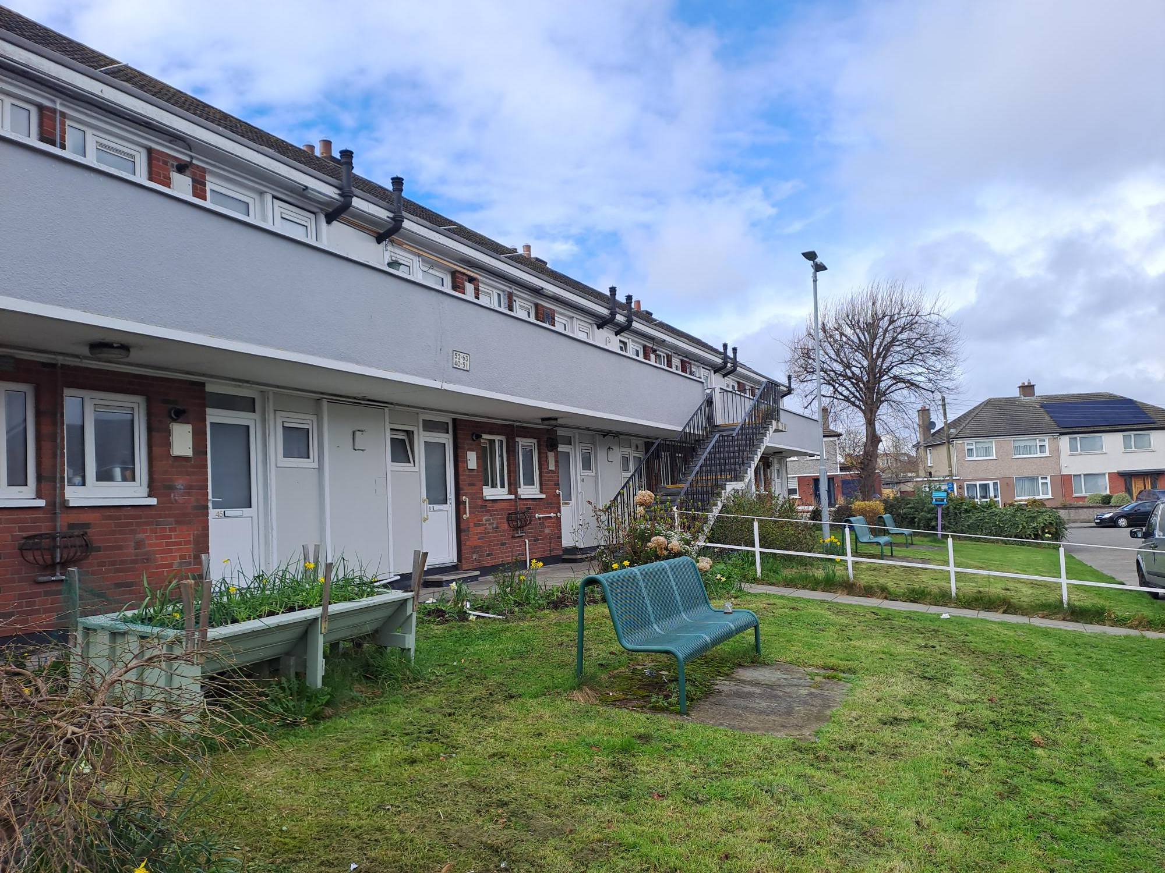

Eligible Senior Citizen applicants can apply for 1 x Bedsit Unit
Start date for applications is Friday June 19th 2026
Closing date for applications is Friday June 26th 2026
Dublin City Council is inviting applicants from all our waiting lists who have AREA B as their area of preference to apply for the property above. This unit is situated at First Floor level and there are a number of steps leading to the property it is not wheelchair accessible. This unit comprises of one bedroom/living space combined, one bathroom, one kitchen.
Furnishings and White Goods are NOT included. It is advised that you familiarise yourself with the location/surroundings of the property before applying.

This Senior Citizen complex is located close to shops, St Anne’s Park and served by several Dublin Buses 6, H1 & H3.

Applications can be made online at:
https://citizenhub.dublincity.ie/service/Choice_Based_Lettings_Application

Procedure and Application Form
- If you need further information regarding the Choice Based Lettings Scheme, please contact the Clontarf/Donaghmede Housing Office on 01-222 8540. All applicants must be listed for Area B. Please do not apply if you are not listed for Area .
- Start date for applications for this property is June 19th 2026 and will close on June 26th 2026 at 5:00pm.
- Applications can be made at this link: https://citizenhub.dublincity.ie/service/Choice_Based_Lettings_Application or by the below application form and returned by post to Dublin City Council North Central Area office, Civic Centre Bunratty Road, Coolock, Dublin 17, D17 K462
- If a number of applications are received for these properties, the final offer will be made to the applicant with the highest position on the list.
- All applicants will be examined on Estate Management Grounds – including rent arrears.
- A successful candidate who refuses a Choice Based Letting will not be eligible for consideration for another Choice Based Letting unit for a period of 1 year.
- If you need further information on the Choice Based Lettings Scheme, please contact the Allocations Section on 01-222 2207.
- PLEASE NOTE: LATE APPLICATIONS WILL NOT BE CONSIDERED.
- As per your Social Housing application form, Dublin City Council will process your Choice Based Letting application in-line with GDPR guidelines. Please see Dublin City Council Privacy Statement on the Dublin City Council website.

Application Form
Name: ______________________________
Address: ______________________________
______________________________
______________________________
______________________________
PPSN: ______________________________
Date of Birth: ______________________________
Family Size: ______________________________
Housing Reference: ______________________________
Contact Number: ______________________________
Email Address: ______________________________

Did you read/understand the Procedures above: Yes: __ No: __

Applicant Signature: ________________________________

