

DUBLIN CITY COUNCIL
SPECIAL SPEED LIMIT BYE-LAWS, 2020

Environment and Transportation Department

Block 2, Floor 7, Civic Offices

Wood Quay, Dublin 8

DUBLIN CITY COUNCIL SPECIAL SPEED LIMIT BYE-LAWS, 2020

Dublin City Council in exercise of the powers conferred on it by Section 9 of the Road Traffic Act, 2004, and with the consent of Transport Infrastructure Ireland, hereby makes the following bye-laws in respect of certain public roads within the area comprising Dublin City.

- These bye-laws may be cited as the Dublin City Council Special Speed Limit Bye-Laws, 2020

- These bye-laws shall come into operation by below dates:

Part A by March, 31st 2020
Part B by June 30th 2020
Part C by Sept 30th 2020

- Eighty kilometres per hour shall be the special speed limit for mechanically propelled vehicles on each of the roads specified in the attached map (colour orange) and the appendix to these bye-laws.

- Sixty kilometres per hour shall be the special speed limit for mechanically propelled vehicles on each of the roads specified in the attached map (colour green) and the appendix to these bye-laws.

- Thirty kilometres per hour shall be the special speed limit for mechanically propelled vehicles on each of the roads specified in the attached map to these bye-laws

Part A – colour yellow
Part B – colour blue
Part C – colour coral

- Special Periodic Speed Limit 30 km/h in the vicinity of schools. Thirty kilometres per hour shall be the special speed limit for mechanically propelled vehicles on each of the roads specified in the attached map to these bye-laws (colour red) during the dates and times specified. At all other times the speed limit on these roads shall revert to fifty kilometres per hour. Thirty kilometres per hour shall be the special periodic speed limit applicable Monday to Friday between hours 08.15 to 9.30 and 12.45 to 16.15. The thirty kilometres per hour special periodic speed limit will apply during the official term time that schools are convened (see appendix)
- Special Speed Limit for Special Circumstances. Fifty kilometres per hour shall be the special speed limit for mechanically propelled vehicles on each of the roads specified in the attached map – (colour navy) , and the appendix to these bye-laws in the event of incident or maintenance works causing an obstruction or when there is a risk of congestion on the roads. This speed limit to be indicated by variable message sign. At all other times the speed limit on these roads shall revert to eighty kilometres per hour.

- Dublin City Special Council Speed Limit Bye-Laws 2018 are hereby revoked.

- The built up area speed limit of fifty kilometres per hour shall apply to all other roads in the Dublin City Council administrative area as specified in the attached map (colour purple).

APPENDIX

- Eighty kilometres per hour shall be the speed limit for mechanically propelled vehicles on the roads specified:

- Chapelizod Bypass from the South Dublin County Council / Dublin City boundary to its junction with Con Colbert Road.

- Santry Bypass northbound, from a point 135 metres south of the south face of the west abutment of the southern bridge of the Coolock Lane Interchange northwards to the Fingal County Council / Dublin City boundary.

- Sixty kilometres per hour shall be the speed limit for mechanically propelled vehicles on the roads specified:

- James Larkin Road (from Watermill Road junction to Howth Road junction).

- Howth Road between a point 32 metres east of its junction with St. Assam’s Road East and its junction with Kilbarrack Road.

- Oscar Traynor Road between a point 65 metres west of its junction with Dundaniel Road and a point 74 metres north-west of its junction with the Malahide Road.

- Finglas Road from a point 90 metres west of junction of Finglas Road and Tower View Cottages (adjacent to Glasnevin Cemetery) to the Finglas By Pass.

- Finglas By Pass from Finglas Road to North Road.

- North Road from the junction of North Road and Finglas By Pass to Fingal County Council / Dublin City boundary.

- Kylemore Road between its junction with Naas Road and a point 46 metres south of Kylemore Road Railway Bridge.

- Walkinstown Avenue between its junction with Naas Road and its junction with Long Mile Road.

- Long Mile Road between the South Dublin County Council / Dublin City boundary and a point 46 metres west of its junction with Walkinstown Parade.

- Stillorgan Road between the Dún Laoghaire- Rathdown County Council / Dublin City boundary and a point 180 metres south of its junction with Anglesea Road.,

- Chapelizod Road between a point 100 metres west of its junction with Phoenix Park access at Islandbridge Gate and a point 100 metres east of its junction with Phoenix Park access at Chapelizod Gate.

- Griffith Avenue between a point 100 metres west of its junction with Ballymun Road and a point 100 metres east of its junction with Ballygall Road East.

- Con Colbert Road, from Con Colbert Road – Chapelizod By Pass junction to a point 150 metres west of its junction with South Circular Road.

- Malahide Road between a point 50 metres north-east of its junction with the roundabout at Artane to a point 50 metres south west of its junction with the Northern Cross Extension and Clare Hall Avenue.

- Northern Cross Extension, from its junction with M1 motorway to a point 50 metres west of its junction with Malahide Road

- Clare Hall Avenue from a point 50 metres east of its junction with Malahide Road to a point 106m west of its junction with Grange Road.

- Malahide Road from a point 50 metres north of its junction with N32 and Clare Hall Avenue to the Fingal County Council / Dublin City boundary.

- St. John’s Road West from its junction with Military Road to its junction with South Circular Road.

- Naas Road from the South Dublin County Council / Dublin City boundary to its junction with Kylemore Road.

- Grange Road from a point 57m east of its junction with Clare Hall Avenue to the Fingal County Council / Dublin City boundary.

- Santry By Pass northbound from the north face of the east abutment of the Shantalla Road over bridge to a point 135m south of the south face of the west abutment of the southern bridge of the Coolock Lane Interchange.

- The northbound diverging lane (exit ramp) of the Santry By Pass at the Coolock Lane Interchange, from a point 165m from the line of the south face of the west abutment of southern bridge at interchange northwards to a point 87m from this line.

- Santry By Pass southbound from a point 127m south of the south face of the east abutment of the southern bridge at interchange to the north face of the east abutment of the Shantalla Road over bridge.

- Southbound converging lane (entry ramp) at the Coolock Lane Interchange, from a point 5m from the line of the south face of the east abutment of the southern bridge at interchange, to junction with Santry By Pass.

- R148 Chapelizod Bypass outbound carriageway, from a point 105m east, of the intersection of the Kylemore Road with the R148 Chapelizod Bypass, westbound to the City/ County Boundary at Palmerstown.

- Fifty kilometres per hour shall be the speed limit for mechanically propelled vehicles on the roads specified:

- Santry By-Pass, southbound between Fingal County Council /Dublin City Council boundary and a point 250m south of the north face of the east abutment of northern bridge at Coolock Lane Interchange.

- The Dublin Port Tunnel (North Port Access Route), Southbound.

- The Dublin Port Tunnel (North Port Access Route), Northbound.

- Special Periodic Speed Limit 30 km/h in the vicinity of schools.

- Long Mile Road ( both eastbound and westbound carriageways) from a point 10m east of its junction with Walkinstown Parade to a point 60m east of its junction with Slievebloom Park

- Slievebloom Park

- Chapelizod Road from a point opposite the common boundary of numbers 4 and 5 Mullingar Terrace for a distance of 140m in a westerly direction

- Howth Road from a point at Public Lamp Standard 86 and heading West for 160m and East for 60m

- Griffith Avenue from a point at Public Lamp Standard 11 and heading West for 373m and East for 67m

- Seamus Ennis Road from a point at Public Lamp Standard 70 and heading West for 78m and East for 92m

- Terenure Road East from a point at Public Lamp Standard 16 and heading East for 200m and West for 80m

- Clareville Road East from a point at Public Lamp Standard 11 and heading East for 79m and West for 100m

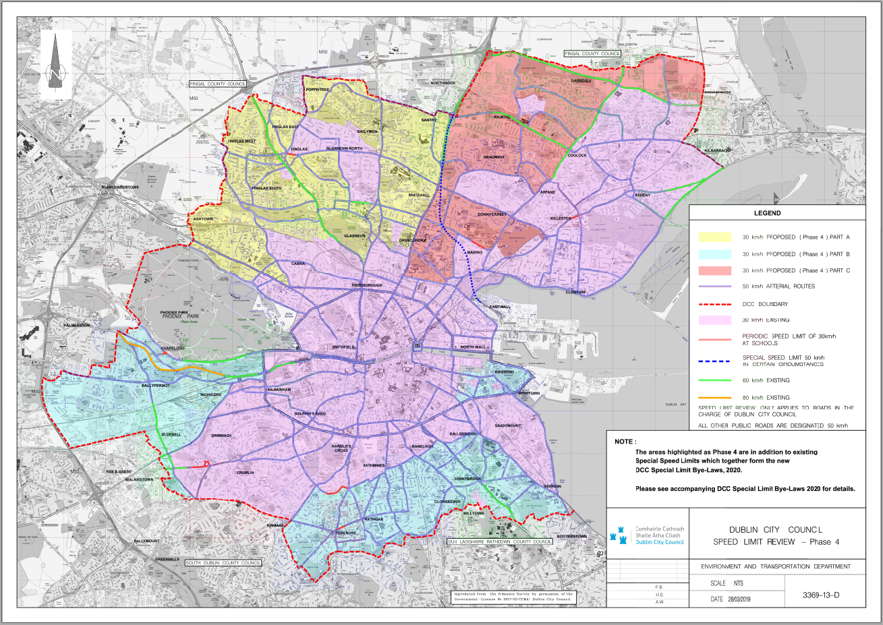
Present when the Seal of
Dublin City Council was
affixed hereto

This day of 2020

