CHOICE BASED LETTING SCHEME
81 SNOWDROP WALK, DARNDALE, DUBLIN 17
3 BEDROOM HOUSE

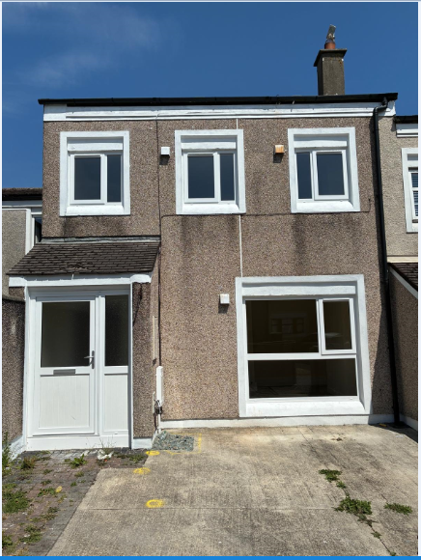

Dublin City Council is inviting eligible applicants from all our waiting lists who have selected Area B as their area of preference to apply for the above 3-bedroom house in the Darndale Area, Dublin 17. It is strongly recommended that you familiarise yourself with this location before applying.
This house is within a short walk of all amenities, including Retail, Schools, Community Amenities, hospital and bus services. It is close to the M1 and M50 motorways and Dublin Airport.
81 Snowdrop Walk, Darndale, Dublin 17 consists of 3 bedrooms, kitchen, bathroom and sitting room. The unit has been recently refurbished.

Furnishings and white goods are not provided.

Applications can be made online at:

https://citizenhub.dublincity.ie/service/ChoiceBasedLettingsAppliciation

Procedure and Application Form
- All applicants must be listed for Area B. Please do not apply if you are not listed for Area B.
- Please apply for this development by following this link for the portal:
https://citizenhub.dublincity.ie/service/Choice_Based_Lettings_Application or
This application form can be completed and returned to Dublin City Council, Darndale Area Office, Darndale Belcamp Village Centre, Bell Building, Dublin 17.

IF YOU APPLY ON THE PORTAL THERE IS NO REQUIREMENT TO POST OR EMAIL YOUR APPLICATION

- Start date of CBL advertisement is 10th July, 2026 to 17th July, 2026 at 5pm.
- If a number of applicants apply for the same property, the final offer will be made to the applicant with the highest position on list.
- All applications will be examined on estate management grounds including rent arrears.
- A successful candidate who refuses a Choice Based Letting will not be eligible for consideration for another Choice Based Letting unit for a period of 1 year.
- If you need further information regarding this Choice Based Letting, please contact the Darndale Area Office on 2226930.
- PLEASE NOTE LATE APPLICATIONS WILL NOT BE CONSIDERED.
- As per your Social Housing application form, Dublin City Council will process your Choice Based Letting application in line with GDPR guidelines. Please see Dublin City Council Privacy Statement on Dublin City Council website

Application Form for 81 Snowdrop Walk, Darndale, Dublin 17

Name _______________________________

Address _______________________________

_______________________________

PPSN _______________________________

Family Size ______________________________

Housing Reference Number ______________________________

Telephone/ Mobile Number ______________________________

Email address ______________________________

Did you read/understand the procedures above: Yes______ No _____
Signature ____________________________

Date ____________________________

