


Strategic Flood Risk Assessment (SFRA)

for

Variation (No. 11)

of the

Dublin City Development Plan 2022-2028

Document History
Strategic Flood Risk Assessment (SFRA) for Proposed Variation (No.11) of the Dublin City Development Plam 2022 - 2028

Department |  | Security Classification
Planning, Property & economic Development Department |  | Zero – For Public Display
Version | Revised Date | Prepared By/Title | Section Revised
Final REV 1 | 03/07/26 | GOC/JOD/CD | Various
Document Owner/ Title | Document Number | Status | Date Approved
Malachy Bradley/Deputy City Planner | - | Final REV1 | 03/07/ 26


Contents

1 Introduction 7
1.1 The Purpose of the Report 7
1.2 The Proposed Variation (No. 11) 7
1.3 National and Regional Planning Policy 8
1.4 The Dublin City Development Plan 2022 - 2028 9
1.5 Flood Policy 10
1.6 Environmental Considerations 10
1.7 Disclaimer 10
2 Flood Risk Management 12
2.1 The Planning System and Flood Risk Management Guidelines for Planning Authorities, 2009 12
2.2 Sources of Flood Risk 12
2.3 Definition of Flood Risk 13
2.4 Stages of Flood Risk Assessment 13
2.5 Flood Zones 13
2.6 Consequences of Flood Risk 14
2.7 Sequential Approach 15
2.8 Justification Test 16
2.9 Climate Change 16
3 3.0 Flood Risk Information 18
4 Flood Risk Assessment 21
4.1 Proposed Rezonings 21
4.2 Rezoning Stage 1 – Flood Risk Identification 21
4.3 Rezoning Stage 2 – Initial Flood Risk Assessment 23
4.4 Amendments to Strategic Development Regeneration Areas (SDRA’s) 23
4.5 SDRA Flood Risk Assessment 24
5 Conclusion of SFRA 28
6 Appendices 29
6.1 Appendix 1: List of 18 Strategic Development Regeneration Areas 29
6.2 Appendix 2: Classification of Vulnerability of Different Types of Development 30
6.3 Appendix 3: Stage 1&2- Flood Risk Identification and Assessment 31
6.4 Appendix 4: Rezoning Justification Test Tables 48
6.5 Appendix 5: List of all development plan land use zoning objectives. 76
6.6 Appendix 6: Development Plan Flooding and Surface Water Management Policies and Objectives 77

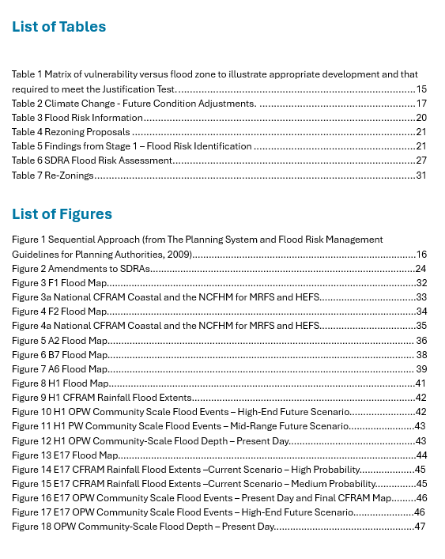

Abbreviations
AEP Annual Exceedance Probability
CDP City Development Plan
CFRAM Catchment-based Flood Risk Assessment and Management
DCC Dublin City Council
EMRA Eastern and Midland Regional Assembly
FRA Flood Risk Assessment
FRMP Flood Risk Management Plan
GSI Geological Survey of Ireland
HEFS High End Future Scenario
ICPSS Irish Coastal Protection Strategy Study (Coastal Flood maps)
ICWWS Irish Coastal Wave and Water Level Modelling Study
JT Justification Test
LUZO Land Use Zoning Objective
MASP Metropolitan Area Spatial Plan
MRFS Mid Range Future Scenario
NCFHM National Coastal Flood Hazard Mapping
NPF National Planning Framework
NPO National Policy Objective
OPW Office of Public Works
PFRA Preliminary Flood Risk Assessment
RPO Regional Policy Objective
RSES Regional Spatial and Economic Strategy
SDRA Strategic Development Regeneration Area
SDZ Strategic Development Zone
SEA Strategic Environmental Assessment
SFRA Strategic Flood Risk Assessment
SuDs Sustainable Drainage Systems
WFD Water Framework Directive

Addendum (following the making of Variation No. 11 by Dublin City Council 22nd June 2026)
Pursuant to Section 58 of the Planning and Development Act 2024, as amended, the Members of Dublin City Council resolved to make Variation No. 11 of the Dublin City Development Plan 2022-2028 (with modifications) at a Special City Council meeting on 22nd June 2026.
The variation was amended following a review of the issues raised during the prescribed public consultation period from 31st March 2026 to 28th April 2026 and subsequent consideration by Elected Members at a Special Council Meeting on 22nd June 2026.
Variation No. 11 of the Dublin City Development Plan 2022-2028 is effective as of the 22nd June 2026.
The Strategic Flood Risk Assessment prepared for the proposed variation (March 2026) has been updated post adoption of the Variation to reflect the amendments made by Elected Members.

- Introduction
  - The Purpose of the Report
The Dublin City Council Development Plan 2022 – 2028 guides the spatial direction of future development and regeneration in the city in line with the principles of compact growth as outlined by the National Planning Framework 2018 – 2040 and the Regional Spatial and Economic Strategy (EMRA) 2019 - 2031. The development plan includes a Strategic Flood Risk Assessment (SFRA), which integrates flood risk management best practice and land use zoning / policy. The SFRA was carried out in accordance with the Planning System and Flood Risk Management – Guidelines for Planning Authorities (2009) and is contained in Volume 7 of the Plan.
The National Planning Framework was revised in April 2025 and the Minister for Housing, Local Government and Heritage advised planning authorities to update development plans to reflect the requirements of the NPF in respect to housing allocations/ requirements[1]. Dublin City Council is proposing to vary the Dublin City Development Plan 2022 – 2028 to accommodate the new housing growth requirements identified for the city.
This purpose of this report is to undertake a Strategic Flood Risk Assessment (SFRA) of the proposed variation to the City Development Plan as described in section 1.2 below. This SFRA has been prepared having regard to the requirements of The Planning System and Flood Risk Assessment Guidelines for Planning Authorities (2009) and Circular PL02/2014 (August 2014). When assessing the appropriateness of rezoning proposals, this SFRA has adopted the sequential approach to flood risk management based on avoidance, reduction and mitigation of flood risk.
  - The Proposed Variation (No. 11)
It is proposed to vary the Dublin City Development Plan 2022 – 2028 to give effect to the First Revision of the National Planning Framework, April 2025, and to incorporate the housing growth requirements set out in in the Ministerial Guidelines - National Planning Framework NPF Implementation: Housing Growth Requirements, Guidelines for Planning Authorities, 2025.
It is proposed to vary the Dublin City Development Plan 2022 – 2028, by making amendments to the Core Strategy and the tables contained therein; to change the land use zoning objective of 7 sites from Z6 Employment/Enterprise to Z1: Sustainable Residential Neighbourhoods, Z10 Inner Suburban and Inner City Sustainable Mixed-Uses and Z14 Strategic Development and Regeneration Areas (SDRAs); to amend 8 Strategic Development and Regeneration Areas to provide for additional housing capacity; and, to identify Santry Key Urban Village as a long-term plan area.

The purpose of the proposed variation is to update the Dublin City Development Plan 2022 – 2028 in accordance with the NPF First Revision housing updates and by taking due account of the objectives in the Ministerial Guidelines - NPF Implementation: Housing Growth Requirements Guidelines for Planning Authorities (2025) as set out in the Chief Executive’s Report No. 237/2025 which was noted and agreed by elected members at a Council Meeting on 16th October 2025.

  - National and Regional Planning Policy
Dublin City is targeted for growth under the National Planning Framework (NPF) First Revision and the Regional Spatial and Economic Strategy (RSES).
The National Planning Framework First Revision contains a major policy emphasis on compact growth and urban consolidation. This is to prevent urban sprawl and to secure the provision of housing, jobs, amenities and services within cities (National Strategic Outcome No. 1). The NPF sets a target that half (50%) of future population and employment growth will be focused in the country’s cities and suburbs (National Policy Objective 4).
As the country’s leading global city of scale, the NPF acknowledges the critical role that Dublin City plays in the country’s competitiveness. It therefore supports Dublin’s growth (jobs and population) and anticipates the city and suburbs to accommodate its growth. To support and manage Dublin’s growth, the NPF is seeking that the city needs to accommodate a greater proportion of the growth it generates within its footprint than was the case heretofore and that housing choice, transport mobility and quality of life are key issues in the future growth of the city. The NPF therefore sets a target of at least 50% of all new homes targeted for Dublin City and suburbs are delivered within its existing built-up footprints (NPO 8). To achieve these targets of compact growth and urban consolidation, the NPF identifies as key, the reusing of large and small ‘brownfield’ land, / Infill sites, and underutilised lands at locations that are well served by existing and planned public transport. The NPF particularly highlights the need to focus on underutilised lands within the M50 ring.
Flood Risk Management (FRM) General Guidance
The revision of the National Planning Framework (2025) sets out National Policy Objective 78 to “Promote sustainable development by ensuring flooding and flood risk management informs place making by:
- Avoiding inappropriate development in areas at risk of flooding that do not pass the Justification Test, in accordance with the Guidelines on the Planning System and Flood Risk Management;
- Taking account of the potential impacts of climate change on flooding and flood risk, in line with national policy regarding climate adaptation’.

The Regional Spatial and Economic Strategy (RSES) for the Eastern and Midland Regional Assembly (EMRA) sets out the vision for growth (homes and jobs) and Regional Policy Objectives (RPO’s) for the Eastern and Midland Region to the year 2031.
The RSES and the Metropolitan Area Spatial Plan (MASP) for Dublin give direction to Dublin City as the ‘gateway core’ for high intensity clusters, brownfield development, urban renewal and regeneration. The RSES/ MASP settlement strategy for the metropolitan area includes a strong policy emphasis on the need to gain maximum benefit from existing assets, such as public transport and social infrastructure, through the continuation of compact growth, consolidation, densification and intensification to achieve optimal use of brownfield, underutilised lands and infill sites within the existing built footprint of the city. A further key aspect is that future development/ redevelopment and regeneration agenda, whether housing or mixed-uses, occur in tandem with high-quality rail based public transport (both planned and existing). Dublin City in its entirety lies within the metropolitan area.

  - The Dublin City Development Plan 2022 - 2028
In line with the National Planning Framework (NPF) and the Regional Spatial Economic Strategy, (RSES), the core strategy of the Dublin City Development Plan 2022 – 2028 promotes compact growth throughout the city, through appropriate infill development and consolidation of brownfield sites and targeted growth along key transport corridors.
The spatial settlement strategy for the city takes account of national and regional population targets and prioritises development in (1) the inner city, (2) Strategic Development and Regeneration Areas (SDRAs) and, (3) Key Urban Villages.
The city’s SDRAs have substantial development capacity (see Core Strategy in Volume 1 Written Statement of the Development Plan). The 18 Strategic Development and Regeneration Areas (SDRAs) identified for the city in the Development Plan are listed in Appendix 1. A series of Framework Plans and detailed guiding principles have been set out for each SDRA in Chapter 13 of the Written Statement of the plan.
  - Flood Policy
The 2011 EU Floods Directive (2007/60/EC) (transposed into Irish Law under Statutory Instrument 122 of 2010) requires Member States to prepare Catchment Based Flood Risk Management Plans (FRMPs) that set out flood risk management objectives, actions and measures. The Office of Public Works (OPW), as the lead agency for implementing flood risk management policy in the country, prepared the National Catchment-based flood Risk Assessment and Management (CFRAM) Studies (studying River Basins), and it subsequently prepared Flood Risk Management Plans identifying measures to alleviate flood risks in vulnerable areas. These can be viewed at www.floodinfo.ie. The OPW also published the Planning System and Flood Risk Assessment guidelines for Planning Authorities in 2009 (see Section 2.0 below).

  - Environmental Considerations
The Water Framework Directive (WFD) (2000/60/EC) aims to improve the overall quality of the rivers, groundwater and coastal waters and is being delivered in Ireland through River Basin Management Plans. The delivery of the Floods Directive is being coordinated with the requirements of the EU Water Framework Directive.
In compliance with the SEA Directive and the Planning and Development Act 2024, as amended and SEA Regulations 2025, a Strategic Environmental Assessment (SEA) of the proposed variation has been carried out in parallel to this SFRA. An Environmental Report of the likely significant effects on the environment of implementing the variation has been prepared. A Natura Impact Statement has also been prepared as part of the Appropriate Assessment of the Variation in compliance with the Habitats Directive.
  - Disclaimer
It is important to note that, although prepared in compliance with the requirements of The Planning System and Flood Risk Management Guidelines for Planning Authorities, 2009, the SFRA is a work in progress and is based on emerging and best available data at the time of preparing the assessment.
Accordingly, all information in relation to flood risk is provided for general policy guidance only and may be updated in light of future data and analysis, or future flood events. As a
result, all landowners and developers are advised that Dublin City Council and their
agents can accept no responsibility for losses or damages arising due to assessments of
the vulnerability to flooding of lands, uses and developments. Owners, users and
developers are advised to take all reasonable measures to assess the vulnerability to
flooding of lands and buildings (including basements) in which they have an interest prior
to making planning or development decisions.

- Flood Risk Management
  - The Planning System and Flood Risk Management Guidelines for Planning Authorities, 2009
The Planning System and Flood Risk Assessment Guidelines for Planning Authorities, 2009, were issued under Section 28 of the Planning and Development Act 2000 as amended, and require Planning Authorities to introduce flood risk assessment as an integral and leading element of their development planning functions.
The Guidelines require the planning system at national, regional and local levels to: -
- Avoid developments in areas at risk of flooding, particularly floodplains, unless there are proven wider sustainability grounds that justify appropriate development and where the flood risk can be reduced or managed to an acceptable level without increasing flood risk elsewhere.
- Adopt a sequential approach to flood risk management when assessing the location for new development based on avoidance, reduction and mitigation of flood risk, and
- Incorporate flood risk assessment into the process of making decisions on zoning and planning applications and planning appeals.
  - Sources of Flood Risk
Within Dublin City, five main sources of flood risk have been identified. The natural causes are:
- Coastal & estuarine flooding of areas adjacent to the coast or tidal estuaries.
- Fluvial or riverine flooding due to the riverbanks overtopping and / or flood defence
collapse.
- Pluvial flooding resulting from water run-off and ponding in low spots following
intense rainfall.
In addition, flooding can occur from human activities including dam break & extreme operation flooding associated with dam failure, either actual failure or high discharge release when in danger of over topping and drainage flooding due to failure or inadequacies of the sewerage system.
  - Definition of Flood Risk
Flood risk is defined as the combination of the probability of a flood event occurring and the potential consequences of that event. It is commonly expressed as:
Flood Risk = Probability of Flooding × Consequences of Flooding
Flood probability is often expressed using Annual Exceedance Probability (AEP). For example, a 1% AEP flood event has a 1 in 100 chance of occurring in any given year.
The assessment of flood risk requires an understanding of where the water comes from (i.e. the source), how and where it flows (i.e. the pathways) and the people and assets affected by it (i.e. the receptors). The principal sources of flooding is rainfall and or higher than normal sea levels. The principal pathways are rivers, drains, sewers, overland flow and river and coastal floodplains. The receptors include people, property and the environment. All three must be examined (including the vulnerability of people/uses etc) to determine the potential consequences.
  - Stages of Flood Risk Assessment
The Guidelines recommend a staged approach when undertaking a Flood Risk Assessment (FRA):
Stage 1 – Flood Risk Identification: Desk-based assessment to identify whether flood risk may be present.
Stage 2 – Initial Flood Risk Assessment: Further assessment to confirm flood sources and determine whether additional surveys or modelling are required.
Stage 3 – Detailed Flood Risk Assessment: Detailed quantitative assessment of flood risk and the identification of mitigation measures where necessary.
Strategic Flood Risk Assessments (SFRAs) undertaken as part of development plans generally incorporate Stage 1 and Stage 2 assessments, while Stage 3 assessments are typically required to support site-specific planning applications where flood risk is identified.
  - Flood Zones
Flood Zones are geographical areas within which the likelihood of flooding is in a particular risk range, and they are a key tool in flood risk management within the planning process as well as in flood warning and emergency planning. There are three types or levels of flood zones defined in ‘The Planning System and Flood Risk Management Guidelines for Planning Authorities and Technical Appendices, 2009':
Zone A: High probability of flooding – Where the probability of flooding from rivers and the sea is highest (greater than 1% or 1 in 100 for river flooding or 0.5% or 1 in 200 for coastal flooding). Most forms of development are deemed to be inappropriate here, only water compatible development would normally be allowed.
Zone B: Moderate probability of flooding – Flood risk is between 0.1% (or 1 in 1000
years) and 1 % (or 1 in 100 years) annually for river flooding, and between 0.1% (or 1 in a 1000 years) and 0.5% (or 1 in 200 years) annually for coastal flooding.
Less vulnerable development such as retail, commercial and industrial uses should only be considered in this zone if adequate lands or sites are not available in Zone C and subject to a flood risk assessment to the appropriate level of detail to demonstrate that flood risk to and from the development can or will be adequately managed.
Zone C: Low probability of flooding – Areas where the risk of flooding (from rivers and the sea) is less than 0.1% annually (or 1 in 1000 years), development is appropriate from a flood risk perspective (subject to flood hazard
from sources other than rivers and coast meeting normal proper planning
considerations).
It is important to note that ‘The Planning System and Flood Risk Management Guidelines
for Planning Authorities and Technical Appendices, 2009' ignore the presence of flood
defences when defining flood zones; this is due to the fact that even areas that benefit
from an existing flood defence can still be vulnerable due to the speed when overtopping
or a breach or other failure takes place. Therefore, this residual risk of flooding where
appropriate should be assessed as part of the application of the justification test and, if the
site is zoned for development, through the site-specific flood risk assessment.
  - Consequences of Flood Risk
The consequence of flooding depends on the hazards associated with the event,
including depth of water, speed of flow, rate of onset, duration, wave action effects and
water quality. The consequences are also determined by the vulnerability of people,
property and the environment potentially affected by a flood. ‘The Planning System and Flood Risk Management Guidelines for Planning Authorities and Technical Appendices, 2009' provide three vulnerability categories based on the type of development which are detailed below: -
Highly vulnerable
Less vulnerable
Water compatible

Appendix 2 sets out the classification of vulnerability of different types of development.

Table 1, taken from ‘The Planning System and Flood Risk Management Guidelines
for Planning Authorities and Technical Appendices, 2009' illustrates the types of
development that would be appropriate to each flood zone and those that would be
required to meet the justification test. Inappropriate development that does not meet the
criteria of the justification test should not be considered at the plan-making stage or
approved within the development management process.

 | Flood Zone A | Flood Zone B | Flood Zone C
Highly vulnerable development | Justification Test | Justification Test | Appropriate
Less vulnerable development | Justification Test | Appropriate | Appropriate
Water compatible  development | Appropriate | Appropriate | Appropriate

Table 1 Matrix of vulnerability versus flood zone to illustrate appropriate development and that required to meet the Justification Test.
  - Sequential Approach
As outlined in subsection 2.1, the sequential approach (see Figure 1) recommends the principle of “Avoid" areas of flood risk as a first consideration but if not possible then “Substitute” a different land use that is less vulnerable to the effects of flooding. When both avoidance or substitution are not a practical approach then a robust Justification Test should be undertaken to quantify and mitigate any potential increase in risk and facilitate the development of the area.
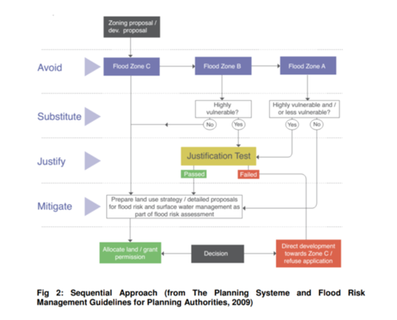
Figure 1 Sequential Approach (from The Planning System and Flood Risk Management Guidelines for Planning Authorities, 2009)
  - Justification Test
A Justification Test is required to be undertaken in instances whereby highly vulnerable development is being considered in Flood Zone A or whereby highly and/or less vulnerable development is being considered in Flood Zone B. The tests comprise of two processes namely the plan making justification test and the development management justification test (see Table 2-1 (in the 2009 Guidelines, Box 4.1)
  - Climate Change
Climate Change is expected to increase flood risk. It could lead to more frequent flooding and increase the depth and extent of flooding. Due to the uncertainty surrounding the potential effects of climate change a precautionary approach is recommended in the Guidelines.
- Recognise that significant changes in the flood extent may result from an increase in rainfall or tide events and accordingly adopt a cautious approach to zoning land in these potential transitional areas.
- Ensure that the levels of structures designed to protect against flooding, such as flood defences, landraising or raised floor levels are sufficient to cope with the effects of climate change over the lifetime of the development they are designed to protect.
- Ensure that structures to protect against flooding and the development protected are capable of adaptation to the effects of climate change when there is more certainty about the effects and still time for such adaptation to be effective
The assessment of climate change is based on two scenarios identified as Mid-Range Future Scenario (MRFS) and High-End Future Scenario (HEFS). HEFS provide information to inform zoning decisions.
Based on these two scenarios the OPW recommended allowances for climate change are given in the Table 2 below
Development vulnerability | Fluvial climate change allowance (increase in flows) | Tidal climate change allowance (increase in sea level) | Storm water / surface water
Less vulnerable | 20% | 0.5m (MRFS) | 20% increase in rainfall
Highly vulnerable | 20% | 0.5m (MRFS)
Critical or extremely vulnerable (e.g. hospitals, major sub-stations, blue light services) | 30% | 1.0m (HEFS) | 30% increase in rainfall
Table 2 Climate Change - Future Condition Adjustments.

- 3.0 Flood Risk Information
The flood risk information for the SFRA is provided from the sources below and by other studies / knowledge. This flood risk information informed the SFRA for the Dublin City Development Plan 2022 – 2028 and informs this SFRA.
Source | Data Gathered
OPW Historic Flood Maps | Historic flood events and flood event reports
OPW National Preliminary Flood Risk Assessment (PFRA) reports and maps (2012) | Information now superseded see: www.floodinfo.ie  The PFRA was reviewed in 2019, under the 2nd cycle of implementation of the EU ‘Floods’ Directive, and again in 2025 under the 3rd cycle. The Report of the 3rd Cycle Review of the PFRA is available at: https://www.gov.ie/en/office-of-public-works/publications/preliminary-flood-risk-assessment-pfra/.
FloodResilienCity Project, Sept 2012 | Pluvial Flood Depth and Hazard Maps as they relate to proposed variation lands examined.
Geological Survey of Ireland (GSI) Maps (Undated) | GSI groundwater vulnerability map consulted.
OPW The Irish Coastal Protection Strategy Study (ICPSS Flood Maps) | Covers the coastal flood zone.
CFRAM Flood Maps (2016) and Flood Risk Management Plans (2018) and subsequent Flood Map Reviews | Final Flood Risk Report and Mapping Eastern CFRAM Study see Flood Maps online, Office of Public Works, and Flood Risk Management Plan for the Liffey & Dublin Bay River Basin (UOMO9) www.floodinfo.ie, 2018
The Irish Coastal Wave and Water Level Modelling Study (ICWWS) (2018) | Updated coastal flood maps.
The GSI GWFlood Project (2020) | Historical and predictive groundwater flood maps (https://dcenr.maps.arcgis.com/apps/webappviewer/index.html?id=848f83c85799436b808652f9c735b1c c)
The National Indicative Fluvial Mapping Project (NIFM) 2016 – 2019 | Aims to provide data for areas not covered under the CFRAM programme see www.floodinfo.ie
National Coastal Flood Hazard Mapping (NCFHM) published by the OPW, 2020 | The NCFHM maps are based on more up-to-date estimates of extreme coastal levels than those used for the CFRAM coastal maps. As such the NCFHM maps may be considered in preference to the CFRAM with regards to the definition of the Flood Zones.
EPA Indicative Flow Network | Contains an integrated flow network that includes known flow connections through rivers, lakes and groundwater aquifers
Dublin City Development Plan 2022 - 2028, Dublin City Council | Contains Flood Management policies and objectives and Surface Water Management and Sustainable Drainage Systems (SuDS) Policies and Objectives Final 1-09 SEI and Flood Risk.pdf
Strategic Flood Risk Assessment (SFRA), Volume 7. Dublin City Development Plan 2022 - 2028, Dublin City Council | The flood maps for the whole city comprise a ‘Composite Flood Map’ and a set of flooding maps overlaid on the Land-Use Zoning Maps (Maps A to H) which are available for viewing on the Development Plan Website Final SFRA Full Doc. 14.12.22.pdf
Current Flood Risk Schemes in the city | Camac River Flood Alleviation Scheme – Stage 1 Scheme Development and Preliminary Design  Dodder Phase 3 – Stage 1 Scheme Development and Preliminary Design  River Wad – Phase 1 B Stage IV: Implementation / Construction  Poddle River Flood Alleviation Scheme – Stage IV: Implementation / Construction  Sandymount (phase 1 & 2 Flood Relief Scheme – Stage 1: Scheme Development and Preliminary Design
Data.gov.ie / Flooding@info.ie | Information includes:  OPW – River Flood Extents - Mid Range Future Scenario  OPW – River Flood Extents – High End Future Scenario  OPW - Coastal Flood Extents – MRFS and HEFS
Table 3 Flood Risk Information
- Flood Risk Assessment
  - Proposed Rezonings
To achieve additional housing capacity for the city the variation proposes the rezoning of lands in 7 locations across the city (see table 4 below). It is proposed to rezone land from Z6 (Enterprise / Employment) to residential use or mixed use including residential use.

No. | Area (ha) | Site Location
1 | 17.6 | Lands at East Point Business Park, Dublin 3
2 | 5.1 | Lands at East Wall Road, Dublin 3
3 | 7.1 | Lands at North Road, Dublin 11
4 | 4.3 | Shanowen Road Lands, Whitehall/Santry, Dublin 9
5 | 1.9 | Finglas Business Park, Tolka Valley Road, Dublin 11
6 | 1.5 | Greenmount Industrial Estate, Harold’s Cross, Dublin 6
7 | 0.2 | Lands at Fumbally Lane / Malpas Street / Blackpitts Lands, Dublin 8
Table 4 Rezoning Proposals
  - Rezoning Stage 1 – Flood Risk Identification
All proposed rezonings as listed in Table 4 above are mapped on the City Development Plan Flood Maps in Appendix 3 and are reviewed as to their potential for fluvial or coastal / tidal flooding risk. The findings from the Stage 1 – Flood Risk Identification are set out in Table 5 below.

Proposed Variations | Subject Lands | Flood Zone A | Flood Zone B | Flood Zone C
1 | Lands at East Point Business Park, Dublin 3 |  | Z14 Strategic Development and Regeneration Areas (SDRAs) | Z14 Strategic Development and Regeneration Areas (SDRAs)
2 | Lands at East Wall Road, Dublin 3 |  | Z14 Strategic Development and Regeneration Areas (SDRAs) | Z14 Strategic Development and Regeneration Areas (SDRAs)
3 | Lands at North Road, Dublin 11 | Z10 Inner Suburban and Inner City Sustainable Mixed-Uses | Z10 Inner Suburban and Inner City Sustainable Mixed-Uses | Z10 Inner Suburban and Inner City Sustainable Mixed-Uses
4 | Shanowen Road Lands, Whitehall/Santry, Dublin 9 |  |  | Z1 Sustainable Residential Neighbourhoods
5 | Finglas Business Park, Tolka Valley Road, Dublin 11 |  |  | Z10 Inner Suburban and Inner City Sustainable Mixed-Uses
6 | Greenmount Industrial Estate, Harold’s Cross, Dublin 6 |  | Z10 Inner Suburban and Inner City Sustainable Mixed-Uses | Z10 Inner Suburban and Inner City Sustainable Mixed-Uses
7 | Lands at Fumbally Lane / Malpas Street / Blackpitts Lands, Dublin 8 | Z10 Inner Suburban and Inner City Sustainable Mixed-Uses | Z10 Inner Suburban and Inner City Sustainable Mixed-Uses | Z10 Inner Suburban and Inner City Sustainable Mixed-Uses
Table 5 Findings from Stage 1 – Flood Risk Identification

  - Rezoning Stage 2 – Initial Flood Risk Assessment
As set out in Appendix 3, the sites are assessed to ensure the proposed zoning is appropriate in the relevant flood zone. As lands at East Point Business Park, lands at East Wall Road, lands at North Road, Greenmount Industrial Estate and lands at Fumbally Lane / Malpas Street / Blackpitts lands are partly located in Flood Zone A/B and since residential development, which is considered “highly vulnerable development”, is permitted in principle under the proposed zoning, a Justification Test for the zoning is appropriate.
In accordance with The Planning System and Flood Risk Management Guidelines for Planning Authorities (OPW, 2009), Justification Tests have been undertaken and these are set out in Appendix 4. The propose zoning at East Point Business Park, lands at East Wall Road, lands at North Road, Greenmount Industrial Estate and at Fumbally Lane passed the Justification Tests.
  - Amendments to Strategic Development Regeneration Areas (SDRA’s)
The variation also proposes amendments to 8 of the city’s Strategic Development and Regeneration Areas to increase housing capacity. Additional housing capacity of 8,600 residential units is to be achieved by applying higher density ranges, identifying new opportunity sites and phasing amendments to statutory plans, see Figure 2 below. Lands are also proposed for rezoning in SDRA 6 Docklands (East Point Business Park and lands on East Wall Road) and these are assessed in Appendix 3 (see 4.3 above).
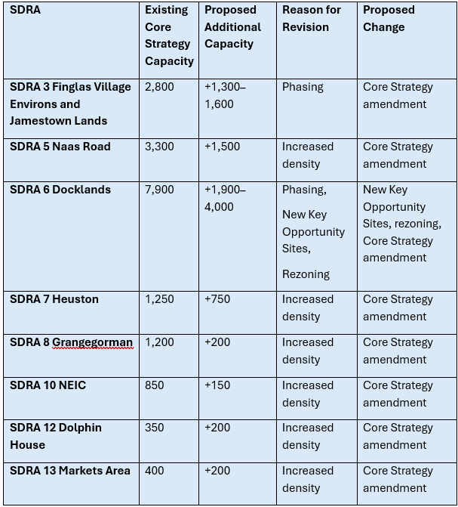
Figure 2 Amendments to SDRAs
  - SDRA Flood Risk Assessment
The Strategic Flood Risk Assessment (SFRA), Volume 7 of the Dublin City Development Plan 2022 - 2028, assessed flood risk in the city’s Strategic Development Regeneration Areas’ (SDRA’s). Appendix C of that SFRA provides specific assessment of flood risk and development frameworks (key opportunity sites) within the SDRAs.
The Justification Test tables for a number of Strategic Development Regeneration Areas (SDRAs) are included in Appendix C of the City Development Plan SFRA Final SFRA Full Doc. 14.12.22.pdf .
As stated above, the proposed amendments to the SDRA’s relate in the main to amendments to the core strategy housing yield numbers and do not relate to the rezoning of lands other than at East Point Business Park and East Wall Road – see Tables 4 and 5 above.
All the non-rezoning amendments to the 8 SDRA’s are listed in Table 6 below and links are provided to masterplan SFRA’s or Development Plan Justifications Tests which justify their zoning / planning. Having reviewed these previous Flood Risk Assessments, it is considered the proposed amendments to the SDRA’s would not result in increased flood risk vulnerability of these areas.

SDRA No. | Name | Additional Capacity Identified | Within Flood Zone A/ B/C | Flood Risk Assessment
SDRA 3 | Finglas Village Environs and Jamestown Lands | Amend Phasing in Jamestown Masterplan | FZC | Flood Risk mitigated and managed as part of SFRA for Jamestown Masterplan (Variation No. 4 to Development Plan
SDRA 5 | Naas Road | Increased density in existing Key Opportunity Sites | FZC | Plan making JT not required for SDRA - see City Development Plan SFRA Appendix C.1
SDRA 6 | Docklands | Amendment to Phasing in Poolbeg SDZ | Coastal Flood Risk southern edge | Flood Risk mitigated and managed as part of SFRA for Poolbeg SDZ
SDRA 6 | Docklands | New Key Opportunity Sites (Sites 16 - 18 of SDRA Map) | Site 16 - IFSC and Custom House  Defended – Existing zoning Z1, Z5, Z9  FZA – Existing zoning Z5 & Z9  FZC – Existing zoning Z1, Z5, Z8, Z9  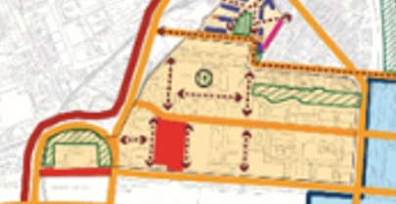  Site 17 Docklands Station  FZA Defended – Existing zoning Z1  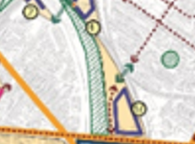  Site 18 Sheriff Street Upper  Defended and FZC – existing zoning Z14   | See JT for SDRA 6 Docklands in CDP 2022 – 2028 SFRA , Appendix C.2.
SDRA 6 | Docklands | New Key Opportunity Sites 19 – 21 – Rezoning - East Wall Road and East Point Business Park. |  | See Stage 2 - Flood Risk Assessment for Proposed Rezonings in Appendix 3
SDRA 7 | Heuston and Environs | Increased density in existing Key Opportunity Sites | See JT in City Development Plan SFRA Appendix C.2. | Addressed in JT for this SDRA in City Development Plan SFRA C.2.
SDRA 8 | Grangegorman/Broadstone | Increased Density | FZC | Plan making JT not required for SDRA - see City Development Plan SFRA Appendix C.1
SDRA 10 | North East Inner City | Increased density in existing Key Opportunity Sites | FZC | Plan making JT not required for SDRA - see City Development Plan SFRA Appendix C.1
SDRA 12 | Dolphin House | Increased density in existing Key Opportunity Sites | FZC | Plan making JT not required for SDRA - see City Development Plan SFRA Appendix C.1
SDRA 13 | Markets Area and Environs | Increased density in existing Key Opportunity Sites | FZC | Plan making JT not required for SDRA - see City Development Plan SFRA Appendix C.1
Table 6 SDRA Flood Risk Assessment
- Conclusion of SFRA
In summary, the proposed rezoning of lands currently zoned Z6 (Employment/Enterprise) to residential and mixed-use zonings (Z1, Z10 and Z14) and amendments to the SDRAs are considered appropriate having regard to the provisions of The Planning System and Flood Risk Management Guidelines for Planning Authorities (OPW, 2009). Sites that were subject to the Justification Test have passed.
Notwithstanding this, any future planning applications relating to these lands should be accompanied by a Stage 3 Detailed Flood Risk Assessment. This will ensure that flood risk is appropriately assessed and managed at project level in accordance with the OPW Guidelines and the Dublin City Development Plan Strategic Flood Risk Assessment (SFRA).
As per development plan policies in respect of surface water management (see Appendix 6), best practice should be implemented to limit surface water run-off to current values or less. The use of SuDS and green infrastructure should be considered in the first instance to reduce flooding as part of a surface water management plan to be prepared for the lands

- Appendices
  - Appendix 1: List of 18 Strategic Development Regeneration Areas
SDRA No. | Name
SDRA 1 | Clongriffin/Belmayne and Environs
SDRA 2 | Ballymun
SDRA 3 | Finglas Village Environs and Jamestown Lands
SDRA 4 | Park West/Cherry Orchard
SDRA 5 | Naas Road
SDRA 6 | Docklands
SDRA 7 | Heuston and Environs
SDRA 8 | Grangegorman/Broadstone
SDRA 9 | Emmet Road
SDRA 10 | North East Inner City
SDRA 11 | St. Teresa’s Gardens and Environs
SDRA 12 | Dolphin House
SDRA 13 | Markets Area and Environs
SDRA 14 | St. James’s Healthcare Campus and Environs
SDRA 15 | Liberties and Newmarket Square
SDRA 16 | Oscar Traynor Road
SDRA 17 | Werburgh Street
SDRA 18 | Broombridge - Hamilton

  - Appendix 2: Classification of Vulnerability of Different Types of Development
Vulnerability  Class | Land uses and types of development which include*:
Highly  vulnerable  development  (including  essential  infrastructure) | Garda, ambulance and fire stations and command centres required to be  operational during flooding; Hospitals; Emergency access and egress points;  Schools; Dwelling houses, student halls of residence and hostels;  Residential institutions such as residential care homes, children’s homes and  social services homes; Caravans and mobile home parks; Dwelling houses designed, constructed or adapted for the elderly or, other  people with impaired mobility; and Essential Infrastructure, such as primary transport and utilities distribution, including electricity generating power stations and sub-stations, water and sewage treatment, and potential significant sources of pollution (SEVESO sites, IPPC sites, etc) in the event of flooding.
Less vulnerable  development | Buildings used for; retail, leisure, warehousing, commercial, industrial and non-residential institutions; Land and buildings used for holiday or short-let caravans and camping, subject to specific warning and evacuation plans;  Land and buildings used for agriculture and forestry; Water treatment (except landfill and hazardous waste); Mineral working and processing; and Local Transport Infrastructure
Water  compatible  development | Flood control infrastructure; Docks, marinas and wharves;  Navigation facilities; Ship building, repairing and dismantling, dockside fish processing and refrigeration and compatible activities requiring a waterside location; Water-based recreation and tourism (excluding sleeping accommodation); Lifeguard and coastguard stations; Amenity open space, outdoor sports and recreation and essential facilities such as changing rooms; and Essential ancillary sleeping or residential accommodation for staff required by uses in this category (subject to a specific warning and evacuation plan).
Uses not listed here should be considered on their own merits
  - Appendix 3: Stage 1&2- Flood Risk Identification and Assessment
The 7 landbanks proposed for rezoning are shown below on the Development Plan flooding maps which are taken from Volume 7 - Strategic Flood Risk Assessment | Dublin City Council .
The flood zones for river and coastal flooding are shown on each map, where relevant. The vulnerability to flooding of the different types of development ‘permitted in principle’ or ‘open for consideration’ under the proposed zoning is identified. Consequently, the appropriateness of the proposed zoning to the flood zone is identified.
Where flood risk has been identified and the Justification Test is required, this is provided in Appendix 4.

No. | Ref | Area (ha) | Site Location
1 | F1 | 17.6 | Lands at East Point Business Park, Dublin 3
2 | F2 | 5.1 | Lands at East Wall Road, Dublin 3
3 | A2 | 7.1 | Lands at North Road, Dublin 11
4 | B7 | 4.3 | Shanowen Road Lands, Whitehall/Santry, Dublin 9
5 | A6 | 1.9 | Finglas Business Park, Tolka Valley Road, Dublin 11
6 | H1 | 1.5 | Greenmount Industrial Estate, Harold’s Cross, Dublin 6
7 | E17 | 0.2 | Lands at Fumbally Lane / Malpas Street / Blackpitts Lands, Dublin 8
Table 7 Re-Zonings
DUBLIN CITY DEVELOPMENT PLAN 2022-2028, VOLUME 3, ZONING MAP
Map Ref: F1
Rezone Lands:
From: Land Use Zoning Objective Z6: ‘To provide for the creation and protection of enterprise and facilitate opportunities for employment creation’ (Z6 Employment/Enterprise),
To: Land Use Zoning Objective Z14: ‘To seek the social, economic and physical development and/or regeneration of an area with mixed-use, of which residential would be the predominant use’ (Z14 Strategic Development and Regeneration Areas (SDRAs).
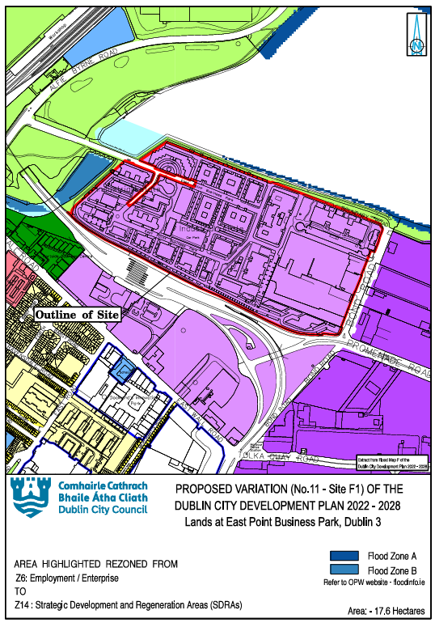
Figure 3 F1 Flood Map
The Development Plan SFRA and CFRAM flood extent maps identify that the Z6 lands are substantially in Flood Zone C and extend into Flood Zone B on the eastern end of the lands. They also identify that there is coastal flood risk along the northern and western boundary of the lands which coincides with the Z9 Zoning Objective for Open Space.
Both the National CFRAM Coastal and the NCFHM show increases in flood risk in the mid-range future scenario (MRFS) flood extents, and large increases predicted for the high-end future scenario (HEFS) for both datasets, see Figure 3a.
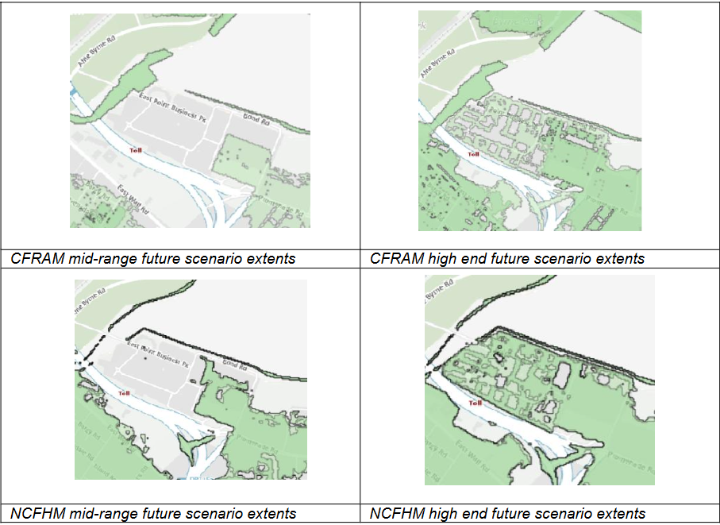
Figure 3a National CFRAM Coastal and the NCFHM for MRFS and HEFS
In terms of future scenario risk, Dublin Port has put in place a walkway / cycle path up to the 200-year tidal event and climate change and freeboard to a level of over 4.15m Malin Head. This was designed to cater for the estimated MRFS (500mm of sea level rise). Some locations are at risk of pluvial flooding.
A Justification Test is required.

DUBLIN CITY DEVELOPMENT PLAN 2022-2028, VOLUME 3, ZONING MAP
Map Ref: F2
Rezone Lands:
From: Land Use Zoning Objective Z6: ‘To provide for the creation and protection of enterprise and facilitate opportunities for employment creation’ (Z6 Employment/Enterprise),
To: Land Use Zoning Objective Z14: ‘To seek the social, economic and physical development and/or regeneration of an area with mixed-use, of which residential would be the predominant use’ (Z14 Strategic Development and Regeneration Areas (SDRAs).
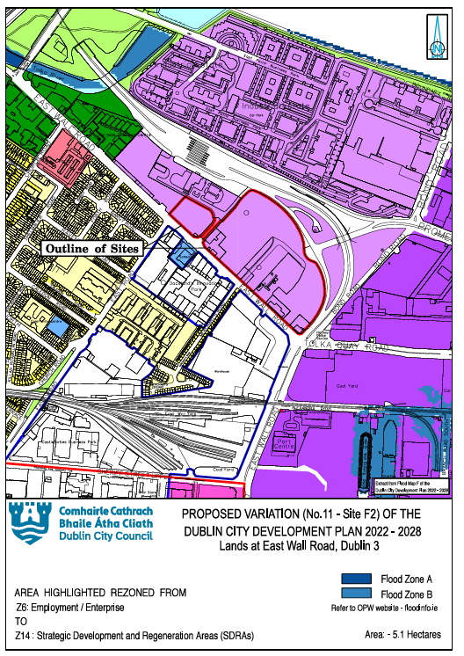
Figure 4: F2 Flood Map
The Development Plan SFRA and CFRAM flood extent maps identify that the Z6 lands are substantially in Flood Zone C and extend into Flood Zone B on the north eastern end of the lands.
Both the National CFRAM Coastal and the NCFHM show increases in flood risk in the mid-range future scenario (MRFS) flood extents, and large increases predicted for the high-end future scenario (HEFS) for both datasets, see Figure 4a.

Figure 4a National CFRAM Coastal and the NCFHM for MRFS and HEFS
In terms of future scenario risk, Dublin Port has put in place a walkway / cycle path up to the 200-year tidal event and climate change and freeboard to a level of over 4.15m Malin Head. This was designed to cater for the estimated MRFS (500mm of sea level rise). Some locations are at risk of pluvial flooding.
A Justification Test is required.

DUBLIN CITY DEVELOPMENT PLAN 2022-2028, VOLUME 3, ZONING MAP
Map Ref: A2
Rezone Lands:
From: Land Use Zoning Objective Z6: ‘To provide for the creation and protection of enterprise and facilitate opportunities for employment creation’ (Z6 Employment/Enterprise),
To: Land Use Zoning Objective Z10: ‘To consolidate and facilitate the development of inner city and inner suburban sites for mixed-uses (Z10 Inner Suburban and Inner City Sustainable Mixed-Uses).
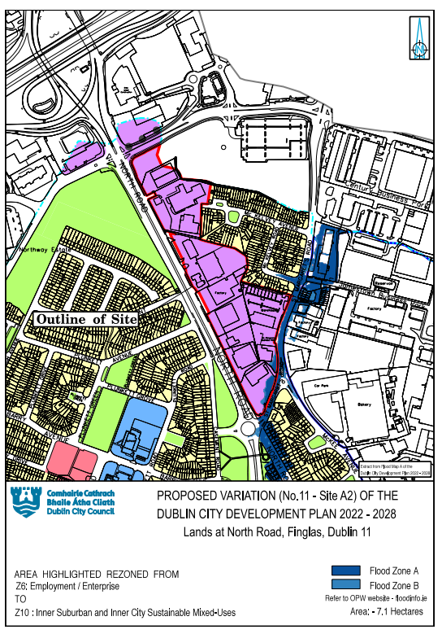
Figure 5 A2 Flood Map
The Development Plan SFRA and CFRAM flood extent mapping identify that the subject lands are located within Flood Zone C.
The Finglas Stream is located on the opposite side of North Road. The stream also flows in a southerly direction near the southeastern corner of these lands from the adjacent SDRA 3 – Jamestown Masterplan lands. The SFRA for the Jamestown Masterplan lands has identified overland flooding impacts on the lands proposed for rezoning, see Figure 3-2 from Masterplan SFRA and Figure 5 above.
Flood Zones A and B are located within SDRA 3 Finglas Village Environs and Jamestown lands. As it is not appropriate to avoid and substitute the Plan Making Justification Test is to be applied to the lands.

DUBLIN CITY DEVELOPMENT PLAN 2022-2028, VOLUME 3, ZONING MAP
Map Ref: B7
Rezone Lands:
From: Land Use Zoning Objective Z6: ‘To provide for the creation and protection of enterprise and facilitate opportunities for employment creation’ (Z6 Employment/Enterprise),
To: Land Use Zoning Objective Z1: ‘To protect, provide and improve residential amenities’ (Z1 Sustainable Residential Neighbourhoods)
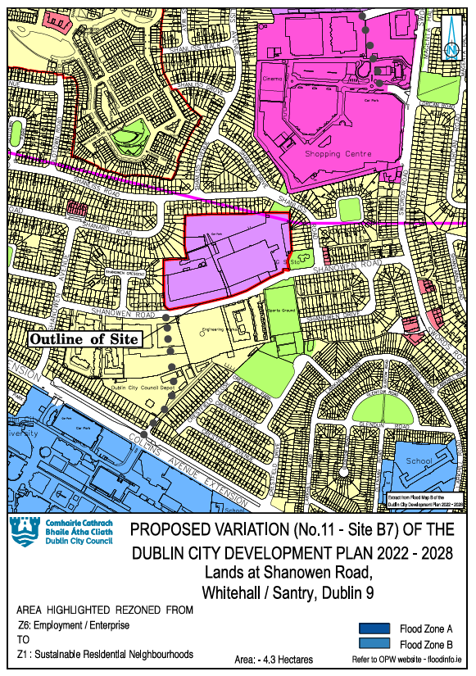
Figure 6 B7 Flood Map
The lands are north of the Wad River culvert but outside of its floodplains. The Development Plan SFRA and CFRAMS flood extent maps identify that the Z6 lands are in Flood Zone C . The proposed zoning is appropriate for development permitted in principle and open for consideration under LUZO Z10 (which includes residential use).
As per development plan policies in respect of surface water management (as set out in Appendix 6), best practice should be implemented to limit surface water run-off to current values or less. The use of SuDS and green infrastructure should be considered in the first instance to reduce flooding as part of a surface water management plan to be prepared for the lands.

DUBLIN CITY DEVELOPMENT PLAN 2022-2028, VOLUME 3, ZONING MAP
Map Ref: A6
Rezone Lands:
From: Land Use Zoning Objective Z6: ‘To provide for the creation and protection of enterprise and facilitate opportunities for employment creation’ (Z6 Employment/Enterprise),
To: Land Use Zoning Objective Z10: ‘To consolidate and facilitate the development of inner city and inner suburban sites for mixed-uses (Z10 Inner Suburban and Inner City Sustainable Mixed-Uses)
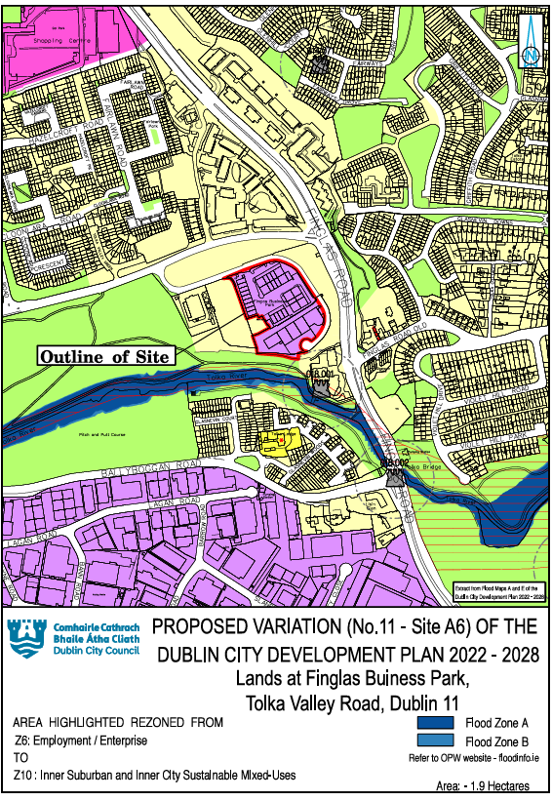
Figure 7 A6 Flood Map
The Development Plan SFRA and CFRAMS flood extent maps identify that the Z6 lands are in Flood Zone C and are appropriate for development permitted in principle and open for consideration under LUZO Z10 (including residential). The increase in future flood extents for the Finglas Stream / Tolka do not extend to the Finglas Business Park lands.

Outlet flows directly to the River Tolka, so pollution protections are necessary.
As per development plan policies in respect of surface water management (as set out in Appendix 6), best practice should be implemented to limit surface water run-off to current values. The use of SuDS and green infrastructure should be considered in the first instance to reduce flooding and pollution as part of a surface water management plan to be prepared for the lands.

DUBLIN CITY DEVELOPMENT PLAN 2022-2028, VOLUME 3, ZONING MAP
Map Ref: H1
Rezone Lands:
From: Land Use Zoning Objective Z6: ‘To provide for the creation and protection of enterprise and facilitate opportunities for employment creation’ (Z6 Employment/Enterprise),
To: Land Use Zoning Objective Z10: ‘To consolidate and facilitate the development of inner city and inner suburban sites for mixed-uses (Z10 Inner Suburban and Inner City Sustainable Mixed-Uses)
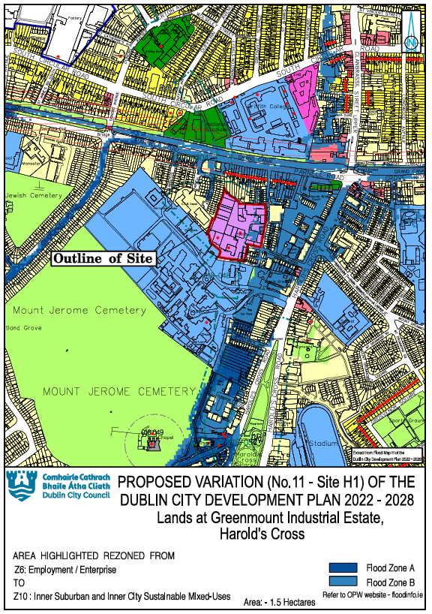
Figure 8 H1 Flood Map

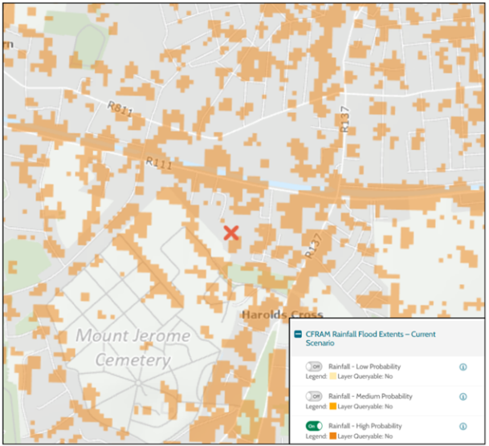
Figure 9 H1 CFRAM Rainfall Flood Extents

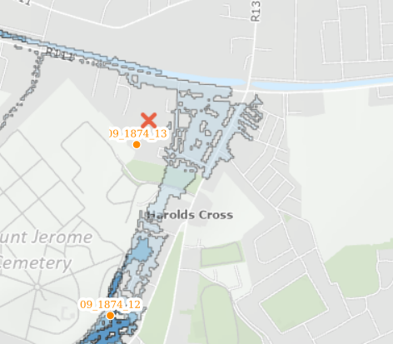
Figure 10 H1 OPW Community Scale Flood Events – High-End Future Scenario
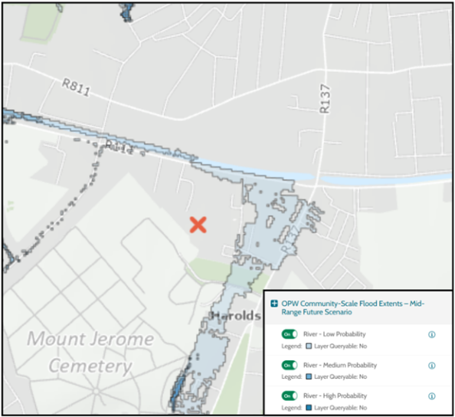
Figure 11 H1 PW Community Scale Flood Events – Mid-Range Future Scenario
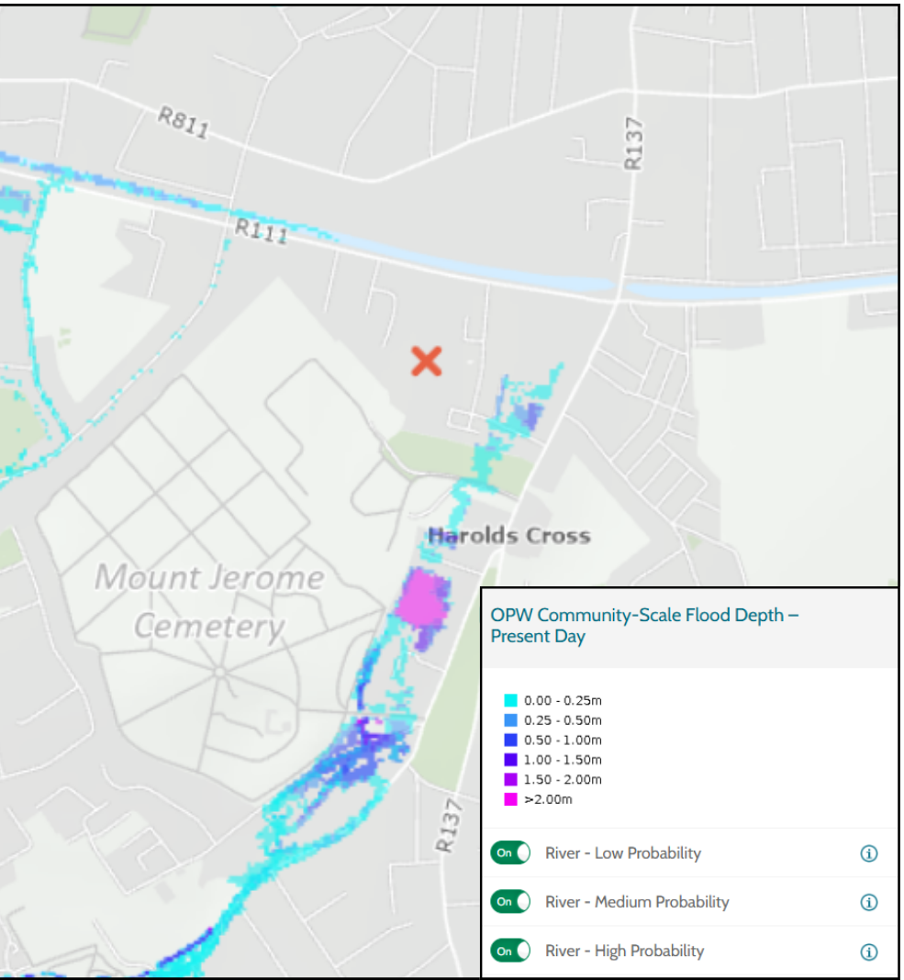
Figure 12 H1 OPW Community-Scale Flood Depth – Present Day
The Development Plan SFRA and CFRAMS flood extent maps indicate that the lands are primarily within Flood Zone C, with the access roads and northern/eastern edges along Greenmount Lane in Flood Zone B. The culverted Poddle river and a diversion run through these lands and will require setbacks.
A Justification Test is required.
DUBLIN CITY DEVELOPMENT PLAN 2022-2028, VOLUME 3, ZONING MAP
Map Ref: E17
Rezone Lands:
From: Land Use Zoning Objective Z6: ‘To provide for the creation and protection of enterprise and facilitate opportunities for employment creation’ (Z6 Employment/Enterprise),
To: Land Use Zoning Objective Z10: ‘To consolidate and facilitate the development of inner city and inner suburban sites for mixed-uses (Z10 Inner Suburban and Inner City Sustainable Mixed-Uses)
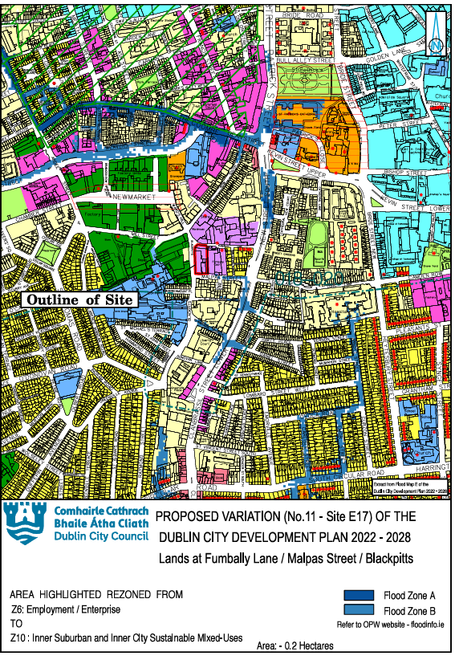
Figure 13 E17 Flood Map
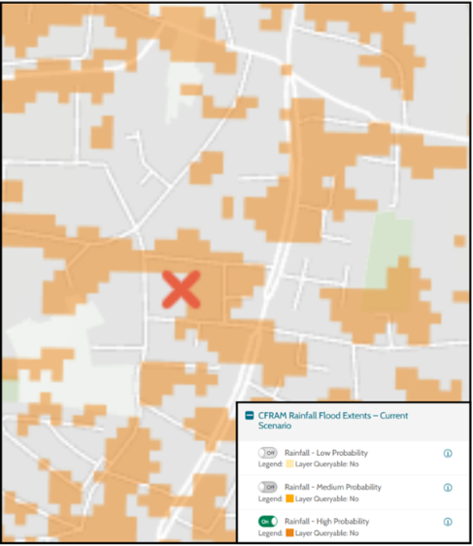
Figure 14 E17 CFRAM Rainfall Flood Extents –Current Scenario – High Probability

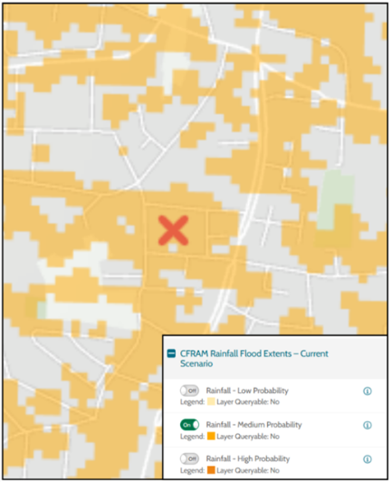
Figure 15 E17 CFRAM Rainfall Flood Extents –Current Scenario – Medium Probability

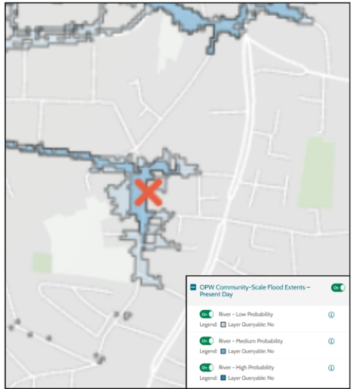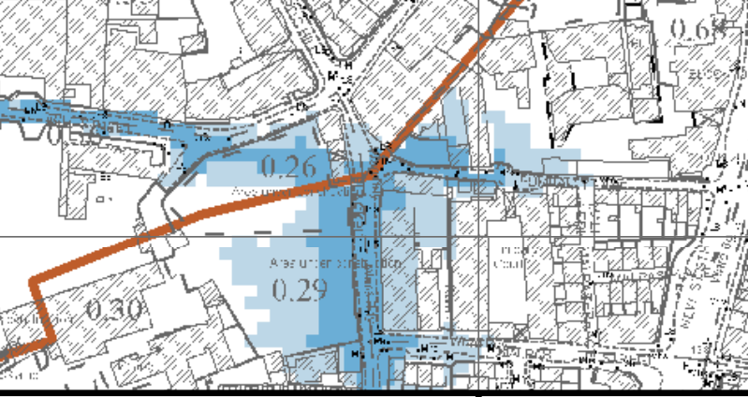
Figure 16 E17 OPW Community Scale Flood Events – Present Day and Final CFRAM Map

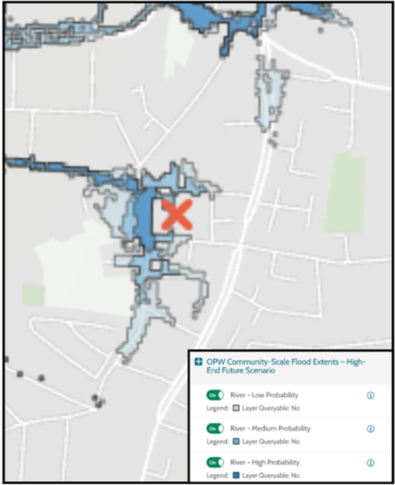
Figure 17 E17 OPW Community Scale Flood Events – High-End Future Scenario

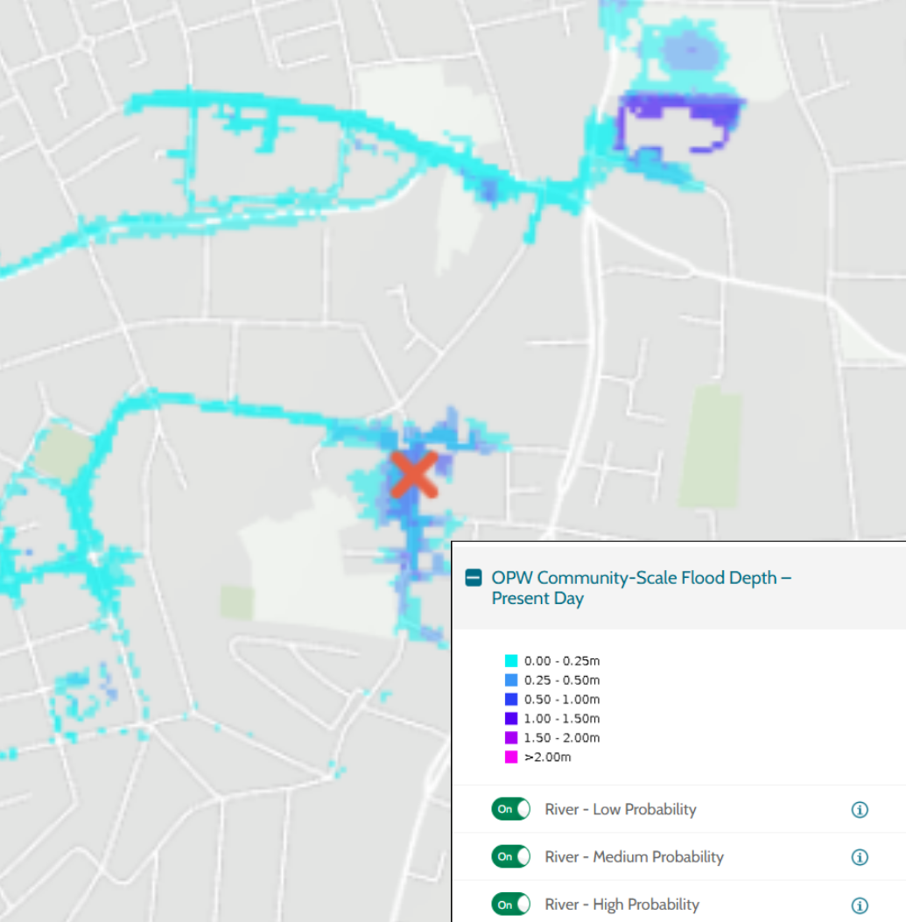
Figure 18 OPW Community-Scale Flood Depth – Present Day
A section of the Poddle Stream (culverted) flows to the north west of the lands. CFRAM flood mapping / flood map extents indicate that the lands are located primarily within Flood Zones B and C and they abut Flood Zone A to the west and partially lie in Flood Zone A on the north western corner of the site.
A Justification Test is required.
The lands are also subject to significant pluvial flooding, with an estimated depth of 0.31 m in a 100-year flood event.

  - Appendix 4: Rezoning Justification Test Tables
The tables that follow detail the Plan Making Justification Tests for the rezoning proposals where development sites with high or less vulnerable development classifications were located within Flood Zones A and / or B.
Name
F1 | Lands at East Point Business Park, Dublin 3
F2 | Lands at East Wall Road, Dublin 3
A2 | Lands at North Road, Dublin 11
H1 | Greenmount Industrial Estate, Harold’s Cross, Dublin 6
E17 | Lands at Fumbally Lane / Malpas Street / Blackpitts, Dublin 8

Justification Test for Lands at East Point Business Park, Dublin 3
Lands at East Point Business Park, Dublin 3
Extract from Flood Maps E & F, from Volume 7 (SFRA) of the 2022-2028 Dublin City Development Plan.

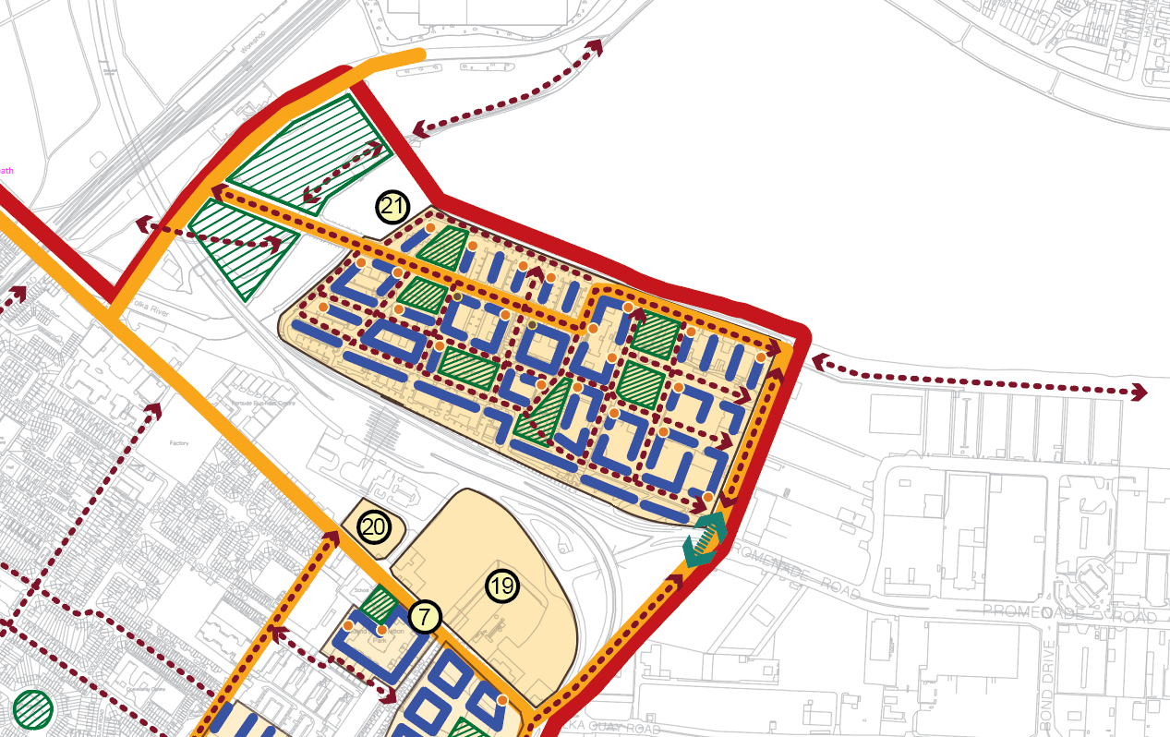
EastPoint and Environs
Area Description: | EastPoint Business Park (c.17 ha) is located on reclaimed land in the northern Docklands, adjacent Dublin Port/Bay and on the south side of the Tolka River Estuary. The lands lie to the north of the M50 Motorway Tunnel and related infrastructure. The lands are accessed from Alfie Byrne Road to the west and Bond Road to the east. The Dublin Port Greenway runs to the north of the lands.  The lands are zoned currently for Z6 employment/enterprise uses. EastPoint Business Park is currently characterised by low rise office blocks with some vacancy.
Land Use Zoning: | From: Land Use Zoning Objective Z6 (Z6 Employment/Enterprise): ‘To provide for the creation and protection of enterprise and facilitate opportunities for employment creation’.  To: Land Use Zoning Objective Z14 (Z14 Strategic Development and Regeneration Areas (SDRAs): ‘To seek the social, economic and physical development and/or regeneration of an area with mixed-use, of which residential would be the predominant use’.
SDRA 6 Docklands: | The lands form part of Strategic Development and Regeneration Area No. 6 Docklands, as identified in the Dublin City Development Plan 2022.  Key Opportunity Site No. 21 comprises Eastpoint Business Park. The opportunity for consolidation and regeneration on these lands to support a mixed use development has been identified, comprising employment uses, with new homes and community facilities and transport-oriented development.  A developer / landowner masterplan is to be prepared for the lands and is to be agreed with the Planning Authority as part of the development management process.
Benefitting from Defences (flood relief scheme works)/  Sensitivity to Climate Change/  Residual Risk/  Surface Water/  Historical Flooding | See Area Assessments in SFRA for Dublin City Development Plan 2022 - 2028:  Area: 2. Dublin Port North of the Liffey to Tom Clarke Bridge, and  Area 20 Tolka: Dublin Port to Drumcondra Bridge, and  Justification Test for SDRA 6 Docklands in Appendix C of Volume 7 (Strategic Flood Risk Assessment) of the Dublin City Development Plan 2022 – 2028.  This area benefits from the newly constructed coastal flood defence and cycleway which is designed to cater for the Medium Range Future sea level rise scenario (500mm of sea level rise) plus a freeboard of 300mm. This can be easily adapted in the future to cater with the High End Future sea level rise scenario (1.0m of sea level rise) plus freeboard.  Outputs from the ongoing Tolka flood study will be incorporated into any site specific development plan.  Currently the whole of the site apart from a small area near Bond Road are above the estimated 0.5% AEP level with proposed habitable floor levels proposed above the 0.1% AEP level plus 300mm safety margin.  The site is sensitive to sea level rise and further protections can be installed to cope with 1m of sea level rise plus freeboard.  The is no recorded historic flooding of this site.  The site must cope with the 1% AEP pluvial flood event using as many Sustainable Urban Drainage Systems as possible including storage to cope with a 20% AEP tidal flood event during the worst case 1% AEP pluvial flood event. The effects of a MRFS rainfall event shall be evaluated and mitigated against during a 20% AEP tidal flood event. Mitigation measures to be proposed for HEFS rainfall flood event during a 20% AEP tidal flood event.
Commentary on Flood Risk:
The flood extents indicate flow paths generally coming directly out of the tidal region. However tide locking during a significant pluvial flood event can also cause significant flooding.
The Development Plan SFRA and CFRAM flood extent maps identify that the Z6 lands are predominantly in Flood Zone C.
Both the National CFRAM Coastal and the NCFHM show there are increases in flood risk in the mid-range future scenario flood extents, with large increases predicted for the high-end future scenario for both datasets. These have to be proven to be catered for in the MRFS and a plan put in place for the HEFS. The NCFHM flood extent maps do not consider the existing flood defences which defend this area.
Dublin Port has put in place a walkway / cycle path up to the 200-year tidal event and climate change and freeboard to a level of over 4.15m Malin Head. This was designed to cater for the estimated MRFS (500mm of sea level rise). A plan has to be put in place in any development to cope with an estimated 1m of sea level rise in the future.

Justification Test for Development Plans

1. Part 1 of the Justification Test is covered under Section 3.2.1 of the SFRA of the 2022-2028 Dublin City Development Plan, Volume 7, which states that ‘Part 1 of the Justification Test has, therefore, been applied universally across the city’.

2. The zoning or designation of the lands for the particular use or development type is required to achieve the proper planning and sustainable development of the urban settlement and, in particular:

(i) Is essential to facilitate regeneration and/or expansion of the centre of the urban settlement.
Answer: Yes, both: The lands are located within Strategic Development and Regeneration Area No. 6 Docklands which corresponds to the Dublin Docklands areas as defined by the Dublin Docklands Development Authority Act, 1997.
This major development parcel lies within the northern Docklands and adjacent the city centre. It is capable of delivering high-density, mixed-use, transit-oriented development. The development of the lands along with lands on East Wall Road, provides the opportunity for coordinated regeneration across the entire Docklands.
A coordinated and urban design-led approach to redevelopment is required to ensure that EastPoint transitions from a largely mono use business park into a dynamic, mixed-use and sustainable urban extension of the city centre. Considering the scale of the lands and the multiple benefits that regeneration at this scale can provide the city, prior to significant redevelopment proposals, a masterplan is to be prepared.

(ii) Comprises significant previously developed and/or under-utilised lands.
Answer: Yes: The identification of the lands for redevelopment is driven by land and office vacancy and underutilisation and aligns with the broader objective of transitioning legacy mono-use employment areas into balanced urban neighbourhoods that integrate residential, employment, cultural, mobility and public realm functions.
EastPoint Business Park and environs constitute a significant landbank of employment and enterprise lands strategically located within the north eastern edge of Dublin’s Docklands. Originally conceived and developed as a purpose-built office and commercial campus, its low rise and low-density form presents opportunities for consolidation and regeneration to support modern employment practices, while facilitating the transition of these lands into a mixed use neighbourhood with new homes and community facilities, underpinned by exemplary urban design and design-led architecture.

(iii) Is within or adjoining the core of an established or designated urban settlement.
Answer: Yes: The lands are located within Strategic Development and Regeneration Area No. 6 Docklands which corresponds to the Dublin Docklands areas as defined by the Dublin Docklands Development Authority Act, 1997. The lands lie adjacent the city centre.
At present, the lands are effectively severed from East Wall by the Port Tunnel access road and while there is controlled access from Bond Road to the east, primary access is via the EastPoint Causeway from Alfie Byrne Road. Future regeneration opportunities provide substantial potential for exploring options for enhanced integration with surrounding neighbourhoods, capitalising on planned active travel interventions in the immediate surrounding area, including the Dublin Port Greenway.
(iv) Will be essential in achieving compact and sustainable urban growth.
Answer: Yes: The SDRA lands have significant potential for further regeneration/ development and can make a valuable contribution to the future physical and social regeneration of this part of the city. The regeneration and redevelopment of opportunity sites beside the city centre is essential in achieving compact and sustainable urban growth in line with the NPF, the RSES and MASP.
(v) There are no suitable alternative lands for the particular use or development type, in areas at lower risk of flooding within or adjoining the core of the urban settlement.
Answer: The regeneration/ redevelopment of the Dublin Docklands has been identified at national and regional level as an imperative for the consolidation of Dublin City. There are no suitable alternative lands for the particular uses or development type in areas at lower risk of flooding, within or adjoining the urban settlement.
3. Specific Flood Risk Assessment
While East Point Business Park is substantially located within Flood Zone C, small portions of it currently used for carparking are located in Flood Zone B. The whole area is defended to a minimum level of 4.15m Malin from the primary source of flood risk which is tidal. Development can reasonably be accommodated within the extents of Flood Zone C and should not need to extend into defended areas of Flood Zone B except for non-residential and or water compatible uses.
Regard must be had to the following requirements:
- The site-specific flood risk assessment to inform the masterplan for the lands and to be agreed with the Planning Authority as part of the development management process, will set out measures to cope with the MRFS (500mm sea level rise locally) and the HEFS (1m increase of sea level rise locally) as per the guidance set out in Section 4 of the Dublin City Council Development Plan SFRA.
- Finished floor levels to include allowance for climate change, as per the guidance set out in Section 4 of the Dublin City Council Development Plan SFRA.
- A surface water management plan for the lands to consider pluvial flood areas with protection against the 100 year pluvial flood level plus 300mm.
- A surface water management plan to identify SuDs and nature based solutions on top of existing SuDS elements in the surface water strategy,
- All stormwater outflows to be discharged to the estuary through double non-return valves or stored until after hightide in site specific storm water management plan.

Conclusion: The subject area passes the Justification Test

Justification Test for Lands at East Wall Road, Dublin 3
Lands at East Wall Road, Dublin 3
Lands at East Wall Road
Area Description | The lands are located at East Wall Road in the north Docklands, adjacent the city centre. The lands adjacent to the Tunnel Control Building are shown as site No. 20 on the above map and lands on East Wall Road / Bond Road are shown as site no. 19.  Both landbanks lie to the south of the M50 Motorway Tunnel and related infrastructure. The lands are located within 1km of the Luas stop at the 3 Arena. There is a planned active travel route along East Wall Road.  Both landbanks are zoned currently for Z6 employment/enterprise uses. The lands on East Wall Road / Bond Road are currently used for port related car storage and are accessed from the port by a bridge over Bond Road. The lands at East Wall Road beside the Tunnel Control Building are vacant.
Land Use Zoning: | From: Land Use Zoning Objective Z6 (Z6 Employment/Enterprise): ‘To provide for the creation and protection of enterprise and facilitate opportunities for employment creation’.  To: Land Use Zoning Objective Z14 (Z14 Strategic Development and Regeneration Areas (SDRAs): ‘To seek the social, economic and physical development and/or regeneration of an area with mixed-use, of which residential would be the predominant use’.
SDRA 6 Docklands: | The lands form part of Strategic Development and Regeneration Area No. 6 Docklands, as identified in the Dublin City Development Plan 2022.  Key Opportunity Sites No.’s 19 and 20 comprise employment lands which are underutilised / vacant. The opportunity for consolidation and regeneration on these lands to support a mixed use development has been identified.  A developer / landowner masterplan is to be prepared for the lands (site 19) and is to be agreed with the Planning Authority as part of the development management process.
Benefitting from Defences (flood relief scheme works)/  Sensitivity to Climate Change/  Residual Risk/  Surface Water/  Historical Flooding | See Area Assessments in SFRA for Dublin City Development Plan 2022 - 2028:  Area: 2. Dublin Port North of the Liffey to Tom Clarke Bridge, and Area 3 Liffey: O’Connell Bridge to Tom Clarke Bridge, and,  Area 20 Tolka: Dublin Port to Drumcondra Bridge, and  Justification Test for SDRA 6 Docklands in Appendix C of Volume 7 (Strategic Flood Risk Assessment) of the Dublin City Development Plan 2022 – 2028  This area benefits from the newly constructed coastal flood defence and cycleway extending to Terminal Road North which is designed to cater for the Medium Range Future sea level rise scenario (500mm of sea level rise) plus a freeboard of 300mm. This can be easily adapted in the future to cater with the High End Future sea level rise scenario (1.0m of sea level rise) plus freeboard.  Currently the whole of the site is above the estimated 0.5% AEP level with proposed habitable floor levels proposed above the 0.1% AEP level plus 300mm safety margin.  The site is sensitive to sea level rise and further protections can be installed to cope with 1m of sea level rise plus freeboard.  The is no recorded historic flooding of this site.  The site must cope with the 1% AEP pluvial flood event using as many Sustainable Urban Drainage Systems as possible including storage to cope with a 20% AEP tidal flood event during this flood event. The effects of a MRFS 1%AEP rainfall event shall be evaluated and mitigated against during a 20% AEP tidal flood event. Mitigation measures to be proposed for HEFS rainfall flood event during a 20% AEP tidal flood event.
Commentary on Flood Risk:
The Development Plan SFRA and CFRAM flood extent maps identify that the Z6 lands are mostly in Flood Zone C.
Both the National CFRAM Coastal and the NCFHM show there are increases in flood risk in the mid-range future scenario flood extents, with large increases predicted for the high-end future scenario for both datasets. The NCFHM flood extent maps do not consider the existing flood defences which defend this area.
Mitigation measures against these future scenario’s are outlined below in the Site Specific Flood Risk Assessment .

Justification Test for Development Plans

1. Part 1 of the Justification Test is covered under Section 3.2.1 of the SFRA of the 2022-2028 Dublin City Development Plan, Volume 7, which states that ‘Part 1 of the Justification Test has, therefore, been applied universally across the city’.

2. The zoning or designation of the lands for the particular use or development type is required to achieve the proper planning and sustainable development of the urban settlement and, in particular:

(i) Is essential to facilitate regeneration and/or expansion of the centre of the urban settlement.
Answer: Yes, both: The lands are located within Strategic Development and Regeneration Area No. 6 Docklands which corresponds to the Dublin Docklands areas as defined by the Dublin Docklands Development Authority Act, 1997.
These lands lie within the northern Docklands and are adjacent the city centre. The re-development of the lands along with the redevelopment of East Point Business Park (site No. 21 shown on the map above), provides the opportunity for the sequential and coordinated regeneration of development lands in the Docklands / adjacent the city centre.

(ii) Comprises significant previously developed and/or under-utilised lands.
Answer: Yes: The identification of the lands for redevelopment is driven by land vacancy and underutilisation and aligns with the broader planning objective of urban consolidation and compact growth.

(iii) Is within or adjoining the core of an established or designated urban settlement.
Answer: Yes: The lands are located within Strategic Development and Regeneration Area No. 6 Docklands which corresponds to the Dublin Docklands areas as defined by the Dublin Docklands Development Authority Act, 1997. The lands lie adjacent the city centre. The lands are therefore located within the core of the established urban settlement.

(iv) Will be essential in achieving compact and sustainable urban growth.
Answer: Yes: The SDRA lands have significant potential for regeneration/ development and can make a valuable contribution to the future physical and social regeneration of this part of the city. The regeneration and redevelopment of opportunity sites beside the city centre is essential in achieving compact and sustainable urban growth in line with the NPF, the RSES and MASP.
(v) There are no suitable alternative lands for the particular use or development type, in areas at lower risk of flooding within or adjoining the core of the urban settlement.
Answer: The regeneration/ redevelopment of the Dublin Docklands has been identified at national and regional level as an imperative for the consolidation of Dublin City. There are no suitable alternative lands for the particular uses or development type in areas at lower risk of flooding, within or adjoining the urban settlement.
3. Specific Flood Risk Assessment

The whole of the site is estimated to be currently in flood zone C (except for a small area of Flood Zone B on the northern side). Floor levels of residential buildings will be above the current 1,000 year tide level plus 300mm safety margin. The site is defended from future sea level rise to the Medium Range Future Scenario assuming a 500mm increase in average sea level by the newly constructed flood defence and cycleway which extends east to Terminal Road North. This can be increased in the future to cope with the HEFS level of protection to this area.

The site will cope with the 1% AEP including MRFS and HEFS against a 20%AEP tidal flood event using SuDS and site storage measures.

Conclusion: The subject area passes the Justification Test

Justification Test for Lands at North Road, Finglas, Dublin 11
Lands at North Road, Finglas, Dublin 11
Area Description: | These lands (c.7 ha) are located along North Road and St. Margaret’s Road to the north of and within the built-up area of Finglas/Finglas Village. The lands are located to the south of the M50 / N2 junction, to the southwest of Charlestown Shopping Centre (in the Fingal County Council’s area) and the northern part of the landbank is located adjacent to lands zoned ‘Town Centre’ lands under the Fingal County Development Plan. The lands are located to the west of lands at Jamestown which are designated for major regeneration and housing development under SDRA 3.
Land Use Zoning: | From: Land Use Zoning Objective Z6 (Z6 Employment/Enterprise): ‘To provide for the creation and protection of enterprise and facilitate opportunities for employment creation’.  To: Land Use Zoning Objective Z10 (Z10 Inner Suburban and Inner City Sustainable Mixed-Uses): ‘To consolidate and facilitate the development of inner city and inner suburban sites for mixed-uses’.
SDRA 3 Finglas Village Environs and Jamestown Lands: | The southern part of the lands is in Strategic DRA 3 Finglas Village and Environs and Jamestown Lands
Benefitting from Defences (flood relief scheme works)/  Sensitivity to Climate Change/  Residual Risk/  Surface Water/  Historical Flooding: | There are no existing areas on this site benefiting from flood defences or flood relief schemes.  Sensitivity to climate change is estimated to be low. The developer will cover any new risks to mitigate climate change in a site specific flood risk assessment.  There is no record of significant historic flooding on the site.  The flood map of the site is updated, using the relevant map from the Jamestown Masterplan SFRA, to show existing flood Zone A and flood Zone B where residential and commercial development will not be allowed.
Commentary on Flood Risk:
The Development Plan SFRA and CFRAM flood extent mapping identify that the subject lands are located within Flood Zone C.
The Finglas Stream is located on the opposite side of North Road. The stream also flows in a southerly direction near the southeastern corner of these lands from the adjacent SDRA 3 – Jamestown Masterplan lands. The SFRA for the Jamestown Masterplan lands has identified overland flooding impacts on the lands proposed for rezoning. The flood map for the lands has been updated to incorporate the Jamestown SFRA mapping and it is shows the overlap of the Flood Zones with the land use zoning. There is little difference between Flood Zone A and B.
Justification Test for Development Plans

1. Part 1 of the Justification Test is covered under Section 3.2.1 of the SFRA of the 2022-2028 Dublin City Development Plan, Volume 7, which states that ‘Part 1 of the Justification Test has, therefore, been applied universally across the city’.

2. The zoning or designation of the lands for the particular use or development type is required to achieve the proper planning and sustainable development of the urban settlement and, in particular:

(i) Is essential to facilitate regeneration and/or expansion of the centre of the urban settlement.
Answer: Yes, both: The southern part of the land bank is located within Strategic Development and Regeneration Area No. 3 Finglas Village Environs and Jamestown Lands, and the northern part of the lands lie adjacent to Charlestown Town Centre as designated in the Fingal County Development Plan 2023.
The Finglas Luas extension will serve the lands with a stop on St. Margaret’s Road adjacent to the Lidl store to the south of the lands. The Luas scheme also proposes the locating of a park-and-ride facility adjacent the Luas stop. The lands lie adjacent to the Finglas / City Centre Bus Connects Core Bus Corridor. With the arrival of Luas and Bus Connects these Z6 lands will be highly accessible and there will be improved access to existing services in Finglas, in Charlestown and the city centre, by bus, Luas and as appropriate by walking and cycling.
This change in zoning will enable the development of high-density, mixed-use, transit-oriented development. The change in zoning will therefore enable the lands to be used more intensively and efficiently and in accordance with National and Regional planning policy will support the development of housing and urban consolidation in this built-up part of Finglas. The redevelopment of the lands represents a sequential expansion of Charlestown Town Centre and Finglas Village.

(ii) Comprises significant previously developed and/or under-utilised lands.
Answer: Yes:
The lands are occupied by low scale warehouse type structures with, in some cases, low intensity commercial and retail uses, and extensive car parking/storage areas. There are active retail and commercial uses on the lands including two supermarkets, retail stores, auto sales/service, wholesale outlets, services etc. The wider surrounding area to the east and west is residential.
The lands located within Flood Zone A and B comprise underutilised brownfield lands located in SDRA 3 of the Development Plan.

(iii) Is within or adjoining the core of an established or designated urban settlement.
Answer: Yes: The southern part of the landbank is located within Strategic Development and Regeneration Area No. 3 Finglas Village Environs and Jamestown Lands. The northern part of the landbank is located directly adjacent Charlestown Town Centre as zoned in the Fingal County Development Plan 2023. It is considered therefore that the land are located within and adjoining the core of an established / designated urban settlement – Finglas Village and Charlestown.

(iv) Will be essential in achieving compact and sustainable urban growth.
Answer: Yes: It is proposed to rezone these serviced but underutilized lands to Z10 (Inner Suburban and Inner City Sustainable Mixed-Uses). This change in zoning will enable the development of high quality and higher density mixed use development including housing. The change in zoning will therefore enable the lands to be used more intensively and efficiently and in accordance with National and Regional planning policy will support the development of housing and urban consolidation in this built-up part of Finglas.

(v) There are no suitable alternative lands for the particular use or development type, in areas at lower risk of flooding within or adjoining the core of the urban settlement.
Answer: The change in zoning and the development of these lands for high quality and higher density mixed use development is very desirable due to their serviced nature, location in the built up footprint of Finglas Village and Charlestown Town Centre and due to the potential for transit-oriented development on the lands. The rezoning will enable the lands to be used more intensively and efficiently and in accordance with National and Regional planning policy will support the development of housing and urban consolidation in this built-up part of Finglas.
There are no suitable alternative lands for the particular uses or development type in areas at lower risk of flooding, within or adjoining the urban settlement.
3. Specific Flood Risk Assessment
Development can procced in Flood Zone C which constitutes most of the site area.
- Development will not be allowed in flood zone A or B which originate from the Finglas Stream in a narrow corridor on the eastern portion of the site

- The developer will cover any new risks to mitigate climate change in a site specific flood risk assessment.

Conclusion: The subject area passes Part 1 and 2 of the Justification Test for Development Plans but Part 3 has found that highly vulnerable development should avoid Flood Zones A and B of the Finglas Stream and less vulnerable development should avoid Flood Zone A of the Finglas Stream.

Justification Test for Greenmount Industrial Estate, Harold’s Cross, Dublin 6
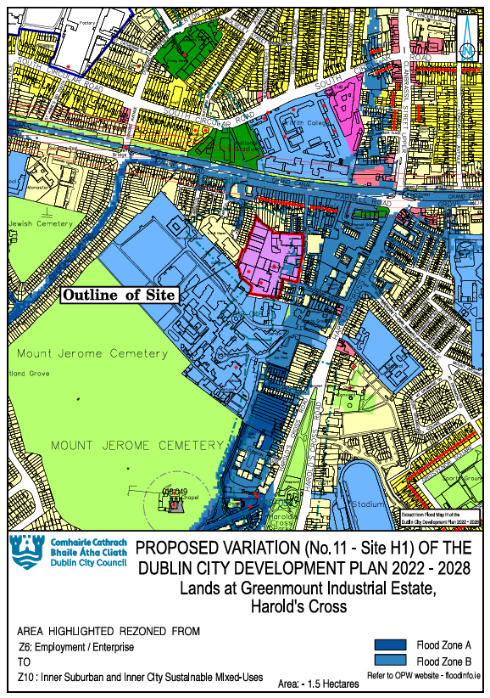
Extract from Flood Map H, from Volume 7 (SFRA) of the 2022-2028 Dublin City Development Plan.

Justification Test for Proposed Variation No. 11 - Greenmount Industrial Estate.
Area Description | These highly accessible serviced employment lands are located adjacent to the city centre to the south of the Grand Canal at Harolds Cross. The lands are in proximity to the Kimmage to City Centre Core Bus Corridor, on Harold’s Cross Road. The lands are accessed via Greenmount Lane and Avenue.  The lands are in use for low scale, low intensity employment / service uses. There are three protected structures on the lands associated with historic industrial uses. The River Poddle traverses the lands and a Poddle diversion (2100mm).  The lands are served by Harolds Cross urban village centre and the city centre. There is a small element of residential use on the lands.
Land Use Zoning | It is proposed to rezone the subject lands from Z6: Employment/Enterprise to Z10: Inner City and Inner Suburban Mixed-Uses.  The Z10 zoning objective is ‘to consolidate and facilitate the development of inner city and inner suburban sites for mixed-uses’.
SDRA | No
Benefitting from Defences (flood relief scheme works)/  Sensitivity to Climate Change/  Residual Risk/  Surface Water/  Historical Flooding | Poddle River Flood Alleviation Scheme – Stage IV: Implementation / Construction. Area to be protected from 100 year flood by end of 2026.  See Area Assessments in the 2022-2028 Dublin City Development Plan, SFRA Volume 7 Final SFRA Full Doc. 14.12.22.pdf  Area: 15. Poddle: Grand Canal to Sundrive Road, DCC SFRA, Appendix B. Part 3 of that Justification Test states:  ‘ Development proposals for sites in Greenmount Industrial Estate and surrounding area encompassed by Flood Zones A and B shall have an emergency plan in place, including the issue and receipt of flood warnings as well as emergency evacuation procedures and recovery plans following an extreme flood event’.  This area benefits from upstream flood storage structures which are part of the Poddle Flood Alleviation Scheme the major elements of which are currently in place and programmed for completion Q4 2026.  Local site specific plans will be required to ensure access and egress from/to any further developments across flood Zone B lands adjoining site H1.  Flood Event: Flooding at Harold’s Cross, Dublin City on 24th Oct 2011, when lands adjoining the site were flooded to significant depths. The Poddle FAS has significantly reduced this risk.  As per development plan policies in respect of surface water management (see Appendix 6), best practice should be implemented to limit surface water run-off to current values or less. The use of SuDS and green infrastructure should be considered in the first instance to reduce flooding as part of a surface water management plan to be prepared for the lands.  Set backs from the river Poddle and bypass are recommended to increase the possible use of SuDS and GI in this site area.
Commentary on Flood Risk:
The majority of the subject lands are identified as being located within Flood Zone C with a small portion of the lands along the eastern boundary identified within Flood Zone B. The established access routes serving the lands are also located within Flood Zone B. Access and evacuation procedures when the Poddle river is in the flood are to be established with the Drainage/ Flooding Division of Dublin City Council prior to any planning application.

Justification Test for Development Plans

1. Part 1 of the Justification Test is covered under Section 3.2.1 of the SFRA of the 2022-2028 Dublin City Development Plan, Volume 7, which states that ‘Part 1 of the Justification Test has, therefore, been applied universally across the city’.

2. The zoning or designation of the lands for the particular use or development type is required to achieve the proper planning and sustainable development of the urban settlement and, in particular:

(i) Is essential to facilitate regeneration and/or expansion of the centre of the urban settlement.
Answer: Yes: These serviced lands are located adjacent the city centre and are well served by local bus services / existing community infrastructure. The lands are currently used for low scale / low intensity employment / service uses and some residential use. In line with national and regional planning policy, the rezoning of the lands is essential to facilitate the intensification / consolidation / regeneration of serviced land in the city and to meet the city’s housing growth requirements. The proposed zoning objective provides the opportunity for more intensive development to achieve more homes, jobs, services at this location through high quality and high-density mixed-use development. The proposed rezoning can also support the continued operation of existing uses on the lands. Therefore, the proposed rezoning is considered essential to facilitate the regeneration and expansion of the urban settlement on these lands.
(ii) Comprises significant previously developed and/or under-utilised lands
Answer:
Yes: These lands comprise previously developed/ underutilised lands.
(iii) Is within or adjoining the core of an established or designated urban settlement.
Answer: Yes: The lands form part of the established / designated urban settlement of Dublin City.
(iv) Will be essential in achieving compact and sustainable urban growth
Answer: Yes: The lands form part of an established built-up part of the inner suburbs and are essential in achieving compact and sustainable urban growth including through providing housing and through the support such development can provide to existing services – transport, service infrastructure and community infrastructure.
(v) There are no suitable alternative lands for the particular use or development type, in areas at lower risk of flooding within or adjoining the core of the urban settlement.
Answer: There are no suitable alternative lands for the particular uses or development type in areas at lower risk of flooding, within or adjoining the urban settlement.
3. Specific Flood Risk Assessment
This site is situated primarily in Flood Zone C with some lands located in Flood Zone B. The Poddle River traverses the lands and there is a 2100mm Poddle diversion located on the western side of the lands (put in as Poddle in poor repair). These would require wayleaves and potentially restrictions for access over.
The adjoining lands are programmed to be protected from 100-year flood event by end of 2026.
Policy SI10 of the Development Plan supports the provision of a setback of 10 - 15 metres on either side of watercourses and promotes the restoration and opening of culverted rivers, where feasible. The River Poddle has approximately 1 metre of cover, which may present an opportunity. Site is substantially in Flood Zone C. However, access to some of the site is located in Flood Zone B. Access and egress during flood must be planned for any building development.

Conclusion: The subject area passes Part 1, 2 and 3 of the Justification Test for Development Plans

Justification Test for Lands at Fumbally Lane/Malpas Street / Blackpitts Lands, Dublin.8
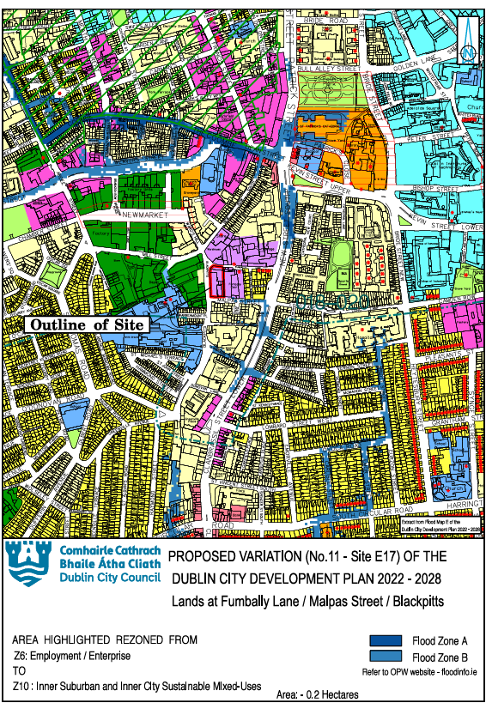
Extract from Flood Map E, from Volume 7 (SFRA) of the 2022-2028 Dublin City Development Plan.

Justification Test for Proposed Variation No. 11 Site E17 Lands at Fumbally Lane / Malpas Street / Blackpitts Lands, Dublin 8.
Area Description | These highly accessible and serviced employment lands are in the inner-city Liberties area.  The lands are used for low intensity employment / service uses. The lands are occupied in the main by mid 20th buildings and an internal courtyard and lie adjacent to the former Maltings complex. The relevant buildings appear underutilized.
Land Use Zoning: | It is proposed to rezone the subject lands from Z6: Employment/Enterprise to Z10: Inner City and Inner Suburban Mixed-Uses.  The Z10 zoning objective is ‘to consolidate and facilitate the development of inner city and inner suburban sites for mixed-uses’.
SDRA | Yes – part of SDRA No. 15 Liberties and Newmarket Square
Benefitting from Defences (flood relief scheme works)/  Sensitivity to Climate Change/  Residual Risk/  Surface Water/  Historical Flooding | Historic Flooding - Clanbrassil Street June 1963  Poddle River Flood Alleviation Scheme – Stage IV: Implementation / Construction. Area to be protected from 100 year flood by end of 2026.  See Area Assessments in the 2022-2028 Dublin City Development Plan, SFRA Volume 7 Final SFRA Full Doc. 14.12.22.pdf  See Area Assessments in the 2022-2028 Dublin City Development Plan, SFRA Volume 7: No. 13 Poddle: Inside Canal and JT for SDRA No. 15 Liberties and Newmarket Square.  The Poddle River Flood Alleviation Scheme has significantly reduced flood risk in this area. The flood zone map for Fumbally Lane as shown in the SFRA reflects the outcome of the Poddle River Flood Alleviation Scheme, and is the most up to date flood risk map. A site-specific flood risk assessment for the site should confirm the flood risks and manage climate change risk.
Commentary on Flood Risk:
The lands are identified as primarily within Flood Zones B and C and they abut Flood Zone A to the west and partially lie in Flood Zone A on the north western corner of the site.
Justification Test for Development Plans

1. Part 1 of the Justification Test is covered under Section 3.2.1 of the SFRA of the 2022-2028 Dublin City Development Plan, Volume 7, which states that ‘Part 1 of the Justification Test has, therefore, been applied universally across the city’.

2. The zoning or designation of the lands for the particular use or development type is required to achieve the proper planning and sustainable development of the urban settlement and, in particular:

(i) Is essential to facilitate regeneration and/or expansion of the centre of the urban settlement.
Answer: Yes: These serviced lands are located in the city centre and are highly accessible and well served by existing community infrastructure. They form part of SDRA No. 15 Liberties and Newmarket Square. The lands are currently used for low intensity employment / service uses. In line with national and regional planning policy, the rezoning of the lands is essential to facilitate the intensification / consolidation / regeneration of serviced land in the city and to meet the city’s housing growth requirements. The proposed zoning objective provides the opportunity for more intensive development to achieve more homes, jobs, services at this location through high quality and high-density mixed-use development. Therefore, the proposed rezoning is considered essential to facilitate the regeneration and expansion of the urban settlement on these lands.
(ii) Comprises significant previously developed and/or under-utilised lands
Answer: Yes: These lands comprise previously developed/ underutilised lands.
(iii) Is within or adjoining the core of an established or designated urban settlement.
Answer: Yes: The lands form part of an established / designated urban settlement.
(iv) Will be essential in achieving compact and sustainable urban growth
Answer: Yes: The lands form part of an established built-up part of the inner city and are essential in achieving compact and sustainable urban growth including through the support such development can provide to existing services – transport, service infrastructure and community infrastructure.
(v) There are no suitable alternative lands for the particular use or development type, in areas at lower risk of flooding within or adjoining the core of the urban settlement.
Answer: There are no suitable alternative lands for the particular uses or development type in areas at lower risk of flooding, within or adjoining the urban settlement.
3. Specific Flood Risk Assessment
This site is situated predominantly in Flood Zone C and Flood Zone B. They abut Flood Zone A to the west and partially lie in Flood Zone A on the north western corner of the site.
The Poddle River Flood Alleviation Scheme has significantly reduced flood risk in this area. The flood zone map for the Fumbally Lane as shown in the SFRA reflects the outcome of the Poddle River Flood Alleviation Scheme, and is the most up to date flood risk map.
The subject site is subject to significant pluvial flooding (0.31m during a 1% AEP (100-year) flood event). To manage the current flood risk and ensure a sustainable development, less vulnerable development is considered viable at ground floor level, while all residential units will be restricted to the first floor and above. This is also considered viable in the future medium range flooding scenario. A site-specific flood risk assessment for the site should confirm the flood risks and manage climate change risk.

Conclusion: The subject area passes Part 1, 2 and 3 of the Justification Test for Development Plans

  - Appendix 5: List of all development plan land use zoning objectives.
Abbreviated Land-Use Description | Land-Use Zoning Objective
Z1: Sustainable Residential Neighbourhood | To protect, provide and improve residential amenities.
Z2: Residential Neighbourhoods (Conservation Areas) | To protect and/or improve the amenities of residential conservation areas.
Z3: Neighbourhood Centres | To provide for and improve neighbourhood facilities.
Z4: Key Urban Villages and Urban Villages | To provide for and improve mixed-services facilities.
Z5: City Centre | To consolidate and facilitate the development of the central area, and to identify, reinforce, strengthen and protect its civic design character and dignity.
Z6: Employment/Enterprise | To provide for the creation and protection of enterprise and facilitate opportunities for employment creation.
Z7: Employment (Heavy | To provide for the protection and creation of industrial uses and facilitate opportunities for employment creation including Port Related Activities.
Z8: Georgian Conservation Areas | To protect the existing architectural and civic design character, and to allow only for limited expansion consistent with the conservation objective.
Z9: Amenity/Open Space Lands/Green Network | To preserve, provide and improve recreational amenity, open space and ecosystem services.
Z10: Inner Suburban and Inner City Sustainable Mixed-Uses | To consolidate and facilitate the development of inner city and inner suburban sites for mixed-uses
Z11: Waterways Protection | To protect and improve canal, coastal and river amenities.
Z12: Institutional Land (Future Development Potential | To ensure existing environmental amenities are protected in the predominantly residential future use of these lands.
Z14: Strategic Development and Regeneration Areas | To seek the social, economic and physical development and/or regeneration of an area with mixed-use, of which residential would be the predominant use.
Z15: Community and Social Infrastructure | To protect and provide for community uses and social infrastructure.

  - Appendix 6: Development Plan Flooding and Surface Water Management Policies and Objectives

Flood Risk Management Policies/Objectives
Flood Management
Flood Management Policies
Flood management policies are found in several chapters in the Development Plan, as follows:

Chapter 3 – Climate Action
CA8: Climate Mitigation Actions in the Built Environment - To require low carbon development in the city which will seek to reduce carbon dioxide emissions and which will meet the highest feasible environmental standards during construction and occupation, see Section 15.7.1 when dealing with development proposals. New development should generally demonstrate/ provide for:
- building layout and design which maximises daylight, natural ventilation, active transport and public transport use;
- sustainable building/services/site design to maximise energy efficiency;
- sensitive energy efficiency improvements to existing buildings;
- energy efficiency, energy conservation, and the increased use of renewable energy in existing and new developments;
- on-site renewable energy infrastructure and renewable energy;
- minimising the generation of site and construction waste and maximising reuse or recycling;
- the use of construction materials that have low to zero embodied energy and CO2 emissions; and
- connection to (existing and planned) decentralised energy networks including the Dublin District Heating System where feasible.
CA9: Climate Adaptation Actions in the Built Environment - Development proposals must demonstrate sustainable, climate adaptation, circular design principles for new buildings / services / site. The Council will promote and support development which is resilient to climate change. This would include:
- measures such as green roofs and green walls to reduce internal overheating and the urban heat island effect;
- ensuring the efficient use of natural resources (including water) and making the most of natural systems both within and around buildings;
- minimising pollution by reducing surface water run-off through increasing permeable surfaces and use of Sustainable Drainage Systems (SuDS);
- reducing flood risk, damage to property from extreme events– residential, public and commercial;
- reducing risks from temperature extremes and extreme weather events to critical infrastructure such as roads, communication networks, the water/drainage network, and energy supply;
- promoting, developing and protecting biodiversity, novel urban ecosystems and green infrastructure.
CA26: Flood and Water Resource Resilience - To support, encourage and facilitate the delivery of soft, green and grey adaptation measures to enhance flood and water resource resilience in the city and support the delivery of grey adaptation measures to enhance flood and water resource resilience where necessary.
CA27: Flood Risk Assessment and Adaptation - To address flood risk at strategic level through the process of Strategic Flood Risk Assessment, and through improvements to the city’s flood defences.
CA28: Natural Flood Risk Mitigation - To encourage the use of natural flood risk mitigation or nature based solutions including integrated wetlands, green infrastructure, and Sustainable Drainage Systems (SuDS) as part of wider adaptation and mitigation responses to achieve flood resilience.
CA30: Coastal Zone Management - To support, encourage and facilitate coastal zone management measures for adapting to climate change which include restoration of degraded ecosystems, increased flood resilience, water quality improvement, habitat conservation and provision of amenities for the residents and visitors of Dublin City.

Chapter 9 – Sustainable Environmental Infrastructure and Flood Risk
SI10: Managing Development Within and Adjacent to River Corridors –
To require development proposals that are within or adjacent to river corridors in the City (excluding the Camac River) to provide for a minimum set-back distance of 10-15m from the top of the river bank in order to create an appropriate riparian zone. The Council will support riparian zones greater than 10 metres depending on site-specific characteristics and where such zones can integrate with public/communal open space.

SI11: Managing Development Within and Adjacent to Camac River Corridor - To manage all development within and adjacent to the Camac River Corridor in a way that enhances the ecological functioning and water quality of the river and aligns with the principles for river restoration. All development shall provide for a minimum set-back distance of 10-25m from the top of the river bank depending on site characteristics. Large development sites in excess of 0.5ha should provide a minimum set-back of 25m from the top of the river bank where informed by a hydromorphological study.
SI12: River Restoration in Strategic Development and Regeneration Areas - To provide opportunities for enhanced river corridors in the following Strategic Development and Regeneration Areas (SDRAs) in order to harness significant opportunities for river restoration where feasible:
- SDRA 1 Clongriffin /Belmayne and Environs
- SDRA 3 Finglas Village Environs and Jamestown Lands
- SDRA 4 Park West/Cherry Orchard
- SDRA 5 Naas Road
- SDRA 6 Docklands
- SDRA 7 Heuston and Environs
- SDRA 9 Emmet Road
- SDRA 10 North East Inner City
- SDRA 16 Oscar Traynor Road
SI13: Minimising Flood Risk - To minimise the flood risk in Dublin City from all other sources of flooding as far as is practicable, including fluvial, coastal, reservoirs and dams, the piped water system, and potential climate change impacts.
SI14: Strategic Flood Risk Assessment - To implement and comply fully with the recommendations of the Strategic Flood Risk Assessment prepared as part of the Dublin City Development Plan 2022-2028, including all measures to mitigate identified climate change and flood risks, including those recommended under Part 3 (Specific Flood Risk Assessment) of the Justification Tests, and to have regard to the Flood Risk Management Guidelines (2009), as revised by Circular PL 2/2014, when assessing planning applications and in the preparation of statutory and non-statutory plans.
SI15: Site-Specific Flood Risk Assessment – All development proposals shall carry out, to an appropriate level of detail, a Site-Specific Flood Risk Assessment (SSFRA) that shall demonstrate compliance with:
The Planning System and Flood Risk Management, Guidelines for Planning Authorities, Department of the Environment, Community and Local Government (2009), as revised by Circular PL 2/2014 and any future amendments, and the Strategic Flood Risk Assessment (SFRA) as prepared by this Development Plan.
The application of the sequential approach, with avoidance of highly and less vulnerable development in areas at risk of flooding as a priority and/ or the provision of water compatible development only.
Where the Justification Test for Plan Making and Development Management have been passed, the SSFRA will address all potential sources of flood risk and will consider residual risks including climate change and those associated with existing flood defences. The SSFRA will include site-specific mitigation measures, flood-resilient design and construction, and any necessary management measures (the SFRA and Appendix B of the above mentioned national guidelines refer). Attention shall be given in the site-specific flood risk assessment to building design and creating a successful interface with the public realm through good design that addresses flood concerns but also maintains appealing functional streetscapes. Allowances for climate change shall be included in the SSFRA.
On lands where the Justification Test for Plan Making has been passed and where a small proportion of the land is at risk of flooding, the sequential approach to development will be applied, and development will be limited to Minor Development (Section 5.28 of the Planning System and Flood Risk Management Guidelines) on the portion at significant risk of flooding. There will be a presumption against the granting of permission for highly or less vulnerable development which encroaches onto or results in the loss of the flood plain. Water compatible development only will be considered in such areas at risk of flooding which do not have existing development on them.
SI16: Site-Specific Flood Risk Assessment - Proposals which may be classed as ‘minor development’, for example small-scale infill, extensions to houses and small-scale extensions to existing commercial and industrial enterprises in Flood Zone A or B, should be assessed in accordance with the Guidelines for Planning Authorities on the Planning System and Flood Risk Management and Technical Appendices (2009), as revised by Circular PL 2/2014 and any future amendments, with specific reference to Section 5.28 and in relation to the specific requirements of the Strategic Flood Risk Assessment. This will include an assessment of the impact of climate change and appropriate mitigation. The policy shall be not to increase the risk of flooding to the development or to third party lands, and to ensure risk to the development is managed.
SI17: Catchment-Based Flood Risk Management Plans - To assist the OPW in implementing catchment-based Flood Risk Management Plans for rivers, coastlines and estuaries in the Dublin City area, including planned investment measures for managing and reducing flood risk, and have regard to their provisions/ recommendations.
SI18: Protection of Flood Alleviation Infrastructure - To put in place adequate measures to protect the integrity of flood alleviation infrastructure in Dublin City and to ensure new developments or temporary removal of any flood alleviation asset does not increase flood risk, while ensuring that new flood alleviation infrastructure has due regard to nature conservation, natural assets, open space and amenity values, as well as potential climate change impacts.

SI19: Provision and Upgrading of Flood Alleviation Assets - To facilitate the provision of new, or the upgrading of existing, flood alleviation assets where necessary and in particular, the implementation of proposed flood alleviation schemes, on the Santry, Camac, Dodder, Wad, Naniken, Mayne, Tolka and Poddle rivers as well as Clontarf Promenade, Sandymount/ Promenade (northwards towards Irishtown Nature Park subject to the outcome of a flood/ environmental study), Liffey estuary and any other significant flood risk areas being progressed through the planning process to completion during the lifetime of the 2022-2028 Dublin City Development Plan, with due regard to the protection of natural heritage, built heritage and visual amenities, as well as potential climate change impacts.
SI20: Basement Flood Risk Management - That there is a general presumption against the development of basements for residential use below the estimated flood levels for Flood Zones A or B (see Section 15.18.4 and Appendix 9 for further guidance).
SI21 Managing Surface Water Flood Risk - To minimise flood risk arising from pluvial (surface water) flooding in the City by promoting the use of natural or nature-based flood risk management measures as a priority, by requiring the use of sustainable drainage systems (SuDS) to minimise and limit the extent of hard surfacing and paving, and requiring the use of sustainable drainage techniques, where appropriate, for new development or for extensions to existing developments, in order to reduce the potential impact of existing and predicted flooding risk and to deliver wider environmental and biodiversity benefits, and climate adaption.

Chapter 10 - Green Infrastructure and Recreation
GI3: Multi-functionality - To ensure delivery of multifunctional green and civic spaces that meet community needs, support biodiversity, promote active and passive recreation, flood and surface water management and local habitat improvements. The multi-functionality of spaces will be balanced against the need to protect and enhance local habitat and the recreational and functional requirements of parks.
GI24: Multi-Functionality (GI) - To incorporate new open space into the green infrastructure network for the city, and providing a multi-functional role including: outdoor recreation, biodiversity, urban drainage, flood management, connection and carbon absorption without compromising public access to and the amenity function of open space (see Section 15.6: Green Infrastructure and Landscaping).
GI29: Protect Character of River Corridors - To protect, maintain, and enhance the watercourses and their river corridors in the city and to ensure that development does not cover or encroach upon rivers and their banks. To maintain natural river banks and restore them as part of any new development. The creation and/or enhancement of river corridors will be required and river restoration opportunities where possible will be supported to help improve water quality, and ecology, provide natural flood relief as well as providing amenity and leisure benefits.

GI34: New Development and Public Open Space along River Corridors - To ensure that new development, in terms of siting and design, responds to the character, importance and setting of the city’s rivers where the context allows, and to require public open space which is to be provided as part of new development, to supplement riparian buffer zones so as to support the attainment of ‘good ecological status’ or higher for water bodies, flood management, the conservation of biodiversity and ecosystem functions.
GI35: General Protection of Coastal Zone - To protect and enhance the coast shoreline and marine environment as open space and valuable natural habitats.

Flood Management Objectives
Flood management objectives included in the Development Plan, are:
Chapter 9 – Sustainable Environmental Infrastructure and Flood Risk
SIO8: River Restoration Strategies/ Masterplans - To prepare river-specific restoration strategies/ masterplans for the City’s rivers and their tributaries in order to create a comprehensive, collaborative and integrated catchment management planning approach to improving the river corridor which addresses water quality, flooding, hydromorphology, ecology, biodiversity, heritage, amenity and tourism.
SIO10: OPW Flood Relief Maintenance - To support and facilitate the OPW in its duty to maintain flood relief schemes completed under the Arterial Drainage Acts, 1945-1995, including the schemes at River Dodder (Tidal), River Tolka, River Wad (Clanmoyle) South Campshires and Spencer Dock.
SIO11: Cross-Boundary Flood Management - To work with neighbouring local authorities when developing cross-boundary flood management work programmes and when considering cross-boundary development.
SIO12: OPW Catchment-Based Flood Risk - To work with the OPW in the development and implementation of catchment-based strategies for the management of flood risk – including those relating to storage and conveyance, and climate adaption.

SUDS Policies
SUDS policies included in the Development Plan, are:
Chapter 9 – Sustainable Environmental Infrastructure and Flood Risk
SI21: Managing Surface Water Flood Risk - To minimise flood risk arising from pluvial (surface water) flooding in the City by promoting the use of natural or nature-based flood risk management measures as a priority, by requiring the use of sustainable drainage systems (SuDS) to minimise and limit the extent of hard surfacing and paving, and requiring the use of sustainable drainage techniques, where appropriate, for new development or for extensions to existing developments, in order to reduce the potential impact of existing and predicted flooding risk and to deliver wider environmental and biodiversity benefits, and climate adaption.
SI22: Sustainable Drainage Systems - To require the use of Sustainable Drainage Systems (SuDS) in all new developments, where appropriate, as set out in the Greater Dublin Strategic Drainage Study (Vol 2: New Development)/ Greater Dublin Regional Code of Practice for Drainage Works and having regard to the guidance set out in Nature-based Solutions to the Management of Rainwater and Surface Water Runoff in Urban Areas, Water Sensitive Urban Design Best Practice Interim Guidance Document (DHLGH, 2021). Sustainable Drainage Systems (SuDS) should incorporate nature-based solutions and be designed in accordance with the Dublin City Council Sustainable Drainage Design & Evaluation Guide (2021) which is summarised in Appendix 12. SuDS should protect and enhance water quality through treatment at source while enhancing biodiversity and amenity.
SI23: Green Blue Roofs - To require all new developments with roof areas in excess of 100 sq. metres to provide for a green blue roof designed in accordance with the requirements of Dublin City Council’s Green & Blue Roof Guide (2021) which is summarised in Appendix 11.
SI24: Control of Paving of Private Driveways / Vehicular Entrances / Grassed Areas - To require that all surface water run-off from new/ extended domestic driveways, repaired/ replacement driveways, and vehicular entrances (where such development is not exempted from the requirement to obtain planning permission), is managed through the use of SuDS, ensuring no increase in surface water discharges to the public drainage network (for further guidance, please refer to Appendices 5 and 12).
SI25: Surface Water Management - To require the preparation of a Surface Water Management Plan as part of all new developments in accordance with the requirements of Appendix 13 – the Council’s Surface Water Management Guidance.

Chapter 3 Climate Action
CA28: Natural Flood Risk Mitigation - To encourage the use natural flood risk mitigation or nature based solutions including integrated wetlands, green infrastructure, and Sustainable Drainage Systems (SuDS) as part of wider adaptation and mitigation responses to achieve flood resilience.
CA9: Climate Adaptation Actions in the Built Environment - Development proposals must demonstrate sustainable, climate adaptation, circular design principles for new buildings / services / site. The Council will promote and support development which is resilient to climate change. This would include:
- measures such as green roofs and green walls to reduce internal overheating and the urban heat island effect;
- ensuring the efficient use of natural resources (including water) and making the most of natural systems both within and around buildings;
- minimising pollution by reducing surface water run-off through increasing permeable surfaces and use of Sustainable Drainage Systems (SuDS);
- reducing flood risk, damage to property from extreme events– residential, public and commercial;
- reducing risks from temperature extremes and extreme weather events to critical infrastructure such as roads, communication networks, the water/drainage network, and energy supply;
- promoting, developing and protecting biodiversity, novel urban ecosystems and green infrastructure.

SUDS Objectives
SUDS objectives included in the Development Plan, are:
Chapter 9 – Sustainable Environmental Infrastructure and Flood Risk
SIO9: Planning for Surface Water Management - To undertake Surface Water Management Plans for each river catchment and as part of this, include a study of relevant zoned lands within the City in order to ensure that sufficient land is provided for nature-based surface water management, SuDS and green infrastructure.

Green Infrastructure Policies
Green Infrastructure policies are found in a number of chapters in the Development Plan.
Chapter 10 - Green Infrastructure and Recreation
GI1: Green Infrastructure Assets - To identify and protect the integrity of the city’s GI assets, as appropriate, and to enhance and expand the connectivity, multi-functionality, and accessibility of the city’s green infrastructure network, while addressing gaps in the network.
GI2: Connectivity - To develop an interconnected green infrastructure network of strategic natural and semi-natural areas with other environmental features including green spaces, rivers, canals, the coastal and marine area and other physical features including streets and civic spaces that supports ecological, wildlife, and social connectivity.
GI5: Greening of Public Realm / Streets - To integrate urban greening features including nature based solutions into the existing public realm where feasible and into the design of public realm projects for civic spaces and streets. The installation of living green walls will be encouraged to the fullest possible extent throughout the city of Dublin and tree pits with mixed planting will be preferred for the greening of streets in recognition of the co-benefits they offer for SuDs, biodiversity, amenity value and traffic calming.
GI6: New Development / New Growth Areas - To integrate Green Infrastructure and an ecosystem services approach into new developments / new growth areas in the city that contributes to the city’s green infrastructure network by its extension and enhancement and that provides for the environmental resilience of new development.
GI7: Connecting Greening Elements in Site Design - To avoid the fragmentation of green spaces in site design and to link green spaces /greening elements to existing adjacent green infrastructure / the public realm where feasible and to provide for ecological functions.
GI24: Multi-Functionality (GI) - To incorporate new open space into the green infrastructure network for the city, and providing a multi-functional role including: outdoor recreation, biodiversity, urban drainage, flood management, connection and carbon absorption without compromising public access to and the amenity function of open space (see Section 15.6: Green Infrastructure and Landscaping).
GI34: New Development and Public Open Space along River Corridors - To ensure that new development, in terms of siting and design, responds to the character, importance and setting of the city’s rivers where the context allows, and to require public open space which is to be provided as part of new development, to supplement riparian buffer zones so as to support the attainment of ‘good ecological status’ or higher for water bodies, flood management, the conservation of biodiversity and ecosystem functions.
GI35: General Protection of Coastal Zone - To protect and enhance the coast shoreline and marine environment as open space and valuable natural habitats.

This document is available in Large Print, High Contrast Print and Braille on request.
Planning, Property & Economic Development Department,
Civic Offices, Wood Quay,
Dublin 8.
D08 RF3F

Tel: 01 222 2222
Email: variations@dublincity.ie
Web: www.dublincity.ie

New Housing Growth Requirements set out on NPF Implementation: Housing Growth Requirements, Guidelines for Planning Authorities – under Section 28 of the Planning and Development Act, 2000, as amended, in July 2025
(Microsoft Word - 5.3 SFRA for the Planning Scheme approved by An Bord Pleanála.doc

