Henrietta House, Dublin 1
Choice Based Lettings Scheme 2026
2 bedroom apartment
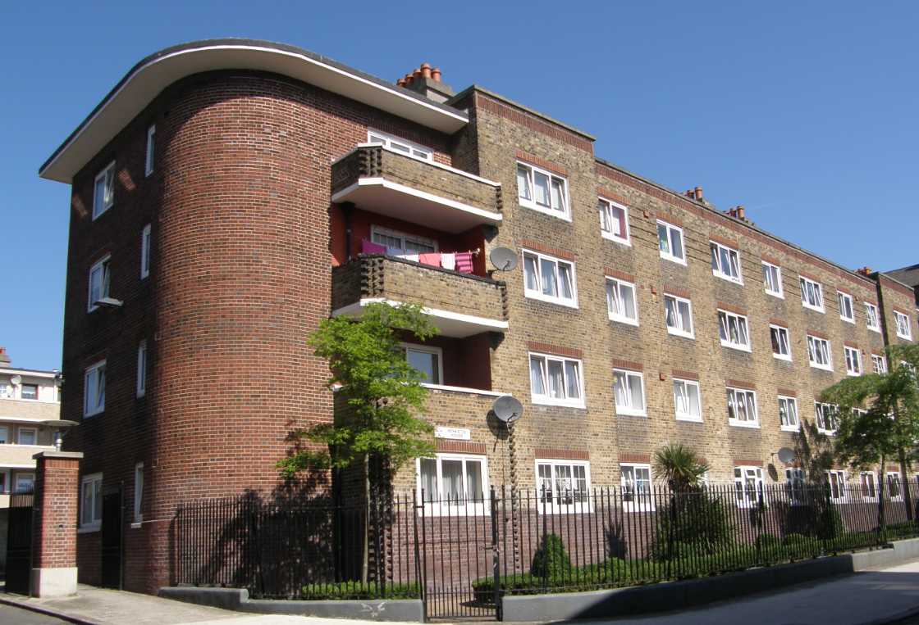

Dublin City Council is inviting applicants from all our waiting lists who have selected Area H on their area of preference to apply for Henrietta House, Dublin 1.

Henrietta House is located in Dublin 1 and is close to all local amenities including schools, shops, and public transport services. The apartment will be fully refurbished. Furnishings and white goods are not provided.

This is a second floor unit. There is no lift access in the complex

Start date for applications: 10th July 2026 @ 5pm, Closing date: Friday 17th July 2026 @ 5pm.

Only applications whose requirements are for 2 bedroom accommodation under the Allocations Scheme of Lettings will be considered for this Choice Based Letting competition.

Please Note Late Applications Will Not Be Considered.
As per your Social Housing Application form, Dublin City Council will process your
Choice Based Letting application in line with GDPR Guidelines.
Please see Dublin City Council Privacy Statement on Dublin City Council website.
Please Turn Over for our Choice Based Lettings procedures and application form.
Procedure and Application Form

- All Applicants Must be listed for Area H. Do not apply if you do not have Area H as a preference.

- Please apply through the portal by following the link below

https://citizenhub.dublincity.ie/service/Choice_Based_Lettings_Application
or by completing the form and returning it to Housing Allocations, Civic Offices, Fishamble Street, Dublin 8
- Start date of CBL advertisement is Friday 10th July @ 5pm, End date Friday 17th July 2026 @ 5pm.

- If a number of applicants express an interest in the same property, the final offer will be made to the applicant with the highest position on the list. This will be subject to Estate Management clearance. As the final offer is made to the applicant in the highest position there is no supporting documentation required as only position on your waiting list is considered.

- All Applications will be examined on estate management grounds including rent arrears.

- A successful applicant who refuses a Choice Based Letting will not be eligible for consideration for another Choice Based Letting Unit for a period of one year.

- Under the choice based letting scheme only the successful candidates will be notified.

- Please Note Late Applications Will Not Be Considered.

- As per your Social Housing Application form, Dublin City Council will process your Choice Based Letting application in line with GDPR Guidelines. Please see Dublin City Council Privacy Statement on Dublin City Council website.

Application Form
Your Name __________________________________________
Your Address _____________________________________________________________
Your Family Size _________________________________
Your Housing Ref. No. ____________________
PPS Number ____________________
Your Telephone/ Mobile Number ____________________________________
Did you read and understand the procedures above Yes ______ No _____
Signature _________________________________________

