DECLARATION ON DEVELOPMENT & EXEMPTED DEVELOPMENT
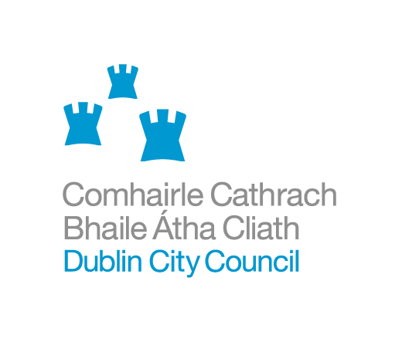
SECTION 5 APPLICATION FORM
NAME OF APPLICANT: _____________________________________________

ADDRESS OF APPLICANT: __________________________________________

______________________________________________________________

EMAIL ADDRESS: ________________________________________________

TELEPHONE NO. Day: _______________Mobile: _________________________

NAME OF AGENT AND AGENT’S ADDRESS: ______________________________

______________________________________________________________

TELEPHONE NO. Day: _______________Mobile: _________________________

ADDRESS FOR CORRESPONDENCE (if different from above)

______________________________________________________________

______________________________________________________________

LOCATION OF SUBJECT SITE: _______________________________________

______________________________________________________________

Is this a Protected Structure or within the curtilage of a Protected
Structure?

If yes, has a Declaration under Section 57 of the Planning & Development Act 2000 been requested or issued for the property by the Planning Authority?

Please provide details of works (where applicable) or proposed development. (Note: only works listed and described under this section will be assessed under this section 5 application. Use additional sheets if required.)

_____________________________________________________________

_____________________________________________________________

_____________________________________________________________

_____________________________________________________________
List of plans, drawings etc. submitted with this application
_____________________________________________________________

_____________________________________________________________

_____________________________________________________________

_____________________________________________________________

_____________________________________________________________

Please state Applicant’s interest in this site: __________________________

If applicant is not owner of site, please provide name & address of owner:

____________________________________________________________________

____________________________________________________________________

Are you aware of any enforcement proceedings connected to this site?
If so please supply details:

_______________________________________________________________

_______________________________________________________________

Where there previous planning application/s on this site?
If so please supply details:

______________________________________________________________

Signed_________________________________Date___________________

NOTES

Application shall be accompanied by 2 copies of site location map with site clearly outlined in red and a fee of €80.00. Please submit 2 copies of any additional plans/reports etc. you may wish to include as part of the application.
Application shall be forwarded to: Dublin City Council, Planning Registry Section, Block 4, Floor 0, Civic Offices, Wood Quay, Dublin 8.
Contact Details: Phone: 01 222 2149 Fax: 01 222 2675

Section 5 Declaration for Protected Structures

Required Documents

- Application form (The application form should be used to provide a numbered list of all the proposed works. Two copies of all supporting information should be submitted).
- Application fee (€80)
- 2 copies of the site location map (location clearly outlined in red).
- A photographic record of the historic fabric to be affected/impacted upon by the proposed works and a general photo of the building. (notes can be added to these photos to explain the proposed works)
- An outline explaining justification for and assessment of the impact of the proposed works on the protected structure.
- A method statement outlining the proposed works to include a specification of the materials to be used.
- Elevation, plan and detail drawings where appropriate.

The Department of Arts, Heritage and the Gaeltacht Advice Series documents are recommended reading before submitting a Section 5 application for proposed works to a protected structure. These publications contain the best practice advice for conservation work and knowledge of best conservation practice must be clearly demonstrated in all applications. (See links below)

http://www.dublincity.ie/Planning/HeritageConservation/Conservation/Pages/DoEHLGArchitecturalHeritagePublicationsandConservationAdviceSeries.aspx
A Guide to the Repair of Historic Brickwork:
The Repair of Wrought and Cast Iron Work :
A Guide to the Repair of Older Buildings:
A Guide the Repair of Historic Windows:
Roofs - A Guide to the Repair of Historic Roofs.pdf
Ruins - The Conservation and Repair of Masonry Ruins.pdf
Energy Efficiency in Traditional Buildings.pdf
Access - Improving the Accessibility of Historic Buildings & Places.pdf
Places of Worship - The Conservation of Places of Worship 2011.pdf

